THE CONTRIBUTION OF MAKHORIJUL HURUF TOWARD THE PRODUCTION OF ENGLISH CONSONANT

M. Zuhri Hasani
Iis Sujarwati
Postgraduate Program of English Education, University of Bengkulu zuhrifc@gmail.com
iissujarwati@unib.ac.id

ABSTRACT

The design of this research is descriptive quantitative research which the backround in this thesis there is a difference in quality of pronounce of English consonant between the students have good makhorijul huruf with the students not good of makhorijul huruf. The purpose was to find out the contribution makhorijul huruf toward the production of English consonant for twelfth grade students at Madrasah Aliyah Ladang Panjang Sarolangun Academic Year 2023/2024. The subject of this research was twelfth grade students of Madrasah Aliyah Ladang Panjang academic year 2023/2024 there were ten students with details 4 men and 6 women. The data was collected by using oral test for all students. The results of research and discussion this research in the title the contribution of makhorijul huruf toward the production of English consonants for twelfth grade students Madrasah Aliyah Ladang Panjang Sarolangun Academic Year 2023/2024, by analyze normality test of makhorijul huruf that X²_{table} value at 5% error level obtained with 9.488, while the X²_{count} = 6.063 so that X²_{count} < X² _{table} or 6.063 < 9.488, it can be concluded that the data of makhorijul huruf were normally distributed. And from the analysis of normality of pronunciation calculation that the value of X²_{table} on error level of 5% was obtained with 9.488, while the X²_{count} = 3.593 so the X²_{count} < X²_{table} or 3.593 < 9.488, it can be concluded that the data of Pronunciation were normally distributed. While the hypothesis test that the α 0:05 with dk = k-1 = 10-1 = 9 and t_{table} = 2.262. So t_{hitung}> t_{table} or 11,489> 2.62, then H₀ is rejected and declared significant, so it can be declared significant. With Coefficient determinant or the magnitude contribution of makhorijul huruf toward the production of English consonants was 97.1%, this indicates that it is very valuable because the positive coefficient is very high contribution.

Key Words: Contribution, Makhorijul Huruf, Pronunciation, English Consonants.

INTRODUCTION

As a means of communication between one individual to another, the language becomes very important, because of that the human always create and develop a new language. By the grace of God do people have more advanced in language processing special for communication means or simply knowledge. However, the English has become a primary subject of learning in Indonesia this proved to be the English language as one of subject in national examination test. There are four skills or ability, which is a primary in learning foreign languages, especially English, i.e. listening, speaking, reading, and writing. Among the four skills that speaking is the most prominent and essential to be have, because as a normal human with speak they would communicate and interact with others, both in area, culture, until business.

Commonly in the learning of language can do in two situations, there are in the classroom situation and natural situation (Jiao: 2022). The classroom situation the learning process can be done in formality and the purpose can be reached because the learning with the rule and planning, but disadvantages the learning process is passive, limited, and difficult to developed. Students could not get a direct experience in the conversation and implementation of the theory of learning and usually they have a difficulties when they have a chance meeting the foreigner (native speaker). A natural situation for foreign language learning is one where the second language is experienced in a situation that is similar to which the native language is learned.
From the language, the researcher continues on the issue of language acquisition that places the school. In this case, the research took place in the Islamic Senior High School, which is equivalent to the high school. Madrasah Aliyah Ladang Panjang place is a school that is shaded by the Ministry of Religious Affairs that taught the curriculum set by the Ministry of Religious Affairs. When the researcher did the observation, the researcher found that in the curriculum of Religious Affairs there are three languages ​​taught at Madrasah Aliyah Ladang Panjang, namely Indonesian, Arabic, and English. However, based on observation the researcher found an incidence in which look obvious at the time to learn English. The students who have the background and education from madrasah diniyah and boarding school and have good quality at Makhorijul Huruf or utter fluency and accuracy in Arabic alphabet, beside that the student also has a slightly better quality pronounce than students who only follow the general education which their Makhorijul Huruf mediocre.
Students need to be introduced consonants before recognize letters vocals and words. This is so due to vowel is to ring the consonants. Vowels without consonants should not be told, otherwise need introduced first consonant versus vowels. Moreover the system of the Arabic consonants and vowels, that Arabic vowels are written in the form of a symbol that is not the same as consonants and he also was not written as consonants such as Malay or English language. From the statement above, it can be concluded that study of Arabic consonants can contribute to improve the quality the production of English consonants, because some Arabic consonants have the same place of pronunciation the English consonants.

CONSONANTS

Consonants are sound produced by obstructing of air coming out from the lungs by organ of speech somewhere in the mouth or nose (Zainuddin et al., 1996:16). In addition by Yallop (1995:13), those in consonants the airflow is rather more impeded or constricted. While in Oxford dictionary (2003:278) there are two senses of consonant, the first consonant sound made ​​by a speech partly or completely stopping the flow of air being breathed out through the mouth, and second consonant is a letter of the alphabet that represents a consonant sound , for example 'b', 'c', 'd', 'f'. According to (Gebhardt 2011:6) some difficult sounds for foreign speakers of English there are: /ə/, /ɜː/, /ʌ/, /ɪ/, /θ/ and /ð/, /w/, /dʒ/, /h/, /s/.
International Phonetic Consonants symbols (Gebhardt, 2011:4)
/p/ play  /b/ bad  /t/ ten  /d/ day  /k/ character  /g/ got  /f/ food  /v/ vain  /θ/ thin  /ð/ they  /s/ small  /z/ zoo  /ʃ/ shell, nation, machine | /ʒ/ vision  /h/ hot  /m/ moon  /n/ can  /ŋ/ string  /tʃ/ chair  /dʒ/ just  /l/ look  /r/ real  /j/ yes  /w/ window

MAKHORIJUL HURUF

Makhorijun (مخارج) in terms of morphology from fi’il madli khoroja (خرج) is means out. Then in convert into isim makaan (noun is a place and time), then it becomes makhrojun (مخرج). The plurality is makhorijun (مخارج) Therefore; makhorijul huruf (مخارج الحرف) is means places out letters. Meanwhile, Mahfan (2005:7) makhorijul huruf (مخارج الحرف) is the name a place out of letters, to which the letter is formed (or spoken). Thus, makhorijul huruf is a letter at the time of discharge letter sounded. On the other opinion (Sidiq and Ghofur, 2012:4 and 12) a makhorijul huruf by language is the place of out a letter. Being under the terms tajwid is where a letter was issued either by the way real or mistaken-estimated. Mahfan (2005:7) makhroj huruf divided into 17 Makhroj. Other opinion, (Aziz, 2011: 27) makhroj huruf generally state from five places, namely: oral cavity (aljauf), larynx (al-halq), tongue (al-lisan), two lips (asy-syafatain), and nose (alkhaisyum):
    - Al-Jauf (الجوف) is means oral cavity. That is the out of point located in the oral cavity, from this makhroj out three letters of mad, namely alif (ا), Wawu (و), and ya (ي) which the death symbol.
    - Al-Halq (الحلق) is means larynx. That is, the exit point is located in the throat or larynx. From al-Halq divided into three places, namely:
- Aqshal halq (الحلق اقصى) is the larynx or throat inside. From this Makhroj out letters hamzah (ء) and ha' (ھ).
- Wasthul halq (الحلق وسط) is the center of the throat. From this Makhroj out the letter 'ain (ع) and cha' (ح).
- Adnal halq (الحلقأدنى ) is the outer throat or throat end. From this Makhroj out letters kha' (خ) and ghain (غ). Total letters coming out of al-halq Makhroj are six letters.
    - Al-Lisan (اللسان) Al-lisan is means tongue. That is, the out of letters is located on the tongue. The number of hijaiyyah the letters that came out of from this makhroj there is 18 letters and divided into 9 makhroj.
      - Verbal base met with upper ceiling. The letter that came out is qof (ق).
      - Base of the tongue, exactly the lower (or forward) a bit of makhroj qof, The letter that came out of this Makhroj is kaf (ك).
      - Mid tongue met the ceiling above. From this makhroj out letters jim (ج), syin (ش), and ya (ي).
      - Edge of the tongue touching the left or right molars. The letter that came out of this is makhroj dlod (ض).
      - Tip of the tongue met the ceiling facing him. From this makhroj out letters lam (ل) and nun (ن).
      - Adjacent to makhroj nun and entered the back of the tongue, but the tongue does not touch the ceiling. From this makhroj out letter ra’ (ر).
      - The base of the tip of the tongue met the incisors. From this makhroj out three letters, namely ta '(ت), tho' (ط) and dal (د).
      - Tip of the tongue meets the tip of incisors. From this Makhroj out are three letters, namely dzal (ذ), zho' (ظ), and tsa' (ث).
      - Tip of the tongue meets the tip of the lower incisors. From this makhroj out three letters, namely shod (ص), zai (ز), and sin (س).
    - Ash-Syafatain (الشفتين) is means two lips. The letter that came out of this makhroj is four letters, namely: fa’ (ف), mim (م), ba' (ب), and wau (و).
    - Al-Khaisyum (الخيشوم) is means aqshol anfi or bridge of the nose. From this makhroj is out one makhroj, al-gunnah (nasal/hum (ghunnah).
      - In pronounce gunnah musyaddad, the nasal passages in the letter mim and nun who with tasydid: (مّ), (نّ)
      - In pronounce idgham bigunnah.
      - In pronounce ikhfa.
      - In pronounce iqlab.

RESEARCH METHOD

The design of this research is descriptive quantitative research because, the aims of the research is to determine the contribution of makhorijul huruf toward the production of English consonant for twelfth grade students at twelfth grade in Madrasah Aliyah Ladang Panjang. The independent variable is makhorijul huruf and the dependent variable is production of English consonant students. The purpose of descriptive research, is to determine relationship between variables or to use these relationships to make predictions (Hendratmoko: 2023). the descriptive research aims to describe things or phenomena. The descriptive research is a type of research that describes a situation or phenomenon, also to see the relationship between one variable with another variable. In accordance, this kind of research then the descriptive research is a statistical tool that can be relationship to compare the results of measurements of two different variables in order to determine the contribution of variables and found a correlation between two or more quantitative variables.
The population is divided up into as many sub-sets as the characteristics we want to observe and the proportion of each sub-set in the sample is the same as in the population (Seale et.al: 2007). A sample is the number of individual cases that you ultimately draw and from which/whom you generate data (Leavy: 2023). Sample is a representative part of the entire population. Here the author only takes a few samples; these samples are taken based on the conditions of students, especially those experiencing the same conditions.
In an effort to collect data, the researcher will test methods. The test as technique to collect the data, the shape of questions to measure knowledge or skills training, Intelligence, skill or talent that occurs in an individual or group (Sürücü, & Maslakçı: 2020). In addition, the test can be divided into two general categories (Harahap, & Rozimela: 2021). a. Teacher-made tests were prepared with a particular procedure, but have not experienced the trials many times so it is unknown traits and kindness. b. Standardized test is usually already available in institutions that have guaranteed potency testing. Has been tested many times, revise many times that has been said to be quite good. (Kotronoulas, et al: 2023) Analysis data in quantitative approach in research the technique of data analysis to answer the calculations regarding the problem formulation and testing hypotheses proposed. Once the necessary data collected, the analyses use the test prerequisites. Normality test perform on the data analysis to determine and in this case the normality test is perform chi-square test. In normality test will test the hypothesis that the samples come from normally distribute populations. To determine the degree of relationship between variable X and Y, the researcher use the formula product moment correlation by Pearson. To test the significance of the correlation variable X and Y, the result of correlation r is test significant with the formula proposed

RESULT AND DISCUSSION

Research subjects taking the entire twelfth class students numbered 10 students conducted this research in Madrasah Aliyah Ladang Panjang. In this study population was taken all for the research sample. Data collection was done by researchers perform oral test to all students in twelfth class were carried out for two days. Test were performed two days, First day performed all four men students and second days performed six women students.
When conducting tests researcher found that some students a little trouble at the mention of certain words, in terms of makhorijul huruf and pronunciation consonants, researcher also found those students' doubts on with reasons that researcher have encountered is the lack of practice speaking or pronunciation either in terms of makhorijul huruf or in terms of Pronunciation consonants.
Test results can be seen in the following table:
Test Result of Makhorijul Huruf,
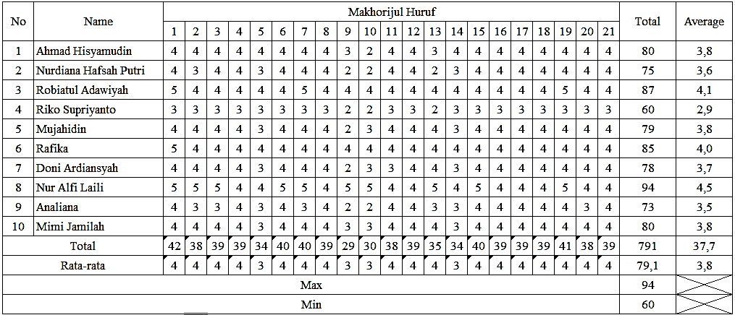

Explanation Number of Question Makhorijul Huruf:
1 | (ب) بَابٌ | 12 | (غ) غَزَالٌ
2 | (ت) تَاجٌ | 13 | (ف) فَأْرَةٌ
3 | )ج( جَامُوْسٌ | 14 | (ق) قَفَصٌ
4 | (د) دَجَاجَةٌ | 15 | (ك) كَلْبٌ
5 | (ذ) ذَنَبٌ | 16 | (ل) لِوَاءٌ
6 | (ر) رَأْسٌ | 17 | (م) مَرْكَبٌ
7 | (ز) زَرَافَةٌ | 18 | (ن) نَمْلٌ
8 | (س) سَمَكٌ | 19 | (و) وَرْدَةٌ
9 | (ش) شَجَرَةٌ | 20 | (ه) هِلَالٌ
10 | (ص) صَدْرٌ | 21 | (ي) يَنَايِرْ
11 | (ع) عَيْنٌ

Test Result of Pronunciation,
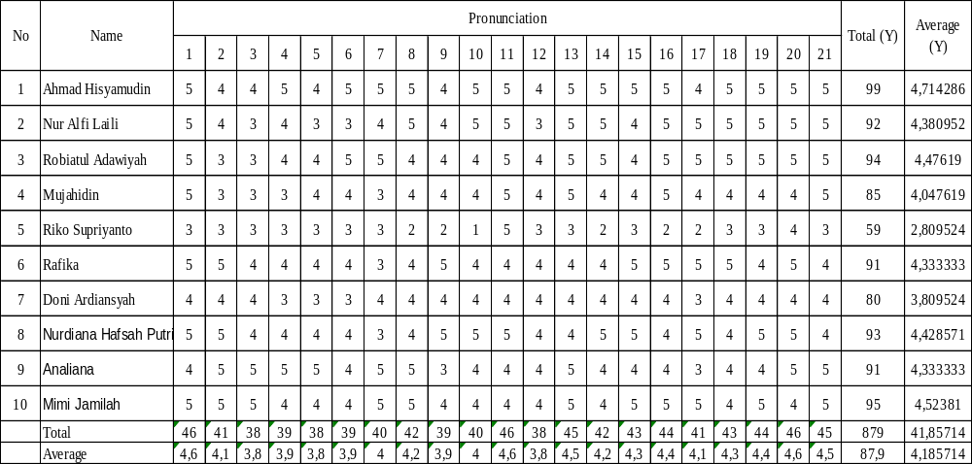

Explanation Number of Question Pronunciation:
1 | /b/ (baby) | 11 | /ŋ/ (string)
2 | /t/ (ten) - /θ/ (method) - /th/ (thin) | 12 | /g/ (got)
3 | /j/ (just) - /dʒ/ (general) - /tʃ/ (chair) | 13 | /f/ (food) - /v/ (over)
4 | /d/ (day) | 14 | /q/ (quick)
5 | /ð/ (they) | 15 | /k/ (cat)
6 | /r/ (real) | 16 | /l/ (look)
7 | /z/ (zoo) - /ʒ/ (vision) | 17 | /m/ (moon)
8 | /s/ (small) | 18 | /n/ (can)
9 | /ʃ/ (information) | 19 | /w/ (window)
10 | /ʃ/ (shell) | 20 | /h/ (hot)
 |  | 21 | /y/ (year)
The researchers analyzed data using normality tests and hypothesis test.
- Normality Test of Makhorijul Huruf
From the analysis normality test of makhorijul huruf that X²_{table} value at 5% error level obtained with 9.488, while the X²_{count} = 6.063 so that X²_{count} < X² _{table} or 6.063 < 9.488, it can be concluded that the data of makhorijul huruf were normally distributed.
- Normality Test of Pronunciation
From the analysis normality test of pronunciation calculation that the value of X²_{table} on error level of 5% was obtained with 9.488, while the X²_{count} = 3.593 so the X²_{count} < X²_{table} or 3.593 < 9.488, it can be concluded that the data of Pronunciation were normally distributed.

Hypothesis Test
From the analysis of hypothesis, the calculation results obtained:
  - To determine the degree of relationship between variable X and Y:
The results of hypothesis test by using the formula product moment correlation by Pearson, that α 0:05 with df = k-1 = 10-1 = 9 and r_{table} = 0.666. So r_{hitung} > r_{table} or 0.971> 0.666, it means that H₁ is accepted and H₀ is rejected, then it can be declared significant.
  - To test the significance of the correlation variable X and Y, the result of correlation r is test significant.
The results of hypothesis test by using the formula proposed by Sugiyono (2010:184), that α 0:05 with df = k-1 = 10-1 = 9 and t_{table} = 2.262. So t_{count}> t_{table} or 11,489> 2.62, then H0 is rejected and declared significant, then it can be declared significant.
  - Coefficient of determination:
Based on the results of calculation that coefficient determinant or the amount of a contribution of 97.1%,
  - Simple linear regression equation, in this analysis only determines the equation:
Then the obtained Y = -4.0444 + 1.084 x where tilapia a negative value then can the equation Y = 4.0444 to 1.084 x.

DISCUSSION

From the data description above it can be seen only few letters that do not contribute significantly, but this most contributing very satisfying, even hypothetical analysis the coefficient determinant showed 97.1%. Results of data analysis showed that large contribution of makhorijul huruf towards the production of English consonants, it can be used as an alternative pronunciation teaching, and school students who have a good background of makhorijul huruf would be a potential and easy to learn English, and for students who are less of makhorijul huruf can be more trained and priority in learning. This is consistent with the statement, that Students need to more study of consonants before recognize letters vocals and words (Adila, & Refnaldi: 2019). This is so due to vowel is to ring the consonants. Vowels without consonants should not be told, otherwise need introduced first consonant versus vowels. Moreover the system of the Arabic consonants and vowels, that Arabic vowels are written in the form of a symbol that is not the same as consonants and he also was not written as consonants such as Malay or English language, because makhorijul huruf has a lot in common pronunciation and consonants of makhorijul huruf more familiar among the rest of the madrasah.
The results of this research also have a correlation with research (Hasibuan et al: 2022) that makhorijul letters have implications for the quality of memorization, it can be concluded that learning or practicing makhorijul letters can be connected, combined with oral lessons or pronunciation practice, the main reason here is When pronunciation and pronunciation are easy without disturbing the reasons or ways to do something then the learning objectives will be easy and can be achieved. So the conclusion here is based on the results of data analysis and looking at the stages, makhorijul letters make a positive contribution to efforts to increase students' ability to pronounce consonant letters, because we all know that pronunciation is wrong, especially in foreign languages, or we are specific to the holy book Al-Qur'an. This will result in misinterpretation and interpretation, which will ultimately result in a misunderstanding in understanding communication.

CONCLUSION

Based on the results of research and discussion this research in the title the contribution of makhorijul huruf toward the production of English consonants for twelfth grade students Madrasah Aliyah Ladang Panjang Sarolangun Academic Year 2023/2024, it can be concluded as follows:
        - The normality test of makhorijul huruf that X²_{table} value at 5% error level obtained with 9.488, while the X²_{count} = 6.063 so that X²_{count} < X² _{table} or 6.063 < 9.488, it can be concluded that the data of makhorijul huruf were normally distributed, and from the analysis of normality of pronunciation calculation that the value of X²_{table} on error level of 5% was obtained with 9.488, while the X²_{count} = 3.593 so the X²_{count} < X²_{table} or 3.593 < 9.488, it can be concluded that the data of Pronunciation were normally distributed.
        - The hypothesis Test that the α 0:05 with dk = k-1 = 10-1 = 9 and t_{table} = 2.262. So t_{hitung}> t_{table} or 11,489> 2.62, then H₀ is rejected and declared significant, so it can be declared significant.
        - Determinant coefficients or the magnitude of contribution is 97.1%.

REFERENCES

Adila, Sherly, & Refnaldi. (2019). Pronunciation Errors Made by Senior High School Students in Speaking Performance. Journal of English Language Teaching Volume 8 No. 3. http://ejournal.unp.ac.id/index.php/jelt

Aziz, Abdul Abdur Rauf. 2011. Pedoman Dauroh Al-Qur’an. Jakarta: Markaz Al Qur’an.

Gebhardt, Frederika. 2011. English Pronunciation.Storia: Facolta di Lettere e Filosofia.

Harahap, Oktaviana, Yulinda, & Rozimela, Yenni. (2021). the Level of Students’ Anxiety in Speech at Universitas Muslim Nusantara Al- Washliyah Medan. Advances in Social Science, Education and Humanities Research, volume 624. http://creativecommons.org/licenses/by-nc/4.0/

Hasibuan, Ilham, Jhonha, & Saputra, Riki, & Romiyilhas. (2022). Implications of Makharij al-Huruf Learning in Improving The Rote Cauldron of The Qur'an Learners. Ruhama : Islamic Education Journal. Vol. 5 No. 1. https://doi.org/10.31869/ruhama..v5i1.3251

Hendratmoko, Suseno. (2023), Dealing with Entrepreneurship Growth and Development in Creative Industry Yogyakarta: Coffee on the Bus Yogyakarta. Formosa Journal of Social Sciences (FJSS) Vol.2, No.2, 2023:231-242. Formosa Journal of Social Sciences (FJSS) Vol.2, No.2, 2023:231-242 https://journal.formosapublisher.org/index.php/fjss

HRL., Zainudin et al.1996.English Pronunciation for Indonesian Students. FPBS IKIP Padang Press.

Jiao, Shi et al. (2022). Motivation and Its Impact on Language Achievement: Sustainable Development of Ethnic Minority Students’ Second Language Learning. Sustainability 2022, 14, 7898. https://doi.org/10.3390/su14137898

Kotronoulas, et al., (2023). An Overview of the Fundamentals of Data Management, Analysis, and Interpretation in Quantitative Research. Seminars in Oncology Nursing 39 (2023) 151398. https://doi.org/10.1016/j.soncn.2023.151398

Leavy, Patricia. 2023. Research Design Quantitative, Qualitative, Mixed Methods, Arts-Based, and Community-Based Participatory Research Approaches. London: The Guilford Press.

Mahfan. 2005. Pelajaran Tajwid Praktis. Jakarta: Sandro Jaya.

Seale, Clive, et al. 2007. Qualitative Research Practice, British Library: Trowbridge.

Sidiq, Sapiudin, & Abdul Ghofur. 2012. Modul Al-Qur’an. Jakarta: Kementerian Agama Press.

Sürücü, L. & Maslakçı, A., Validity and Reliability in Quantitative Research, BMIJ, (2020), 8(3): 2694-2726, doi: http://dx.doi.org/10.15295/bmij.v8i3.1540

Yallop, Collin. 1995. English Phonology. Sydney: Macquarie University Press.

