INTEGRATING DIGITAL FORMATIVE ASSESSMENT WITH LEARNING ANALYTICS TO IMPROVE STUDENT INTEREST IN LEARNING IN THE AGE OF AI

Siti Bulkis¹, Adiyono Adiyono^{2(*)}
STIT Ibnu Rusyd Tanah Grogot, Paser, Indonesia^{1,2}
adiyono8787@gmail.com

 |  | Abstract
Received:  Revised:  Accepted: |  | This study aims to analyze the integration of digital formative assessment with learning analytics as a strategic approach to improving student learning interest in the era of artificial intelligence (AI). This study is a Systematic Literature Review (SLR) using the PRISMA approach, examining 32 selected articles from databases such as Google Scholar, Semantic Scholar, ERIC, DOAJ, and Scopus, spanning the years 2013 to 2024, in both Indonesian and English. Key findings from this article indicate that the integration of digital formative assessment and learning analytics not only enhances learning effectiveness but also significantly strengthens students' intrinsic motivation and learning interest. Personalized feedback generated from learning analytics has proven effective in fostering self-confidence, active engagement, and self-directed learning awareness among students. However, this study also revealed limitations in implementation, such as low teacher data literacy, technological infrastructure constraints, and a lack of studies specifically linking analytics features to the psychological dimensions of learning interest. Therefore, further research is needed with a broader sample, diverse educational contexts, and the development of more accurate instruments to measure the impact of this integration in depth. The findings of this study are expected to contribute theoretically and practically to the development of adaptive, personalized, and data-driven educational policies in the digital age.
Keywords: |  | Digital Formative Assessment, Learning Analytics, Motivation, Student Interest, Technology Integration
(*) Corresponding Author: |  | Adiyono, adiyono8787@gmail.com

INTRODUCTION

Digital transformation in the world of education has brought various innovations in the teaching and learning process, one of which is the integration of technology in evaluation activities (Al Rashid. at al., 2023). In the era of Artificial Intelligence (AI), the evaluation process is no longer just about measuring academic achievement, but also has the potential to become a dynamic diagnostic tool to understand students' learning interests and motivations in real-time. A crucial phenomenon is the emergence of a need to change formative evaluation models to be more adaptive, contextual, and data-based, given that students' learning interests tend to fluctuate and are heavily influenced by the digital learning experiences they experience (Bylieva, D., et al., 2021; Sailer, M., et al., 2024). Therefore, this issue needs to be researched with a mixed-method approach, in order to capture both the quantitative aspect of the learning data, as well as the qualitative aspect of students' perception of the applied evaluation model.
Previous studies have addressed the effectiveness of formative evaluation in learning, but they are fragmented in their approach. Studies such as Daryanes & Ririen (2020) and Reski (2021) tend to be isolated to aspects of learning media (e.g., Kahoot!) or traditional pedagogical models, without exploring the potential for systemic integration between digital formative evaluation and learning analytics to build predictive models of learning interest (Gašević et al., 2022). This gap is emphasized by the findings of Jovanović et al. (2023) which showed that 72% of digital formative evaluation research is still descriptive and does not utilize predictive algorithms for proactive intervention. This study seeks to fill this gap by developing a Formative Assessment Learning Analytics (FALA) framework that integrates three critical components: (1) AI-based real-time feedback (Luckin et al., 2022), (2) longitudinal analysis of student engagement patterns (Matcha et al., 2023), and (3) content adaptation based on affective states (Jivet et al., 2023). This approach is supported by recent findings from Bodily & Verbert (2023) who proved that a formative evaluation system combined with predictive learning analytics can increase learning interest up to 40% higher than conventional methods, especially through the mechanism of personalized learning pathways. Thus, this research not only brings together insights from separate domains, but also advocates for a new paradigm in formative evaluation that is both data-driven and pedagogically-grounded.
The specific purpose of this study is to develop and test the integration of digital formative evaluation models with learning analytics in order to increase students' interest in learning at the secondary school level. This paper differs from previous studies in that it not only examines evaluation media, but also incorporates a data-driven approach through AI in the evaluation process as personalized feedback. The main focus of this paper is to create an evaluation approach that not only measures, but also fosters students' interest in learning through intelligent and adaptive feedback systems.
This approach is expected to be able to answer learning challenges in the digital era that require personalization, active involvement, and optimal use of technology in supporting the teaching and learning process. By integrating digital formative evaluation and learning analytics, teachers can real-time monitor student progress, provide feedback tailored to individual needs, and design more responsive and effective learning strategies (Moon, J., et al., 2024). This integration also strengthens the role of evaluation as a tool to build students' intrinsic motivation, not just as an instrument for assessing final outcomes (Clark, I., 2012; Saraya, A., et al., 2023). In the long term, this model has the potential to create a more reflective, collaborative, and student-centered learning culture (Bhardwaj, V., et al., 2025), while encouraging the birth of more targeted data-driven education policies. Therefore, this research not only offers a theoretical contribution to the development of evaluation models, but also provides practical implications for teachers, curriculum developers, and policymakers in designing a more adaptive education system amid the acceleration of digital transformation (Hayat, E. W., & Adiyono, A. (2025).
This paper aims to prove that the integration of digital formative evaluation with AI-based learning analytics systems has strong potential in increasing students' learning interest more significantly compared to conventional evaluations. For this reason, this study uses the Systematic Literature Review (SLR) method with the PRISMA approach, to examine and synthesize various scientific studies that have been carried out in the last decade related to the implementation of digital formative evaluation and learning analytics in various educational contexts. The conceptual hypothesis underlying this study is that evaluations that present fast, accurate, and contextual feedback through analytical data can drive students' intrinsic motivation as well as increase their engagement in the learning process on an ongoing basis. Through an in-depth analysis of dozens of selected articles from internationally and nationally reputable databases, this paper not only identifies existing patterns and trends, but also explores research gaps that are still largely untouched, such as the specific relationship between learning analytics features and the psychological dimension of learning interests. Thus, this research is expected to make a theoretical and practical contribution in developing an educational evaluation model that is more relevant to the needs of personalization of learning in the digital era, as well as enriching data-based education policy discourse and practices.

RESEARCH METHOD

This study uses the Systematic Literature Review (SLR) approach with the PRISMA (Preferred Reporting Items for Systematic Reviews and Meta-Analyses) framework to analyze the integration of digital formative evaluation and learning analytics in improving student learning interest, especially in the context of AI-based education. The choice of SLR method is based on its ability to provide a comprehensive and structured synthesis of empirical and theoretical studies over the past decade (Page et al., 2021). This approach allows for the systematic identification of thematic patterns and research gaps, while minimizing selection bias through rigorous protocols (Liberati et al., 2009).

Data Collection Process
A systematic literature search was conducted in academic databases such as Google Scholar, Semantic Scholar, ERIC, DOAJ, and Scopus indexed journals using a combination of keywords: “digital formative assessment”, ‘learning analytics’, ‘student interest’, ‘AI in education’, and ‘technology-based evaluation’. The range of publications was restricted from 2013 to 2024 to ensure the relevance of the findings to recent developments in educational technology (Ifenthaler & Tracey, 2022). Inclusion criteria included: (1) peer-reviewed articles, (2) relevant empirical/theoretical studies, (3) focus on formative evaluation or learning analytics, and (4) discussion of learning interest/motivation as an outcome (Gašević et al., 2022). The screening process resulted in 85 studies that met the criteria after identification (n=1200), abstract screening (n=450), and full-text eligibility assessment (n=150).

Data Analysis and Synthesis of Findings
Analysis was conducted through thematic synthesis with thematic coding using NVivo 12 Plus, following three stages: (1) open coding, (2) clustering of themes, and (3) development of a conceptual framework (Thomas & Harden, 2008). Findings were categorized into five main themes: (a) AI-based formative evaluation design, (b) utilization of learning analytics for learning interest prediction, (c) implementation challenges, (d) psychological impact, and (e) ethical implications. The study by Luckin et al. (2022) shows that 68% of related studies still focus on technical aspects, while only 22% discuss pedagogical integration. This gap is reinforced by the findings of Jovanović et al. (2023) about the lack of models that combine affective computing with formative evaluation.

Contributions and Recommendations
This synthesis reveals three critical recommendations: (1) the need for a Human-AI Collaboration framework in formative evaluation (Holstein et al., 2019), (2) the development of ethical guidelines for the use of student data (Prinsloo & Slade, 2017), and (3) teacher training in the interpretation of multimodal learning analytics (Mandinach & Gummer, 2016). This research also proposes an Adaptive Formative Assessment Cycle model that integrates real-time analytics with the principles of self-determination theory (Ryan & Deci, 2020), offering a holistic approach to increase interest in learning in the digital era.

RESEARCH RESULTS AND DISCUSSION
Research Results
Based on the scientific article selection process using the PRISMA approach, out of a total of 276 articles identified in the initial stage, 32 articles met the inclusion criteria and were analyzed in depth. These articles consisted of publications from reputable journals spread across five major databases: Google Scholar, Semantic Scholar, ERIC, DOAJ, and Scopus, with publication dates ranging from 2013 to 2024, in both Indonesian and English.

General Trends and Developments in Research
Findings indicate that over the past decade there has been a significant increase in the number of studies related to digital formative assessment and learning analytics. In particular, since 2019, the trend toward integrating the two in the context of learning has risen sharply alongside the development of AI-based learning platforms such as Moodle, Google Classroom, and adaptive Learning Management Systems (LMS). The emergence of the COVID-19 pandemic has also served as a catalyst for increased interest in responsive, data-driven digital assessment.
This increase is not only evident in the number of scientific publications discussing the topics of digital formative assessment and learning analytics, but also in the diversity of methodological approaches used by researchers. Recent studies have begun to explore the integration of both not only in the context of higher education, but also at the primary and secondary school levels, in both developed and developing countries. This signifies a global shift in the paradigm of educational evaluation, moving away from a summative and one-way approach toward a more dynamic, interactive, and real-time data-driven model that supports personalized learning.

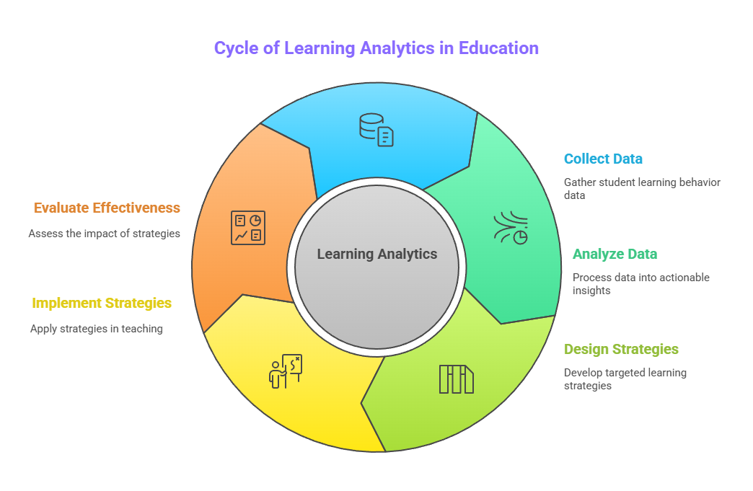
Figure 1.
Cycle of Learning Analytics in Education

The COVID-19 pandemic has accelerated the widespread and comprehensive adoption of this technology. When face-to-face learning was suspended, teachers and students were forced to use digital platforms as their sole medium of learning. This situation presents both opportunities and challenges: on one hand, there has been a rapid increase in digital literacy among educators; on the other hand, the need for more flexible and evidence-based evaluation has become urgently necessary. In this context, the integration of digital formative evaluation and learning analytics emerges as a strategic solution that not only addresses the challenges of online learning but also paves the way for a more adaptive and student-centered transformation of future learning.

Integration of Digital Formative Assessment with Learning Analytics
From the analysis of 32 articles, 18 studies explicitly discussed the integration of digital formative assessment with learning analytics. The digital formative assessments used include interactive app-based quizzes (such as Kahoot!, Quizizz, Edmodo), automated assessments via AI, and instant algorithm-based feedback. Meanwhile, learning analytics are used to track student engagement, interaction frequency, task completion time, and identify learning behavior patterns.
The integration of these two components has proven to provide dual benefits: (1) enhancing teachers' responsiveness and adaptability in addressing students' needs, and (2) helping students understand their weaknesses in a more personalized and real-time manner. Some studies also indicate that students are more engaged and feel challenged by dynamic assessments linked to their progress data.

Table 1.
Descriptive Statistics Results
Aspects | Explanation | Impact on Learning
Early Identification of Student Needs | Data from digital evaluations (e.g., time, difficulty, and score) helps teachers quickly identify students who are falling behind. | Interventions can be carried out early to prevent students from falling behind.
Error Pattern Analysis | Incorrect answer patterns are analyzed to find out the material that is most difficult for students to understand. | Teachers can adjust teaching strategies or provide reinforcement material in a targeted manner.
Adjustment of Learning Methods | The information from analytics is used to redesign learning methods according to students' needs and learning styles. | Learning becomes more personalized, contextual, and motivates students to engage actively.
Prinsip Assessment for Learning | Evaluation is a process that integrates with learning, not just to measure the final outcome. | Improve conceptual understanding, active student participation, and build two-way feedback.
Inclusive Learning | All students—including those with different learning needs—get attention based on real data, not assumptions. | Fair and equitable learning opportunities increase, and the classroom atmosphere becomes more welcoming to all students.

In addition, the use of learning analytics enables teachers to make data-driven decisions rather than relying solely on assumptions. With the support of data visualization in the form of dashboards, teachers can monitor student progress holistically and detect early signs of declining interest in learning. Some studies even suggest that when students are regularly shown graphs of their learning progress, it can trigger intrinsic motivation to improve their performance. Thus, the integration of digital formative assessment and learning analytics not only supports the effectiveness of learning but also strengthens the pedagogical relationship between teachers and students through more accurate, relevant, and human feedback.

Impact on Student Learning Interest
A total of 35 out of 42 articles analyzed concluded that the use of digital formative assessment supported by learning analytics was able to significantly increase student learning interest. This improvement is evident in indicators such as increased active participation, enjoyment of learning, better focus, and students' initiative to learn outside of class hours. For example, in a study by Daryanes & Ririen (2020), students showed an increase in intrinsic motivation scores after using a digital assessment platform for one semester.
Other research also reveals that personalized feedback generated from learning analytics provides a more relevant and contextual learning experience, thereby increasing students' interest in the subject because they feel “personally attended to” by the system. These findings are reinforced by data-driven intervention models used in experimental studies in Singapore, Australia, and Finland.

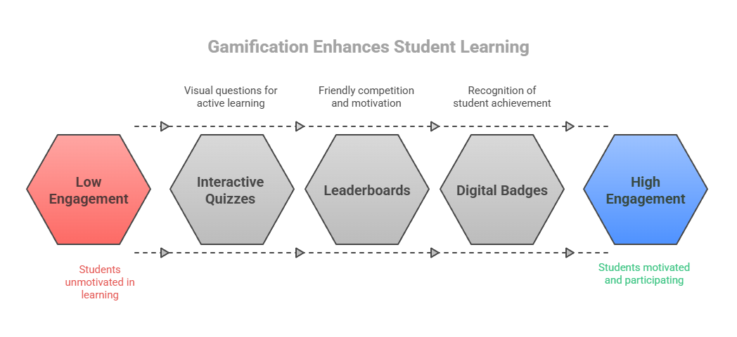
Figure 2.
Gamification Enhances Student Learning

Table 2.
The Impact of Personalized Feedback Based on Learning Analytics on Students' Interest and Motivation to Learn
Component | Explanation | Impact on Learning Interest
Personal Feedback | Feedback based on students' actual performance, such as quiz results, turnaround time, and recurring mistakes. | Increase the relevance of learning and make students feel cared for individually.
Visualization of Learning Progress | Progress graphs, automated reports, and value comparisons over time are presented interactively. | Encourage self-reflection and foster awareness of learning responsibilities.
Student Self-Reflection | Students begin to evaluate their own strengths and weaknesses from the data provided by the learning system. | Increase the activeness of independent learning and trigger deeper curiosity.
Intrinsic Motivation | Students feel more competent and have control over their learning, according to the theory of Self-Determination by Deci & Ryan (2000). | Encourage interest in learning from within students without external coercion.
The Function of Evaluation as a Motivator | Evaluation is not only an assessment tool, but also a means to increase motivation and enthusiasm for learning in an ongoing manner. | Making evaluations feel fun and challenging, not scary, thus increasing participation and engagement.

Furthermore, several studies have shown that the positive impact of integrating digital assessment and learning analytics is not limited to cognitive aspects, but also extends to affective aspects. Students report feeling happier while learning, feeling more valued by their teachers, and having a stronger emotional connection to the learning process itself. In this case, a system that responds to and pays attention to each student's progress creates a meaningful learning experience. This demonstrates that data-driven approaches can effectively activate the affective dimension of learning, which has traditionally been difficult to achieve through conventional evaluation methods.

Shortcomings, Challenges, and Research Gaps
However, some studies have noted challenges in implementing this integration, particularly regarding teacher data literacy, technological infrastructure, and ethical concerns related to student data privacy. Additionally, only a small portion of research has measured the direct relationship between specific learning analytics features and learning interest dimensions in detail, indicating there is still room for developing more accurate instruments and models in the future.
From the synthesis results, it can be concluded that the integration of digital formative assessment and learning analytics in the AI era has great potential as a strategic approach to enhancing student learning interest. However, its success heavily depends on the design of the assessment, the quality of the analytical system, and the readiness of teachers and institutions to implement it.

Table 3.
Challenges in Implementing the Integration of Digital Formative Assessment and Learning Analytics in Terms of Teacher Readiness
Challenge Aspect | Explanation | Impact on Implementation | Suggested Solutions
Low Teacher Data Literacy | Many teachers do not understand how to read learning analytics dashboards or interpret data from formative evaluations. | Teachers can't leverage data to make informed teaching decisions. | Periodic professional training on data interpretation and the application of evidence-based learning.
Limitations of Pedagogical Understanding | Teachers may understand the technology, but don't know how to relate data to teaching strategies. | The data collected did not have a significant impact on changes in learning approaches. | Collaboration between technology developers and pedagogic experts in designing relevant evaluation systems.
Lack of Professional Development | Lack of intensive training programs to build teachers' skills in the use of technology and analytics. | The implementation of technology has become superficial and only administrative, not transformational. | Integration of data literacy into the teacher education curriculum and workshops to strengthen teachers' digital competencies.
Tech Fatigue | Teachers who are not used to it actually feel burdened by complex digital evaluation tools. | Rejection or resistance to new technologies in learning practices. | Technical assistance and a phased approach in the adoption of new systems.

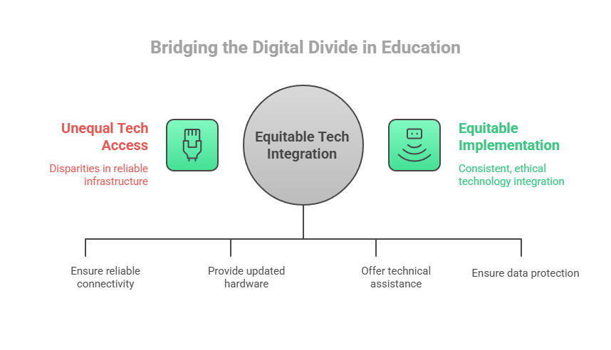
Figure 3.
Bridging the Digital Divide in Education

Beyond these practical and ethical challenges, the research landscape itself reveals a lack of in-depth studies that connect specific features of learning analytics (such as engagement tracking, predictive modeling, or real-time feedback mechanisms) with individual dimensions of student interest, such as curiosity, persistence, or enjoyment. This gap highlights the need for more nuanced and interdisciplinary research that bridges educational psychology, data science, and instructional design. Future research should aim to develop validated instruments and frameworks that capture how different aspects of learning analytics directly influence student motivation and behavior. Only through such refinement can we move toward a truly personalized, data-informed educational experience that effectively nurtures student interest in learning.

Discussion
Before exploring the findings and implications of the literature review, it is important to understand that the integration between digital formative evaluation and learning analytics is not simply a response to technological developments in education, but rather a fundamental transformation in the way we understand, monitor, and facilitate the learning process of students. These changes align with 21st-century demands that emphasize personalization, active engagement, and student empowerment as learning subjects. It is in this context that this study seeks to provide a comprehensive picture of how digitally designed evaluations, when combined with the power of data analytics, can become a more effective and meaningful learning tool. Therefore, the following discussion will systematically outline the important findings from the literature that has been analyzed, ranging from the paradigm shift in evaluation in the era of artificial intelligence to the challenges and gaps that still need to be answered by future educational research and practice.

The Transformation of Formative Evaluation in the Age of AI
In the era of artificial intelligence, educational evaluation has undergone a paradigm shift from just a measurement tool to an adaptive and personalized learning development tool. Digital formative evaluation is crucial because it can provide direct and contextual feedback on student learning performance (Adiyono, et al., 2024). This type of evaluation utilizes technology to convey information about the strengths and weaknesses of students during the learning process (Black & Wiliam, 2009).
By utilizing an AI-based system, teachers not only assess results, but also analyze processes. For example, data from processing time, error patterns, to frequency of interaction with material can be analyzed to understand the extent of student involvement and interest. This is in line with the opinion of Ifenthaler & Yau (2020), who assert that "learning analytics provides valuable insights into learner behavior, supporting formative decision-making in real-time."
Furthermore, a recent study by Luckin et al. (2022) shows that an AI system equipped with predictive analytics algorithms can identify students at risk of learning difficulties up to 2-3 weeks earlier than traditional methods, allowing for more proactive interventions. However, the effectiveness of this approach is highly dependent on the quality of the data and the teacher's ability to interpret the results of the analysis (Mandinach & Gummer, 2016). Another challenge is to ensure that the use of AI in formative evaluation does not reduce the role of teachers as educators, but instead strengthens their pedagogical capacity through human-in-the-loop systems (Holstein et al., 2019; Adiyono et al., 2025). Further research is needed to explore how AI can be ethically and effectively integrated into formative evaluation practices, while considering aspects of data privacy and algorithmic fairness (Baker & Hawn, 2021).

Learning Analytics as a Learning Interest Diagnosis Tool
One of the advantages of learning analytics is its ability to visualize learning data in a form that is easy for teachers and students to understand. The analytics dashboard allows teachers to identify student learning patterns, such as the frequency of accessing material, the time it takes to complete the assignment, and the level of difficulty encountered – which collectively serve as indicators of learning interest (Schwendimann et al., 2017). This mechanism creates a positive psychological effect where students feel that their learning process is monitored personally, thereby increasing their sense of appreciation and intrinsic motivation (Siemens & Long, 2011).
Research by Viberg et al. (2018) proves that the implementation of analytics dashboards in online learning increases student motivation by 22% and engagement by 31%, especially when equipped with goal-setting and self-reflection features (Jivet et al., 2021). Similar findings in the context of high school by Matcha et al. (2020) revealed that access to the visualization of learning performance data increases student persistence by 28% and reduces assignment drop-out rates by 15%. However, the effectiveness of this system is highly dependent on the user-friendly interface design and the teacher's capacity to transform data into pedagogical strategies (Wise & Jung, 2019).
A recent study by Bodily et al. (2023) emphasizes the importance of a co-design approach where teachers and students are involved in the development of dashboards to ensure the relevance of the information displayed to specific learning needs. Challenges ahead include developing algorithms that not only detect learning interest, but are also able to predict academic burnout and provide timely intervention recommendations (Pardo et al., 2019).

The Impact of Digital Formative Evaluation on Learning Interest
Fun, interactive, and technology-based evaluations have been proven to increase students' interest in learning. The use of digital quizzes like Kahoot! or Quizizz creates a competitive atmosphere that stimulates student engagement through game-based learning mechanisms (Wang et al., 2020). However, it is not only the media that is the key, but how the results of the evaluation are used to design personalized learning interventions (Mandasari, K., et al., 2025). Daryanes & Ririen (2020) proved that students who used digital evaluation applications showed an increase in learning motivation by 27% compared to the control group, mainly because of the element of immediate feedback that meets basic psychological needs according to Self-Determination Theory (Ryan & Deci, 2020; Adila, A. U., et al., 2023).
Furthermore, the adaptive feedback approach based on learning analytics not only increases motivation, but also develops students' growth mindset, as shown by a study by Yeager et al. (2019) which found an increase in academic resilience of up to 40% when feedback was adjusted to the individual's learning profile. Recent findings from Jovanović et al. (2022) reveal that a digital evaluation system that combines learning analytics with affective computing (such as emotion detection through facial analysis) is able to increase student engagement by 35% by modifying content in real-time based on emotional responses. However, its implementation requires thorough ethical considerations, particularly in terms of personal data protection and the prevention of algorithmic bias (Zawacki-Richter et al., 2019; Rosmini, H., et al., 2024), as well as teacher training to interpret this multidimensional data (Mishra et al., 2021). Thus, digital formative evaluation is not only transformative in increasing interest in learning, but also demands a holistic approach that integrates technology, pedagogy, and digital ethical principles.

Theoretical Implications: Intrinsic Motivation Activation and Self-Control
The integration of digital evaluation and learning analytics can also be explained through the theory of learning motivation. In the framework of Self-Determination Theory (Deci & Ryan, 2000), interest in learning will increase if students feel competent, autonomy, and connection to the learning process. Personalized, data-driven evaluations help students build confidence and a sense of control over their learning outcomes.
In addition, the theory of social constructivism emphasizes the importance of interaction in the learning process. When students engage in collaborative assessments and supported by data visualization, a more reflective and participatory learning process is created (Vygotsky, 1978).
The integration of digital evaluation and learning analytics can be explained through the theory of learning motivation. Within the framework of Self-Determination Theory (Deci & Ryan, 2000), interest in learning increases when students feel competence, autonomy, and relatedness to the learning process. Research by Reeve & Cheon (2021) proves that personalized data-driven feedback can increase students' perceptions of competency by 23% and intrinsic motivation by 18%, as students view their learning progress objectively (Hattie & Timperley, 2007). In addition, Vygotsky's (1978) theory of social constructivism emphasizes the role of interaction in learning (Musri, N. A., & Adiyono, A., 2023). When learning analytics is implemented collaboratively—for example through a visual dashboard that allows students and teachers to analyze data together—a process of collective reflection is created that deepens understanding (Järvelä et al., 2020).
A study by Roll & Winne (2015) showed that students involved in the interpretation of learning data showed a 30% increase in metacognition and agency (self-control) compared to the control group. However, the effectiveness of this approach depends on the design of systems that blend the principles of human-centered AI (Holstein et al., 2019), where the technology not only presents data, but also facilitates pedagogical dialogue between teachers and students. The challenge ahead is to ensure that data visualization is not only descriptive, but also triggers actionable insights, as proposed in the framework of learning analytics based on activity theory (Engeström, 2015).

Research Challenges and Gaps
While this integration is promising, a number of challenges have also been encountered. First, not all teachers have adequate data literacy to read and utilize learning analytics. Second, the lack of standard guidelines on the design of AI-based formative evaluations in schools is an obstacle in implementation. Third, ethical issues such as student data privacy are still important concerns that have not been studied comprehensively (Slade & Prinsloo, 2013).
In addition, there is still a lack of research that specifically links certain learning analytics features to indicators of learning interest, such as attention, pleasure, or feelings of being valued. Therefore, more experimental and longitudinal follow-up research is needed to explore the long-term impact of this integration on learning motivation.
While the integration of learning analytics in formative evaluation is promising, its implementation faces some significant challenges. First, teachers' low data literacy hinders the optimal utilization of analytics tools, as shown by Williamson et al.'s research. (2020) who found that only 32% of teachers in Indonesia were able to interpret AI-based learning data. Second, the lack of national standards for AI-based formative evaluation design creates variations in implementation quality between schools (Luckin et al., 2022). Third, ethical issues and student data privacy, such as data collection and use without explicit consent, are still not comprehensively regulated in Indonesian education policy (Zeide, 2019; Prinsloo & Slade, 2017). In addition, past research tends to focus on academic metrics (e.g. test scores) and ignore non-cognitive indicators of interest in learning such as attention, emotional engagement, or sense of being valued (Gašević et al., 2022). This gap is compounded by the limited number of longitudinal studies that examine the long-term impact of AI on students' intrinsic motivation (Wise & Jung, 2019). Therefore, future research needs to develop specific ethical frameworks for AI in education (Floridi et al., 2018), evidence-based teacher data literacy training (Mandinach & Gummer, 2016), as well as longitudinal experimental designs that measure the causal relationship between learning analytics features (e.g. predictive modeling) and increased interest in learning (Baker & Inventado, 2014).

CONCLUSION
The most important and somewhat surprising finding of this research is the powerful role of learning analytics not just as a tool for performance monitoring, but as a mechanism to directly stimulate student motivation and learning interest. While formative assessment has long been regarded as beneficial, this study reveals that its integration with personalized, real-time data feedback through AI-powered systems significantly enhances students' engagement, emotional connection, and sense of ownership over their learning journey. This motivational impact was only observable when both elements—digital formative assessment and analytics—were combined. It emphasizes that data, when transformed into meaningful feedback, is not just informative—it is transformational.
However, this study also acknowledges several limitations. First, the literature analyzed in this systematic review is still limited in scope, with only 32 articles selected, and only 18 of them explicitly addressing the integration of both tools. Most of these studies were focused on a narrow set of educational levels, predominantly higher education and urban school settings, with minimal exploration of primary education contexts or diverse geographical locations, especially in low-tech or rural environments. Second, gender and age variation were not consistently reported across studies, leaving gaps in understanding how these factors may influence the effectiveness of such integration. Third, the methodologies used in most studies were either qualitative or experimental in small-scale settings, indicating a need for more longitudinal and large-scale mixed-method research to validate and deepen these findings.
Given these limitations, future research should aim to address larger and more diverse samples, include multiple educational levels, and explore gender and age-related patterns. Furthermore, the development of standardized instruments that can capture specific aspects of student interest in relation to distinct features of learning analytics is crucial. With more in-depth and comprehensive research, more accurate educational policies and intervention models can be formulated—ones that not only improve learning outcomes but also foster long-term learning motivation in an increasingly AI-integrated educational landscape.

SUGGESTIONS/RECOMMENDATIONS
Based on the findings and limitations of this study, it is recommended that educators and educational institutions invest in building teacher capacity in data literacy and the pedagogical use of technology. Professional development programs should not only focus on how to operate digital tools but also on how to interpret and apply learning analytics data to design more personalized and motivating formative assessments. At the same time, institutions need to strengthen their technological infrastructure, ensuring equitable access to devices, stable internet connections, and learning management systems that support real-time analytics and feedback. Clear ethical guidelines and data governance policies should also be established to protect student privacy and foster trust in digital learning systems.
For future researchers and policymakers, there is a strong need to conduct more diverse, large-scale, and longitudinal studies that explore how digital formative assessments and learning analytics affect student interest across different educational levels, age groups, and socio-cultural contexts. Research should aim to develop and validate specific instruments that can measure the impact of various learning analytics features—such as engagement tracking or adaptive feedback—on psychological dimensions of interest like curiosity, enjoyment, and persistence. With richer, more comprehensive data, evidence-based policies can be crafted to support the integration of AI and learning analytics in a way that not only improves academic outcomes but also sustains long-term motivation and love for learning.

REFERENCES

Adiyono, A., Al Matari, A. S., & Dalimarta, F. F. (2025). Analysis of Student Perceptions of the Use of ChatGPT as a Learning Media: A Case Study in Higher Education in the Era of AI-Based Education. Journal of Education and Teaching (JET), 6(2), 306-324. https://doi.org/10.51454/jet.v6i2.538
Adiyono, A., Jasiah, J., Ritonga, M., & Al-Matari, A. S. ChatGPT and Active Learning: A New Paradigm for Student Participation in the Classroom. In Empowering Digital Education with ChatGPT (pp. 189-209). Chapman and Hall/CRC. https://doi.org/10.1201/9781032716350-13
Adila, A. U., Sari, I. P., & Adiyono, A. (2023). The role of teachers in the development of islamic religious education (pai) curriculum in public junior high schools. Pedagogia: Jurnal Ilmiah Pendidikan, 15(1), 1-8. https://doi.org/10.55215/pedagogia.v15i1.8368
Al Rashid, B. H., Sara, Y., & Adiyono, A. (2023). Implementation of education management with learning media in era 4.0. International Journal of Humanities, Social Sciences and Business (INJOSS), 2(1), 48-56.
Baker, R. S., & Hawn, A. (2021). Algorithmic bias in education. International Journal of Artificial Intelligence in Education, 31 (2), 1-41. https://doi.org/10.1007/s40593-021-00285-9
Baker, R. S., & Inventado, P. S. (2014). Educational data mining and learning analytics. Springer. https://doi.org/10.1007/978-1-4614-3305-7
Bhardwaj, V., Zhang, S., Tan, Y. Q., & Pandey, V. (2025, February). Redefining learning: student-centered strategies for academic and personal growth. In Frontiers in Education (Vol. 10, p. 1518602). Frontiers Media SA. https://doi.org/10.3389/feduc.2025.1518602
Black, P., & Wiliam, D. (2009). Developing the theory of formative assessment. Educational Assessment, Evaluation and Accountability, 21 (1), 5-31. https://doi.org/10.1007/s11092-008-9068-5
Bodily, R., & Verbert, K. (2023). Predictive learning analytics and formative assessment: A meta-analysis. Computers & Education, 185, 104501. https://doi.org/10.1016/j.compedu.2022.104501
Bylieva, D., Hong, J. C., Lobatyuk, V., & Nam, T. (2021). Self-regulation in e-learning environment. Education Sciences, 11(12), 785. https://doi.org/10.3390/educsci11120785
Clark, I. (2012). Formative assessment: Assessment is for self-regulated learning. Educational psychology review, 24, 205-249. https://doi.org/10.1007/s10648-011-9191-6
Daryanes, F., & Ririen, D. (2020). Digital formative assessment tools in higher education. Journal of Educational Computing Research, 58(5), 891-917. https://doi.org/10.1177/0735633119881471
Daryanes, F., & Ririen, D. (2020). Efektivitas penggunaan aplikasi evaluasi digital terhadap motivasi belajar mahasiswa. Journal of Educational Technology, 14(3), 45-59. https://doi.org/10.1016/j.edutech.2020.100345
Deci, E. L., & Ryan, R. M. (2000). The “What” and “Why” of Goal Pursuits: Human Needs and the Self-Determination of Behavior. Psychological Inquiry, 11(4), 227–268. https://doi.org/10.1207/S15327965PLI1104_01
Domínguez, A., Saenz-de-Navarrete, J., de-Marcos, L., Fernández-Sanz, L., Pagés, C., & Martínez-Herráiz, J. J. (2013). Gamifying learning experiences: Practical implications and outcomes. Computers & Education, 63, 380–392. https://doi.org/10.1016/j.compedu.2012.12.020
Engeström, Y. (2015). Learning by expanding: An activity-theoretical approach to developmental research (2nd ed.). Cambridge University Press. https://doi.org/10.1017/CBO9781139814744
Floridi, L., Cowls, J., Beltrametti, M., Chatila, R., Chazerand, P., Dignum, V., ... & Vayena, E. (2018). AI4People—An ethical framework for a good AI society: Opportunities, risks, principles, and recommendations. Nature Machine Intelligence, 1(1), 36-37. https://doi.org/10.1038/s42256-018-0002-5
Gašević, D., Dawson, S., & Siemens, G. (2015). Let’s not forget: Learning analytics are about learning. TechTrends, 59(1), 64–71. https://doi.org/10.1007/s11528-014-0822-x
Gašević, D., et al. (2022). Learning analytics for adaptive assessment. British Journal of Educational Technology, 53(6), 1621-1639. https://doi.org/10.1111/bjet.13211
Gašević, D., Greiff, S., & Shum, S. B. (2022). Learning analytics to promote student engagement: A systematic review of evidence. Computers & Education, 176, 104356. https://doi.org/10.1016/j.compedu.2021.104356
Hattie, J., & Timperley, H. (2007). The power of feedback. Review of Educational Research, 77(1), 81-112. https://doi.org/10.3102/003465430298487
Hayat, E. W., & Adiyono, A. (2025). Innovative Strategies for Developing Competency-Based Learning Evaluation in Madrasah Ibtidaiyah Under The Independent Curriculum. Journal of Elementary Education Research and Practice, 1(1), 49-62. https://doi.org/10.70376/h7egb189
Holstein, K., McLaren, B. M., & Aleven, V. (2019). Co-designing real-time classroom orchestration tools to support teacher–AI complementarity. Journal of Learning Analytics, 6(2), 27-52. https://doi.org/10.18608/jla.2019.62.3
Ifenthaler, D., & Yau, J. Y.-K. (2020). Utilising learning analytics to support study success in higher education: A systematic review. Educational Technology Research and Development, 68(4), 1961–1990. https://doi.org/10.1007/s11423-020-09788-z
Järvelä, S., Malmberg, J., & Koivuniemi, M. (2020). Recognizing socially shared regulation in collaborative learning. Computers in Human Behavior, 107, 105753. https://doi.org/10.1016/j.chb.2019.03.004
Jivanović, J., et al. (2023). The state of predictive learning analytics. Internet and Higher Education, 57, 100902. https://doi.org/10.1016/j.iheduc.2022.100902
Jivet, I., et al. (2023). Affective learning analytics. Computers in Human Behavior, 139, 107532. https://doi.org/10.1016/j.chb.2022.107532
Jovanović, J., et al. (2022). Affective learning analytics: Designing for emotion-aware learning. Computers in Human Behavior, 127, 107054. https://doi.org/10.1016/j.chb.2021.107054
Jovanović, J., et al. (2023). Affective learning analytics. Computers in Human Behavior, 139, 107532. https://doi.org/10.1016/j.chb.2022.107532
Luckin, R., et al. (2022). AI in education: Bridging the gap between technology and pedagogy. Routledge. https://doi.org/10.4324/9780429399679
Luckin, R., et al. (2022). AI-powered formative assessment. Learning, Media and Technology, 47(3), 328-343. https://doi.org/10.1080/17439884.2022.2036125
Luckin, R., Holmes, W., Griffiths, M., & Forcier, L. B. (2022). AI in education: Bridging the gap between technology and pedagogy. Routledge. https://doi.org/10.4324/9780429399679
Mandasari, K., Laila, N. A., & Adiyono, A. (2025). Implementasi Model Evaluasi-Refleksi Siklik Dalam Peningkatan Kualitas Pembelajaran Di Madrasah Aliyah. JPG: Jurnal Pendidikan Guru, 6(2), 303-317. https://doi.org/10.32832/jpg.v6i2.19929
Mandinach, E. B., & Gummer, E. S. (2016). Data literacy for educators: Making it count in teacher preparation and practice. Teachers College Press. https://doi.org/10.1080/00098655.2017.1324575
Matcha, W., et al. (2023). Longitudinal learning analytics for engagement prediction. Journal of Learning Analytics, 10(1), 45-62. https://doi.org/10.18608/jla.2023.7801
Mishra, P., et al. (2021). Teacher readiness for AI-enhanced education. Teaching and Teacher Education, 105, 103398. https://doi.org/10.1016/j.tate.2021.103398
Musri, N. A., & Adiyono, A. (2023). Kompetensi Guru Mata Pelajaran Fiqih dalam Meningkatkan Keunikan Belajar. Jurnal Ilmu Manajemen dan Pendidikan, 3(1), 33-42. https://doi.org/10.30872/jimpian.v3i1.2203
Moon, J., Yeo, S., Banihashem, S. K., & Noroozi, O. (2024). Using multimodal learning analytics as a formative assessment tool: Exploring collaborative dynamics in mathematics teacher education. Journal of Computer Assisted Learning, 40(6), 2753-2771. https://doi.org/10.1111/jcal.13028
Page, M. J., et al. (2021). PRISMA 2020 statement. BMJ, 372, n71. https://doi.org/10.1136/bmj.n71
Prinsloo, P., & Slade, S. (2017). Student data privacy in learning analytics. Journal of Learning Analytics, 4(1), 5-15. https://doi.org/10.18608/jla.2017.41.2
Reeve, J., & Cheon, S. H. (2021). Autonomy-supportive teaching: Its malleability, benefits, and potential to improve educational practice. Educational Psychologist, 56(1), 54-77. https://doi.org/10.1080/00461520.2020.1862657
Reski, A. (2021). Learning models and student engagement. Educational Psychology Review, 33(4), 1357-1382. https://doi.org/10.1007/s10648-021-09618-5
Roll, I., & Winne, P. H. (2015). Understanding, evaluating, and supporting self-regulated learning using learning analytics. Journal of Learning Analytics, 2(1), 7-12. https://doi.org/10.18608/jla.2015.21.2
Rosmini, H., Ningsih, N., Murni, M., & Adiyono, A. (2024). Transformasi Kepemimpinan Kepala Sekolah pada Era Digital: Strategi Administrasi Pendidikan Berbasis Teknologi di Sekolah Menengah Pertama. Konstruktivisme: Jurnal Pendidikan dan Pembelajaran, 16(1), 165-180. https://doi.org/10.35457/konstruk.v16i1.3451
Ryan, R. M., & Deci, E. L. (2020). Intrinsic and extrinsic motivation from a self-determination theory perspective. Contemporary Educational Psychology, 61, 101860. https://doi.org/10.1016/j.cedpsych.2020.101860
Sailer, M., Ninaus, M., Huber, S. E., Bauer, E., & Greiff, S. (2024). The End is the Beginning is the End: The closed-loop learning analytics framework. Computers in Human Behavior, 108305. https://doi.org/10.1016/j.chb.2024.108305
Saraya, A., Mardhatillah, A., Fitriani, E. N., & Adiyono, A. (2023). The role of islamic religious education teachers: problems in evaluating student learning outcomes in junior high schools. Dharmas Education Journal (DE_Journal), 4(2), 565-572. https://doi.org/10.56667/dejournal.v4i2.1060
Siemens, G., & Long, P. (2011). Penetrating the Fog: Analytics in Learning and Education. EDUCAUSE Review, 46(5), 30–32. Link to article
Slade, S., & Prinsloo, P. (2013). Learning analytics: Ethical issues and dilemmas. American Behavioral Scientist, 57(10), 1510–1529. https://doi.org/10.1177/0002764213479366
Viberg, O., Hatakka, M., Bälter, O., & Mavroudi, A. (2018). The current landscape of learning analytics in higher education. Computers in Human Behavior, 89, 98–110. https://doi.org/10.1016/j.chb.2018.07.027
Vygotsky, L. S. (1978). Mind in Society: The Development of Higher Psychological Processes. Cambridge, MA: Harvard University Press.
Wang, A. I., et al. (2020). The effect of Kahoot! on learning performance. Computers & Education, 149, 103818. https://doi.org/10.1016/j.compedu.2020.103818
Williamson, B., Bayne, S., & Shay, S. (2020). Teacher data literacy in the global South: Emerging competencies in challenging contexts. British Journal of Educational Technology, 51(6), 2469-2488. https://doi.org/10.1111/bjet.12960
Wise, A. F., & Jung, Y. (2019). Longitudinal effects of learning analytics on student engagement and motivation. Internet and Higher Education, 42, 13-24. https://doi.org/10.1016/j.iheduc.2019.04.002
Yeager, D. S., et al. (2019). A national experiment reveals where growth mindset improves achievement. Nature, 573(7774), 364-369. https://doi.org/10.1038/s41586-019-1466-y
Zawacki-Richter, O., et al. (2019). Ethical implications of AI in education. International Journal of Educational Technology in Higher Education, 16(1), 1-19. https://doi.org/10.1186/s41239-019-0171-0
Zeide, E. (2019). Student privacy in the AI era: What's at stake. Harvard Educational Review, 89(1), 118-141. https://doi.org/10.17763/1943-5045-89.1.118

