IMPROVING THE PROCESS AND LEARNING OUTCOMES IN MATHEMATICS THROUGH THE TALKING STICK MODEL ASSISTED BY PUZZLE MEDIA IN SECOND
GRADE STUDENTS

Ida Linur Insan¹, Puput Wahyu Hidayat ², Subhanadri³
Universitas Muhammadiyah Muara Bungo Indonesia^{1,2,3}
Email: nurinsan063@gmail.com¹, puputwahyuhidayat@gmail.com² inet.subhanadri@gmail.com³

 |  | Abstract
Received:  Revised:  Accepted: |  | The objectives of this study are to determine: the learning process through the Talking Stick model assisted by puzzle media in Grade III of SDN 36/II Sarana Jaya, Bathin III Subdistrict, Bungo Regency; and the learning outcomes through the Talking Stick model assisted by puzzle media in Grade III of SDN 36/II Sarana Jaya, Bathin III Subdistrict, Bungo Regency. This study employed Classroom Action Research (CAR) as its method. The Classroom Action Research was conducted in Grade III at SDN 36/II Sarana Jaya, Bathin III Subdistrict, Muaro Bungo Regency. This research was carried out every Monday and Wednesday, from May 26, 2025, to June 4, 2025, during the even semester of the 2024/2025 academic year. The subjects of this study were third-grade students at SDN 36/II Sarana Jaya, Bathin III Subdistrict, Muaro Bungo Regency, totaling 25 students, in the subject of Mathematics. The object of this Classroom Action Research was the implementation of the Talking Stick learning model assisted by puzzle media to improve the learning process and learning outcomes in Mathematics for Grade III students at SDN 36/II Sarana Jaya. The research findings on of learning using the Talking Stick model assisted by puzzle media can improve the learning process. This was evident from the improvement in the teacher's teaching process in Cycle I, which reached a success rate of 78.94% and was categorized as "Good." Meanwhile, the success rate of the students’ learning process was 48%, which fell under the "Less Good" category. In Cycle II, the teacher's teaching process improved significantly, reaching a success rate of 94.73% with a "Very Good" category. Similarly, the students' learning process also improved and was categorized as "Very Good" with a success rate of 88%. the Talking Stick model assisted by puzzle media in Mathematics can enhance students’ learning outcomes. This was proven by the fact that prior to using the Talking Stick model with puzzle media, the learning mastery rate was only 44% (11 students). In Cycle I, this increased to 72% (18 students) who achieved the Minimum Mastery Criteria (KKTP). Therefore, the researcher proceeded to Cycle II, where the mastery level further improved to 92%. The actions implemented in Cycle II showed an increase and exceeded the predetermined mastery standard or success indicators.  .
Keywords: |  | Mathematics Learning Process And Outcomes, Talking Stick Model Used By Puzzle Media
(*) Corresponding Author: |  | Ida Linur Insan / nurinsan063@gmail.com

INTRODUCTION

Human life is significantly influenced by education. According to the draft version of the National Education System Law (RUU Sisdiknas) in August 2022, the Indonesian government mandates 10 years of basic education and 3 years of secondary education. Specifically, citizens aged 6 to 15 years are required to complete basic education. This shows that education is a lifelong process that aims to develop all the potential within an individual to become an effective, educated, and skilled human being in cognitive and psychomotor domains.
Education plays a major role in preparing and developing human resources (HR) who are competent and globally competitive. In this increasingly advanced era, education becomes the key path for individuals to keep up with rapid development (Materi et al., 2024).
Education also holds a crucial role in enlightening the nation. According to Law No. 20 of 2003 on the National Education System, Chapter 1 Article 1 Paragraph 1, education is a conscious and planned effort to create a learning environment and learning process that allows students to actively develop their potential to possess religious spiritual strength, self-awareness, personality, intelligence, noble character, and skills needed by themselves, society, the nation, and the state (Sari & Maisharoh, 2024).
Education is vital for everyone’s life. Through education, individuals are expected to improve their behavior and attitude, and lead better lives. It also aims to fully develop human potential, both individually and socially (Wahyuni et al., 2022).
One essential component of education is the curriculum. Since 1945, Indonesia has repeatedly revised and improved its curriculum in response to technological developments, student growth, and rising educational standards. The curriculum serves as the foundation for educators in carrying out the teaching and learning process (Istiqomah et al., 2024).
The curriculum outlines lesson plans, teaching materials, and learning experiences in a structured way. It guides educators in conducting the learning process. Indonesia has implemented several curriculum changes, the latest being the Merdeka Curriculum. The Merdeka Curriculum emphasizes student independence and flexibility in accessing knowledge both formally and informally. It promotes creativity in both teachers and students (Manalu et al., 2022).
At the elementary level (SD/MI), the Merdeka Curriculum emphasizes project-based learning to develop the Pancasila Student Profile, aligning with 21st-century education by focusing not only on knowledge but also on character development (Istiqomah, 2023).
In applying this curriculum at the elementary school level, mathematics is a fundamental subject that supports logical thinking and technological development. It plays a vital role across disciplines and in enhancing human reasoning. Mathematics is both a subject to be understood and a conceptual tool for problem-solving (Nabilah et al., 2022).
At SDN 36/II Sarana Jaya, the mathematics learning process has not been optimal. Observations show that students tend to be passive during lessons, mostly listening to the teacher without engaging in discussions. When asked questions, only 7 or 8 out of 25 students actively respond, while the rest remain silent or rely on the teacher's explanations. Such teaching practices hinder the learning objectives set by the Merdeka Curriculum.
Elementary students are in the concrete operational stage, meaning they learn better with physical, tangible objects. Therefore, using real-world examples and concrete teaching aids is crucial for effective learning (Haryadi, 2023).
Mathematics instruction should develop students' reasoning through a structured thought process, leading to understanding concepts, operations, and problem-solving in a formal and universal context (Nuryanti, 2022).
Mathematics is a deductive science dealing with numbers, patterns, and logic, and is essential for developing analytical, systematic, and critical thinking skills. At the elementary level, mathematics also fosters teamwork in problem-solving (Andini & Zakki, 2024).
Initial observations conducted by the researcher from November 4–11, 2024, with the classroom teacher, Ms. Asmanidar, S.Pd., showed that students' mathematical competency was still low. The minimum passing criterion (KKTP) was set at 70, yet many students failed to meet this standard.

Table I.: Summary of Midterm Test Results, Class III, Academic Year 2024/2025
No | Name | Kkm | Score | Achieved | Not Achieved
1 | Az | 70 | 66 |  | Not Achieved
2 | Aa | 70 | 75 | Achieved
3 | Ab | 70 | 68 |  | Not Achieved
4 | Ap | 70 | 65 |  | Not Achieved
5 | Ah | 70 | 70 | Achieved
6 | Aa | 70 | 67 |  | Not Achieved
7 | An | 70 | 70 | Achieved
8 | Ds | 70 | 65 |  | Not Achieved
9 | Ds | 70 | 60 |  | Not Achieved
10 | Dp | 70 | 75 | Achieved
11 | Ja | 70 | 80 | Achieved
12 | Mf | 70 | 65 |  | Not Achieved
13 | Mr | 70 | 60 |  | Not Achieved
14 | Ml | 70 | 75 | Achieved
15 | Mj | 70 | 65 |  | Not Achieved
16 | Nr | 70 | 80 | Achieved
17 | Ns | 70 | 75 | Achieved
18 | Np | 70 | 78 | Achieved
19 | Na | 70 | 65 |  | Not Achieved
20 | Pb | 70 | 60 |  | Not Achieved
21 | Rm | 70 | 68 |  | Not Achieved
22 | Rp | 70 | 70 | Achieved
23 | Sm | 70 | 60 |  | Not Achieved
(Source: Class III Homeroom Teacher, SDN 36/II Sarana Jaya)
From the table, it is clear that 14 out of 25 students (56%) scored below the KKTP. This low performance is due to several factors: poor classroom instruction, lack of student engagement, low interest in math, and overall ineffective learning strategies.
To improve learning outcomes, teachers must implement engaging and active learning strategies. One approach is the Talking Stick Cooperative Learning Model. This method uses a physical stick passed among students, requiring whoever holds the stick to respond to a question or share an idea (Molan, Ansel, & Mbabho, 2020).
The Talking Stick model is especially effective at the elementary level, where students enjoy interactive and playful learning. It helps identify students’ understanding and allows teachers to provide targeted support. Consequently, it contributes to improved academic performance (Beno et al., 2022).

RESEARCH METHOD
The research design used in this study is Classroom Action Research (CAR). According to Arikunto (2016:16) as cited in Ria, Awe, and Laksana (2023), Classroom Action Research consists of the following stages: Planning, Action, Observation, Reflection. The implementation of Classroom Action Research involves a cycle that must be carried out. The stages of Classroom Action Research can be illustrated in the following diagram:
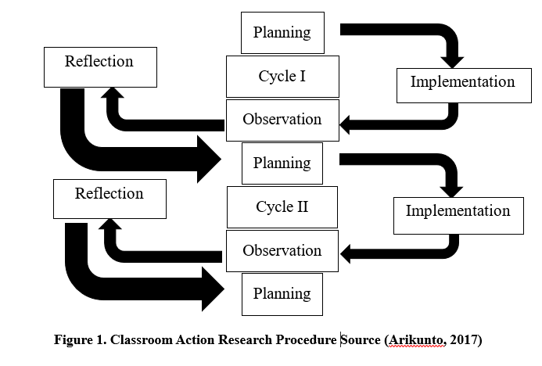
The Classroom Action Research was conducted in Grade III at SDN 36/II Sarana Jaya, Bathin III Subdistrict, Muaro Bungo Regency. This research was carried out every Monday and Wednesday, from May 26, 2025, to June 4, 2025, during the even semester of the 2024/2025 academic year. The subjects of this study were third-grade students at SDN 36/II Sarana Jaya, Bathin III Subdistrict, Muaro Bungo Regency, totaling 25 students, in the subject of Mathematics. The object of this Classroom Action Research was the implementation of the Talking Stick learning model assisted by puzzle media to improve the learning process and learning outcomes in Mathematics for Grade III students at SDN 36/II Sarana Jaya.. The data collection techniques used in this study include observation, interviews, and documentation. The data analysis techniques involve analyzing observation data and student learning outcomes.

RESEARCH RESULTS AND DISCUSSION
Teacher’s Teaching Process
Teacher’s Teaching Process
Based on the research findings regarding the teacher’s teaching process over two cycles, there was a consistent improvement in each meeting. In Cycle I, the average percentage increased from 68.42% to 78.94%, which falls under the "Good" category. In Cycle II, the percentage rose from 84.21% to 94.73%, categorized as "Very Good."
The overall improvement from Cycle I to Cycle II was 15.79%, indicating a significant enhancement in the teacher’s instructional performance. The overall percentage of the teacher’s teaching process in each cycle is summarized as follows:
Diagram 1 Teacher’s Teaching Process
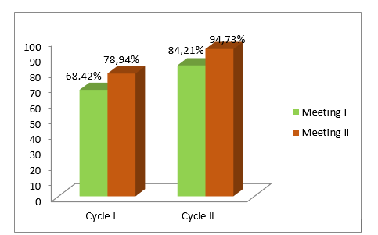

Based on Diagram 1, it can be concluded that the teacher's teaching process in Mathematics using the Talking Stick model assisted by puzzle media reached the "Very Good" category. This was due to the teacher’s improved ability in managing the learning process during Cycle II, including providing motivation and guiding students to be more actively engaged in learning compared to Cycle I. Moreover, the teacher successfully implemented the learning activities—covering the introduction, main activities, and closing—according to the predetermined lesson plan.

Students’ Learning Process
The learning process can be considered optimal when there is active participation from both teachers and students. Observations of students’ learning processes during the implementation of the Talking Stick model assisted by puzzle media in Grade III over two cycles showed the following results:
In Cycle I, the percentage of active students increased from 48% (12 students) to 60% (15 students), which falls under the "Less Good" category. In Cycle II, the percentage further increased from 80% (20 students) to 88% (22 students), categorized as "Very Good."
The improvement from Cycle I to Cycle II was 28%, which indicates that the use of the Talking Stick model assisted by puzzle media in Mathematics for Grade III students can significantly enhance student engagement in the learning process. The teacher consistently made efforts to maximize student participation, leading to an overall improvement in learning quality.
The increase in student learning activity percentages in Cycle I and Cycle II for each session is illustrated in the diagram below:
Diagram 2 – Student Learning Process
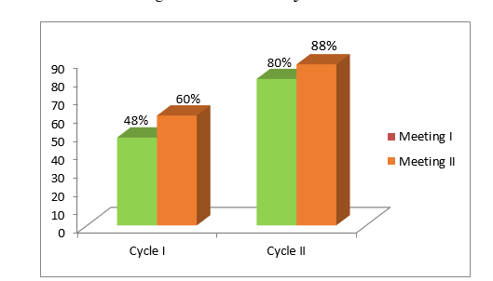

Based on Diagram 4.2, it can be concluded that the students' learning process over the two cycles using the Group Investigation model in Social Studies (IPS) learning was in the "Very Good" category. This was due to the fact that students' learning activities improved in each cycle, and nearly all indicators were fulfilled.
It can also be concluded that the learning process of students in Mathematics using the Talking Stick model assisted by puzzle media in Grade III showed significant improvement, and the success indicators were achieved. Therefore, the cycle could be concluded.

Students’ Learning Outcomes
Based on the research findings, before using the Talking Stick model assisted by puzzle media, students' learning mastery score was only 44%, or 11 students who met the Minimum Mastery Criteria (KKTP), while 56% or 14 students were still below the KKTP. After applying the Talking Stick model assisted by puzzle media, the mastery of learning outcomes increased from 44% to 72%, with 18 students meeting the KKTP and 28% or 7 students still below the threshold.
Although there was an improvement in Cycle I, it had not yet reached the minimum mastery standard of ≥75%. Therefore, further improvement was needed in Cycle II. After enhancing the learning process in Cycle II, student learning mastery increased from 72% to 92%, with 23 students meeting the KKTP.
The students' learning outcomes showed continuous improvement, as observed in each cycle. Overall, the percentage of learning mastery in each cycle is illustrated in the diagram below:
Diagram 3 – Student Learning Outcomes
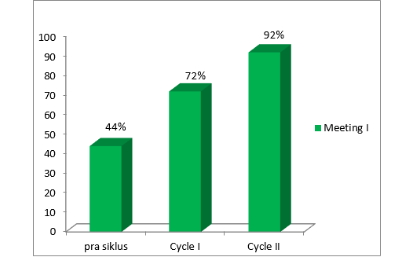
The students’ learning outcomes in Diagram 4.3 showed an improvement in each cycle. Before the research was conducted, the learning mastery level was only 40%. After the implementation of the research, in Cycle I, student mastery increased to 60%, or 9 students, which was categorized as "Fairly Good." After implementing Cycle II, students’ learning mastery further improved to 86.6%, or 13 students, which was categorized as "Very Good" based on the predetermined indicator (≥75%).
The results of the study indicate that the application of the Group Investigation model can improve students’ learning outcomes in Social Studies (IPS). This learning model has proven to be effective, as it consistently enhanced students’ learning outcomes in each cycle.

CONCLUSION
Based on the Classroom Action Research conducted on third-grade students of SDN 36/II Sarana Jaya in the Mathematics subject using the Talking Stick model assisted by puzzle media, the following conclusions can be drawn:
- The implementation of learning using the Talking Stick model assisted by puzzle media can improve the learning process. This was evident from the improvement in the teacher's teaching process in Cycle I, which reached a success rate of 78.94% and was categorized as "Good." Meanwhile, the success rate of the students’ learning process was 48%, which fell under the "Less Good" category. In Cycle II, the teacher's teaching process improved significantly, reaching a success rate of 94.73% with a "Very Good" category. Similarly, the students' learning process also improved and was categorized as "Very Good" with a success rate of 88%.
- The use of the Talking Stick model assisted by puzzle media in Mathematics can enhance students’ learning outcomes. This was proven by the fact that prior to using the Talking Stick model with puzzle media, the learning mastery rate was only 44% (11 students). In Cycle I, this increased to 72% (18 students) who achieved the Minimum Mastery Criteria (KKTP). Therefore, the researcher proceeded to Cycle II, where the mastery level further improved to 92%. The actions implemented in Cycle II showed an increase and exceeded the predetermined mastery standard or success indicators.

REFERENCES

Arikunto, Suharsimi dkk. 2017. “Penelitian Tindakan Kelas”. Jakarta: Bumi Aksara.
Beno, J, A.P Silen, and M Yanti. 2022. “Penggaruh Penggunaan Model Pembelajaran Talking Stick Terhadap Hasil Be;Ajar Matematika Sidwa Di Sdn 10 Sungai Are Kelas V Kabupaten Oku Selatan.” Braz Dent J. 33(1): 1–12.
Haryadi, Herjan. 2023. “Problematika Penguasaan Kompetensi Pedagogik Dalam Pembelajaran Matematika Berbasis Literasi.” Media Pendidikan Matematika 11(1): 94. doi:10.33394/mpm.v11i1.7860
Istiqomah, Annisa Amalia. 2023. “Problematika Guru Kelas IV Dalam Menerapkan Kurikulum Merdeka Belajar Di Madrasah Ibtidaiyah Negeri 1 Banyumas.” Repository.Uinsaizu.Ac.Id: 1–65.
Manalu, Juliati Boang, Pernando Sitohang, Netty Heriwati, and Henrika Turnip. 2022. “Prosiding Pendidikan Dasar Pengembangan Perangkat Pembelajaran Kurikulum Merdeka Belajar.” Mahesa Centre Research 1(1): 80–86. doi:10.34007/ppd.v1i1.174.
Materi, Pada, Sistem Komputer, D I Kelas, V I I Smp, And Y O S Sudarso. 2024. “Pengembangan Game Edukasi Berbasis Android Pada Materi Sistem Komputer Di Kelas Vii Smp Yos Sudarso Parindu San Fhun 1* , Sri Koriaty 2 1,2.” 02(02): 66–72.
Molan, Agustinus Suban, Maria Finsensia Ansel, and Finsensius Mbabho. 2020. “Pengaruh Model Pembelajaran Kooperatif Tipe Talking Stick Terhadap Ketrampilan Berbicara Di Kelas V Sekolah Dasar.” Prima Magistra: Jurnal Ilmiah Kependidikan 1(2): 176–83. doi:10.37478/jpm.v1i2.625.
Nabilah, Bunga, Supratman Zakir, Eny Murtiyastuti, and Ramadhanu istahara Mubaraq. 2022. “Analisis Penerapan Mata Pelajaran Informatika Dalam Implementasi Kurikulum Merdeka Tingkat SMP.” PIJAR: Jurnal Pendidikan dan Pengajaran 1(1). doi:10.58540/pijar.v1i1.97.
Nuryanti, Feny Eka. 2022. “Analisis Proses Berpikir Matematis Siswa Pada Sistem Persamaan Linear Dua Variabel.” SUBSET - Jurnal Pendidikan Matematika dan Terapan 1(1): 30–39.
Sari, Dian. Maisharoh, Syadita Cholifa. 2024. “Pelaksanaan Pembinaan Terhadap Residivis Anak Pada Lembaga Pembinaan Khusus Anak Klas Ii Tanjung Pati Kabupaten Limapuluh Kota Anny.” Ensiklopedia Of Journal Perancangan 2(2): 155–64.
Wahyuni, Dianisa, Neng Ani, Tin Rustini, and Muh. Husen Arifin. 2022. “Analisis Nilai-Nilai Budaya Pada Pembelajaran Ips Di Kelas 2 Sd.” Harmony: Jurnal Pembelajaran IPS dan PKN 7(1): 32–39. doi:10.15294/harmony.v7i1.55990.

