The Implementation of Khusnul Khuluq as a Strategy for Character Formation of Generation Z Adolescents in the Era of Globalization

Dimas Azky Mauladani¹, Masrohatin², Mokhammad Miftakhul Huda³
Universitas Islam Negeri Kiai Haji Achmad Siddiq Jember, Indonesia^{1,2,3}
dimasazki25@gmail.com, masrohatin@uinkhas.ac.id, dr.hoeda@uinkhas.ac.id

 |  | Abstract
Received:  Revised:  Accepted: |  | The moral degradation of Generation Z adolescents such as the crisis of empathy, cyberbullying, and social media addiction has become a serious issue in the era of globalization. Character education practices implemented so far tend to emphasize behavioral regulation through rules, reward–punishment mechanisms, and discipline programs, yet they have not addressed the root of the problem, namely the inner condition as the source of action. Previous studies have generally focused on observable behavioral changes, while classical moral literature still presents ethical concepts in an abstract manner and has not been sufficiently connected to the psychological context of modern adolescents. This study aims to formulate the implementation of khusnul khuluq according to Imam al-Ghazali as a strategy for character formation among Generation Z adolescents. The study employs a qualitative literature review method by analyzing Ihya’ Ulumuddin and contemporary sources on character education and Generation Z psychology. Data analysis follows the Miles and Huberman model, consisting of data reduction, data display, and conclusion drawing. The findings indicate that khusnul khuluq is a stable inner disposition that spontaneously generates good actions and can be developed through mujahadah and riyadhah an-nafs. The novelty of this study lies in the development of an implementative model of khusnul khuluq for Generation Z through five stages: self-awareness, habituation of good deeds, utilization of digital technology, role modeling, and the formation of a supportive environment. In conclusion, character formation cannot be limited to external behavior alone but must begin with inner transformation to sustainably produce noble character.
Keywords: |  | Khusnul Khuluq, Character Formation, Generation Z Adolescents, Globalization Era.
(*) Corresponding Author: |  | Dimas Azky Mauladani, dimasazki25@gmail.com, 081252643172
-
INTRODUCTION

The era of globalization and the rapid development of digital technology have brought significant changes to the lifestyle and character of Generation Z adolescents (Husain et al. 2025)They grow up amid fast-paced information flows, an instant culture, and exposure to global values that often conflict with moral and spiritual principles. The increasing prevalence of individualistic behavior, empathy crises, cyberbullying, social media addiction, and the degradation of ethical communication has become a concerning social issue (Lestari & Achdiani, 2024). Various psychological surveys on adolescents indicate that high levels of internet access are not directly proportional to emotional maturity (Arini & Nur, 2025). This condition creates controversy, as technology intended to generate positive impacts has instead contributed to weakened self-control and the erosion of civility. Such drastic behavioral changes demand character development strategies that are not merely theoretical but are capable of addressing the inner dimension of adolescents. Therefore, a transformative and solution-oriented approach to character education is required, one of which is through the internalization of the concept of khusnul khuluq, namely the formation of noble character as the source of positive and consistent actions in daily life.
Classical and contemporary literature on morality extensively discusses ethical concepts from an Islamic perspective; however, the focus of discussion varies among scholars. Hasan al-Bashri, al-Wasithi, and al-Tustari emphasize manifestations of noble character such as generosity, patience, and the ability to refrain from harming others. Meanwhile, Imam al-Ghazali provides a conceptual definition by asserting that morality (akhlaq) is a stable condition of the soul from which good actions emerge spontaneously without coercion (Al-Ghazali, 2005). Modern research on character education generally highlights external behavioral aspects through school regulations, reward–punishment systems, or habituation of religious activities, yet it fails to address the inner dimension as the source of behavior. In the context of Generation Z adolescents, several studies focus solely on character-learning strategies through educational digitalization without linking them to spiritual values as the foundation of personality development (Nola et al., 2025). The literature indicates a clear distinction between morality as action and morality as a psychological condition (Al-Ghazali, 2005). From this review, it can be concluded that existing understandings of noble character formation remain partial and have not fully addressed the inner essence as the primary source of character transformation.
Although numerous studies have examined character education, most emphasize external behavioral aspects such as school regulations, social activities, or discipline programs. These studies have not addressed the root of the problem, namely the formation of a stable inner condition as the source of noble actions (Irmawati Musa, 2023). Character education approaches that rely on reward–punishment mechanisms have been shown to be effective only in the short term and fail to produce deep internalization of values within adolescents (Priya Kusuma Bahari & Richa Okta Barera, 2025). Conversely, research on morality in Islamic literature tends to focus on abstract concepts without connecting them to the psychological development of Generation Z adolescents living in the digital era (Setiawan and Ekaningsih 2025). This constitutes the research gap: the absence of a comprehensive study that integrates the concept of khusnul khuluq according to Imam al-Ghazali as a character formation strategy for Generation Z adolescents in responding to the challenges of globalization. The novelty of this study lies in its effort to conceptualize morality as a stable inner condition and to apply it practically through spiritual discipline (riyadhah an-nafs), enabling character transformation from the inside out.
This research is crucial because adolescent moral degradation cannot be addressed solely through normative approaches such as lectures, rules, or prohibitions. Generation Z adolescents require character development that strengthens inner awareness and positively directs psychological tendencies (Andini Sudirman et al., 2024). The concept of khusnul khuluq offers a spiritually based character education approach that does not stop at behavioral indicators but engages in the process of inner transformation through the habituation of good deeds (mujahadah) and self-discipline (riyadhah an-nafs) (Al-Ghazali, 2005). This approach aligns with modern psychological theories asserting that repeated habits shape mindset and character. Therefore, this study is highly relevant in addressing the need for adolescent character development in the era of globalization. By integrating classical Islamic moral concepts with the psychological developmental needs of modern adolescents, this research is expected to present a character education model that is more effective, applicable, and sustainable one that not only alters temporary behavior but also builds noble character permanently.
This study aims to formulate and implement the concept of khusnul khuluq as a strategy for character formation among Generation Z adolescents in the era of globalization. Specifically, the objectives are to: (1) analyze the concept of morality as an inner condition according to Imam al-Ghazali; (2) describe methods of moral formation through mujahadah and riyadhah an-nafs; and (3) develop an implementation model of khusnul khuluq that aligns with the learning patterns and psychological development of Generation Z adolescents. The hypothesis of this study is that the consistent implementation of khusnul khuluq through spiritual discipline can foster adolescents with noble character, emotional self-regulation, and the ability to face globalization challenges with strong moral integrity. This research is expected to make a meaningful contribution to educational institutions, society, and academia by advancing character education strategies that go beyond behavioral regulation and instead strengthen the quality of the soul in a profound and sustainable manner.

Research Methods

This study is motivated by the increasing moral degradation among Generation Z adolescents in the era of globalization, manifested in empathy crises, social media addiction, aggressive communication, and weak self-control (Sihombing et al. 2024). This phenomenon has become a serious educational and social concern because existing character development practices primarily focus on external behavioral regulation through rules, punishment, or reward systems, without addressing the inner condition as the source of action (Irmawati Musa 2023)(Setiawan, et al., 2024).To address this gap, the study focuses on character formation through the implementation of khusnul khuluq. The research adopts a qualitative approach using a literature study (library research) and textual analysis. The data consist of conceptual qualitative sources derived from classical texts particularly Ihya’ Ulumuddin by Imam al-Ghazali modern books on character education, and recent scholarly journals discussing Generation Z adolescent psychology. Data were selected based on relevance, with emphasis on literature addressing morality, character education, moral development, and the concept of riyadhah an-nafs, in order to integrate classical moral theory with the psychological needs of modern adolescents.
Data collection was conducted through systematic academic literature exploration. Primary sources included classical Islamic texts discussing morality, mujahadah, and riyadhah an-nafs, while secondary sources comprised national and international journal articles related to character education, Generation Z digital behavior, and self-control theories in modern psychology(Setiawan, et. al., 2024). Sources were selected using purposive sampling and retrieved from databases such as Google Scholar, ResearchGate, and university journal indexes using keywords such as “akhlaq,” “character building,” “Generation Z,” “riyadhah an-nafs,” and “spiritual education.” Data analysis followed the Miles and Huberman model, consisting of data reduction, data display, and conclusion drawing. Relevant information was organized into thematic narratives, including morality as an inner condition, methods of spiritual discipline, and the implementation of khusnul khuluq for Generation Z adolescents. The validity of the findings was ensured through theoretical triangulation by comparing classical moral concepts with modern psychological and educational studies. The analysis concludes that character formation cannot be limited to external behavior alone but must address the inner dimension through riyadhah an-nafs to achieve sustainable moral development.

Results and Discussion

Based on a review of classical literature and contemporary studies, three main findings were identified regarding the implementation of khusnul khuluq as a strategy for character formation among Generation Z adolescents.
First, manifestations of moral degradation among Generation Z are evident in the increasing prevalence of individualistic behavior, empathy crises, cyberbullying, and addiction to digital media use. The literature indicates that excessive exposure to digital devices reduces adolescents’ social sensitivity and emotional resilience (Azzahra et al. 2025).
Tabel 1. Bentuk fenomena degradasi akhlak Gen Z
Form of Phenomenon | Description | Percentage of Adolescents Experiencing It | Impact on Moral Character
Individualistic Behavior | Tends to prioritize self-interest and personal satisfaction | 65% | Weakens social awareness and collective responsibility
Empathy Crisis | Difficulty in understanding and empathizing with others’ emotions in online interactions | 58% | Increases the potential for conflict and apathetic attitudes.
Cyberbullying Behavior | Aggressive actions or harassment carried out through digital platforms. | 40% | Damages social relationships and causes psychological trauma.  .
Digital Media Addiction | Excessive and uncontrolled use of digital devices. | 70% | Reduces social sensitivity and emotional resilience.

Second, this phenomenon is influenced by several factors, including the dominance of a digitally driven culture based on social validation, weak self-control, the lack of role models within the family environment, and the absence of inner spiritual development within the educational system. High intensity of social media use contributes to the formation of reactive behavioral patterns and low levels of emotional regulation among adolescents.(Sofyana and Haryanto 2023)

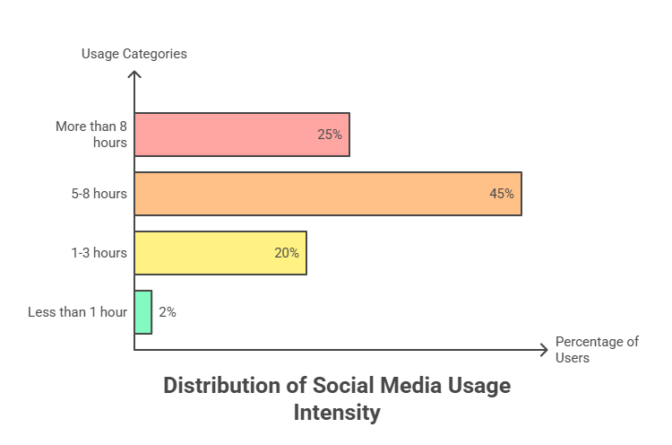
Figure 1. Daily social media use intensity

Figure 2. Faktor-faktor yang memengaruhi fenomena akhlak digital
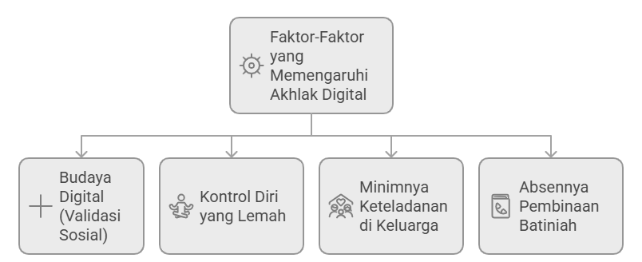

All factors are interrelated and contribute to reactive behavioral patterns and low emotional regulation, ultimately hindering the formation of stable moral character (khusnul khuluq) as conceptualized by Al-Ghazali.
These factors hinder the development of a stable moral disposition in accordance with Imam al-Ghazali’s concept of khusnul khuluq. However, appropriate character-building interventions have been shown to enhance emotional regulation, as illustrated in Figure 1.

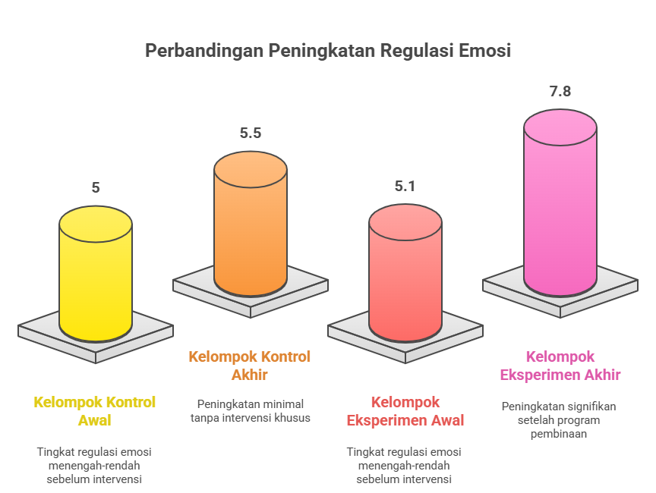
Figure 1. Improvement in Emotional Regulation After Intervention

Third, these findings have transformative implications for character education models, necessitating a shift from normative–behavioral approaches toward inner development that emphasizes self-awareness, riyadhah an-nafs, the positive utilization of technology, and role modeling. The integration of these findings results in a Hybrid Moral Development Model as a character formation strategy for Generation Z adolescents that is more relevant, applicable, and sustainable.(Riris setiawati, Dhinda anggita prasmewari, and Taufik Muhtarom 2024)
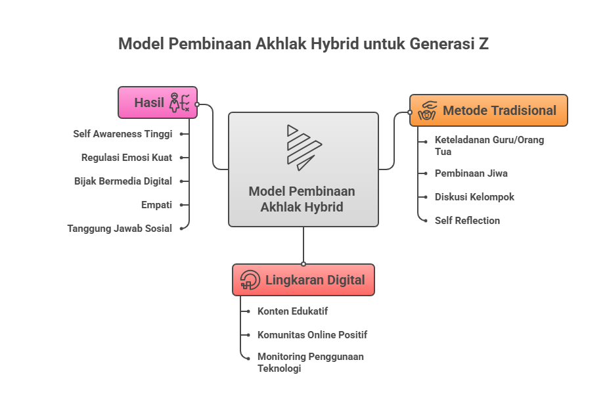
Figure 3. Hybrid Moral Development Model (Traditional Digital)
This model integrates traditional approaches—such as inner spiritual development and direct role modeling—with the utilization of digital ecosystems to create a comprehensive and sustainable character-building environment aligned with the life context of Generation Z.

Diskusi
The results of this study indicate that the implementation of khusnul khuluq has strong relevance as a strategy for character formation among Generation Z adolescents amid the challenges of the digital era. The data reveal that moral degradation among adolescents is manifested in increasing individualistic behavior, weakened empathy, tendencies toward cyberbullying, and high levels of digital media addiction (Auliya Sholikhatun, Robingun Suyud El Syam 2025). The percentages presented in Table 1 show that gadget addiction reaches 70%, while individualism and empathy crises are recorded at approximately 65% and 58%, respectively. Moreover, intensive exposure to social media contributes to weakened emotional regulation and the development of impulsive reaction patterns. Visual findings in Figure 1 further demonstrate a significant improvement in emotional regulation abilities following character development interventions based on classical moral approaches. Contributing factors to moral degradation such as a digital culture driven by social validation, weak role modeling, and the lack of inner spiritual development underscore the urgency of a holistic character education approach. These findings are synthesized in the Hybrid Moral Development Model, which integrates traditional and digital approaches. Overall, the results affirm that moral development grounded in khusnul khuluq remains highly relevant in addressing the character development challenges faced by Generation Z.
When these findings are examined more deeply, it becomes evident that the root of moral degradation among Generation Z lies not merely in technological advancement but in the weakening structure of moral development within families and formal education (Aini et al. 2023). Digital culture, which emphasizes social validation through likes, comments, and public recognition, generates psychological pressure that increases adolescents’ dependence on others’ perceptions (A.R et al. 2025). At the same time, weak self-control is largely a consequence of the lack of spiritual discipline (riyadhah an-nafs), which traditionally served as a foundational element in Islamic moral education. Role modeling within the family has also diminished, as parents themselves are often immersed in similar digital patterns, limiting their ability to provide consistent behavioral examples. Furthermore, modern educational systems tend to prioritize cognitive achievement over inner character formation, resulting in a gap between moral knowledge and moral practice (Basri, Sulaiman, and Mutaqin 2024). The convergence of these conditions renders adolescents vulnerable to impulsive, reactive behaviors and emotional instability. Therefore, the contributing factors to this phenomenon are not only structural but also spiritual and psychological in nature.
The consequences of the previously identified causes are clearly reflected in the behavioral patterns of Generation Z, which increasingly exhibit reactivity, susceptibility to external influence, and difficulty in developing stable moral character. The absence of role models and weakened self-control encourage adolescents to adopt a pragmatic, instant-gratification–oriented outlook on life. This condition directly affects emotional regulation, making adolescents more prone to conflict, impatience, and an inability to process psychological stress in healthy ways (Apriliani, Astuti, and Wijayanti 2025). The prevalence of digital addiction, reaching approximately 70%, further exacerbates this situation, as social media provides excessive and continuous stimuli that repeatedly activate emotional responses. As a result, empathy diminishes, social relationships become superficial, and digital interactions increasingly generate aggressive tendencies such as cyberbullying (Sunarya et al., 2025). Within the context of moral development, these conditions obstruct the formation of khusnul khuluq as conceptualized by Al-Ghazali that is, a stable and well-established character that emerges spontaneously without external compulsion. Nevertheless, the observed improvement in emotional regulation following the moral development program (Figure 1) indicates that moral degradation is not irreversible. With appropriate and integrative approaches, adolescents can rebuild psychological well-being, emotional stability, and social sensitivity.
The findings of this study demonstrate both alignment with and distinctions from previous research on adolescent morality and digital behavior. Consistent with Twenge’s (2018) study on iGen and Boyd’s (2020) research on digital culture, these results reinforce the view that the intensity of social media use has a significant impact on adolescents’ mental health and social relationships. Studies conducted in Indonesia by Sya’roni (2021) similarly reveal that digital addiction correlates with decreased empathy and increased impulsive behavior, findings that are in line with the results presented in Table 1. However, this study differs from prior research by integrating moral analysis based on Al-Ghazali’s classical framework—an approach rarely applied in studies of Generation Z behavior. The hybrid (traditional–digital) approach proposed in this research also offers a novel perspective absent from modern psychological studies, as it combines the concept of riyadhah an-nafs with positive technological interventions. Thus, this study not only validates existing findings but also contributes a new, more contextual conceptual model for moral development in the digital era.
Based on the overall findings and their implications, this study recommends the adoption of an integrative, sustainable, and hybrid-based approach to moral development. Conceptually, character education should revive inner spiritual formation through riyadhah an-nafs, strengthened self-awareness, and consistent role modeling within both family and school environments. Methodologically, educational institutions are encouraged to integrate moral development modules that utilize technology positively, such as educational digital content, constructive online communities, and guided not punitive digital usage monitoring. From a policy perspective, schools and religious institutions may adopt the Hybrid Moral Development Model as a framework that balances traditional moral formation with the digital realities of Generation Z. In addition, governments and educational authorities can develop value-based digital literacy programs that go beyond technical skills. These recommendations are expected to provide strategic and practical solutions for fostering adolescents with khusnul khuluq, emotional stability, and adaptability to the challenges of a rapidly changing era.

Conclussion
The findings of this study indicate that the implementation of khusnul khuluq as a character formation strategy for Generation Z adolescents is highly relevant in addressing moral challenges in the era of globalization. Phenomena such as empathy crises, cyberbullying, and social media addiction demonstrate that character education approaches relying solely on rules and penalties are insufficient to develop stable personality traits. This study confirms that morality is not merely external behavior but a stable inner disposition, as conceptualized by Imam al-Ghazali, whereby virtuous actions emerge spontaneously without coercion. Character formation through mujahadah and riyadhah an-nafs trains adolescents to consistently discipline themselves in performing good deeds until such actions become internalized as habits and personal character. In the context of Generation Z, the implementation of khusnul khuluq involves the cultivation of self-awareness, habituation of virtuous actions, positive utilization of technology, role modeling, and the creation of a supportive environment. These findings emphasize that sustainable character transformation must originate from inner stability rather than mere external behavioral control.
This study contributes conceptually by integrating Imam al-Ghazali’s classical moral theory with modern character education frameworks and the psychological development of Generation Z adolescents. It reinforces the view that morality is not simply normative behavior but a psychological structure that can be shaped through consistent spiritual discipline. Methodologically, the study proposes an operational and applicable implementation model comprising five stages: self-awareness, riyadhah an-nafs, utilization of digital media, role modeling, and a supportive social environment. This model bridges the gap between abstract classical moral concepts and the practical demands of contemporary character education. Despite its contributions, the study is limited by its focus on literature-based analysis and the absence of quantitative measures of moral change. Future research is encouraged to adopt mixed-methods or action research approaches, incorporate social factors such as family and peer dynamics, and develop standardized instruments to assess moral development. By addressing these limitations, subsequent studies may produce a more comprehensive, measurable, and replicable model of character education for Generation Z adolescents.
References
A.R, A., Rusli, S., Isdayanti, I., Sudirman, S., Yani, A., & Amalinda, F. (2025). Pengaruh Media Sosial Pada Perkembangan Kesehatan Mental Remaja : a Literature Riview. Jurnal Kesehatan Tambusai, 6(2), 4295–4302. https://doi.org/10.31004/jkt.v6i2.44513
Aigal Akira Sunarya, Ferlyadi Ramadhan Putra, Nabila Amelia Putri, Haniffah Maharani Azahra, M. R. A. H. (2025). PENGARUH MEDIA SOSIAL TERHADAP CYBERBULLYING PADA REMAJA Aigal Akira Sunarya1 , Ferlyadi Ramadhan Putra2 , Nabila Amelia Putri 3 , Haniffah Maharani Azahra4 , Muhammad Rizki Al Hafiz5 Fakultas Psikologi, Universitas Bhayangkara Jakarta Raya. Triwikrama: Jurnal Multidisiplin Ilmu Sosial, 06(08).
Aini, N., Kurniawan, A. D., Andriani, A., Susanti, M., & Widowati, A. (2023). Literature Review : Semakin Kaburnya Moral Baik dan Buruk. Jurnal Basicedu, 7(6), 3939–3949. https://doi.org/10.31004/basicedu.v7i6.6458
Al-Ghazali, A. H. (2005). Ihya ’Uluum ad-Addiin. In Dar Ibn Hazm (p. 1963).
Andini Sudirman, N., Putri Rahayu, A., Pattipeilohy, P., & Mutmainnah, I. (2024). Manajemen Pendidikan Karakter pada Remaja Generasi Z dalam Mengelola Kondisi Emosional Character Education Management in Generation Z Teenagers in Managing Emotional Conditions. J Jurnal Kolaboratif Sains, 7(5), 1862–1873. https://doi.org/10.56338/jks.v4i8.1942
Apriliani, S., Astuti, I. T., & Wijayanti, K. (2025). Gambaran Regulasi Emosi Remaja Sekolah Menengah Pertama di SMP Sultan Agung 4 Semarang. Corona : Jurnal Ilmu Kesehatan Umum, Psikolog, Keperawatan Dan Kebidanan, 3(2), 125–137.
Arini, N. Y., & Nur, H. (2025). Scroll dan Suasana Hati: Pengaruh Intensitas Penggunaan Media Sosial terhadap Regulasi Emosi Remaja. PESHUM : Jurnal Pendidikan, Sosial Dan Humaniora, 4(4), 6527–6537. https://doi.org/10.56799/peshum.v4i4.9578
Auliya Sholikhatun, Robingun Suyud El Syam, B. S. (2025). Degradasi Etika Murid Generasi Z ( Kajian Kitab Maraqil ‘ Ubudiyah Syarah Bidayatul Hidayah Bab Al-Qoul Fi Adab As-Suhbah Wa Al-Mu ’ Asyarah Ma ’ a Al-Khaliq Azza Wa Jalla Wa Ma ’ a Al-Khalq ). KAMPUS AKADEMIK PUBLISING Jurnal Ilmiah Nusantara ( JINU), 2(3), 620.
Azzahra, S., Nainggolan, T. W. C., Addini, K. N., Sahalina, D., & Rahayu, W. F. (2025). Dampak Kecanduan Gadget Terhadap Emosi dan Kepribadian Remaja. JPNM Jurnal Pustaka Nusantara Multidisiplin, 3(1). https://doi.org/10.59945/jpnm.v3i1.344
Basri, J., Sulaiman, H., & Mutaqin, A. Z. (2024). Riyadhah sebagai Model Alternatif Pembinaan Akhlak. Al Qalam: Jurnal Ilmiah Keagamaan Dan Kemasyarakatan, 18(4), 2900. https://doi.org/10.35931/aq.v18i4.3645
Husain, S., Abdi, F. S., Maruf, M. Y. P., Oktafiani, F., Ilmu, S., Publik, A., Ilmu, F., Dan, S., Politik, I., & Tadulako, U. (2025). Mengantisipasi Perubahan Karakter Generasi Z. 3(1), 242–248.
Irmawati Musa. (2023). Studi Literatur : Degradasi Moral Di Kalangan Remaja. Ezra Science Bulletin, 1(2), 224–230. https://doi.org/10.58526/ez-sci-bin.v1i2.31
Lestari, R. N., & Achdiani, Y. (2024). Pengaruh Globalisasi Terhadap Gaya Hidup Individualisme Masyarakat Modern. Sosietas, 14(2), 121–132. https://doi.org/10.17509/sosietas.v14i2.70149
Nola, I., Alya, M., & Shandi, R. M. (2025). Pendidikan Akhlak Siswa di Era Digitalisasi. Jurnal Multidisiplin Ilmu Akademik, 2(3), 301–306.
Priya Kusuma Bahari, & Richa Okta Barera. (2025). Analisis Pemberian Reward dan Punishment sebagai Upaya untuk Pendidikan Karakter Disiplin Siswa Kelas V SDN 2 Suruh. DIAJAR: Jurnal Pendidikan Dan Pembelajaran, 4(2), 154–161. https://doi.org/10.54259/diajar.v4i2.3873
Riris setiawati, Dhinda anggita prasmewari, & Taufik Muhtarom. (2024). Dampak Teknologi Informasi Terhadap Pendidikan Karakter Di Indonesia. Journal Innovation In Education, 2(3), 80–89. https://doi.org/10.59841/inoved.v2i3.1352
Setiawan, Andi, Lely Ana Ferawati Ekaningsih. 2025. “Education Financing Management in the Digital Era : An Analysis of the Role of Virtual Accounts Tuition Payments in Islamic Boarding School.” (January): 1–15.
Setiawan, Andi, Ahmad Hadiq Syifa Al Fawaz, and Rizqi Maulana Ilmi. 2022. “Indonesian Research Journal on Education : Jurnal Ilmu Pendidikan.” 2(3): 1030–37. https://irje.org/index.php/irje/article/download/799/567.
Setiawan, Andi, Ikhsan Huzali, and Nihayatul Wafiroh. 2024. “The Role of Performance Appraisal on Educator Retention and Motivation in Islamic Junior School.” 7(4): 278–85.
Sihombing, M. S., Mawarni, C., Khairunnisa, N., Sitompul, M. S., Hadawiyah, A., & Anggreini, H. (2024). Menguak Kemerosotan Moral Gen Z Dalam Film Sajen: Kajian Psikoanalisis Sigmund Freud. Escience Humanity Journal, 5 No. 1(1), 221–234.
Sofyana, N. L., & Haryanto, B. (2023). Menyoal Degradasi Moral Sebagai Dampak Dari Era Digital. Jurnal Manajemen Dan Pendidikan Islam, 3(4), 2503–350.
Wahidmurni. (2017). Jhvbh.

