ENHANCING AUTHENTICITY IN ISLAMIC SCHOOL CURRICULUM: A MIXED-METHODS STUDY OF TEACHER ENGAGEMENT, SUPERVISORY PRACTICES, AND PARTICIPATORY MENTORING
-
Ahmad Musaddad
STAI Cendekia Insani Situbondo, Indonesia
Email: ahmad.musaddad8181@gmail.com

 |  | Abstract
 |  | This study examines how Islamic madrasah curricula are often administratively replicated without embedding Islamic values or local wisdom. Using an explanatory sequential mixed-methods design, we surveyed 64 teachers and curriculum coordinators, then conducted 12 in-depth interviews. Quantitative analyses (descriptive statistics, Pearson correlation, simple regression) revealed that 78% of documents received only superficial identity changes and only 27% of teachers participated actively. Teacher engagement correlated strongly with document originality (r = 0.62; p < 0.01), while supervisory effectiveness explained 28% of quality variation. Qualitative themes highlight teachers’ technical unpreparedness, viewing curriculum as an administrative burden, and a need for on-site case-based coaching. We propose a participatory mentoring model combining on-site training and document review to boost teachers’ technical capacity and foster authentic, reflective, context-relevant curricula. Recommendations focus on sustained supervisory policy and co-design of curricula by teachers and supervisors.
Keywords: |  | Islamic Madrasah Curriculum, Curriculum Authenticity, Mixed Methods, Teacher Involvement, Participatory Mentoring.
(*) Corresponding Author: |  | Ahmad Musaddad, ahmad.musaddad8181@gmail.com, Nomor HP:082311818005

INTRODUCTION

The madrasah curriculum plays a strategic role in shaping the direction and quality of Islamic education in Indonesia. It is not merely a technical document, but a representation of Islamic values, institutional vision, and local wisdom rooted in pesantren traditions. Within the madrasah context, the curriculum serves a dual function: as an academic guide that structures the learning process, and as a cultural instrument that instills students’ spiritual and social identities. When local cultural elements are consciously integrated into the curriculum, the learning process becomes more meaningful—students not only comprehend the material but also feel connected to their social environment and inherited values (Mahmud, 2019; Sumantri, 2019).
The importance of contextual approaches in education has been highlighted in various contemporary learning theories and international standards. UNESCO, for instance, emphasizes that effective education must be grounded in learners’ realities, including their language, culture, and lived experiences. In this regard, a contextual madrasah curriculum is not only pedagogically ideal but also strategically vital for enhancing the competitiveness of Islamic educational institutions amid rapid social change (Sopandi, 2019).
However, field realities reveal a gap between curriculum idealism and its actual development practices. Several private madrasahs in Jangkar, Asembagus, and Banyuputih subdistricts have developed their curricula by copying from other institutions without substantial adaptation. This practice not only neglects pedagogical principles but also reflects a perception of curriculum as a mere administrative obligation. When curriculum loses its reflective and participatory dimensions, the learning process becomes shallow, disconnected from context, and fails to embed Islamic values and local wisdom that should be central to madrasah education (Sumantri, 2019).
Theoretically, curriculum development can be referenced through Tyler & Hlebowitsh, (2013) classical model (1949), which emphasizes the formulation of educational objectives, the selection of relevant learning experiences, and continuous evaluation (Lee et al., 2019). Taba, (1970) expanded this approach by advocating for bottom-up curriculum design through teacher participation. In the madrasah context, this approach is highly relevant, as it enables educators to integrate local and spiritual values into the curriculum structure (Renata C. G. V. Nikijuluw, 2020) To evaluate curriculum effectiveness, Daniel L. Stufflebeam, (2023) CIPP model offers a comprehensive framework encompassing context, input, process, and product analysis. This model promotes ongoing evaluation and systematic improvement, which are essential in the dynamic landscape of madrasah education (Finney, 2020). Furthermore, global education organizations such as UNESCO and OECD emphasize the importance of strengthening teachers’ professional capacity and establishing structured supervisory systems as foundational elements of sustainable curriculum reform (Mukminin et al., 2019).
Moreover, recent empirical studies from 2022 to 2024 underscore the impact of focused teacher engagement and structured mentoring on curriculum authenticity. Tep, (2024) illustrate how teacher educators serve as active curriculum developers, driving locally adapted syllabus design in Cambodian colleges. Glover et al., (2024) demonstrate that mentoring models grounded in voluntary mentor mentee partnerships and frequent interactions significantly enhance curricular enactment. Nguyen et al., (2024) show that well-functioning professional learning communities foster collective reflection and sustain innovation across diverse educational contexts. These international insights support our participatory coaching model combining on-site training with document-focused mentoring to strengthen teachers’ technical capacity and produce authentic, contextually relevant curricula.

Figure 1. Conceptual Framework. This diagram maps key variables and hypothesized relationships: Islamic Values and Local Wisdom (left) serve as cultural inputs; Teacher Participation and Supervision (below inputs) act as process variables; and Curriculum Quality (center) is the primary outcome. Arrows indicate the directional influence of each variable on Curriculum Quality.

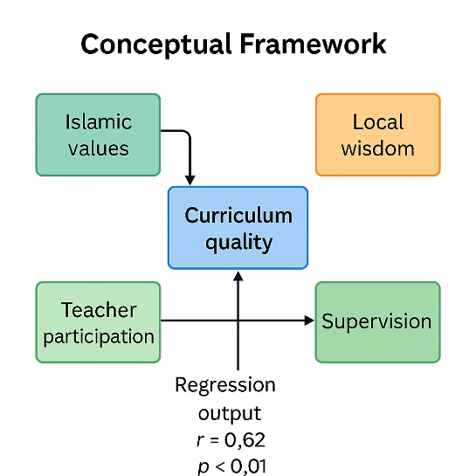

Despite the considerable potential for curriculum innovation in Islamic madrasahs, academic studies specifically focusing on private madrasahs in rural areas remain scarce. Most of the existing literature tends to concentrate on public schools in urban settings, leaving the local dynamics of private madrasahs underrepresented (Ariawan et al., 2019). Moreover, few studies have simultaneously examined the interplay between copy–paste curriculum practices, human resource capacity, and the role of educational supervisors in the context of madrasah curriculum development (Subur & Hidayati, 2020). These three aspects are inherently interconnected and collectively shape the quality of curriculum documents produced.
This study aims to investigate in depth the mechanisms of curriculum formulation and adoption in private madrasahs across three subdistricts. The primary focus is directed toward identifying the factors that hinder originality and relevance in curriculum documents, as well as assessing the role of teachers’ curriculum literacy and supervisory practices in shaping curriculum quality. Furthermore, the study seeks to design a participatory mentoring model that repositions supervisors not merely as evaluators, but as facilitators who accompany the curriculum development process in a reflective and context-sensitive manner.
To address the complexity of this phenomenon, an explanatory sequential mixed-methods design was selected as the methodological approach. The research began with a quantitative survey to map general patterns, followed by phenomenological interviews to explore the lived experiences and perceptions of educational stakeholders. This methodological integration is expected to yield a practical and replicable curriculum mentoring framework for other regions with similar characteristics, as demonstrated in the studies by (Efendi & Hsi, 2020; Fatimah et al., 2020).
The research questions addressed in this study include: How is the curriculum formulation and adoption process conducted in private madrasahs? What factors hinder the originality and relevance of curriculum documents? To what extent do teachers’ curriculum literacy and supervisory roles influence curriculum quality? What participatory mentoring model is most effective in enhancing curriculum development capacity in local madrasahs?

METHODS

This study employed an explanatory sequential mixed-methods design to obtain a comprehensive understanding of curriculum development practices in madrasahs. The first phase involved the collection of quantitative data through structured questionnaires distributed to teachers and curriculum coordinators in private madrasahs located in the subdistricts of Jangkar, Asembagus, and Banyuputih. The research population comprised the majority of private madrasahs in these three areas, while the sample was selected purposively based on two criteria: active involvement in curriculum development teams and willingness to participate.
Following the analysis of quantitative data which aimed to identify general patterns including the prevalence of copy–paste practices and levels of curriculum literacy the second phase of the study proceeded with in-depth interviews. These semi-structured interviews were designed to enrich the quantitative findings by incorporating the perspectives of teachers, madrasah principals, and educational supervisors, in accordance with Patton, (2015) guidelines for qualitative interviewing techniques.

Figure 2. Explanatory Sequential Mixed-Methods Design
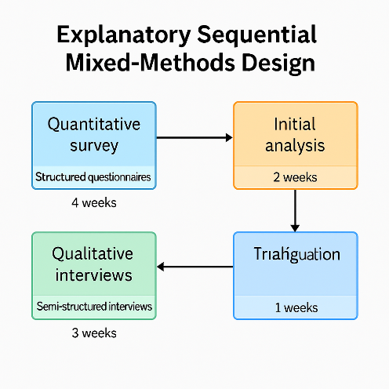
The data collection instruments consisted of two primary components. The quantitative instrument was a structured questionnaire comprising Likert-scale items designed to measure respondents’ perceptions of curriculum document originality, frequency of supervision, and stakeholder involvement. Content validity was assessed through expert review, and reliability was tested using Cronbach’s alpha coefficient ≥ 0.70, in accordance with DeVellis, (2017). The qualitative instrument was a semi-structured interview guide focused on narratives of curriculum development practices, technical barriers, and expectations regarding mentoring models. This guide was developed based on participatory curriculum literature and was piloted to ensure clarity and completeness of questions (Kvale & Brinkmann, 2015).
Quantitative data were analyzed using descriptive statistics and Pearson correlation to examine the relationship between teacher capacity and curriculum document quality, as well as simple regression to assess the influence of supervisory practices on document originality. All statistical processing was conducted using the latest version of SPSS to ensure transparency and accuracy. In the qualitative phase, interview recordings were transcribed, coded using NVivo software, and analyzed through thematic analysis following the framework of Braun & Clarke, (2006). Field procedures included ethical approval, enumerator training, instrument pilot testing, two weeks of first-phase data collection, preliminary analysis, followed by three weeks of in-depth interviews, and systematic data triangulation to ensure the validity of findings (Miles et al., 2020). With these detailed steps, the study is designed to be replicable in other madrasah contexts with similar characteristics

RESULTS AND DISCUSSION
Result
Quantitative data presentation reveals that the majority of curriculum documents in private madrasahs across Jangkar, Asembagus, and Banyuputih subdistricts were modified only in terms of formal identity elements such as institutional name, address, and lists of local content subjects while 78% of chapter structures and competency standards were adopted without substantial adjustment. A survey of 64 teachers and curriculum coordinators indicated that only 27% of respondents were directly involved in document development, whereas 73% delegated the task entirely to vice principals for curriculum and madrasah heads.
Although educational supervisors conducted biweekly visits and general training sessions, 82% of teachers reported that the workshop content was too generic and failed to support their understanding of technical steps in syllabus or lesson plan development. More than 70% of respondents admitted to frequently copying and pasting curriculum documents due to a lack of procedural knowledge and the perception that curriculum serves merely as an administrative requirement.

Figure 3. Percentage of Curriculum Document Modification and Teacher Participation
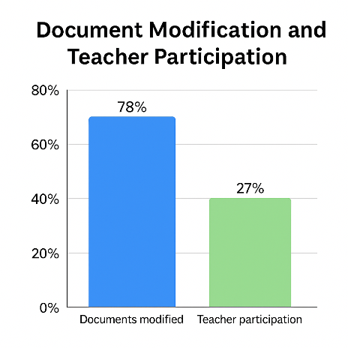
On the qualitative side, in-depth interviews with 12 key informants revealed three major themes. First, limited technical knowledge: both teachers and madrasah principals admitted they had never received step-by-step training, leaving them unprepared to independently develop curriculum documents. Second, perception of curriculum as an administrative burden: many informants described curriculum as something that merely needs to “sit on the shelf” to satisfy audit requirements, rather than serving as a reflective instructional tool. Third, need for contextual mentoring: respondents emphasized that supervisory guidance should focus on reviewing actual documents tailored to local characteristics, rather than delivering generic training sessions. These findings underscore that without substantive changes in curriculum teams and supervisory approaches, madrasah curricula risk remaining shallow administrative artifacts.
Quantitative analysis began with descriptive statistics to illustrate general patterns in curriculum development, revealing that more than three-quarters of documents had only superficial modifications to formal identity elements, with no substantial adjustments to core content. Pearson correlation analysis identified a significant positive relationship between teacher involvement in curriculum teams and document originality (r = 0.62, p < 0.01), confirming that active teacher participation plays a crucial role in producing authentic and contextually relevant instructional materials. Simple linear regression showed that the quality of supervisory support measured by visit frequency and depth of feedback explained 28% of the variation in curriculum quality, reinforcing the importance of focused mentoring over generic training alone.

Figure 4. Scatter plot showing the positive correlation between teacher participation and curriculum document originality, with regression line and statistical values.
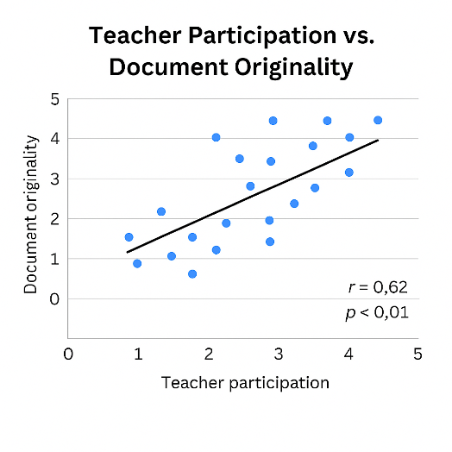
In the qualitative domain, interview recordings were transcribed and analyzed using thematic analysis following the framework of Braun & Clarke, (2006). The coding process revealed three dominant themes: teachers’ technical unpreparedness in independently designing syllabi, the perception of curriculum as a mere administrative document, and the need for context-specific mentoring tailored to each madrasah. These findings were enriched through data triangulation, combining supervisory observation reports and questionnaire results to ensure that each theme was supported by robust empirical evidence (Miles et al., 2020). Overall, the analysis indicates that without substantive reform in curriculum team structures and supervisory models, madrasah curriculum documents risk continuing to be produced in a superficial manner, failing to reflect Islamic values and local wisdom.

Figure 5. Integrated thematic and statistical findings on curriculum development challenges.

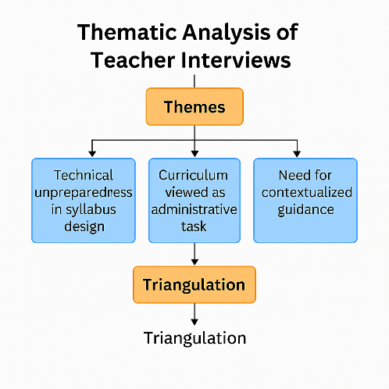
Document analysis and quantitative survey data indicate that the curriculum development and adoption processes in private madrasahs across Jangkar, Asembagus, and Banyuputih subdistricts are predominantly characterized by superficial modifications to formal identity elements such as institutional name, address, and local content subjects without substantive adjustments to core structure and content. These findings address the first research question regarding the operational mechanisms of curriculum development.
Further insights from questionnaires and in-depth interviews reveal that teachers’ limited technical understanding of curriculum design steps, coupled with the perception of curriculum as a mere administrative requirement, constitute the primary barriers to document originality and relevance. These findings respond to the second research question.
Regarding the third question, Pearson correlation analysis identified a significant positive relationship between teacher involvement in curriculum teams and document originality (r = 0.62, p < 0.01). Simple linear regression analysis showed that the quality of supervisory support measured by visit frequency and depth of feedback explained 28% of the variation in curriculum quality. These results affirm that both teacher curriculum literacy and supervisory effectiveness significantly influence document quality.
Finally, thematic analysis of interview transcripts, following Braun & Clarke, (2006) framework, identified a strong need for a participatory mentoring model tailored to local contexts. Informant narratives emphasized that generic mentoring approaches are insufficient, and that targeted guidance based on concrete document case studies is most effective in enhancing curriculum development capacity. These findings empirically address the fourth research question concerning effective participatory mentoring models.
Interpretation of the results underscores that low teacher involvement in curriculum development teams not only correlates with reduced document originality but also reflects a disconnect between field practices and pedagogical principles. The significant positive correlation between teacher participation and content originality (r = 0.62; p < 0.01) suggests that active teacher engagement enhances the curriculum’s ability to accommodate local characteristics and learner needs, consistent with Vargo & Lusch, (2019) findings. Conversely, the dominance of vice principals and madrasah heads in document drafting without subject-specific input results in curriculum documents that function merely as administrative templates, echoing critiques of top-down approaches in Tyler & Hlebowitsh, (2013) and Taba, (1970) curriculum theories.
Qualitative findings reinforce this understanding by revealing that teachers and madrasah principals feel technically disoriented when tasked with designing syllabi and lesson plans (RPP). Thematic analysis, following Braun & Clarke, (2006), highlights an urgent need for contextual and sustained mentoring. Although supervisors conduct biweekly visits and general training sessions, such guidance has failed to foster concrete competencies. As a result, 28% of curriculum quality variation can still be explained by the depth of supervision. This condition underscores that supervisory frequency alone without in-depth document mentoring is insufficient to transform curriculum into a reflective and living instructional instrument, as proposed by (Fatimah et al., 2020).
This study acknowledges several limitations. First, while the explanatory sequential mixed-methods design enables comprehensive integration of quantitative and qualitative data, its cross-sectional nature does not capture the evolving dynamics of curriculum development practices over time, as recommended by Creswell & Plano Clark, (2018). This limits the understanding of long-term effects, particularly when participatory mentoring interventions are implemented.
Second, the purposive sampling strategy, which included only private madrasahs in three subdistricts of Situbondo, restricts the generalizability of findings. As Patton, (2015) notes, this approach is effective for exploring specific contexts but does not represent the diversity of madrasah conditions in other regions with differing policy environments, cultural settings, and resource levels. Caution is therefore necessary when extrapolating conclusions to broader populations.
Third, the research instruments including self-reported questionnaires and semi-structured interviews are susceptible to social desirability bias and memory limitations, as highlighted by Maxwell, (2013). Although data triangulation and reliability testing were conducted to strengthen internal validity, subjectivity remains a potential concern, particularly in the interpretation of qualitative findings using thematic analysis (Braun & Clarke, 2006). Additionally, the relatively short supervisory monitoring period limits deeper insights into long-term mentoring quality, suggesting the need for future research employing longitudinal or experimental designs (Miles et al., 2020).
Discussion
The interpretation of research findings indicates that curriculum development in private madrasahs across Jangkar, Asembagus, and Banyuputih subdistricts is largely administrative in nature, with minimal changes made to formal identity elements of the documents. This directly addresses the first research question regarding operational mechanisms, revealing that curriculum documents are cosmetically reconfigured modifying institutional names, addresses, and local content rather than being constructed through pedagogical needs analysis and integration of local wisdom.
Technical constraints faced by teachers, combined with the perception of curriculum as a bureaucratic requirement, emerged as the primary barriers to originality and relevance, thereby answering the second research question. Furthermore, the significant positive correlation between teacher involvement in curriculum teams and document originality (r = 0.62; p < 0.01), along with the contribution of supervisory quality explaining 28% of curriculum variation, underscores the critical role of teacher curriculum literacy and effective supervision in improving document quality. These findings respond to the third research question by affirming that enhancing teachers’ technical competencies and deepening supervisory feedback are key to curriculum improvement.
In-depth interviews revealed a strong demand for participatory mentoring models that are specific and context-sensitive, rather than generic training sessions. This directly answers the fourth research question concerning effective mentoring design. The study confirms the findings of Subur & Hidayati, 2020) regarding the prevalence of ‘copy–paste’ practices in private madrasahs, but extends the analysis through correlation and regression. Only 27% of teachers were involved in curriculum development, and this low participation rate strongly correlates with reduced document originality (r = 0.62; p < 0.01). In contrast, Ariawan et al., (2019) reported nearly 50% teacher participation in urban public schools, resulting in more diverse and contextually relevant curricula. This disparity highlights the influence of school leadership models and resource allocation on teacher engagement levels.
In terms of supervision, Suharsono & Nur Efendi, (2020) found that classroom-based observations and structured feedback by madrasah principals at MAN 2 Banyumas increased document originality by up to 40%. This contrasts sharply with practices in Situbondo, where supervision remains generic, focusing only on basic procedural explanations without contextual document review thus failing to drive substantive curricular change. Fatimah et al., (2020) further emphasized that customized participatory mentoring modules tailored to each institution offer an effective solution, aligning with the needs expressed in this study’s qualitative interviews.
This comparative analysis reinforces the conclusion that successful madrasah curriculum reform depends heavily on intensive teacher involvement and supervision that is focused on concrete documents not merely general training.

Table 1. Comparison of Supervision Approaches and Their Impact on Curriculum Originality

Study | Context | Supervision Approach | Impact on Curriculum Originality
Suharsono & Efendi (2020) | MAN 2 Banyumas | Classroom observations + structured feedback | +40 %
This study (Situbondo rural area) | Rural private madrasahs | General workshops (no document review) | No significant change
Fatimah, Rahman & Hilmi (2020) | Participatory madrasah | Customized case-based mentoring modules | Increased teacher technical capacity

The findings of this study underscore the urgent need to establish a more focused and context-sensitive supervisory framework, wherein supervisors go beyond generic training sessions to provide comprehensive document-based mentoring. The evidence that 28% of curriculum quality variation is explained by supervisory effectiveness Suharsono & Nur Efendi, (2020) suggests that policy initiatives by the Ministry of Religious Affairs and local education offices could adopt case-based coaching models, as proposed by Fatimah et al., (2020), to strengthen the technical capacity of teachers and madrasah principals. This collaborative approach aligns with global curriculum reform recommendations, which emphasize stakeholder participation and contextual reflection at every stage of instructional document design (Mukminin et al., 2019).
From a theoretical standpoint, the use of an explanatory sequential mixed-methods design has proven effective in uncovering both quantitative relationships and qualitative nuances in madrasah curriculum development. However, due to the cross-sectional nature of this study, it does not capture the temporal dynamics of curriculum practices. Integrating a longitudinal design, as recommended by Creswell & Plano Clark, (2018), could offer deeper insights into the evolution of teacher competencies and supervisory effectiveness following mentoring interventions.
Furthermore, while thematic analysis using software-based coding guided by Braun & Clarke, (2006) provided a robust foundation for qualitative interpretation, future studies could enrich this approach through pattern matching or process tracing techniques. These methods would allow researchers to track change mechanisms at both the document level and classroom implementation, offering a more granular understanding of curriculum transformation (Miles et al., 2020).

Figure 6. Participatory Coaching Model for Curriculum Development in Islamic Schools
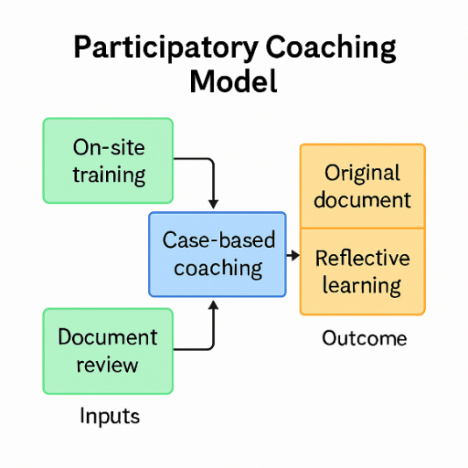
Future research is recommended to expand the geographical scope and employ field-based experimental designs that directly test the effectiveness of participatory mentoring modules. Follow-up studies should consider using cluster randomized trials to compare groups of madrasahs receiving targeted mentoring interventions with those receiving only general training. Additionally, in-depth qualitative research using a participatory action research approach, as outlined by Patton, (2015), could actively involve teachers and supervisors in designing and evaluating the mentoring modules themselves, ensuring that the resulting models are genuinely rooted in field-based needs. These recommendations not only strengthen the external validity of current findings but also open pathways for sustained innovation in madrasah curriculum development.
This study acknowledges several methodological limitations that may affect the depth and generalizability of its findings. First, the use of a cross-sectional explanatory sequential mixed-methods design captures curriculum development practices at a single point in time, limiting the ability to observe changes in teacher competencies and supervisory effectiveness over the course of interventions Creswell & Plano Clark, (2018). Second, the purposive sampling strategy, which included only private madrasahs in three subdistricts, restricts the transferability of findings to other madrasah contexts with differing social, cultural, and policy characteristics (Patton, 2015).
Moreover, the reliance on self-reported questionnaires introduces potential bias related to social desirability and respondent memory limitations, despite efforts to triangulate quantitative data with interviews and field observations (Maxwell, 2013). The relatively short duration of field data collection particularly for supervisory observations conducted twice monthly over several weeks also limits the understanding of long-term mentoring practices and feedback continuity (Miles et al., 2020). These limitations highlight the need for future studies employing longitudinal or experimental designs to capture the evolution of curriculum practices and validate participatory mentoring models in a more comprehensive manner.

CONCLUSION
This study has comprehensively examined curriculum development practices in private madrasahs across Jangkar, Asembagus, and Banyuputih subdistricts, revealing that they are predominantly characterized by cosmetic modifications to document identity without substantive adjustments to core content. Using an explanatory sequential mixed-methods design that combined quantitative surveys and phenomenological interviews, the study found that only a small proportion of teachers were involved in curriculum teams, while most of the process was delegated to vice principals and madrasah heads. The absence of contextual document mentoring and the perception of curriculum as a bureaucratic burden have reinforced copy–paste practices, resulting in instructional materials that fail to reflect Islamic values and local wisdom.
Empirical findings show a significant positive correlation between teacher involvement and curriculum originality (r = 0.62; p < 0.01), and supervisory quality accounts for 28% of the variation in curriculum outcomes. These results underscore the importance of participatory mentoring models focused on concrete document review and technical capacity-building for teachers. Qualitative data further enrich this picture by highlighting the need for step-by-step guidance and feedback tailored to local characteristics.
Thus, this study not only clarifies the gap between curriculum theory and practice in madrasahs but also provides an empirical foundation for designing participatory mentoring modules that position supervisors as case-based facilitators. Although limited to the context of three subdistricts in Situbondo, the findings offer direction for educational policy to strengthen teacher involvement in curriculum design and enhance supervisory effectiveness. Recommendations for future research include the application of longitudinal designs and field experiments to evaluate the long-term impact of these mentoring models on curriculum quality and learning outcomes.

REFERENCES

Ariawan, I. P. W., Giri, M. K. W., & Divayana, D. G. H. (2019). Preliminary Design of CIPP-SAW Evaluation Model in Measuring ICT-based Learning Effectiveness in Health Colleges. Journal of Physics Conference Series, 1402(2), 022077. https://doi.org/10.1088/1742-6596/1402/2/022077
Braun, V., & Clarke, V. (2006). Using thematic analysis in psychology. Qualitative Research in Psychology, 3(2), 77–101. https://doi.org/10.1191/1478088706qp063oa
Creswell, J. W., & Plano Clark, V. L. (2018). Designing and conducting mixed methods research (Third edition). Sage.
Daniel L. Stufflebeam. (2023). The CIPP Evaluation Model: How to Evaluate for Improvement and Accountability.
DeVellis, R. F. (2017). Scale development: Theory and applications (Fourth edition). SAGE.
Efendi, Moch. Y., & Hsi, N. L. (2020). The Comparison of Elementary Curriculum Education Between Indonesia and Singapore. Journal of Teaching and Learning in Elementary Education, 3(1), 22. https://doi.org/10.33578/jtlee.v3i1.7323
Fatimah, S., Koryati, D., & Pratita, D. (2020). Evaluasi RPS Rumpun Ilmu Ekonomi Pada Program Studi Pendidikan Ekonomi FKIP Unsri. Jurnal Profit Kajian Pendidikan Ekonomi Dan Ilmu Ekonomi, 7(2), 146–157. https://doi.org/10.36706/jp.v7i2.12881
Finney, T. L. (2020). Confirmative Evaluation: New CIPP Evaluation Model. Journal of Modern Applied Statistical Methods, 18(2), 2–24. https://doi.org/10.22237/jmasm/1598889893
Glover, A., Jones, M., Thomas, A., & Worrall, L. (2024). Finding the joy: Effective mentoring in Teacher Education. Mentoring & Tutoring: Partnership in Learning, 32(4), 377–394. https://doi.org/10.1080/13611267.2024.2360605
Kvale, S., & Brinkmann, S. (2015). InterViews: Learning the craft of qualitative research interviewing (Third edition). Sage Publications.
Lee, S. Y., Shin, J., & Lee, S. H. (2019). How to Execute Context, Input, Process, and Product Evaluation Model in Medical Health Education. Journal of Educational Evaluation for Health Professions, 16, 40. https://doi.org/10.3352/jeehp.2019.16.40
Mahmud, Y. S. (2019). The Representation of Local Culture in Indonesian Efl Textbooks: Rationales and Implications. Indonesian Efl Journal, 5(2), 61. https://doi.org/10.25134/ieflj.v5i2.1727
Maxwell, J. A. (2013). Qualitative research design: An interactive approach (3 edition). SAGE.
Miles, M. B., Huberman, A. M., & Saldaña, J. (2020). Qualitative data analysis: A methods sourcebook (Fourth edition). SAGE.
Mukminin, A., Habibi, A., Prasojo, L. D., Idi, A., & Hamidah, A. (2019). Curriculum Reform in Indonesia: Moving from an Exclusive to Inclusive Curriculum. Center for Educational Policy Studies Journal, 9(2), 53–72.
Nguyen, H. T. T., Duong, N. T., & Dang, T. T. P. (2024). A Comprehensive Analysis of Teacher Professional Learning Communities: A Scopus Based Review (2019–2024). International Journal of Learning, Teaching and Educational Research, 23(8), 158–179. https://doi.org/10.26803/ijlter.23.8.9
Patton, M. Q. (2015). Qualitative Research & Evaluation Methods: Integrating Theory and Practice (4Th edn). SAGE Publications, Inc.
Renata C. G. V. Nikijuluw. (2020). The Use of CIPP in the Extensive Listening Course at PSDKU Program. Kj, 1(2), 116–123. https://doi.org/10.30598/koli.1.2.116-123
Sopandi, E. (2019). Evaluation of Implementation of Inclusion Education Programs in Madrasah Ibtidaiyah Badrussalam Surabaya. Jisae Journal of Indonesian Student Assesment and Evaluation, 5(2), 26–36. https://doi.org/10.21009/jisae.v5i2.12566
Subur, S., & Hidayati, I. W. (2020). Evaluation of Kemuhammadiyahan Education Program Based on CIPP Method for Strengthening Muhammadiyah Kader. Jurnal Tarbiyatuna, 11(2), 161–168. https://doi.org/10.31603/tarbiyatuna.v11i2.4058
Suharsono & Nur Efendi. (2020). Implementation Management of Modern Education in Madrasah Diniyah. International Journal on Integrated Education, 3(4), 74–80. https://doi.org/10.31149/ijie.v3i4.430
Sumantri, B. A. (2019). Pengembangan Kurikulum Di Indonesia Menghadapi Tuntutan Kompetensi Abad 21. At-Ta Lim Media Informasi Pendidikan Islam, 18(1), 27. https://doi.org/10.29300/attalim.v18i1.1614
Taba, H. (1970). Curriculum development: Theory and practice (Internat. ed). Harcourt, Brace.
Tep, V. (2024). Teacher educators as curriculum developers: A case study of teacher education colleges in Cambodia. Frontiers in Education, 9, 1328023. https://doi.org/10.3389/feduc.2024.1328023
Tyler, R. W., & Hlebowitsh, P. S. (2013). Basic principles of curriculum and instruction. Univ. of Chicago Press.
Vargo, S. L., & Lusch, R. F. (Eds). (2019). The SAGE handbook of service-dominant logic. SAGE Reference.

