Exploring Students’ Perceptions of Writing in English as a Foreign Language

Wildan As’at Taufik Hasibuan^{*,1}
Maslathif Dwi Purnomo²

¹Master of English Education, Tarbiyah Science and Teacher Training , Universitas Islam Negeri Sumatera Utara, Medan, INDONESIA
²Master of English Education, Tarbiyah Science and Teacher Training , Universitas Islam Negeri Sumatera Utara, Medan, INDONESIA
*Corresponding author, email: hasibuanwildan3@gmail.com

Abstract
This study examines students’ perceptions of writing in English as a Foreign Language, especially in terms of confidence, motivation, organization, and feelings toward writing. The research used a quantitative survey design and involved 16 students from the English Department at UIN SU, who participated voluntarily. Data were collected through a Likert-scale questionnaire containing ten statements about students’ attitudes and challenges in English writing. The responses were analyzed descriptively using frequency and percentage data. The findings show that most students have positive perceptions of English writing. All students reported that they feel confident when writing and believe that writing helps improve their English skills. They also feel satisfied after completing writing tasks and agree that writing is important for their education. However, some students still experience difficulties, such as organizing ideas into coherent paragraphs, feeling stressed when working on long writing tasks, and being afraid of making mistakes. This indicates that although students value writing, they still face several cognitive and emotional challenges. Overall, the study suggests that writing instruction should not only improve language skills but also provide more support in organizing ideas, reducing anxiety, and increasing students’ confidence in writing. These findings contribute to a better understanding of students’ perceptions and support the development of more learner-centered EFL writing instruction.

Keywords: Students’ Perceptions, Writing, EFL.

Introduction
Writing in English as a Foreign Language (EFL) has long been recognized as one of the most complex and intellectually demanding components of language learning. Unlike receptive skills such as listening and reading, writing requires learners to actively generate, organize, and refine ideas while simultaneously managing grammar, vocabulary, mechanics, and discourse conventions (Hyland, 2019; Weigle, 2014). For many students, this process becomes even more challenging in academic contexts, where writing is not only a linguistic activity but also an academic and cognitive task that requires clarity of argument, coherence, and critical engagement with content (Nation, 2009). As a result, students often perceive writing in English as a demanding and sometimes intimidating process, especially when their linguistic competence and academic literacy are still developing (Fareed et al., 2016).
In many EFL learning environments, students report a variety of difficulties when engaging in writing tasks. These include challenges in generating ideas, limited vocabulary, grammatical inaccuracy, and difficulty organizing thoughts into coherent and logically structured texts (Chen, 2019; Latif, 2013). Such challenges may contribute to feelings of anxiety, frustration, and lack of confidence, which can negatively influence students’ willingness to engage in writing activities. Writing requires sustained attention, planning, and revision, and students must balance multiple demands at once including accuracy, organization, idea development, and audience awareness (Weigle, 2014). Therefore, students’ perceptions of writing are closely connected to their emotional responses, learning attitudes, and levels of engagement in writing classrooms (MacIntyre & Mercer, 2014).
The role of writing in education, however, continues to expand, especially as academic environments increasingly emphasize critical thinking, analytical reasoning, and written communication. Writing is not merely a means of language practice but a key medium through which students construct knowledge, express understanding, and participate in academic discourse (Hyland, 2016). In EFL contexts, this expectation presents additional challenges, as students must develop both language proficiency and academic writing competence simultaneously. Mastery of grammatical accuracy alone is no longer sufficient; students are also expected to organize ideas logically, support arguments appropriately, and demonstrate coherence across sentences and paragraphs (Graham & Perin, 2007). These demands highlight the importance of instructional approaches that support students not only at the linguistic level but also at the level of text organization and idea development.
Despite these developments, numerous studies have shown that many EFL learners continue to struggle with aspects of organization, coherence, and paragraph development in academic writing (Fareed et al., 2016; Weigle, 2014). Students often produce texts that lack unity, sufficient elaboration, or logical connection between ideas, indicating that organization remains a major area of difficulty. These challenges may arise from limited exposure to academic writing conventions, lack of explicit instruction in text structure, or unfamiliarity with expectations regarding academic argumentation in English (Hyland, 2019). At the same time, students’ difficulties in organization may also be shaped by how they perceive the writing process itself, including their beliefs about what constitutes good writing and how writing tasks should be approached.
Students’ perceptions are therefore an important factor in understanding writing development in EFL contexts. Perception influences how learners interpret learning tasks, evaluate their own abilities, and respond to instructional practices (Bandura, 1997; Zimmerman, 2000). Students who perceive writing instruction as meaningful, supportive, and relevant to their learning needs are more likely to engage actively, experiment with strategies, and develop greater confidence as writers (Teng, 2016). In contrast, when writing activities are perceived as overly difficult, unclear, or disconnected from students’ goals, learners may adopt surface level approaches, avoid complex writing tasks, or experience increased anxiety. Understanding students’ perceptions thus provides valuable insight into how writing instruction is experienced at the classroom level.
However, much of the existing research on students’ perceptions of writing has tended to focus on specific aspects such as writing anxiety, self-efficacy, or general attitudes toward writing, rather than on how students perceive their experiences in structured academic writing and paragraph organization (Latif, 2013; MacIntyre & Mercer, 2014). While studies have examined writing strategies, teacher feedback, and assessment practices, fewer studies have explored how students perceive approaches to writing that emphasize idea development, textual organization, and coherence. This indicates a need for more learner centered inquiry into how students experience academic writing as a structured and cognitive process rather than merely a linguistic one.
Exploring students’ perceptions from this perspective is significant for several reasons. First, perceptions offer insight into how students make sense of their writing experiences, including how they approach planning, composing, organizing, and revising written texts. These perceptions may reveal whether writing activities help students clarify their ideas, develop understanding of text structure, or engage more critically with content. Second, students’ perceptions can highlight the kinds of challenges they continue to experience, such as difficulties in maintaining coherence, elaborating supporting information, or linking ideas between sentences and paragraphs. Such insights may not always be visible through written products alone but can be understood more deeply through students’ reflections on their own writing processes. Third, examining students’ perceptions contributes to the development of more responsive and context appropriate writing pedagogy. EFL learning environments are diverse, and instructional approaches may not affect all learners in the same way. Students interpret and experience writing activities differently depending on prior learning experiences, language background, academic expectations, and personal confidence (Dörnyei, 2005). By considering students’ perspectives, educators and researchers can better understand whether writing instruction aligns with learners’ needs, whether it supports or constrains learning, and how it might be improved to foster greater engagement and writing development.
From a broader educational perspective, understanding students’ perceptions of writing also supports the development of learner autonomy and reflective learning. When students are encouraged to reflect on their writing experiences, they become more aware of their strengths, difficulties, and learning strategies. This awareness may promote more active self-regulation and greater responsibility for learning, particularly in writing tasks that require sustained effort and independent thinking (Zimmerman, 2000; Teng, 2016). Thus, exploring students’ perceptions is not only useful for instructional improvement but also for supporting students’ long-term development as independent writers and language learners.
Against this background, the present study aims to explore students’ perceptions of writing in English as a Foreign Language within the context of structured academic writing and paragraph organization. The study focuses on how students perceive their experiences in generating ideas, elaborating information, organizing written texts, and constructing coherence in English. By examining students’ reflections and perceptions, this research seeks to provide a deeper understanding of how learners experience academic writing, how they interpret the demands of writing tasks, and how these perceptions shape their engagement, motivation, and learning behavior in writing classrooms.
The findings of this study are expected to contribute to the growing body of literature on EFL writing by offering empirical insight into learners’ subjective experiences of writing in English. In practical terms, the results may inform writing instruction by helping teachers better understand how students experience writing tasks, which aspects of writing they find most challenging, and which areas of instruction may require greater support. The study may also provide implications for curriculum developers and educators in designing writing programs that place greater emphasis on organization, coherence, and learner engagement, while taking into account students’ perceptions and learning needs. Ultimately, a deeper understanding of students’ perceptions of writing may support the development of more effective, meaningful, and learner centered approaches to teaching writing in EFL contexts.

Literature Review

Students’ Perceptions in EFL Learning
Perception refers to how learners interpret and evaluate their learning experiences, which in turn influences their attitudes and behavior in the classroom (Oxford, 2016). In EFL writing, students’ perceptions include their confidence, motivation, anxiety, perceived difficulty, and value toward writing tasks. Positive perceptions are associated with greater participation and persistence, whereas negative perceptions may result in avoidance or writing apprehension (Latif, 2007). Research in second language learning shows that learners’ attitudes and perceptions strongly influence language achievement and task engagement (Dörnyei & Ushioda, 2011). When students perceive writing as meaningful and useful, they are more likely to develop intrinsic motivation and invest effort in improving their skills. Conversely, when writing is perceived as difficult or stressful, learners may experience low confidence and reluctance to participate (Hyland, 2019). Thus, investigating students’ perceptions provides insight into their cognitive and emotional responses to writing instruction.

Writing in English as a Foreign Language

Writing in EFL settings differs from first-language writing because learners must manage limited linguistic resources while simultaneously generating and organizing ideas (Richards & Renandya, 2002). EFL students often struggle with vocabulary, grammar accuracy, and rhetorical organization, which can create additional cognitive load and uncertainty during writing tasks (Weigle, 2002).

Method
The research employed a quantitative survey design to investigate students’ perceptions of writing in English. The study involved 16 students from the 7th English Department at UIN SU, who were selected through voluntary sampling, allowing only students who were willing and relevant to the study context to participate. Data were collected using an online questionnaire distributed through Google Forms. The survey was administered on December 6, 2025, and respondents were given approximately one week to complete and submit their responses. The entire research process, including data collection, processing, and interpretation, was completed within two weeks.
The questionnaire was developed using a Likert scale format, which served as the primary instrument for exploring and interpreting students’ perceptions of writing in English. The instrument consisted of four response options: Strongly Agree, Agree, Disagree, and Strongly Disagree. These categories enabled respondents to indicate the degree of agreement or disagreement with each statement related to their writing experiences. The use of a Likert scale also allowed the researcher to quantify students’ perceptions and identify the extent to which they viewed writing as beneficial, understandable, engaging, and supportive of their English language development. Overall, the study highlights the important role of writing in enhancing students’ English proficiency and academic learning.

Result & Discussion
- Result
The data analysis in this section was conducted based on the responses obtained from a Google Forms https: //docs.ngoogle. com/forms/ d/e/1FAIpQLSdM6JGcdGnhz_ bK9enwusK4DXOD dEWPU9jSwmj XF0T7cZSHOw /viewform?usp =header survey completed by 16 participants, each responding to 10 statements related to students’ perceptions of English writing. The statements covered key affective and cognitive aspects of writing, including confidence in writing English texts, the ability to express ideas through writing, feelings of boredom toward writing activities, the role of writing in supporting English learning, difficulties in organizing ideas into coherent paragraphs, stress when completing long writing assignments, writing motivation driven by teacher requirements, feelings of satisfaction after completing writing tasks, the importance of writing skills for education, and fear of making mistakes when writing.
To present the findings clearly, each survey item is displayed using screenshots taken directly from Google Forms, which visually illustrate the distribution of responses. These visuals are complemented by statistical calculations processed in Microsoft Excel, including percentages, frequency distributions, and descriptive summaries. For better organization and clarity of interpretation, the analysis is divided into two main sections: the first explains respondents’ answers based on the visual charts from Google Forms, while the second provides a deeper interpretation using the statistical results generated in Excel. This structured approach ensures that the findings are comprehensive, easy to understand, and aligned with the objectives of the study.

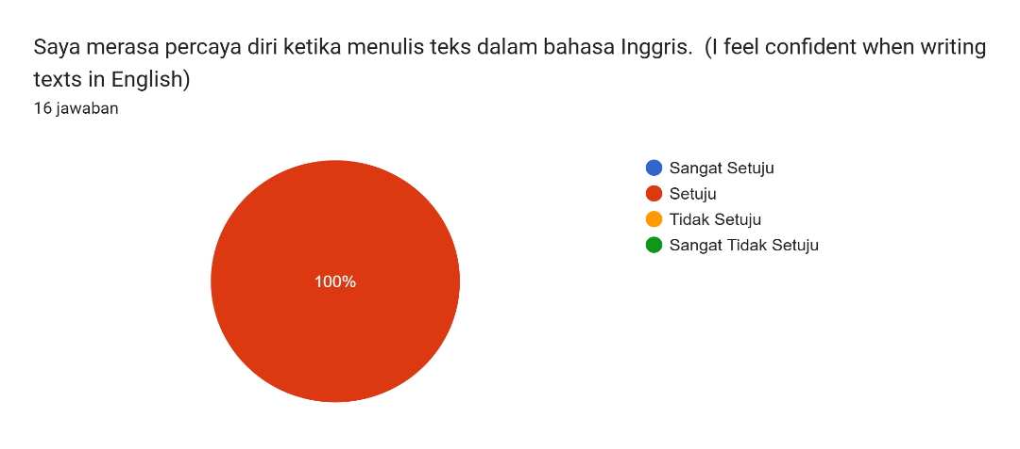
Item 1: I feel confident when writing texts in English
A total of 16 respondents participated in the questionnaire, in which each item consisted of four response options: Strongly Agree, Agree, Disagree, and Strongly Disagree. Based on the frequency diagram for Item 1, all respondents expressed a positive perception toward the statement. Specifically, 100% of the participants selected “Agree,” indicating full agreement with no responses recorded in the Disagree or Strongly Disagree categories. These findings demonstrate a strong and consistent positive perception among all respondents regarding the content of Item 1, suggesting that the statement is well-received and aligns with their views or experiences.

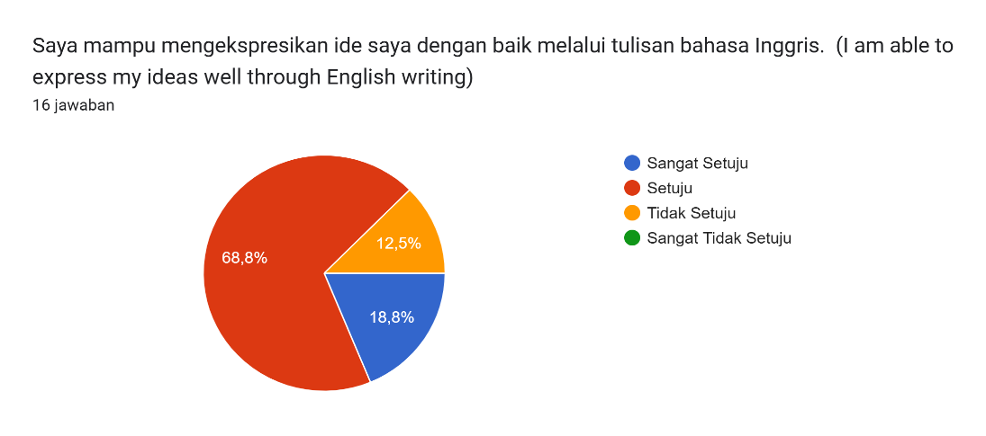
Item 2: I am able to express my ideas well through English writing

A total of sixteen respondents participated in the questionnaire. Each item in the questionnaire provided four response options: Strongly Agree, Agree, Disagree, and Strongly Disagree. Based on the frequency diagram for Item 2, the majority of respondents expressed agreement with the statement. Specifically, three students (18.8%) selected Strongly Agree, eleven students (68.8%) selected Agree, and two students (12.5%) selected Disagree, while none of the respondents chose Strongly Disagree. These results indicate that only a small proportion of participants disagreed with Item 2, whereas most respondents demonstrated a positive perception toward the statement.

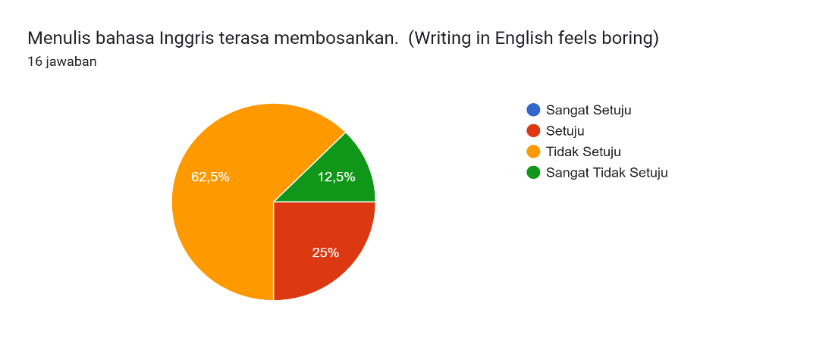
Item 3: Writing in English feels boring

Out of sixteen respondents, the results for Item 3 indicate that most participants expressed disagreement with the statement. A total of ten students (62.5%) selected Disagree, while two students (12.5%) chose Strongly Disagree. In contrast, only four students (25%) selected Agree, and none of the respondents indicated Strongly Agree. These findings demonstrate that the majority of participants held an unfavorable perception toward Item 3. Overall, the responses suggest that the statement in Item 3 was generally not supported by the respondents.

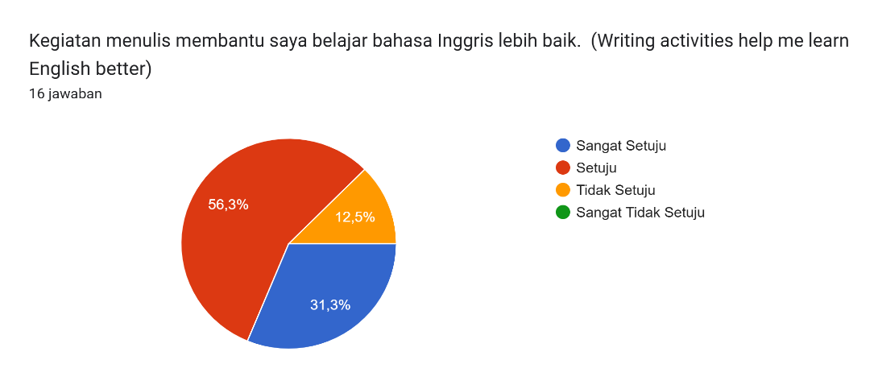
Item 4: Writing activities help me learn English better

From the total of sixteen respondents, the results for Item 4 reveal that the majority of participants agreed with the statement. Nine students (56.3%) responded Agree, and five students (31.3%) selected Strongly Agree. Meanwhile, only two students (12.5%) chose Disagree, and no respondents selected Strongly Disagree. These results indicate that most participants demonstrated a positive perception of Item 4. Overall, the responses reflect that the statement received substantial support from the respondents.

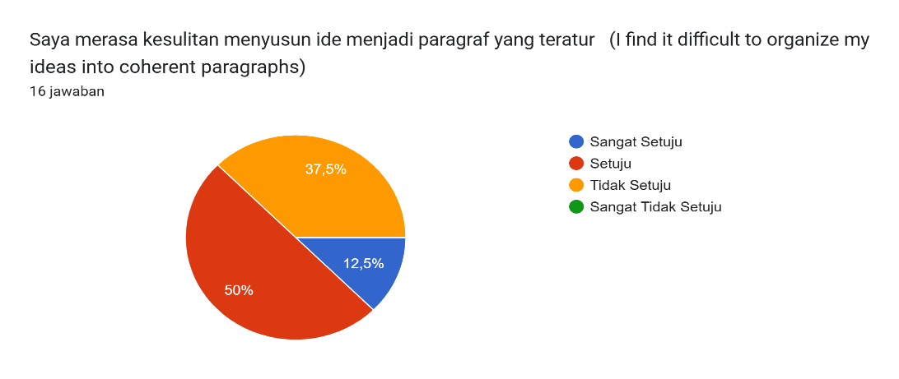
Item 5: I find it difficult to organize my ideas into coherent paragraphs

From the total of sixteen respondents, the findings for Item 5 show that most participants expressed agreement with the statement. A total of eight students (50%) selected Agree, while two students (12.5%) indicated Strongly Agree. In comparison, six students (37.5%) chose Disagree, and none of the respondents selected Strongly Disagree.
These results suggest that a larger proportion of respondents still showed agreement with the statement, despite the presence of some differing views. The distribution of responses indicates that the perception toward Item 5 remained generally positive among participants. Overall, the results imply that the statement received meaningful support from the majority of respondents.

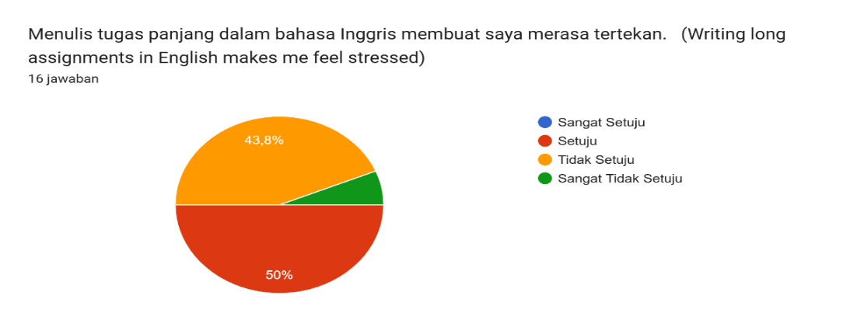
Item 6: Writing long assignments in English makes me feel stressed

From the total of sixteen respondents, the results for Item 6 indicate that most participants expressed agreement with the statement. Eight students (50%) selected Agree, while seven students (43.8%) chose Disagree, and one respondent (6.3%) selected Strongly Disagree. These findings suggest that although a considerable proportion of participants supported the statement, there were also differing opinions among the respondents. Overall, the distribution of responses reflects a generally mixed yet meaningful level of agreement toward Item 6.

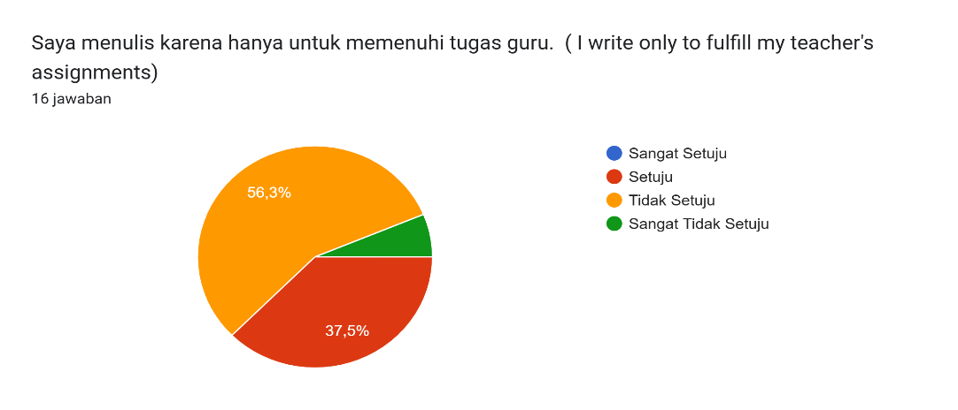
Item 7: I write only to fulfill my teacher's assignments

Out of the sixteen respondents, the results for Item 7 reveal that most participants expressed disagreement with the statement. A total of nine students (56.3%) selected Disagree, and one student (6.3%) chose Strongly Disagree, indicating a predominantly negative response pattern. In contrast, only six students (37.5%) selected Agree, and none of the respondents indicated Strongly Agree.
These findings suggest that the majority of participants held an unfavorable perception toward Item 7, as the level of disagreement exceeded the proportion of students who expressed agreement. The distribution of responses further implies that the statement in Item 7 did not resonate strongly with the respondents and was generally not supported. Overall, the results highlight a tendency among participants to challenge or reject the idea presented in this item, reflecting a lower level of acceptance compared to other statements in the questionnaire.

Item 8: I feel satisfied when I successfully complete an English writing assignment
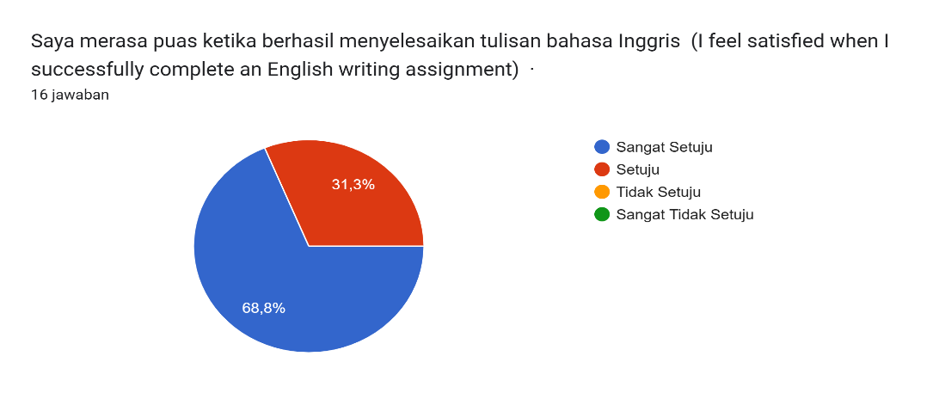

A total of 16 respondents took part in the questionnaire, which provided four response options for each item: Strongly Agree, Agree, Disagree, and Strongly Disagree. The distribution of responses for Item 8 shows a clearly favorable perception among participants. In particular, 11 students (68.8%) selected Strongly Agree, while the remaining 5 students (31.3%) chose Agree. None of the respondents reported Disagree or Strongly Disagree. These findings demonstrate that all participants were in agreement with the statement in Item 8, reflecting a uniformly strong and positive perception toward its content.

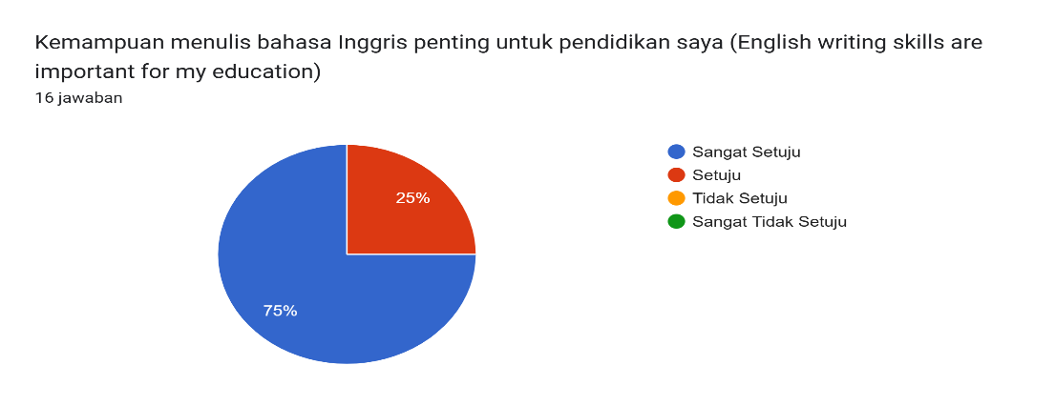
Item 9: English writing skills are important for my education

A total of 16 individuals completed the questionnaire, which included four possible response options for each item: Strongly Agree, Agree, Disagree, and Strongly Disagree. The response pattern for Item 9 reflects a distinctly positive tendency among the participants. Of the total respondents, 12 students (75%) indicated Strongly Agree, while the other 4 students (25%) selected Agree. There were no responses recorded in either the Disagree or Strongly Disagree categories. Taken together, these outcomes show that all participants were supportive of the statement in Item 9, indicating a strong and uniform positive perception toward the item.

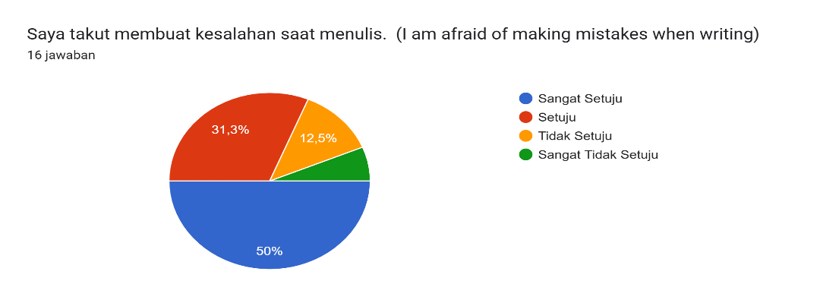
Item 10: I am afraid of making mistakes when writing

A total of 16 respondents participated in the questionnaire, which offered four response options for each item: Strongly Agree, Agree, Disagree, and Strongly Disagree. The distribution of responses for Item 10 indicates a clearly positive trend among participants. Specifically, 8 students (50%) selected Strongly Agree and 5 students (31.5%) chose Agree, while only three respondents (18.5%) were recorded in the Disagree or Strongly Disagree categories. Overall, these results suggest that participants generally supported the statement in Item 10, reflecting a consistently favorable perception toward the item.

- Discussion
The findings of this study provide a comprehensive picture of students’ perceptions of writing in English as a Foreign Language, as reflected in the frequency and percentage distributions of their responses to the questionnaire items. Overall, the data indicate that students hold predominantly positive attitudes toward English writing, although some cognitive and affective challenges remain evident, particularly in relation to organization, stress, and fear of making mistakes. For Item 1, all respondents (100%) selected Agree, indicating a unanimous positive perception of confidence in writing English texts. The absence of responses in the Disagree or Strongly Disagree categories suggests a strong level of self-belief among students.
Similarly, the distribution of responses for Item 2 shows that three students (18.8%) selected Strongly Agree and eleven students (68.8%) selected Agree, while only two students (12.5%) chose Disagree. These frequencies indicate that the majority of students perceive themselves as able to express ideas effectively through English writing. The small proportion of disagreement suggests that although most students feel capable, some still face linguistic or expressive limitations. This aligns with Hyland’s (2016) view that writing supports idea development but remains a cognitively demanding skill. For Item 3, most respondents expressed disagreement, with ten students (62.5%) selecting Disagree and two students (12.5%) choosing Strongly Disagree, while only four students (25%) selected Agree. The frequency pattern shows that the majority do not perceive writing as boring. Instead, students appear to engage positively with writing activities. This aligns with MacIntyre and Mercer (2014), who highlight the role of positive emotion and enjoyment in sustaining learning motivation.
The responses to Item 4 further strengthen this finding, as nine students (56.3%) selected Agree and five students (31.3%) selected Strongly Agree, while two students (12.5%) chose Disagree. The high concentration of agreement responses indicates that students perceive writing as beneficial for improving English skills. These frequencies suggest that writing is not only viewed as a classroom activity but also as a meaningful tool for language development (Nation, 2009; Hyland, 2016). However, challenges emerge in Item 5, where eight students (50%) selected Agree and two students (12.5%) selected Strongly Agree, compared to six students (37.5%) who chose Disagree. The frequency distribution shows that more than half of the respondents experience difficulty organizing ideas into coherent paragraphs. Although disagreement responses are also considerable, the higher proportion of agreement indicates that organizational challenges remain a common issue. This finding supports previous studies reporting that coherence, unity, and paragraph development are persistent areas of difficulty for EFL learners (Fareed et al., 2016; Weigle, 2014).
A similar pattern is seen in Item 6, where eight students (50%) selected Agree, while seven students (43.8%) selected Disagree and one student (6.3%) chose Strongly Disagree. These frequencies indicate a relatively balanced perception, suggesting that while many students feel stressed when completing long writing assignments, a nearly equal number do not share this experience. This variation may reflect different levels of writing confidence and coping strategies among learners, consistent with Latif’s (2013) findings on individual differences in writing anxiety. For Item 7, most respondents expressed disagreement, with nine students (56.3%) selecting Disagree and one student (6.3%) selecting Strongly Disagree, while six students (37.5%) selected Agree. The frequency pattern indicates that students generally do not write solely to fulfill teacher requirements. Instead, many appear to engage in writing for broader learning purposes. This suggests the presence of internal or self-regulated motivation, which is essential for developing learner autonomy (Teng, 2016).
A particularly strong positive tendency appears in Item 8, where eleven students (68.8%) selected Strongly Agree and five students (31.3%) selected Agree, with no responses in the Disagree categories. The uniform frequency distribution indicates that all students feel satisfied after successfully completing writing tasks. This finding highlights the emotional reward associated with writing accomplishment, reinforcing the motivational role of positive affect in learning (MacIntyre & Mercer, 2014). Likewise, the responses to Item 9 show complete agreement, with twelve students (75%) selecting Strongly Agree and four students (25%) selecting Agree. The frequency data demonstrate unanimous recognition of writing as an important skill for academic development. This indicates that students perceive writing as highly relevant to their educational goals and future learning (Hyland, 2019). Finally, Item 10 reveals that eight students (50%) selected Strongly Agree and five students (31.5%) selected Agree, while only three students (18.5%) selected Disagree or Strongly Disagree. These frequencies indicate that fear of making mistakes remains a common concern among students. This finding reflects the presence of writing anxiety and performance pressure, which may affect students’ risk-taking and confidence when composing texts (Latif, 2013).
Taken together, the frequency patterns across the ten items illustrate a dual-dimension perception: students demonstrate strong appreciation, motivation, and confidence toward writing, yet continue to experience cognitive and emotional challenges. These results emphasize the importance of writing instruction that not only develops linguistic accuracy, but also supports organization skills, reduces anxiety, and fosters positive learning experiences. Pedagogically, the findings suggest that writing instruction should incorporate explicit teaching of coherence and paragraph organization, guided practice, and modeling of text structure. In addition, supportive feedback and process-based approaches may help reduce stress and fear of error, while reinforcing students’ confidence and engagement. Addressing both frequency-based evidence and students’ perceived experiences can therefore contribute to more responsive and learner-centered writing pedagogy in EFL contexts.

Conclusion
This research highlights that, despite students’ generally positive perceptions and confidence in English writing, significant cognitive and emotional challenges remain, particularly concerning paragraph organization, stress, and fear of errors. These difficulties can hinder learners’ overall engagement and development as autonomous writers. The findings emphasize the importance of adopting instructional strategies that promote clarity in text structure, provide supportive feedback, and address emotional factors such as anxiety. By understanding students’ perceptions, educators can tailor pedagogical practices to foster a more learner-centered environment that enhances both motivation and skill acquisition. Ultimately, integrating learners’ perspectives into writing instruction can contribute to more effective, meaningful, and sustainable language development in EFL settings.

Referencess
Bandura, A. (1997). Self-efficacy: The exercise of control. W. H. Freeman.
Chen, M. (2019). EFL students’ writing challenges and strategy use. Journal of Language Teaching and Research, 10(2), 397–404.
Dörnyei, Z. (2005). The psychology of the language learner: Individual differences in second language acquisition. Routledge.
Fareed, M., Ashraf, A., & Bilal, M. (2016). ESL learners’ writing skills: Problems, factors and suggestions. Journal of Education and Social Sciences, 4(2), 81–92.
Graham, S., & Perin, D. (2007). Writing next: Effective strategies to improve writing of adolescents in middle and high schools. Alliance for Excellent Education.
Hyland, K. (2016). Methods and methodologies in second language writing research. System, 59, 116–125.
Hyland, K. (2019). Second language writing and writer development. Journal of Second Language Writing, 45, 100–114.
https://docs.google.com/forms/d/e/1FAIpQLSdM6JGcdGnhz_bK9enwusK4DXO DdEWPU9jSwmjXF0T7cZSHOw/viewform?usp=header
Latif, M. A. (2013). Affective factors and EFL writing performance. English Language Teaching, 6(11), 190–200.
MacIntyre, P. D., & Mercer, S. (2014). Introducing positive psychology to SLA. Studies in Second Language Learning and Teaching, 4(2), 153–172.
Nation, I. S. P. (2009). Teaching ESL/EFL reading and writing. Routledge.
Richards, J. C., & Renandya, W. A. (2002). Methodology in language teaching: An anthology of current practice. Cambridge University Press.
Teng, F. (2016). Learner autonomy and writing strategies in EFL learning. English Language Teaching, 9(11), 1–10.
Weigle, S. C. (2014). Assessing writing. Cambridge University Press.

