COMBINATION OF FP-GROWTH AND FP-TREE ALGORITHMS IN TREATMENT SELECTION DECISION SYSTEM IN BEAUTY CLINICS (Case Study: Christa Aesthetic Clinic)

Fanny Abdillah¹

Program Studi Matematika, Universitas Islam Negeri Sumatera Utara, Medan, Indonesia

ABSTRACT
The beauty industry encounters substantial obstacles in comprehending consumer preferences for treatment services. This study created a data mining-based decision support system that integrates FP-Growth and FP-Tree algorithms to resolve this issue. Customer transaction data was employed to conduct the investigation at the Christa Aesthetic Clinic. Treatment selection patterns were identified through frequent pattern mining, which was based on skin type. The findings indicated that this methodology is capable of enhancing service efficacy and offering pertinent recommendations. The FP-Growth algorithm was employed to conduct association analysis, which revealed that each skin type has a propensity to select specific treatment combinations. A combination of acne exfoliation, acne skinbooster, and acne facial was selected by customers with acne-prone skin. Brightening peeling, dermapen derma glow, and brightening facial were the most popular choices among customers with lackluster skin. The emerging trend indicated that facial detox, salmon DNA skinbooster, and moisturizer were recommended for individuals with sensitive skin. In contrast, customers with normal skin preferred light peeling after using sunscreen, moisturizer, and a facial, suggesting a larger emphasis on skin maintenance.

Keywords: cosmetic clinic, treatment, FP-Growth, FP-Tree, decision support system.
Email Address: ¹ nama@email.com

DOI: http://dx.doi.org/10.30829/jistech.v9i2.xxxx
Received 10 February 2025; Received in revised form 10 April 2025; Accepted 15 June 2025

This work is licensed under a Creative Commons Attribution-NonCommercial-ShareAlike 4.0 International License.

Introduction
In a time of escalating business competition, the utilization of information technology has become an essential strategy for facilitating decision-making. In order to gain a more precise understanding of consumer requirements, beauty clinics, which are a component of the healthcare and aesthetics industry, must manage transaction data. Christa Aesthetic Clinic is a healthcare service that is situated at No. 66, Medan Resort City Housing Complex, Deli Tua District. The Christa Aesthetic Clinic was founded to offer healthcare services to the local community.
Christa Aesthetic Clinic frequently encounters obstacles when assisting consumers in selecting the appropriate treatment. Consequently, the objective of this investigation is to develop a decision support system that generates treatment recommendations based on the transaction history of customers by utilizing a combination of FP-Growth and FP-Tree algorithms. Service quality, post-procedure medication effects, availability of appropriate equipment, and price considerations, which are frequently observed on social media, are the primary factors to consider when selecting a treatment. Beauty clinics are not only locations where individuals can receive beauty treatments, but also centers where consumers can locate solutions that align with their health and aesthetic requirements (Rahmawati.2021).
FP-Growth is a data mining method that is effective in identifying frequently occurring patterns. It employs a divide-and-conquer approach, which recursively divises data into smaller projections to reduce the search space and increase efficacy (F. Kurnia. 2017). This algorithm can directly derive frequently occurring patterns in the data by utilizing the FP-Tree structure. FP-Tree is a data structure that is shaped like a tree and is constructed from a collection of objects in a database. The root node of the tree is null, and each node in the tree represents a single item. Subsequent nodes represent combinations of items (itemsets). The efficient mining of frequently occurring patterns is facilitated by the maintenance of relationships between nodes that reflect associations between items during the tree formation process (Nurul Arifin.2015).
This study endeavors to investigate the decision-making process of individuals when selecting a treatment at the Christa Aesthetic Clinic, utilizing a combination of the Fp-Growth and Fp-Tree algorithms, in light of the aforementioned context. Additionally, the objective of this investigation is to employ the Fp-Growth and Fp-Tree algorithms to conduct data analysis in order to develop data mining applications that optimize service sales using Rapidminer 5 software.

Research methodology
This study employs quantitative research, which employs objective and quantifiable methodologies. In order to guarantee that the research results obtained are consistent with the actual conditions, quantitative research must be conducted using valid instruments and appropriate statistical analysis (Hamzah & Susanti,2021).
The data utilized in this investigation is primary data. Typically, researchers collect primary data from individuals or primary sources, such as the results of interviews or questionnaires (Fauzi, Rahmat.2023).
In this study, the research variables are divided into two, namely the independent variable (free variable), namely the type of treatment and the skincare product. Where the dependent variable (bound variable) is the decision to choose the treatment.
A Decision Support System (DSS) is an information system that is extensible, adaptable, interactive, and flexible. It provides information, modeling, and data manipulation to generate alternative decisions and answers to assist management in addressing semi-structured and unstructured problems, where no one is certain of the appropriate course of action (Riadi.2022). The objective of a decision support system is to facilitate the process of making more precise and effective decisions by supplying pertinent and dependable information (Jeperson, Fito,Dahlan,Qurrotul. 2023)

Association Rule Mining Method
Association rule mining is a data mining technique that is employed to determine the relationships or connections between entities in a dataset. Its primary objective is to identify patterns that are frequently encountered, as they provide a critical foundation for the development of more precise and efficient data analysis algorithms (Abdullah.2018).
At this stage, the database is searched for a combination of items that satisfy the minimal support value requirement. The subsequent equation is employed to determine the support value of an item:
$$Support \left(A\right)=\frac{Number of transactions containing A}{Total transactions}$$

$$Support \left(A∩B\right)=\frac{Number of transactions containing A and B}{Total transactions}$$

Pembentukan aturan asosiatif. Setelah semua pola frekuensi tinggi ditemukan,kemudian dicari aturan asosiatif yang memenuhi syarat minimum untuk confidence dengan menghitung confidence aturan asosiatif A→B. Nilai confidence dari aturan A→B di peroleh sebagai berikut :(Yuyun,2015)

$$Confidence \left(A | B\right)= \frac{The number of transactions containing A and B}{The transaction amount contains A}$$

Fp-Growth Method Algorithm
Based on a preset minimum support value, the FP-Growth algorithm is a pattern mining technique for identifying frequently occurring itemsets in a dataset. Using a divide-and-conquer strategy, this method first looks for single items that appear frequently before creating a conditional database for each pattern. The projected data is then subjected to this procedure in a recursive manner. By doing this, FP-Growth can decrease the search space, circumvent the lengthy Apriori algorithm candidate generation process, and improve scalability and efficiency when working with big amounts of data. Because of this method, it is a well-liked technique for data mining's frequent pattern analysis (F. Kurnia,2017).
A Frequent Pattern Tree is a tree-like structure created with an initial set of items from a database. The goal of a Frequent Pattern Tree is to mine the most frequent patterns. Each node of the Frequent Pattern Tree represents an item in the set. The root node represents null, while the lowest nodes represent itemsets (Tahir,2021).

Research Procedures
The following figure illustrates how this research process was conducted using the Fp-Growth and Fp-Tree methods:

Start

Data collection

Support Calculation
Fp-Growth Algorithm Calculation Results
Formation of Fp-Tree

Conditional Pattern Base Formation

Formation of Conditional Fp-Tree

Frequent Item Set Search

Finished

Figure 1. Flowchart

Results and Discussion
Data collection
This information was obtained from the Christa Aesthetic Clinic, which kept track of patients' treatment preferences from November 2024 to January 2025. 100 clients are included in the data, which is categorised by skin type: normal, dry, sensitive, dull, and acne-prone. Twenty clients in each skin type category selected treatments according to their skin requirements. A facial, peeling, dermapen, and skin booster are among the available treatments; each has a variation depending on the client's skin issues.
FP – Tree Formation
After classifying the data according to skin type, the frequency of each treatment is determined to create the FP-Tree. Only noteworthy patterns can be examined when treatments with frequencies below a minimal support level are eliminated. Each transaction is ordered by item frequency once the items have been filtered. Transactions are added from the root in that sequence to create the FP-Tree. An item's support is added if it already exists in the tree path; otherwise, a new node is made. To make pattern recognition easier, nodes that have the same item are connected via a header table.

The plants are listed here by skin kind.
- Skin Prone to Acne
Table 1. List of Skin Care Products for Acne
NO. | TREATMENT | AMOUNT
1 | Peeling Acne | 8
2 | Skinbooster Acne | 10
3 | Facial Acne | 11
4 | Dermapen PRP | 7
5 | Peeling Eropa Premium (Berjerawat) | 10
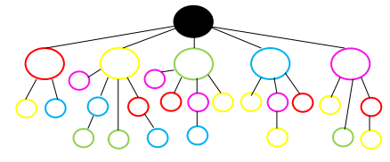

Figure 2. FP: Acne Skin Tree

- Brightening is needed for dull skin.
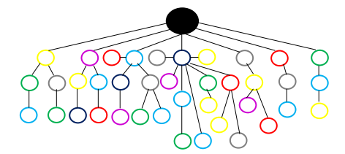
Table 2. List of Skin Care Procedures for Dull and Brightening Skin
NO. | TREATMENT | AMOUNT
1 | Skinbooster Mochi Skin | 9
2 | Dermapen Derma Glow | 6
3 | Peeling Eropa Premium (Mencerahkan) | 10
4 | Facial Brightening | 5
5 | Peeling Brightening | 10
6 | Facial Korean Glow | 6
7 | Skinbooster Glass Skin | 6

Figure 3. FP – Tree with Dull Bark Requires Brightening

- Sensitivity and Intuition
Table 3. Treatment of Sensitivity and Aggression
NO. | TREATMENT | AMOUNT
1 | Facial Hydra | 14
2 | Skinbooster DNA Salmon | 9
3 | Facial Detox | 13
4 | Moisturizer | 6

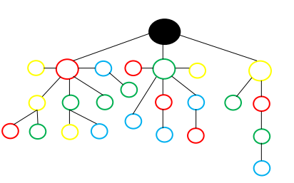

Figure 4. FP – Tree of Sensitive Skin and Requires Hydration

- Dry skin
Table 4. List of Dry Skin Treatments

NO. | TREATMENT | AMOUNT
1 | Moisturizer | 13
2 | Sunscreen | 10
3 | Facial Diamond Dermabration | 12
4 | Facial Hydra | 8

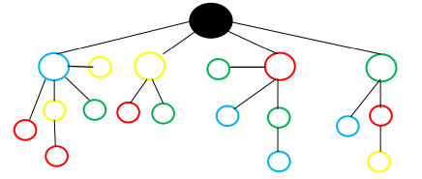

Figure 5. FP – Tree Grown from Dry Bark

- Typical Skin Care and Routine Maintenance
Table 5. List of Normal Skin Treatments & Routine Care
NO. | TREATMENT | AMOUNT
1 | Facial | 10
2 | Moisturizer | 12
3 | Peeling Ringan | 14
4 | Sunscreen | 12
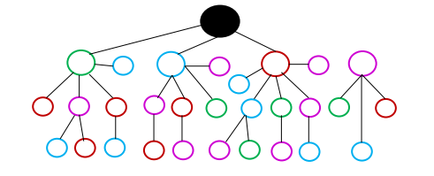

Figure 6. Tree of Normal Height and Rutin Permit

FP – Growth
The FP-Growth algorithm is employed to extract frequent itemsets without the need to investigate all item combinations, as in Apriori, once the FP-Tree has been established. By traversing the FP-Tree and establishing a conditional pattern base to identify frequently occurring patterns, FP-Growth operates more efficiently.
The process of integrating this algorithm into RapidMiner commences with the importation of transaction data in XLS format, which includes the skin varieties and treatments of customers. The user then applies the FP-Growth operator and establishes a minimum support value, such as 0.2, to guarantee that only patterns that appear in at least 20% of transactions are processed. The Create Association Rules operator is subsequently employed to generate association rules, with a confidence parameter of 0.8 to guarantee the reliability of the generated rules.
The analysis yields frequently selected treatment combinations and association rules between items. These discoveries have the potential to inform the development of treatment recommendations that are customised to the skin types of clients and to facilitate data-driven business decisions in beauty clinics.
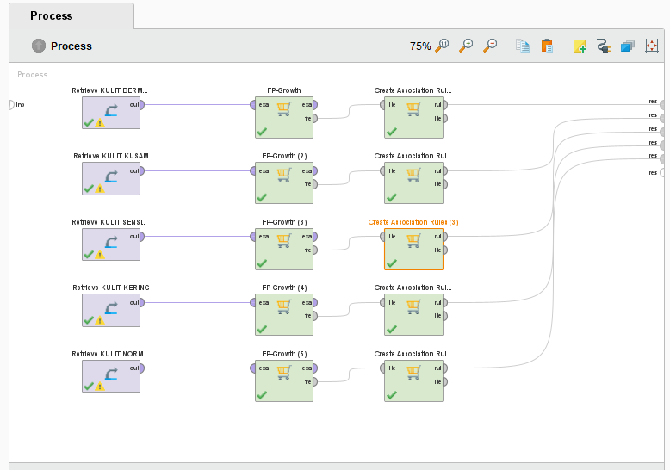

Figure 7. Data Connection Process Utilizing FP Growth
- Skin Prone to Acne
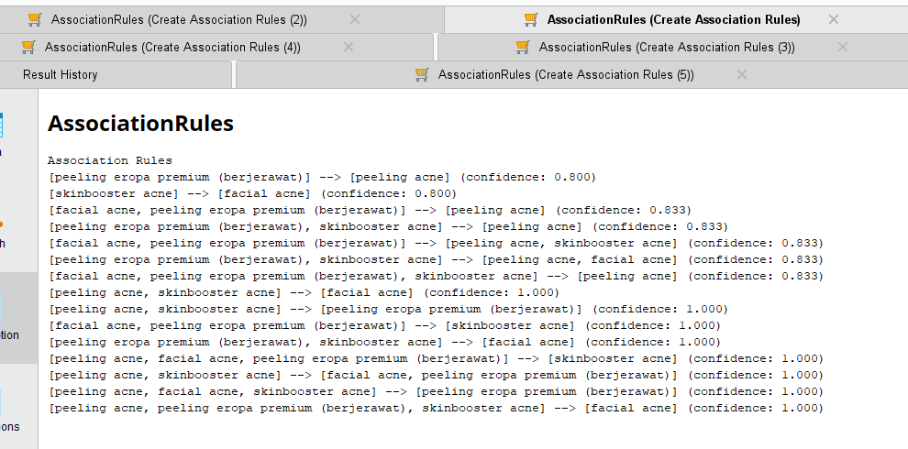

Figure 8. Rules that have been generated
A pattern of relationships between the types of skin care products for acne-prone skin types that customers at the Christa Aesthetic Clinic most frequently select between November 2024 and January 2025 can be found based on the results of the association rules obtained using the FP-Growth algorithm. These association principles explain how different skin care procedures performed by clients with varying degrees of confidence relate to one another.

- Brightening is needed for dull skin.
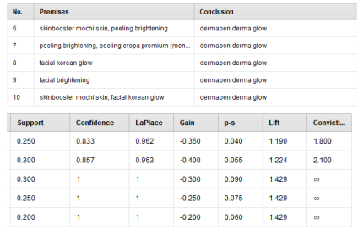

Figure 9. Frequent Item Set Results

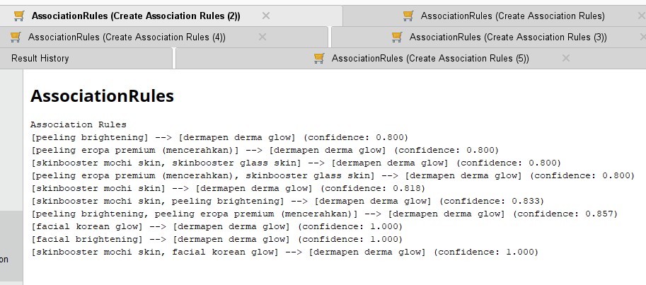

Figure 10. Generated Rules
The association rule results for dull skin indicated a robust correlation between various remedies that are designed to hydrate and brighten the skin.

- Sensitivity and Intuiti
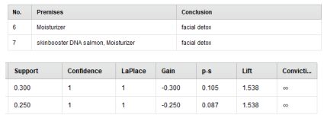

Figure 11. Frequent Item Set Results
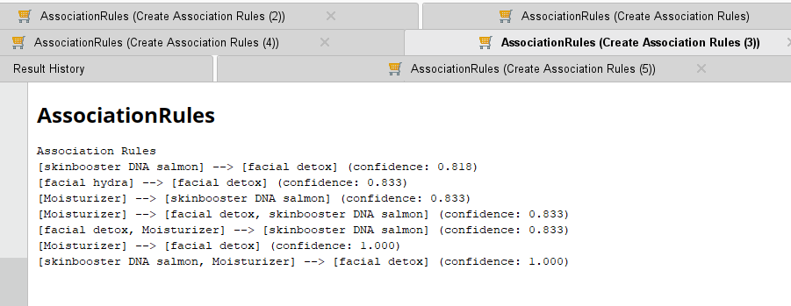

Figure 12. Generated Rules
A pattern of associations was identified between several treatments that are frequently selected by consumers with sensitive skin, as indicated by the results of the FP-Growth analysis. This section provides a comprehensive explanation of each association rule that was identified.

- Dry skin
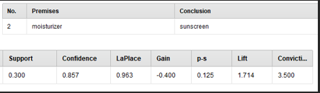

Figure 13. Frequent Item Set Results

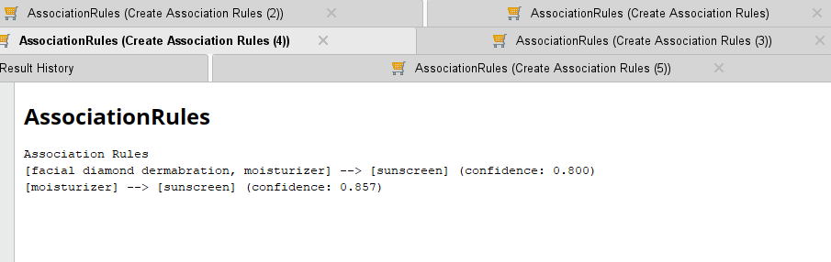

Figure 14. Rules that have been generated

Berdasarkan hasil analisis FP-Growth, ditemukan pola keterkaitan antara beberapa perawatan yang sering dipilih oleh pelanggan dengan kulit kering. Berikut adalah penjelasan dari setiap aturan asosiasi yang ditemukan.
- Typical Skin Care and Routine Maintenance
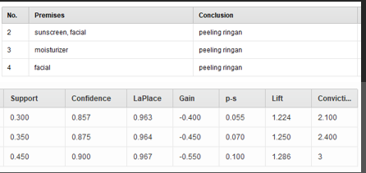

Figure 15. Results of the Most Common Item Set

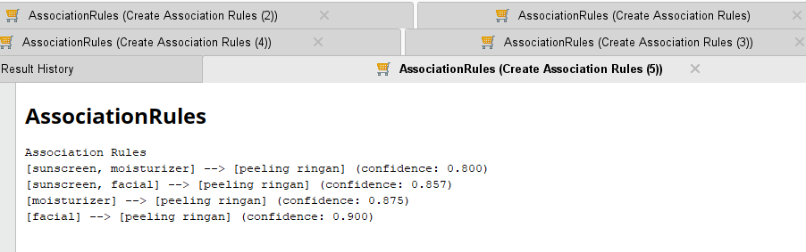
Gambar 4.16 Rules yang Dihasilkan

Figure 16. Rules that have been generated

Conclusion
According to the findings of the association study conducted with the FP-Growth algorithm, each type of skin has a propensity to select a particular set of therapies. Acne-control-based treatments are in high demand since customers with acne-prone skin are more likely to combine acne peels, acne skin boosters, and acne facials. In contrast, clients with dull skin frequently select skin-brightening facials, dermapen derma shine, and brightening peels, suggesting a strong desire for skin-brightening procedures. The use of moisturizers, face detoxes, and salmon DNA skin boosters for sensitive skin is on the rise, suggesting that consumers are more interested in skin-soothing and skin-hydrating treatments. Sunscreen and moisturizer work best together for dry skin, highlighting how crucial skin protection and hydration are.
Customers who have average skin, on the other hand, like a mild peel following facials, moisturizer, and sunscreen, suggesting a higher emphasis on skincare upkeep. Beauty clinics can reinforce data-driven marketing strategies and improve customer happiness by creating more customized treatment packages, such the "Acne Treatment Package," "Brightening Glow Package," or "Hydration Care Package," by comprehending this pattern.

Reference
[1] Rahmawati, N. W. (2021). Kepercayaan Konsumen Dengan Kepuasan Konsumen Klinik Kecantikan. 9(3), 472–481. https://doi.org/10.30872/psikoborneo
[2] F. Kurnia, S. Monalisa, and I. Fahmi, “Penerapan Algoritma Fp-Growth dalam Menentukan Pola Kecelakaan Lalu Lintas,” Semin.Nas. dan Expo Tek.Elektro 2019,pp.90-96.2017,[online].Available:http://snete.unsyiah.ac.id/2019/wp content/uploads/2019/12/Naskah-16-Irwanto.pdf."
[3] R. Nurul Arifin, “Implementasi Algoritma Frequent Pattern Growth (FP-GROWTH) Menentukan Asosiasi Antar Produk (Study KAsus Nadia Mart),” Dok. Karya Ilm., pp. 0–1, 2015 R. Rachman, “Penentuan Pola Penjualan Media Edukasi dengan Menggunakan Metode Algoritme Apriori dan FP-Growth,” Paradig. - J. Komput. Dan Inform., vol. 23, no. 1, 2021, doi: 10.31294/p.v23i1.9884.
[4] Hamzah, Amir, Dkk. 2020.” Metode Penelitian Kuantitatif Kajian Teoritik & Praktik”. Literasi Nusantara ISBN978-623-6508-29-9 hal : viii + 194
[5] Riadi,M.(2022).‘Sistem Pendukung Keputusan (SPK)’. Available at: https://www.kajianpustaka.com/2022/02/sistem-pendukung keputusanspk.html
[6] Rahmat Fauzi, Dkk. 2023. Implementasi Data Mining Pada Penjualan Pakaian Dengan Algoritma Fp-Growth Jurikom (Jurnal Riset Komputer), Vol. 10 No.2. DOI 10.30865/jurikom.v10i2.5795 Hal 436- 445
[7] Abdullah, Asrul. 2018. “Rekomendasi Paket Produk Guna Meningkatkan Penjualan Dengan Metode FP Growth.” Khazanah Informatika: Jurnal Ilmu Komputer Dan Informatika 4(1):21. doi: 10.23917/khif.v4i1.5794.
[8] Lestari, Yuyun Dwi. 2015. “Penerapan Data Mining Menggunakan Algoritma FP Tree Dan FP Growth Pada Data Transaksi Penjualan Obat Yuyun Dwi Lestari Program Studi Teknik Informatika , Sekolah Tinggi Teknik Harapan Seminar Nasional Teknologi Informasi Dan Komunikasi ( SNASTIKOM 2015 ).” Seminar Nasional Teknologi Informasi Dan Komunikasi (SNASTIKOM 2015) ISBN 976-602-19837-9-9 (Snastikom):60–65.
[9] Jeperson Hutahaean., dkk. Sistem Pendukung Keputusan Yayasan Kita Menulis, 2023 xii; 68 hlm; 16 x 23 cm ISBN: 978-623-342-827-9
[10] Tahir, Muhlis, Dkk. 2021.” Penerapan Algoritma Fp-Growth Dalam Menentukan Kecenderungan Mahasiswa mengambil mata kuliah Pilihan” . Jurnal Ilmiah Nero Vol 6 No.1

