Variables Entered/Removed^{b}
Model | Variables Entered | Variables Removed | Method
1 | X3, X2, X1ª | . | Enter
a. All requested variables entered.
b. Dependent Variable: Y

Model Summary^{b}
Model | R | R Square | Adjusted R Square | Std. Error of the Estimate
1 | .833ª | .694 | .691 | 1.98432
a. Predictors: (Constant), X3, X2, X1
b. Dependent Variable: Y

ANOVA^{b}
Model |  | Sum of Squares | df | Mean Square | F | Sig.
1 | Regression | 2642.635 | 3 | 880.878 | 223.713 | .000ª
1 | Residual | 1165.512 | 296 | 3.938
1 | Total | 3808.147 | 299
a. Predictors: (Constant), X3, X2, X1
b. Dependent Variable: Y

Coefficientsª
Model |  | Unstandardized Coefficients |  | Standardized Coefficients | t | Sig.
 |  | B | Std. Error | Beta | t | Sig.
1 | (Constant) | -.985 | .511 |  | -1.928 | .055
1 | X1 | .177 | .044 | .246 | 4.022 | .000
1 | X2 | .207 | .045 | .279 | 4.629 | .000
1 | X3 | .234 | .031 | .383 | 7.573 | .000
a. Dependent Variable: Y

Residuals Statisticsª
 | Minimum | Maximum | Mean | Std. Deviation | N
Predicted Value | 5.5422 | 17.2908 | 11.8867 | 2.97292 | 300
Std. Predicted Value | -2.134 | 1.818 | .000 | 1.000 | 300
Standard Error of Predicted Value | .117 | .482 | .220 | .062 | 300
Adjusted Predicted Value | 5.5081 | 17.2440 | 11.8870 | 2.97368 | 300
Residual | -5.99807 | 7.15991 | .00000 | 1.97434 | 300
Std. Residual | -3.023 | 3.608 | .000 | .995 | 300
Stud. Residual | -3.051 | 3.661 | .000 | 1.002 | 300
Deleted Residual | -6.11002 | 7.37207 | -.00030 | 2.00179 | 300
Stud. Deleted Residual | -3.095 | 3.741 | .000 | 1.006 | 300
Mahal. Distance | .048 | 16.622 | 2.990 | 2.427 | 300
Cook's Distance | .000 | .099 | .003 | .008 | 300
Centered Leverage Value | .000 | .056 | .010 | .008 | 300
a. Dependent Variable: Y

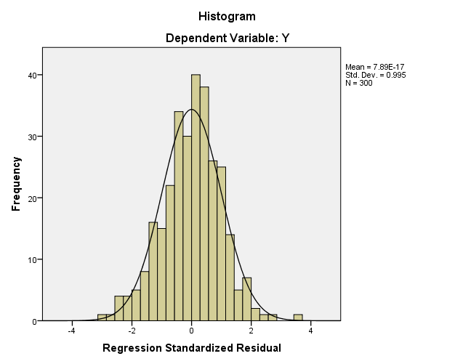

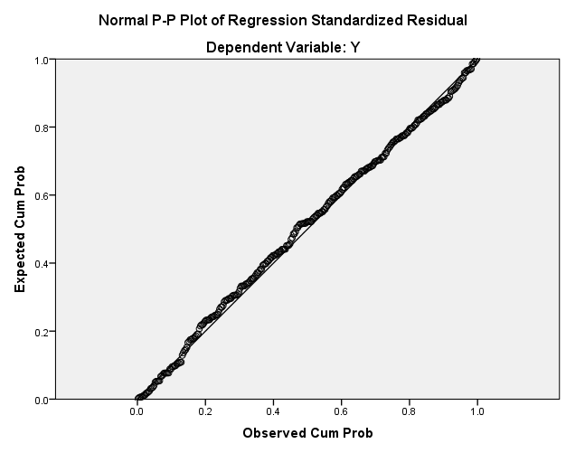

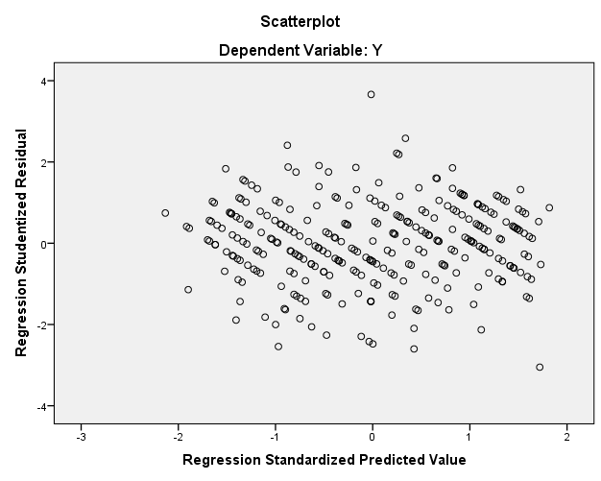

Hasil Validitas Variabel

No | Pertanyaan | Keterangan
1 | X1
 | 1 | Valid
 | 2 | Valid
 | 3 | Valid
 | 4 | Valid
 | 5 | Valid
 | 6 | Valid
2 | X2
 | 7 | Tidak Valid
 | 8 | Valid
 | 9 | Tidak Valid
 | 10 | Valid
 | 11 | Valid
 | 12 | Valid
 | 13 | Valid
 | 14 | Valid
3 | X3
 | 15 | Valid
 | 16 | Tidak Valid
 | 17 | Valid
 | 18 | Valid
 | 19 | Valid
 | 20 | Tidak Valid
 | 21 | Valid
 | 22 | Valid
 | 23 | Valid
 | 24 | Valid
4 | Y
 | 25 | Valid
 | 26 | Valid
 | 27 | Valid
 | 28 | Valid

