THE INFLUENCE OF DIGITAL MARKETING AND ELECTRONIC WORD OF MOUTH ON PURCHASING DECISIONS AT
POJOK KESAWAN CAFE
^
Nindya Yunita, S.Pd, M.Si¹ , Jully Angreani Tanjung²
¹Lecturer of the Management, Universitas Medan Area, Medan, Indonesia
²Student of the Management, Universitas Medan Area, Medan, Indonesia
¹ nindyayunita@staff.uma.ac.id ² jullyangreani821@gmail.com

Abstract— Examining the impact of electronic word-of-mouth and digital marketing on purchasing decisions at Pojok Kesawan Cafe is the goal of this study. This study employs a quantitative, descriptive research design, and it is assessed using the SPSS 27 software and a multiple linear regression-based methodology. questionnaires for gathering data. Customers who visited Pojok Kesawan Cafe between September and November 2024 made up the study's population, and there were 92 respondents in the research sample. Purposive sampling was employed in the sample collection procedure. Instrument testing, multiple linear regression testing, classical assumption testing, and hypothesis testing were all employed in the data analysis process. Based on the results of the study, it shows that (1) Digital Marketing and (2) Electronic Word of Mouth, simultaneously have a positive and significant effect on Purchasing Decisions at Pojok Kesawan Cafe.
Keywords: Digital Marketing, Electronic Word of Mouth, and Purchasing Decisions

1. INTRODUCTION
In the current era of globalization, especially in Indonesia, business actors continue to spread their wings to build and develop their businesses. One of the businesses that is currently developing in Indonesia is the cafe business. The cafe business is currently experiencing rapid growth due to the many innovations [1]. Therefore, it is important to study dynamic consumer behavior, including the purchasing decision process [2].
According to Kotler and Armstrong in research [3] Purchasing Decision is a stage in the buyer's decision-making process where consumers actually buy. Buyers make decisions to buy a product using their money based on their desires and needs, which ultimately encourages them to consider purchasing decisions [4]. The decision to buy a product is often influenced by various factors that interact complexly in the minds of consumers, one of which is Digital Marketing [5]. Apart from Digital Marketing, what influences purchasing decisions is Electronic Word Of Mouth [6].
Electronic Word Of Mouth is a form of positive or negative statement about a product or service that consumers share with other consumers through online platforms, by having information online consumers can easily know about the business, consumers can get a clearer perspective [7]. Electronic Word of Mouth given by customers greatly influences the reputation of a business and can influence purchasing decisions in various businesses, one of which is Pojok Kesawan Cafe [7].
Pojok Kesawan Cafe is one of the culinary destinations that is currently developing in the city of Medan, Indonesia. Located in a strategic area, this cafe offers a comfortable atmosphere and a diverse menu, including various local and international dishes.
Table 1. Income Data of Pojok Kesawan Cafe
Month | Income(Rp)
January 2024 | 1.000.000
February 2024 | 1.500.000
March 2024 | 4.000.000
April 2024 | 7.000.000
May 2024 | 5.000.000
June 2024 | 4.000.000
July 2024 | 7.000.000
source : Pojok Kesawan Kafe
Purchasing Decisions at Pojok Kesawan Cafe can be seen from the table obtained from the cafe owner. It can be seen from January-July 2024, Pojok Kesawan Cafe experienced fluctuations, which can affect purchasing decisions. Pojok Kesawan Cafe has a lot of potential to attract customers, but the number of visitors shopping at the cafe is still fluctuating. There are times when the number of sales increases significantly, and there are times when the number of sales decreases significantly. This shows that purchasing decisions are uncertain and may be influenced by other factors such as digital marketing.
The digital marketing carried out by Pojok Kesawan Cafe is by promoting through their Instagram and Facebook pages Pojok Kesawan Cafe has not promoted its social media accounts to the fullest. Pojok Kesawan Cafe has used Instagram and Facebook as the main platforms to run digital promotions in the hope of encouraging customer purchasing decisions. However, this strategy faces several challenges that result in less than optimal results. Pojok Kesawan Cafe has not routinely posted promotional content on Instagram and Facebook. This causes posts and followers not to increase and may indicate that advertising content may be less interesting, less relevant, or may not be able to attract viewers effectively. In addition to digital marketing, there are other factors that influence purchasing decisions, namely Electronic Word Of Mouth [8].
Electronic Word of Mouth carried out by Pojok Kesawan Cafe can be seen from the ratings and reviews given by consumers on Google. Like many other businesses, Pojok Kesawan Cafe relies on customer reviews on Google to build its reputation and attract new customers. However, negative reviews that are not handled properly and the low number of recent positive reviews indicate that the current review management strategy is ineffective. This problem has the potential to reduce the cafe's reputation and influence the purchasing decisions of potential customers.
From the problems of digital marketing and electronic word of mouth at Pojok Kesawan Cafe, it seems that it has not optimized its marketing strategy and increased customer appeal and loyalty. This study will provide useful insights for cafes in designing more effective marketing campaigns and maintaining a competitive position in the Medan culinary market, one of which is at Pojok Kesawan Cafe.
Based on the explanation of the background above, which has encouraged me to be interested in conducting research on "The Influence of Digital Marketing and Electronic Word Of Mouth on Purchasing Decisions at Pojok Kesawan Cafe".

2. LITERATURE REVIEW
2.1 Buying Decision
A decision chosen by someone is one of the consumer behaviors, including purchasing decisions [9]. Every consumer often takes certain steps when deciding whether or not to make a purchase. These actions are referred to as behavior, which is a term that describes the actual physical acts that consumers take [10]. The decision to choose something that is in great demand has two components, namely the purpose of the purchase and the purchase decision, it can be said that all people have more or less the same decision-making method, interaction of choice activities where at least two choices are made to arrive at each important point of view [11]. Purchasing decisions include the process by which consumers identify a problem, seek information about a particular product or brand, evaluate the extent to which each choice solves the problem, and reach a purchasing decision [12]. Purchasing decisions are problem-solving activities carried out by individuals by choosing the appropriate action from two or more choices of actions, and in making a purchase by first going through the decision-making stage which is considered the most appropriate procedure [13]. According to [14] the indicators used to measure purchasing decisions are as follows: Problem Recognition: The stage where consumers identify the appropriate brand to meet their needs, Information Search: Information about a brand in various media helps consumers find the benefits of the brand, Alternative Evaluation: This brand is the most suitable compared to other alternative brands, Purchase decision: Consumer confidence when making decisions about something, Post-purchase behavior: Consumers have a positive perception after using the product from the purchased brand.
2.2 Digital Marketing
Digital marketing, according to Prasetyo, Fahimatul, and Mustaqim, is the process of using information technology and the internet to enhance and broaden conventional marketing functions [15]. Businesses utilize digital marketing extensively because it allows customers to follow the trend of digitalization [16]. Since the advent of smartphones and the rise in internet usage, digital marketing has expanded quickly. Digital marketing is the term for the use of digital technology to market products and services that are interactive, measurable, and targeted. Its primary objective is to promote brands, influence consumer preferences, and boost sales traffic through a variety of digital marketing strategies. Online marketing, often known as internet marketing, is another term for digital marketing. It is nearly the same as marketing in general, but the instruments employed are different [17]. The implementation of digital marketing as a business strategy has several benefits, including making it easier for consumers to receive the latest information (updates), In fact, consumers search for information about products and services via the Internet and it may be easier for them to do so, In addition, digital marketing makes information more accessible to consumers and gives consumers enough time to learn about products and services and provides access to 24/7 stores that never close [18]. The indicators of digital marketing according to Yazer Nasdini [19] : Accessibility (Accessibility) Users' access to services and information that offer online advertising. In general, accessibility describes how people use social media platforms, Interactivity (Interactivity) The degree of two-way communication that describes the capacity of customers and advertisers to converse in both directions and react to feedback, Entertainment (Entertainment) This is the capacity of advertising to entertain and delight customers. In general, there are a lot of commercials that simultaneously offer amusement and information, Credibility (Trust) The level of consumer trust in online advertising, or the extent to which advertising provides reliable, impartial, competent, trustworthy, and specific information about consumers, Irritation (Disruption) This includes online advertising fraud and advertising manipulation that results in a bad consumer experience, Informativeness (Informative) The nature of advertising is to provide information to consumers. For advertising to help consumers financially, it must also present an accurate image of the product.
2.3 Electronic Word of Mouth
Consumer experiences and opinions when using a product shared online are electronic word of mouth [20]. Electronic word-of-mouth is a term used to describe a form of communication that has replaced face-to-face or physical communication. Electronic word-of-mouth plays a part in encouraging customers to provide information [21]. A remark made about a company by current, potential, or past customers is known as electronic word of mouth, and individuals and organizations can access this information online [22]. This is a new idea in the field of communication, especially in the field of marketing communication, which has so far allowed each individual to share information based on their personal experiences, both positive and negative [23]. Electronic word of mouth refers to recommendations regarding experiences and services from people who have visited a place, this is where electronic word of mouth has a very strong influence, influencing the interest of potential consumers and leading to their decision to visit [24]. Electronic Word of Mouth includes the exchange of knowledge among a wide audience of consumers of a business, this is directly related to customer loyalty, which ultimately affects the value of a business [25]. According to Goyette et al. [26] Electronic word of mouth indicators are Intensity: The number of opinions written by consumers on social networking sites. The indicators include the frequency of access to social networks, the frequency of interaction with users, the number of reviews written, Positive Valence: Positive consumer opinions about a product, service, or brand, Negative Valance: Negative consumer opinions about a product, service, or brand, Content: information content from social networking sites related to your product or service.

- METHODOLOGY
This study employs a quantitative methodology and falls under the causal or associative category, which seeks to ascertain how independent variables affect dependent variables. The sample taken was 92 respondents using the slovin formula. The research trial was conducted to ensure that the statements in the questionnaire were valid and reliable. A total of 1 statement was removed because it was invalid. Meanwhile, all statements were declared reliable. The data analysis technique used was multiple linear regression analysis which functions to find the effect between dimensions of brand equity on customer loyalty. Data processing with classical assumption tests then t-tests to prove the previously formulated hypotheses.

- RESULT AND DISCUSSION
4.1 Classical Assumption Test
4.1.1 Normality Test

a. histogram approach

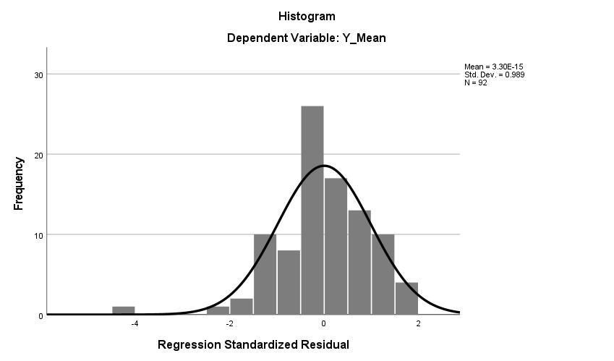

Figure 1. Histogram Normality Test
The data distribution, which takes the shape of a bell curve and is very symmetrical, shows that the variables are normally distributed, as can be seen from Figure 1.

b. p-plot approach
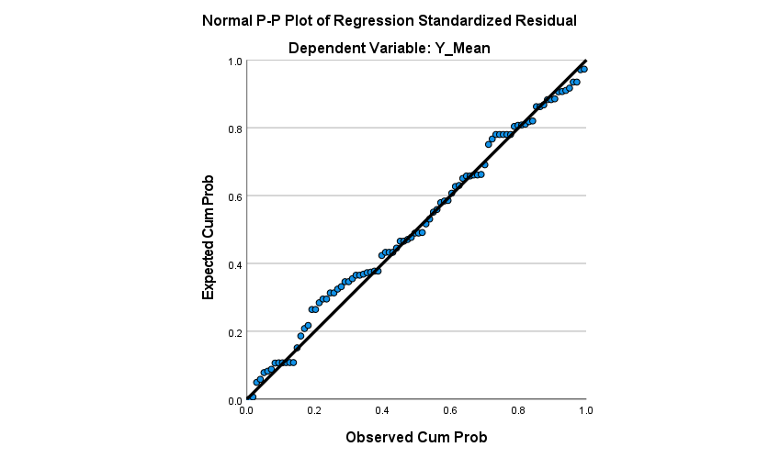
Figure 2. Normality Test Plot
It may be inferred from Figure 2 that the data has a normal distribution since the points approach and follow the diagonal line. Additionally, the Kolmogorov-Smirnov test is performed to further confirm that the data is regularly distributed along the diagonal line.
c. Kolmogorov-Smirnov approach
Table 2 Kolmogorov–Smirnov test
One-Sample Kolmogorov-Smirnov Test
 |  | Unstandardized Residual
N |  | 92
Normal Parameters^{a,b} | Mean | .0000000
Normal Parameters^{a,b} | Std. Deviation | .23635734
Most Extreme Differences | Absolute | .077
Most Extreme Differences | Positive | .041
Most Extreme Differences | Negative | -.077
Test Statistic |  | .077
Asymp. Sig. (2-tailed)^{c} |  | .200^{d}
a. Test distribution is Normal.
b. Calculated from data.
c. Lilliefors Significance Correction.
Table 2 above indicates that the data is regularly distributed because the significance value is 0.200, which is higher than 0.05.

4.1.2 Multikolinearitas Test
Table 3 Test Tolerance and VIF values
Coefficientsª
Model |  | Collinearity Statistics
 |  | Tolerance | VIF
1 | (Constant)
1 | X1_Mean | .295 | 3.387
1 | X2_Mean | .295 | 3.387
a. Dependent Variable: Y_Mean
As can be observed from Table 3, there is no multicollinearity issue because the tolerance value of the two independent variables is 0.295, or larger than 0.1. The two independent variables' VIF values are then displayed in the table. They are 3.387, which is less than 10 and further suggests that there is no multicollinearity issue. Thus, it can be said that there is no multicollinearity issue with the regression model used in this investigation.

4.1.2 Heteroskedasitas Test
Figure 3 Scatterplot Heteroscedasticity
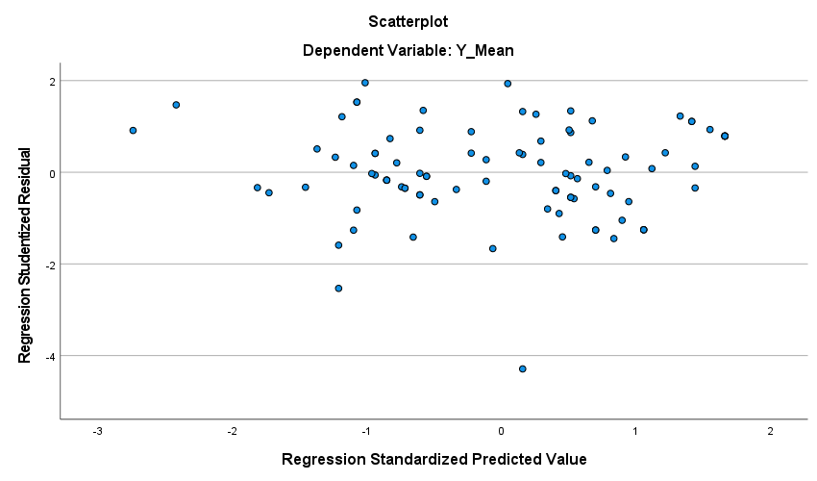

Since the graph in Figure 3 shows no discernible pattern and the points are widely spaced, it can be said that there is no heteroscedasticity issue with the data.

4.2 Multiple Linear Regression Test
Table 4 Multiple Linear Regression Results

Coefficientsa
Model |  | Unstandardized Coefficients |  | Standardized Coefficients | t | Sig.
 |  | B | Std. Error | Beta | t | Sig.
1 | (Constant) | .941 | .275 |  | 3.426 | .001
1 | X1_Mean | .502 | .113 | .526 | 4.428 | .000
1 | X2_Mean | .273 | .108 | .299 | 2.520 | .014
a. Dependent Variable: Y_Mean
According to Table 4, the value of β_1 for the Digital Marketing variable is 0.502, the value of β_2 for the Electronic Word of Mouth variable is 0.273, and the value of β_0 is 0.941 in the second column (Unstandardized Coefficients) section B. As a result, the multiple linear regression equation is as follows:
Y=0.941+ 0.502 X_1+ 0.273 X_2

4.3 Hipotesis Test
4.3.1 Simultaneous Test (F Test)
Table 5 Simultaneous Significant F Test Results (F Test)
ANOVAª
Model |  | Sum of Squares | Df | Mean Square | F | Sig.
1 | Regression | 8.647 | 2 | 4.324 | 75.693 | .000^{b}
1 | Residual | 5.084 | 89 | .057
1 | Total | 13.731 | 91
a. Dependent Variable: Y_Mean
b. Predictors: (Constant), X2_Mean, X1_Mean
With a significance level of 0.000, the F count value, as determined by ANOVA Table 5, is 75.693. At a 95% confidence level (α = 0.05), however, the F table is 3.10. Therefore, F_Count > F_table (75.693 > 3.10) or significance (Sig.) < 5% (0.000 < 0.05) indicates that the variables Electronic Word of Mouth and Digital Marketing have a significant and positive impact on purchasing decisions, meaning that rejected information is accepted.

4.3.2 Partial Test (t-Test)
Table 6 Partial Significance Test (t-Test)
Coefficientsª
Model |  | Unstandardized Coefficients |  | Standardized Coefficients | t | Sig.
 |  | B | Std. Error | Beta | t | Sig.
1 | (Constant) | .941 | .275 |  | 3.426 | .001
1 | X1_Mean | .502 | .113 | .526 | 4.428 | .000
1 | X2_Mean | .273 | .108 | .299 | 2.520 | .014
a. Dependent Variable: Y_Mean
- The value of the Digital Marketing variable is 4.428 and the T_table is 1.987 so that < (4.428> 1.987) and the significance value (sig.) (0.000 < 0.05) so that it can be concluded that Digital Marketing does not have a positive and significant effect on Purchasing Decisions (The first hypothesis is accepted)
- The value of the Electronic Word of Mouth variable is 2.520 and the T_table is 1.987 so that < (2.520> 1.987) and the significance value (sig.) (0.014 < 0.05) so that it can be concluded that Electronic Word of Mouth has a positive and significant effect on Purchasing Decisions (The second hypothesis is accepted.

4.4 Determinant Coefficient Test
Table 7 Results of Determinant Coefficient Testing
Model Summary^{b}
Model | R | R Square | Adjusted R Square | Std. Error of the Estimate
1 | .794ª | .630 | .621 | .23900
a. Predictors: (Constant), X2_Mean, X1_Mean
b. Dependent Variable: Y_Mean

Table 7 shows that the Adjusted R Square value of 0.621 indicates that electronic word of mouth and digital marketing account for 62.1% of purchasing decisions. However, 37.9% can be accounted for by additional characteristics that this study did not look at.

4.5 Discussion
4.5.1 The Influence of Digital Marketing on Purchasing Decisions
According to the findings of the t-test data analysis, revisit intention is positively and significantly impacted by the Digital Marketing variable. based on the t-count (4.428) being higher than the t-table (1.987) and the significant value (0.000) <0.05. This demonstrates that digital marketing influences more purchasing decisions and that this influence is substantial, making the digital marketing variable at Pojok Kesawan Kafe a favorable one.
Based on the respondents' responses, the majority of Pojok Kesawan Kafe's digital marketing indicators received the Strongly Agree (SS) category, indicating an effective strategy. The indicator with the highest average value is X1.11 (Attractiveness of digital content) of 4.62, which is the main strength. In addition, indicators X1.6 (Ease of finding product information) and X1.10 (Digital platform efficiency) with a value of 4.52 are also highly appreciated by consumers. consumer satisfaction.
However, several aspects such as memorable promotional messages (X1.3), consumer connectedness with the brand (X1.9), and the suitability of promotions to consumer expectations (X1.12) require more attention. Improvements can be made by creating more creative and memorable promotional messages, increasing personal interaction through social media, and adjusting promotions based on survey results or consumer preferences.
Pojok Kesawan needs to improve the quality of digital content, such as creating more attractive visuals and increasing interactive promotions to increase engagement. In addition, the delivery of information must be more detailed and consistent to strengthen customer trust. By optimizing this strategy, digital marketing can be more effective in driving consumer purchasing decisions.
These findings are consistent with those of Cahyani's (2022) and Anggraini and Eko's (2019) analysis of the impact of digital marketing on purchasing decisions, which revealed a positive and substantial relationship between the two variables.

4.5.2. The Influence of Electronic Word of Mouth on Purchasing Decisions

Purchasing decisions are positively and significantly impacted by the findings of the t-test data analysis of the Electronic Word of Mouth variable. based on the fact that the t-count (2,250) is higher than the t-table (1,987) and the significant value (0.014 < 0.05). This demonstrates that electronic word-of-mouth influences more purchasing decisions and that this influence is substantial, making the electronic word-of-mouth variable at Pojok Kesawan Cafe a good one.
Based on the respondents' responses, the majority of electronic word of mouth indicators for Pojok Kesawan Cafe are categorized as Strongly Agree (SS), the indicator with the highest average value is X2.2 is 4.50 indicating that e-Wom is considered very credible. In addition, the indicator with the lowest average is X2.4 is 3.98 (Agree) indicating that there are some consumers who are less sure. Improvements can be made by clarifying the benefits of the product through reviews and testimonials.
Pojok Kesawan needs to increase the number of positive and credible reviews with strategies such as holding loyalty programs or incentives for customers who provide testimonials. In addition, improvements can be focused on enriching review content, such as utilizing visuals, videos, or in-depth descriptions to increase customer trust that is not yet fully convinced.
This result is in line with the results of the analysis of the Electronic Word of Mouth variable on Purchasing Decisions conducted by Rahmadhani & Endang, (2018) and Maulana et al., (2021) which found that there was a positive and significant influence between these two variables.

4.5.3. The Influence of Digital Marketing and Electronic Word of Mouth on Purchasing Decisions

The f-test indicates that the factors of electronic word-of-mouth and digital marketing significantly and favorably influence purchasing decisions. The F-count result of 75,693 at a significance level of 0.000 explains this. At a 95% confidence level (α = 0.05), however, the F table is 3.10. Thus, the variables Digital Marketing and Electronic Word of Mouth together have a Positive and Significant effect on purchasing decisions at Pojok Kesawan Cafe, as demonstrated by both calculations, where F-count> F-table and the level of significance (0.000) <0.05. As a result, the variables are regarded as good. Based on the respondents' responses, the majority of digital marketing and e-WOM indicators at Pojok Kesawan are good, with several aspects reaching the "Strongly Agree" (SS) category. However, several indicators such as Y.1, Y.2, and Y.3 are still in the "Agree" (S) category, so they need improvement. The recommended improvement strategy is to increase the creativity of digital content to attract more attention, utilize user-generated content to strengthen e-WOM, and maximize the use of digital platforms such as social media and communities.

- CONCLUSION
The following conclusions can be made in light of the findings and analysis of the study on the impact of electronic word-of-mouth and digital marketing on purchasing decisions at Pojok Kesawan Cafe:
- At Pojok Kesawan Cafe, digital marketing significantly and favorably influences customer purchasing decisions. Digital marketing tactics on platforms like Facebook and Instagram are crucial for boosting customer interest and attractiveness.
- Purchase decisions are also positively and significantly impacted by electronic word-of-mouth. Online customer reviews, comments, and recommendations have been shown to influence consumer decisions in choosing Pojok Kesawan Cafe.
- Electronic word-of-mouth and digital marketing both significantly improve customer purchasing decisions at the same time. This strategic collaboration strengthens customer appeal and loyalty.

REFERENCES

[1] A. Fatmawaty and A. Halim, “The Influence Of Digital Marketing, Price, Consumer Perception, Store Atmosphere And Word Of Mouth On Purchasing Decisions At Cafe Halona Coffee Rantauprapat Pengaruh Digital Marketing, Harga, Persepsi Konsumen, Store Atmosphere Dan Word Of Mouth Terhadap,” Manag. Stud. Entrep. J., vol. 5, no. 2, pp. 3661–3673, 2024, [Online]. Available: http://journal.yrpipku.com/index.php/msej
[2] N. I. B. Tri Lestari, Eni Karsiningsih, “the Influence of Cafe Atmosphere and Lifestyle on Generation Z ’ S,” J. Ekon. Pertan. dan Agribisnis, vol. 7, pp. 505–517, 2023.
[3] I. Maulana and K. Aprianti, “Pengaruh Promosi Melalui Media Sosial Instagram Terhadap Keputusan Pembelian Di Cafe Fix La Luna Kota Bima,” J. Ekon. Dan Kewirausahaan, vol. 21, no. 3, pp. 249–255, 2022, doi: 10.33061/jeku.v21i3.6899.
[4] S. Saota, P. Buulolo, and S. H. Fau, “Pengaruh lokasi terhadap keputusan pembelian konsumen di UD. TRIAL VELA kecamatan fanayama kabupaten nias selatan,” J. Ilm. Mhs. Nias Selatan, vol. 4, no. 2, pp. 135–142, 2021.
[5] W. Ardani, “Pengaruh Digital Marketing Terhadap Perilaku Konsumen,” J. Tadbir Perad., vol. 2, no. 1, pp. 40–47, 2022, doi: 10.55182/jtp.v2i1.102.
[6] R. Putri and B. Munas, “PENGARUH DIGITAL MARKETING DAN WORD OF MOUTHTERHADAP KEPUTUSAN PEMBELIAN KONSUMEN DENGANBRAND IMAGE SEBAGAI VARIABEL MEDIASI (Studi Pada Konsumen Wingko Babat Pak Moel di Kota Semarang),” Diponegoro J. Manag., vol. 12, no. 1, pp. 1–15, 2023, [Online]. Available: https://ejournal3.undip.ac.id/index.php/djom/index
[7] Khusnul Fikriyah & Elsa Rizki Yulindasari, “Pengaruh e-WoM (Electronic Word of Mouth) terhadap Keputusan Pembelian Kosmetik Halal di Shopee,” vol. 3, no. 1, pp. 55–69, 2022.
[8] N. Viani, “Volume 1 Nomor 4 Tahun 2023 BISMA Business and Management Journal Pengaruh Digital Marketing, Electronic Word of Mouth dan Lifestyle terhadap Keputusan Pembelian pada Tiktok Shop Indonesia,” vol. 1, 2023.
[9] A. R. Anggraini and M. Hadi, “Pengaruh Electronic Word of Mouth Dan Brand Terpadu Bandung,” J. Apl. Bisnis, vol. Vol 9 No 1, pp. 179–185, 2023.
[10] M. D. Ruhamak and A. N. Rahmadi, “Pengaruh E-WOM, Brand Image dan Brand Trust Terhadap Keputusan Konsumen (Studi Kasus Pada Lembaga Kursus Fajar English Course Pare-Kediri),” BISNIS J. Bisnis dan Manaj. Islam, vol. 7, no. 2, p. 233, 2019, doi: 10.21043/bisnis.v7i2.6160.
[11] W. Mustika, “PENGARUH PEMASARAN DIGITAL TERHADAP MINAT BELI HANDUK PADA MARKETPLACE ‘ X ,’” pp. 709–716.
[12] Z. Warni, “PENGARUH KUALITAS PRODUK DAN CITRA MEREK TERHADAP KEPUTUSAN PEMBELIAN KONSUMEN PADA RUMAH MAKAN SRI MELAYU DI KOTA PALEMBANG,” vol. 11, no. 1, pp. 1–14, 2019, [Online]. Available: http://scioteca.caf.com/bitstream/handle/123456789/1091/RED2017-Eng-8ene.pdf?sequence=12&isAllowed=y%0Ahttp://dx.doi.org/10.1016/j.regsciurbeco.2008.06.005%0Ahttps://www.researchgate.net/publication/305320484_SISTEM_PEMBETUNGAN_TERPUSAT_STRATEGI_MELESTARI
[13] P. Sopiyan, “Pengaruh Digital Marketing dan Kualitas Pelayanan Terhadap Keputusan Pembelian,” Coopetition J. Ilm. Manaj., vol. 13, no. 2, pp. 249–258, 2022, doi: 10.32670/coopetition.v13i2.1057.
[14] P. dan K. L. K. Kotler, Marketing Management, vol. 37, no. 1. 2020. doi: 10.2307/1250781.
[15] P. D. Saputro, F. Ulya, and Mustaqim, “Pengenalan Google My Business untuk Pemanfaatan Digital Marketing pada Pengenalan Google My Business untuk Pemanfaatan Digital Marketing …,” J. Pengabdi. Balerang, vol. 2, no. 1, pp. 20–24, 2020, doi: 10.33884/jpb.v2i01.1625.CITATIONS.
[16] Wiranata I, Agung A, and Prayoga I, “Pengaruh Digital Marketing, Quality Product dan Brand Image terhadap Keputusan Pembelian Roti di Holland Bakery Batubulan,” J. EMAS, vol. 2, no. 3, pp. 133–146, 2021, [Online]. Available: https://e-journal.unmas.ac.id/index.php/emas/article/view/1827%0Ahttps://e-journal.unmas.ac.id/index.php/emas/article/download/1827/1480
[17] D. I. Wati, Martha, Digital Marketing. Edulitera (Anggota IKAPI – No. 211/JTI/2019), 2020.
[18] R. N. Syavira, “Pengaruh Digital Marketing , Electronic Word of Mouth , Dan Fitur Marketplace Terhadap Keputusan,” vol. 8, no. 2, pp. 1–11, 2024.
[19] M. Iqbal, “Efektifitas Digital Marketing Terhadap Kualitas Layanan pada Usaha di Masa Pandemi Covid 19 ( Studi Kasus di Aceh ),” vol. 7, no. 2, pp. 83–93, 2021.
[20] R. Rahmadhani and A. E. Prihatini, “Pengaruh Electronic Word Of Mouth Dan Perceived Risk Terhadap Keputusan Pembelian Pada Konsumen Tokopedia,” J. Adm. Bisnis, vol. 8, no. 1, pp. 23–30, 2019, doi: 10.14710/jab.v8i1.23766.
[21] W. Sosanuy, S. Siripipatthanakul, W. Nurittamont, and B. Phayaphrom, “SSRN-id3944079,” vol. 1, no. 10, pp. 1–16, 2021.
[22] N. P. N. A. Ni Made Dwi Apriastuti, “Pengaruh Brand Awareness Dan Electronic Word of Mouth (Ewom)Terhadap Keputusan Pembelian Di Situs Belanja Online Shopee Di Kota Denpasar,” vol. 3, 2022.
[23] R. S. Noviana and Khuzaini, “Pengaruh Brand image, E-WOM dan Kualitas Pelayanan Terhadap Keputusan Pembelian,” J. Ilmu dan Ris. Manaj., vol. 11, no. 12, pp. 1–15, 2022.
[24] I. Khotimah and R. Sulistyowati, “Pengaruh Electronic Word of Mouth (Ewom) Di Media Sosial Terhadap Minat Dan Keputusan Berkunjung Di Surabaya (Studi Pada Wisatawan Yang Pernah Mengunjungi Wisata Sejarah Surabaya),” J. Pendidik. Tata Niaga, vol. 10, no. 2, pp. 1679–1688, 2022, doi: 10.26740/jptn.v10n2.p1679-1688.
[25] M. Kuant and R. Erdiansyah, “Pengaruh Electronic Word of Mouth (E-WoM) dan Brand Trust terhadap Keputusan Pembelian Konsumen Modelano,” Kiwari, vol. 1, no. 3, pp. 526–535, 2022, doi: 10.24912/ki.v1i3.15843.
[26] A. Sulistiono, B. Wahyu Fitriadi, and D. Muhamad Pauzy, “Pengaruh Lokasi Dan Promosi Terhadap Keputusan Pembelian,” JISMA J. Ilmu Sos. Manajemen, dan Akunt., vol. 1, no. 3, pp. 363–368, 2022, doi: 10.59004/jisma.v1i3.63.

^Received: Reviewed: Accepted:

