MODERATION OF PESANTREN TEGALSARI, PONOROGO
Ahmad Choirul Rofiq
Institut Agama Islam Negeri of Ponorogo

Abstract
Pesantren Tegalsari (1700s-1964) contributed significantly to spreading Islam in Indonesia, especially in Ponorogo Regency, East Java. This study examined how Pesantren Tegalsari carried out religious, socio-cultural, and political moderation. This research used the historical method and theory of moderation. This research was conducted at the Pesantren Tegalsari in August 2023 by collecting data from observation at Tegalsari, in-depth interviews with the descendants of Kyai Ageng Muhammad Besari, and relevant references, such as Sejarah Kyai Ageng Mohammad Besari written by KH Moh. Poernomo, Babad Ponorogo written by Purwowijoyo, and other previous works on Pesantren Tegalsari. The analysis of moderation of Tegalsari Pesantren showed that Pesantren Tegalsari not only provided an example of implementing moderation in religious and socio-cultural aspects that prioritize tolerant behavior but also chose to be neutral in political conflict disputes on Java Island for the sustainability of education in Pesantren Tegalsari.
Keywords: Islamic Boarding School; Pesantren Tegalsari; Moderation; Wasathiyah.

INTRODUCTION
Islam entered Indonesia in the first century of the Hijri calendar (or the 7th century AD) directly from Arabia. The propagation of Islam was carried out peacefully (Hasymi, 1993). The arrival of Islam through peaceful trade was in line with the statement of Thomas Walker Arnold (Arnold, 1913). News from China told that since 674 AD, there had been Muslim settlements in the west of Sumatra Island (Abdullah, 1991) because of the strategic position of the Strait of Malacca (Saifullah, 2010). This confirmed the Mecca theory that Islam came directly from Arabia (Suryanegara, 2009). The spreading of Islam in Indonesia then accelerated between the 12th and 16th centuries, especially after some of these Muslim traders intermarried with local noble families (Azra, 1994). However, there was information from the books Izhhar al-Haqq and Tadzkirat Thabaqat Jam’u Salathin that the first Islamic kingdom was the Kingdom of Perlak, which was established in the 9th century AD (Hasymi, 1993). Islamization in Indonesia through several channels, i.e., trade, marriage, Sufism, art, and education (Poesponegoro, 1992). There was also a process of Islamization through the delivery of military aid, as happened in the Islamization of the Banjar Kingdom by the Kingdom of Demak (Daliman, 2012).
Because the spread of Islam was generally pursued through peaceful means, the majority of Indonesian Muslims were moderate. One of the main differences of Indonesian Muslims was their consistency of the wasathiyah Islamic paradigm (Azra, 2016). Pesantren Tegalsari was an Islamic Boarding School implementing religious moderation in spreading Islam in Ponorogo, East Java. Pesantren Tegalsari emerged as a pioneer of efforts to systematize pesantren institutions. Pesantren Tegalsari began a whole day learning process with various books. There was a learning classification between beginner students and advanced students. Beginner students were taught about the reading and writing of intermediate Arabic. Advanced students were taught to read and explain religious classical books in Arabic or “the yellow books” (Nurdianto et al., 2018).
Several studies examined Pesantren Tegalsari. Some writers analyzed the figures of Kyai Ageng Muhammad Besari (founder of Pesantren Tegalsari) and Kyai Ageng Hasan Besari (leader who brought the glory of Pesantren Tegalsari to its peak). Alfiana Yuniar Rahmawati (2021) wrote “Kontribusi Kiai Ageng Muhammad Besari dalam Akulturasi dakwah Islam di Ponorogo, Jawa Timur”, Muhammad Sam’ani (2017) wrote “Kiai Khasan Besari: Biografi dan Peranannya bagi Pondok Pesantren Gebang Tinatar Tegalsari, Ponorogo (1797-1867 M)”, and Muhammad Hasyim (2019) wrote “Ketokohan Syekh Hasan Besari dalam Bidang Keagamaan, Kebudayaan, dan Kebangsaan). Some authors highlighted the development of Pesantren Tegalsari from its inception until its decline. Ali Makhrus (2020) wrote “Pendidikan Islam dan Nilai Kejawen: Kiai Ageng Muhammad Besari dan Pesantren Tegalsari Ponorogo (1743-1773)”, and Mohammad Alwi Shiddiq (2022) wrote “Sejarah Pondok Pesantren Tegalsari Ponorogo Pasca Kiai Hasan Besari Tahun 1862-1964 M". Some other authors analyzed Pesantren Tegalsari related to its cultural products and manuscripts founded in Pesantren Tegalsari, as well as the works of Pesantren Tegalsari and its successful students. Amiq Ahyad (2015) wrote “Islamic Manuscript Culture in the Pondok Pesantren of East Java in the Nineteenth and Twentieth Centuries”, Dawam Multazam (2018) wrote “Akar dan Buah Tegalsari: Dinamika Santri dan Keturunan Kiai Pesantren Tegalsari Ponorogo”, and Arik Dwijayanto (2018) wrote “Ponorogo, the Little Java: Potret Kebudayaan dan Keberagamaan Masyarakat Muslim Ponorogo Abad XX”.
In order to complement scientific studies related to Pesantren Tegalsari, this study examined how Pesantren Tegalsari carried out moderation in religious, socio-cultural, and political aspects. Besides, the current era of globalization and digital has brought societal changes, resulting in weak mutual respect between community groups and religious people. Indonesia is a plural country of many tribes, religions, and races. This plurality certainly has positive and negative impacts. Its positive impacts can increase the formation of a new culture on the structure of society by managing the plurality of the Indonesian state. Conversely, pluralism also has negative impacts that can seriously threaten state sovereignty, such as conflicts based on racial and religious elements (Kemenag, 2019). Therefore, it is beneficial for the Muslim generation to analyze the history of moderation implemented in the Pesantren Tegalsari with its contribution to the spread of Islam in Indonesia.

RESEARCH METHOD
This research used the historical method (Gottschalk, 1985). It is a systematic set of rules and principles for effectively collecting historical sources, assessing them critically, and proposing a synthesis of the results achieved in written reports (Garraghan, 1948). This research was conducted at the Pesantren Tegalsari in August 2023 by collecting data from observation at Tegalsari, in-depth interview with Setyo Wardani (one of the descendants of Kyai Ageng Muhammad Besari who lives in front of Dalem Ageng), and critically reading references relevant to the topic of discussion, such as books Sejarah Kyai Ageng Mohammad Besari written by KH Poernomo, Babad Ponorogo written by Purwowijoyo, and other works that have studied Pesantren Tegalsari. Then, criticism of sources and interpretations of data obtained until historiography is carried out to present historical explanations analytically through a theory of Islamic moderation (Ali Muhtarom & Sahlul Fuad, 2020).

RESULT AND DISCUSSION
a. History of Pesantren Tegalsari at a Glance
Bathoro Katong came to his sovereignty of Ponorogo in 1496 AD. The year is based on carved stone located at the meditation place between gate II and gate III in the tomb of Bathoro Katong. The picture shown by Candra Sengkala was dated 1418 Saka. After this number was added with 78 years, it would be 1496 AD (Purwowijoyo, 1985). The picture that stated the year 1418 Saka was in the pictures of man (number 1), tree (number 4), eagle (number 1), and elephant (number 8). Then, the Regional Government of Ponorogo determined that the anniversary of Ponorogo was on Sunday Pon, the first of Besar month, 1418 Saka, which coincided with 11 August 1496 AD or 1 Dzulhijjah 901 AH (Toebari, 1996).
Islamic da’wah grew in Ponorogo after many pesantren students came from Demak Bintoro Sultanate to Ponorogo. Among the preachers was Pangeran Sumendhe Ragil, son of Sunan Bayat (the Second Duke of Semarang, who resigned and preached in the area now Klaten Regency in Central Java Province). Pangeran Sumendhe Ragil followed in his father's footsteps and became a cleric to spread Islam in Ponorogo. After his death, he was buried in his pioneer land, Setono (currently one of the hamlets in Tegalsari Village), about 10 km south of the city and located near the Keyang River, Jetis District (Shiddiq, 2022). Sunan Bayat lived during the reign of Raden Fattah and Sunan Kalijaga, the same time as Bathoro Katong's lifetime. Thus, it can be estimated that Pangeran Sumendhe Ragil was a young man who lived during Bathoro Katong's reign and belonged to the group of pesantren students from Demak or Bagelen who spread Islam in Ponorogo.
Respect from the government of Ponorogo was given to Setono Village as a fief village with the provision that the descendants of Pangeran Sumendhe Ragil would take care of his tomb. Among his descendants was Raden Donopoero or Kyai Donopuro, who became a teacher for Kyai Ageng Muhammad Besari (founder of Pesantren Tegalsari). In detail, it was known that his genealogy was Kyai Donopuro bin Singonojo bin Kyai Raden Nojo bin Raden Wongso bin Pangeran Sumendhe Ragil bin Sunan Bayat. Kyai Donopuro, as the Head of Setono Perdikan Village, continued to take care of his ancestral grave with his pesantren students until the early 18th century when the three sons of Kyai Anom Besari (i.e., Khatib Anom, Muhammad Besari, and Nur Shadiq) went to study in Setono (Poernomo, 1961).
The couple of Kyai and Nyai Anom Besari had a genealogy that was quite prominent among Javanese people because there was a hereditary relationship with Sunan Ampel (one of the Walisongo) and Prabu Brawijaya V (King of Majapahit). Prabu Brawijaya V had a son named Raden Fattah (Sultan of Demak Bintoro); then had a son named Sultan Trenggono; then had a son named Panembahan Prawoto; then had a son named Panembahan Wirasmoro; then had a son named Pangeran Demang I or Raden Jalu (Duke of Kediri); then had a son named Pangeran Demang II or Raden Irawan; later had a son named Kyai Abdul Mursyad; then had a son named Kyai Anom Besari. Raden Rahmat (Sunan Ampel) had a son named Sayyid Qosim Syarifuddin (Sunan Drajat); then had a son named Pangeran Trenggana (Duke of Surabaya); then had a son named Raden Panji Wirya Krama (Duke of Surabaya); then had a son named Raden Panji Jayalengkara (Duke of Surabaya); then had a son named Pangeran Pekik Jenggolo (Duke of Surabaya); then had a son named Prince Pengampon; then had a son named Raden Satmoto (Kyai Ngarobi); and later had a son named Nyai Anom Besari (Poernomo, 1961).
The arrival of three students from Caruban (Madiun) to study at Kyai Donopuro, Setono occurred in 1700. Then, they meditated in Bedali Cave (east of Ponorogo City) for three years. The three years of asceticism were for his blessings, family, and future students (santri). As ascetic provisions for three years, they only brought three ontong (cobs) of corn. Muhammad Besari then married the daughter of Kyai Nur Salim. Although Kyai Nur Salim was not quite famous compared to Kyai Donopuro in his time, Kyai Nur Salim also had noble blood on him. In the EAP061.3.105 script (2021), it was said that he was a descendant of Ki Ageng Mentawis or Ki Ageng Pemanahan. This Kyai was also a descendant of Prabu Brawijaya V, the same as Kyai Anom Besari Caruban, Muhammad Besari's father. After getting married, Kyai Donopuro ordered his proud student to open his land east of Setono. The land opened by Muhammad Besari was originally a garden owned by Kyai Donopuro, so later this land was named Tegalsari (Poernomo, 1961).
Between Pesantren Setono and the land opened by Muhammad Besari, it was separated by the Keyang River. Pesantren Setono was located west of the river, while Tegalsari was east of the river. In Tegalsari, and with the blessing of Kyai Donopuro, Muhammad Besari also established a pesantren. Along with the decline of Pesantren Setono due to the condition of Kyai Donopuro (who was getting older and eventually died), Setono students were ordered to move to Pesantren Tegalsari. Not only the Setono students who were brought to Tegalsari, the fief status previously owned by Kyai Donopuro also dropped to Kyai Ageng Muhammad Besari. Kyai Ageng Muhammad Besari inherited the position of leader of the fief village. The move of religious center and government activities from Setono to Tegalsari was natural because it moved its pulung (a kind of revelation or blessing), so Setono became subordinate to Tegalsari since the time of Kyai Ageng Muhammad Besari. Some sources explicitly mentioned that Muhammad Besari's arrival in Setono occurred in 1700 (Poernomo, 1961). Using the benchmark year of Muhammad Besari's arrival to Setono in 1700, Pesantren Tegalsari was established before 1742 (Rohmatulloh, 2018)
Kyai Ageng Muhammad Besari with Nyai Ageng Mantup had nine descendants, namely Nyai Ageng Abdurrahman Tegalsari, Kyai Ageng Jakub, Kyai Ismangil, Nyai Buchori, Kyai Ageng Muhammad Ishaq, Kyai Kholifah, Kyai Muhammad Ilyas (father of Kyai Ageng Hasan Besari), Nyai Banjarsari, and KH. Zaenal Abidin who became Sultan in Selangor, Malaysia (Poernomo, 1961). Kyai Ilyas cared for the pesantren for 11 years (1747-1758 AD). His leadership was mainly used for the construction of the mosque. Unfortunately, he did not prepare the next generation to continue the Pesantren Tegalsari. It was during Kyai Ilyas' leadership that the tradition of sending prospective royal poets (pujangga) to study at Pesantren Tegalsari. Sastranegara was one of the poets, and after being appointed court poet, he changed his name to Yasadipura II (Nurdianto et al., 2018).
Kyai Hasan Yahya succeeded his father and ruled for 40 years (1758-1797 AD). However, there has been no significant development in Kyai Hasan Yahya's 40 years of leadership. Kyai Hasan Yahya received a letter of removal from Pakubuwana IV, who considered that Kyai Hasan Yahya was only busy enriching himself with his students' agricultural activities to cut rice and plant soybeans. Pakubuwana IV removed him because the caretaker of the Tegalsari also doubled as a Lurah (head of the village) in the Tegalsari fief land, which was administratively included in the territory of the Surakarta Palace. Then Kyai Ageng Hasan Besari became the caretaker of Pesantren Tegalsari, replacing his brother, Kyai Hasan Yahya. Kyai Ageng Hasan Besari became the caretaker of Pesantren Tegalsari in the fourth period of Pesantren Tegalsari (1797-1862 AD). Kyai Ageng Hasan Besari succeeded in bringing Pesantren Tegalsari to its golden age. It is said that the number of Tegalsari students reached 16.000 people (Daryono, 2018).
On 9 January 1862, Kyai Ageng Hasan Besari died. He was buried in the family cemetery near his grandfather, Kyai Ageng Muhammad Besari, in the Tegalsari cemetery. About 3.000 people attended the funeral procession (Shiddiq, 2022). Kyai Ageng Hasan Besari's leadership was the peak of Pesantren Tegalsari's glory (Ahyad, 2015). However, the development of Pesantren Tegalsari after Kyai Ageng Hasan Besari (from the period of Kyai Hasan Anom in 1862 to Kyai Algreani in 1964 AD) regressed. This condition was influenced by internal factors from the Pesantren Tegalsari and external factors outside the Pesantren Tegalsari. Kyai leadership was a position that determined all aspects of Pesantren Tegalsari so that it tended to cultivate absolute authority. This situation happened in the Pesantren Tegalsari, where after being left behind by Kyai Ageng Hasan Besari (who was very charismatic) and the subsequent leadership (who was less capable), as well as descendants who entered the political realm, the existence of Pesantren Tegalsari was finally abandoned. Besides, there was a national law after the Indonesian independence, i.e., the law of the Republic of Indonesia, number 13 of 1946, concerning the abolition of fief villages, which was implemented in Tegalsari Village in 1964, so that the position of the Kyai no longer served as Lurah (Shiddiq, 2022).
The decline in the enthusiasm of students and relatives of Kyai at Pesantren Tegalsari was caused by several causes. First, the disorderly management of pesantren was due to the appointment of two different caretakers to manage and lead the fief village. In 1930, the pesantren split into Pondok Lor (Northern Boarding School) and Pondok Kidul (Southern Boarding School), so there was a conflict. This division triggered competition in the Pesantren Tegalsari. Second, the differences in the Kyai Ageng Hasan Besari's descendants. Kyai's wife, who had a Pesantren background, and her children were actively studying religion and continuing her father's charity at the Pesantren Tegalsari or other Islamic boarding schools. From noble wives such as Raden Ayu Murtosiyah were born many descendants who were more active in the government. So when the Dutch East Indies colonial government implemented ethical politics and established European-style schools, many Dutch schools were attended by descendants of Kyai. Third, other pesantren increased in densely populated areas. At the beginning of the 20th century, among the Islamic boarding schools in East Java were Pesantren Siwalan Panji in Surabaya, Pesantren Sidogiri in Pasuruan, Pesantren Sukorejo in Situbondo, and Pesantren Tebuireng in Jombang, which attracted students from all regions (Rohmatulloh, 2018).
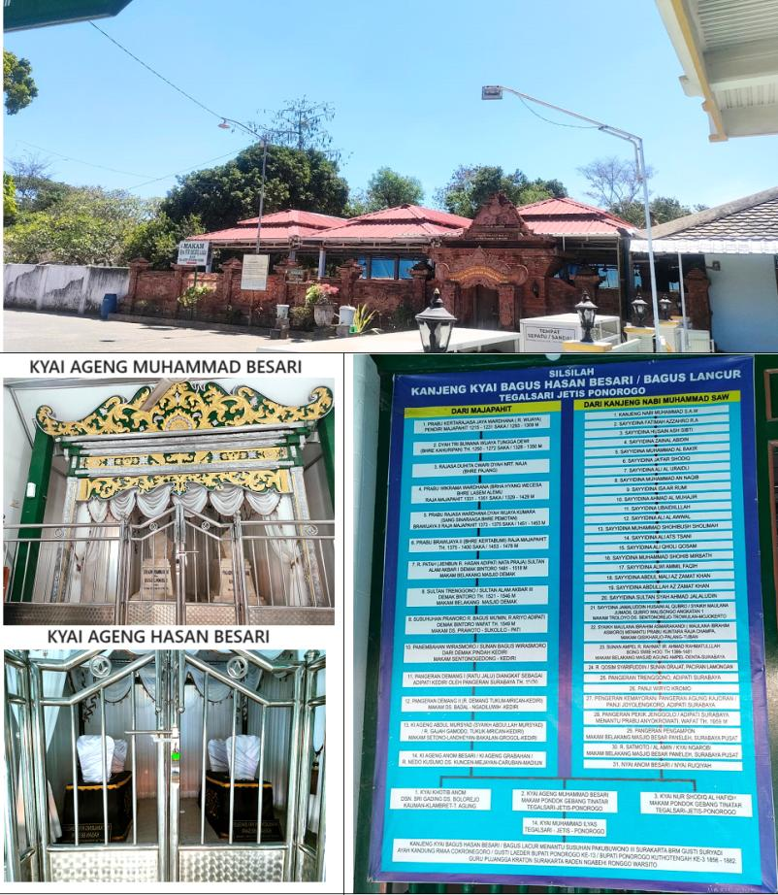
Figure 1: Tomb of Kyai Ageng Muhammad Besari and Kyai Ageng Hasan Besari
b. Religious moderation
As an Islamic educational institution, Pesantren Tegalsari had a special mission to spread Islam in Ponorogo. This institution continued the Islamic da’wah of Bathoro Katong. Before the spread of Islam in Ponorogo, there were Hinduism and Buddhism in Ponorogo, which were embraced by the residents of the Wengker Kingdom of Ponorogo and submitted to the Majapahit Kingdom. In addition, during the reign of the Islamic Mataram Kingdom, the religious characteristics of the people in Mataraman were syncretic, so that the religious pattern of the Ponorogo people was not much different from the syncretic tendency (known as Kejawen Islam or Javanese religion). In the 15th and 16th centuries, the inhabitants of Mataram had been influenced by Islamic religious values, but they did not give up their Javanese-Hindu-Buddhist practices. The propagators of Islam in Ponorogo during the existence of Pesantren Tegalsari could not be separated from the character of Kejawen. In carrying out various activities to spread Islam, Pesantren Tegalsari strived to harmonize Islamic and Javanese values.
The Islamic education of Pesantren Tegalsari was carried out in various ways, with a Sorogan system (students offered study materials to their teachers) and practicing Shatariyah Dhikr. The reading of the classical books was carried out in the Tegalsari mosque to learn religious knowledge. Pesantren taught Kanuragan (self-defense) training to maintain health and body strength. The students were ordered to practice asceticism, fasting, and reading Mantra or mystical oral prayers. One of the traditions owned by the Pesantren Tegalsari was asceticism carried out by the founder of Pesantren Tegalsari. The beginning of Pesantren Tegalsari could be traced from the arrival of Khotib Anom, Muhammad Besari, and Nur Shadiq to Pesantren Setono of Kyai Donopuro. The ascetic practice was intended to obtain a blessing from Allah for himself, his family, and his descendants. Then, all students of Pesantren Tegalsari were educated by doing Tirakat or restraining lust (Makhrus, 2020; Poernomo, 1961). The Mantra was a poetic saying used to pray to God or communicate with subtle spirits. Mantra of Hinduism beliefs were commonly performed using Javanese, and Mantra rooted in Islam were commonly spoken in Arabic. The Mantra taught by Kyai Ageng Hasan Besari was intended to be Dhikr. The place and time of chanting the Mantra were different for each student according to the orders of the Kyai. Mantra in Pesantren Tegalsari became a tradition to form a Muslim warrior soul. Pesantren Tegalsari encouraged its students to ask Allah for help. Some Dhikr used recitations of Basmalah and Syahadat (Makhrus, 2020).
c. Socio-cultural moderation
Local religious and cultural relations could coexist harmoniously in Ponorogo. Religion and culture are two things that interact and influence each other. The acceptance of Islam in traditional societies, especially Javanese society, acculturation between religion and local culture is quite good. The Reyog art existed before the arrival of Bathoro Katong in Ponorogo. The story of Reyog began when Kelana Sewandana and Kelana Wijaya in Bantarangin, Ponorogo, proposed marriage to the daughter of Kediri Kingdom in 1200. After Bathoro Katong came to power, the dominance of Islamic elements was highlighted. Then, Reyog art gained some additions to its equipment under the rule of Bathoro Katong. The modification was intended to make Islamic elements visible in the art (Achmadi, 2013; Rofiq, 2017; Soemarto, 2014).
Although Pesantren Tegalsari did not develop Reyog Ponorogo specifically, this pesantren had made distinctive Islamic culture, namely Unto-Untoan (using artificial camels), Islamic poetry (reading praise to God and Shalawatan to Muhammad). Setyo Wardani said that the religious and cultural traditions of Kyai Ageng Muhammad Besari are still preserved and implemented in Tegalsari (2023). The religious traditions of Pesantren Tegalsari are the following. First, Shalawat Shallalahu is recited every Maghrib prayer and led by the kyai of the mosque or the imam of prayer. Second, Shalawat Ujud-Ujudan is recited every Friday after Shubuh praying. Third, Shalawat Utawen is recited after the Tarawih prayer in Ramadhan. Fourth, Shalawat Maulud is held every month of Maulud. Fifth, Tahlil and Ambengan are carried out on every Islamic holiday, such as Muludan (Rabi’ul Awwal), the night of the month of Suro (Muharram), Isra' Mi’raj, and after Eid al-Fitr and Eid al-Adha prayers, and during the mosque thanksgiving (Selametan) for the activities that have been carried out. Sixth, the recitation of the classical Islamic books by the mosque's imam. Seventh, Mujahadah Nawafil Prayer by performing Hajat prayer, Tasbih prayer, Taubatan Nasuha prayer, Awwabin prayer every Friday night led by the mosque's imam. Eighth, I’tikaf and Tarawih prayers are performed every month of Ramadhan on odd nights of the last Ramadhan. Ninth, the art of Ronggo Besari or Unto-Untoan by reading Shalawat to Muhammad (Fauza, 2018; Nurdianto et al., 2019; Researcher, 2023; Tegalsari, 2020).

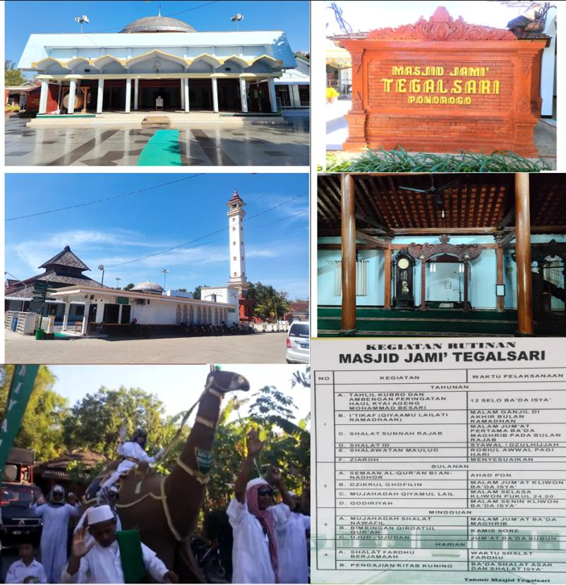
Figure 2: Masjid Jami’ Tegalsari

d. Political moderation
The first political conflict involving Pesantren Tegalsari was the Geger Pecinan in Kasunanan Kartasura in 1742. The conflict destroyed the Kartasura Palace and forced Pakubuwana II, King of Mataram, to flee the palace. Pesantren Tegalsari was chosen as his place of escape and seeking tranquillity with spiritual guidance from Kyai Ageng Muhammad Besari (Poernomo, 1961). The second conflict was the Third Javanese War of Succession (1746-1757). In the war that eventually led to the splitting of Javanese power into Kasunanan of Surakarta and Sultanate of Yogyakarta, Pesantren Tegalsari became one of the places visited by the palace elite in conflict to ask for political support. Pangeran Mangkubumi and Pangeran Singasari (opposition parties against Pakubuwana II) came to Kyai Ageng Muhammad Besari to ask for political support to separate from Kasunanan of Surakarta. There was no evidence that Kyai Ageng Muhammad Besari supported Pangeran Mangkubumi and Pangeran Singasari. However, the efforts of the two princes to seek political support of the Kyai showed how important the legitimacy given by Kyai Ageng Muhammad Besari (Nurdianto et al., 2018).
After the death of Kyai Ageng Muhammad Besari, the leadership of Pesantren Tegalsari was continued by his son, Kyai Muhammad Ilyas (1773-1800). During the leadership of Kyai Ilyas, there was not much that could be told from the Pesantren Tegalsari other than the beginning of the tradition of sending prospective poets to study there. The year 1800 began the skyrocketing prestige of Pesantren Tegalsari after the leadership of Kyai Ageng Hasan Besari (1800-1862). Pesantren Tegalsari transformed into the most famous religious educational institution throughout Java. The popularity of Pesantren Tegalsari made Kyai Ageng Hasan Besari the most sought-after figure to be asked for help or just for a fatwa because of his religious authority. Kyai was placed in an honorable position. At this point, Kyai acted his role as an activist of harmony in the social institutions of Javanese society (Nurdianto et al., 2018).
In the Java War (1825-1830), Kyai Ageng Hasan Besari was asked by Sasradilaga (on behalf of Pangeran Diponegoro) to fight too. This request was not denied, but it was also not entirely accepted. Kyai Ageng Hasan Besari supported resisting the domination of the Dutch colonial government not militarily but more morally. This strategy also freed Kyai Ageng Hasan Besari from Dutch accusations of involvement in the Java War. The resistance strategy of Kyai Ageng Hasan Besari was intended to maintain the existence of Pesantren Tegalsari and keep the economy of Tegalsari Village with its dluwang (paper) production. Kyai Ageng Hasan Besari's behavior to maintain the community's economy was a form of implementation of Kyai's function in the social institutions of Javanese society. Kyai is not only the leader of a religious educational institution (pesantren), but also a figure who must be able to protect his society (Nurdianto et al., 2018).
Between the 18th and 19th centuries, the land of Java was full of turmoil, both social and political. The first turmoil occurred when Geger Pecinan of Kartasura in 1742. This event began with the disappointment of the ethnic Chinese and Javanese communities towards the inconsistency of Pakubuwana II. He firstly supported ethnic Chinese resistance against the VOC but suddenly changed his decision by antagonizing ethnic Chinese and punishing the troops who had been sent to Semarang. Troops from both ethnicities then collaborated to vent their disappointment with Pakubuwana II by attacking the Kartasura Palace. The rebellion succeeded in seizing the Kartasura palace and forced Pakubuwana II to take refuge in the Pesantren Tegalsari, Ponorogo. Pakubuwana II's decision to flee to Pesantren Tegalsari was based on the consideration that the pesantren located in Ponorogo was considered not involved with the rebellion in Kartasura. The conflict in Kartasura was dominated by aristocrats who tried to overthrow the Pakubuwana II (Nurdianto et al., 2018; Poernomo, 1961).
Kyai Ageng Muhammad Besari spiritually helped Pakubuwana II to end the Kartasura conflict. Pakubuwana II then gave the status Tanah Perdikan (tax-free land) to Tegalsari Village. In addition, Kyai Ageng Muhammad Besari (under the charter dated 9 April 1746 from Sunan Pakubuwana II) was also a judge from the court who handled matters of family disputes, inheritance, marriage, and divorce, as well as decided all cases from the court. However, Pakubuwana II (w. 1749) left an internal conflict between Pangeran Mangkubumi, Raden Mas Said, and Pakubuwana II himself. Pangeran Mangkubumi and Raden Mas Said (who previously supported Geger Pecinan in 1742) still wanted to separate from Kasunanan of Surakarta. In this Third Javanese War of Succession (1749 to 1757), Pesantren Tegalsari did not interfere too much in this internal conflict, although Pangeran Mangkubumi came to Kyai Ageng Muhammad Besari in Tegalsari to ask for moral and spiritual support (Nurdianto et al., 2018).
Then, in 1825, there was a Java War, which Pangeran Diponegoro echoed as Sabil war (holy war) because the purpose of the war was to fight the infidels and fight for the restoration of the noble position of Islam in Java. Diponegoro aspired to restore a broader moral value system with a real movement rather than just preaching the teachings of Islam orally. One of the elements in society that was invited to join and significantly contributed to this holy war was the pesantren. In 1828, Sasradilaga, on behalf of Pangeran Diponegoro, came to Pesantren Tegalsari to ask for support from Kyai Ageng Hasan Besari. Kyai had to stand between two equally difficult choices, namely to fight for the establishment of Islam in Java at the risk of the destruction of the Pesantren Tegalsari if defeated or not to join the war at the risk of being accused of seeking a safe position. Kyai Ageng Hasan Besari did not want to engage in physical warfare but morally and ideologically fully supported Pangeran Diponegoro (Carey, 2007; Nurdianto et al., 2018). This choice was related to the moderation of political neutrality. Setyo Wardani confirmed that the character of Kyai Ageng Muhammad Besari's family always upholds peace and avoids violence (2023).

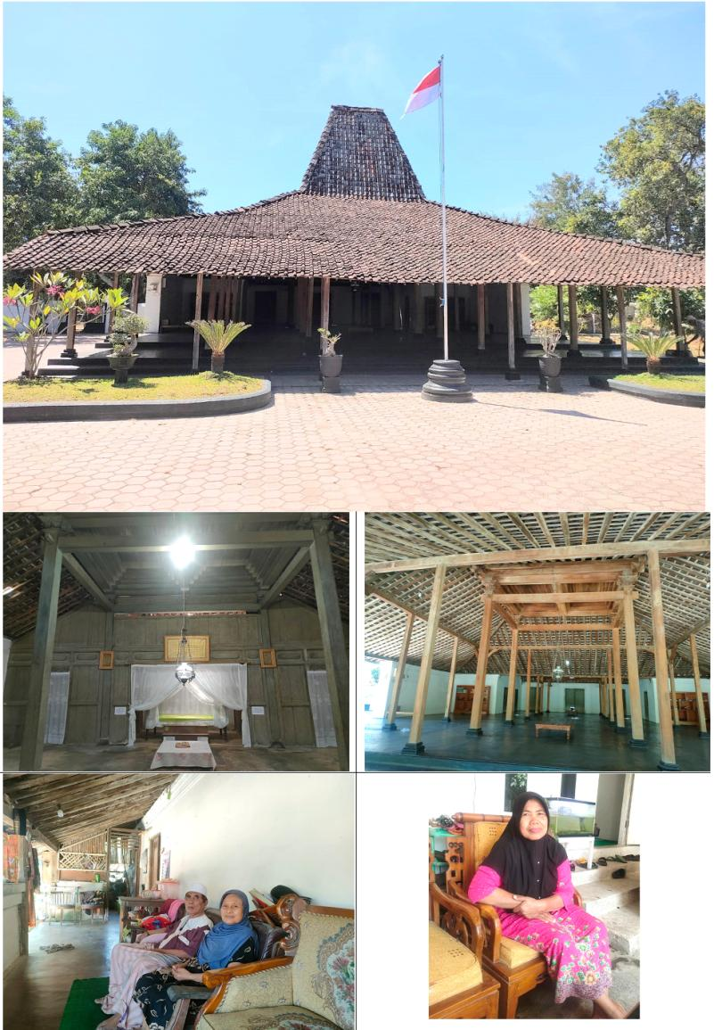
Figure 3: House and Descendants of Kyai Ageng Muhammad Besari in Tegalsari

Based on the research findings above, it can be stated that Pesantren Tegalsari has applied peaceful Islamic moderation. Religious moderation means balance in beliefs. Religious behavior based on balanced values consistently acknowledges and understands other individuals. This balanced understanding in the context of religious moderation is fully performed consistently by every religious adherent in holding the principles of their religious teachings while still acknowledging the existence of other persons. Religious moderation behavior shows tolerance, respect for any differences of opinion, respect for pluralism, and not imposing any will on behalf of religious beliefs by violence. Religious moderation makes someone neither on the left nor the right path extremely. The explanation of ummatan wasathan has the notion of a middle position in looking between God and the world, not denying God but also not following the polytheism of many gods. Wasathiyah, as a commitment in the middle attitude, will be able to be an example for all people to face diversity (Ali Muhtarom & Sahlul Fuad, 2020). Every Muslim must own the principle of Islamic wasathiyyah. Moderation in Islam cannot be described unless gathered in a fundamental element, i.e., honesty, openness, compassion, and flexibility. As a middle position, Islam loves the peace of life. Muslims must uphold the values of justice, freedom, and equal rights for equal welfare and mercy for all nature. Religious moderation's goal is to establish unity among human beings to obtain happiness and salvation both in the world and in the hereafter (Ashari, 2021).
Pesantren Tegalsari has followed the da’wah strategy of Walisongo (the Nine Saints of Islam) and Bathoro Katong, exemplified through cultural da’wah to spread Islam. Pesantren was an educational institution to spread Islam through educational and cultural channels. Walisongo were very successful perpetrators of Islam in the Nusantara (Indonesia) through a peaceful and moderate da’wah strategy. They propagated Islam using a cultural approach so that there was a cultural dialogue and tolerant social relations. During the growth of Islam in Java, Sunan Ampel or Raden Rahmat established a pesantren in Ampel Denta, Surabaya. Sunan Giri had a famous pesantren in Gresik. The Muslim Moluccans, especially Hitu, studied with Sunan Giri. Some of them became religious leaders and judges in Maluku. Kings, their families, and nobility usually brought clerics as teachers or religious advisors. Shaykh Yusuf was the religious advisor of Sultan Ageng Tirtayasa, Kyai Ageng Sela was Jaka Tingkir's teacher, and many more clerics became advisors or teachers to kings and noble children. At that time, Islamization was also done through branches of art, such as building arts, sculpture (carving), dance, music, and literature. The results of building art can be found in the Demak Mosque, the Sendang Duwur Agung Kasepuhan Mosque in Cirebon, the Great Mosque of Banten, the Baiturrahman Mosque in Aceh, and so on (Poesponegoro, 1992).
Along with the period of Walisongo's da’wah in the Nusantara, Ponorogo Regency was Islamized by Bathoro Katong (the founder and first regent of Ponorogo). After Bathoro Katong became Duke of Ponorogo in 1496, he earnestly paid attention to the development of Ponorogo and preached to spread Islam. Among the developments he carried out were the arrangement of the city of Ponorogo and the construction of mosques. As a means of da’wah, he still preserved Reyog, which previously existed during the Wengker Kingdom. He even modified the Reyog by adding a peacock with a string of jewels in its beak. In addition, he created a new art called Jemblung. Then, many immigrants from outside Ponorogo decided to settle in Ponorogo because Ponorogo was getting more advanced. The leaders of Ponorogo after Bathoro Katong continued the development exemplified by Bathoro Katong (Purwowijoyo, 1985; Soemarto, 2014).
Bathoro Katong carried out activities to spread Islam in Ponorogo with various methods of da’wah. He did this by building mosques, marrying Ki Ageng Suryangalam's daughter, Niken Gandini, and utilizing Reyog as a medium of da’wah. The Bathoro Katong policy aligned with the general method of spreading Islam in Indonesia, i.e., trade, marriage, Sufism, art, and education. In the perspective of da’wah, Bathoro Katong applied the Islamic da’wah method persuasively following the principles of da’wah activities guided by the Qur'an, al-Nahl: 125, namely the activity of spreading Islam by prioritizing wise steps (hikmah) and the delivery of religious advice (mau’izhah hasanah) so that Islam could be accepted by the people of Ponorogo voluntarily and without feeling any coercion. Then, the Islamization of Ponorogo was continued by Pesantren Tegalsari (Rofiq, 2017).
Pesantren Tegalsari applied moderation in political aspects by being neutral during political conflicts for the sustainability of educational institutions. In the context of ushul fiqh, the attitude of Pesantren Tegalsari was following the rule of an Islamic legal principle Dar'ul Mafasid Muqaddamun 'ala Jalbil Mashalih. According to this principle, the prevention of damage takes priority over the pursuit of good. In obtaining advantages or positive results, it is essential to prioritize avoiding harmful repercussions or causing damage to others. In order to ensure that laws are used in the best manner that is beneficial to both individuals and society as a whole, this concept serves as a guide for the interpretation and implementation of laws (Bahrudin, 2019).
The political stance of Pesantren Tegalsari was taken to maintain the existence of Pesantren Tegalsari and the socio-economic community of Tegalsari Village. Kyai Ageng Muhammad Besari did not want to be involved in the Third Javanese Succession War. Likewise, Kyai Ageng Hasan Besari carried out the political line of pesantren to fully educate and protect the community without engaging in practical politics. Kyai Ageng Hasan Besari's leadership was the peak of the glory of Pesantren Tegalsari. Pesantren Tegalsari was a multifunctional institution, not only as an educational-religious institution but as a place to seek social, academic, and political legitimacy (Nurdianto et al., 2018). However, the glory of Tegalsari Pesantren gradually declined (Ahyad, 2015; Rohmatulloh, 2018) and was finally replaced by Pesantren Gontor Darussalam on 19 September 1926. This Islamic Boarding School was founded by KH Ahmad Sahal, KH Zainudin Fananie, and KH Imam Zarkasyi. They were sons of Kyai Santoso Anom Besari bin Kyai Arham Anom Besari bin Kyai Raden Mas Hadikusumo Sulaiman Jamaludin or son-in-law of Kyai Kholifah bin Kyai Ageng Hasan Besari bin Kyai Muhammad Ilyas Besari bin Kyai Ageng Muhammad Besari (Rofiq et al., 2020; Sanusi, 2016).

CONCLUSION
The explanation of moderation at Pesantren Tegalsari above proved that Pesantren Tegalsari provided an example of implementing moderation in religious and socio-cultural aspects prioritizing tolerance. Besides, Pesantren Tegalsari also chose to be neutral in political conflict disputes on Java Island at that time to protect everyone and for the benefit and sustainability of education in Pesantren Tegalsari, even though in 1964 its existence ended and was taken over by Pesantren Gontor Darussalam. Even so, it must be admitted that Pesantren Tegalsari had a significant contribution to spreading Islam in Indonesia, especially in the Ponorogo Regency. Today, the principle of religious moderation is a serious concern of the Ministry of Religious Affairs in Indonesia to be socialized and practiced in various aspects of life in this plural Indonesian society. Therefore, it is very appropriate when the Ponorogo State Islamic Institute pinned the name of the founder of Pesantren Tegalsari in the naming of Kyai Ageng Muhammad Besari State Islamic University Ponorogo.

REFERENCES
Abdullah, T. (1991). Sejarah Umat Islam Indonesia. MUI. https://opac.perpusnas.go.id/DetailOpac.aspx?id=802247
Achmadi, A. (2013). Pasang Surut Dominasi Islam terhadap Kesenian Reog Ponorogo. Analisis, 13(1). http://ejournal.radenintan.ac.id/index.php/analisis/article/view/644
Ahyad, A. (2015). Islamic manuscript culture in the Pondok Pesantren of East Java in the nineteenth and twentieth centuries. https://hdl.handle.net/1887/64322%0Ahttps://scholarlypublications.universiteitleiden.nl/handle/1887/64322/
Ali Muhtarom & Sahlul Fuad. (2020). Moderasi Beragama: Konsep, Nilai, dan Strategi Pengembangannya di Pesantren. Yayasan Talibuana Nusantara.
Arnold, T. W. (1913). The Preaching of Islam: A History of the Propagation of the Muslim Faith. Constable and Company. https://books.google.co.id/books/about/The_Preaching_of_Islam.html?id=PAgpuGY-IZEC&redir_esc=y
Ashari, M. R. (2021). Moderasi Beragama di Pondok Pesantren. K-Media.
Azra, A. (1994). Jaringan Ulama Timur Tengah dan Kepulauan Nusantara Abad XVII dan XVIII. Mizan. https://opac.perpusnas.go.id/DetailOpac.aspx?id=152670
Azra, A. (2016). Kembali ke Jati Diri. Republika. https://profazra.wordpress.com/tag/islam-moderat
Bahrudin, M. (2019). Ilmu Ushul Fiqh. In AURA (Vol. 53, Issue 9). AURA. http://repository.radenintan.ac.id/10167/1/Buku %26 covernya Buku Ushul Fiqh Moh Bahrudin.pdf
Carey, P. B. R. (2007). The Power of Prophecy. In The Power of Prophecy. KITLV. https://doi.org/10.1163/9789067183031
Daliman, A. (2012). Islamisasi dan Perkembangan Kerajaan-kerajaan Islam di Indonesia. Ombak. https://opac.perpusnas.go.id/DetailOpac.aspx?id=1058607
Daryono, H. (2018). Menggali Pemerintahan Negeri Doho: Dari Majapahit Menuju Pondok Pesantren. Penerbit Elmatra.
Dwijayanto, A., & Rohmatulloh, D. M. (2018). Ponorogo, the Little Java: Potret Kebudayaan Dan Keberagamaan Masyarakat Muslim Ponorogo Abad XX. Al-Adabiya: Jurnal Kebudayaan Dan Keagamaan, 13(01), 1–31. https://doi.org/10.37680/adabiya.v13i01.2
Fauza, F. I. I. (2018). Peran Takmir Masjid Dalam Melestarikan Budaya Keagamaan Di Masjid Jami’ Tegalsari, Jetis, Ponorogo. http://etheses.iainponorogo.ac.id/4343/1/Farih Ighfar I.F _Skripsi PAI 2018.pdf
Garraghan, G. J. (1948). A Guide to Historical Method. Fordham University Press. https://openlibrary.org/books/OL6500122M/A_guide_to_historical_method
Gottschalk, L. (1985). Mengerti Sejarah. Universitas Indonesia Press. https://books.google.co.id/books/about/Mengerti_sejarah.html?id=SFWWswEACAAJ&redir_esc=y
Hasyim, M. (2019). Ketokohan Syekh Hasan Besari dalam Bidang Keagamaan, Kebudayaan, dan Kebangsaan. http://repository.uin-malang.ac.id/5588/
Hasymi, A. (1993). Sejarah Masuk dan Berkembangnya Islam di Indonesia. PT Al-Maarif.
Kemenag, T. (2019). Tanya Jawab Moderasi Beragama. Kementerian Agama RI.
Library, B. (2021). British Library: Endangered Archives Programme " Islamic Manuscripts held at the Pondok Pesantren Langitan, Widang, Tuban, Indonesia " (18th century-20th Century).
Makhrus, A. (2020). Pendidikan Islam dan Nilai Kejawen: Kiai Ageng Muhammad Besari & Pesantren Tegalsari Ponorogo 1743-1773 M.
Nurdianto, S. A., Joebagio, H., & Djono. (2019). Pesantren Tegalsari: The Synergy between Islam and Local Wisdom in Cultural Acculturation. Al-Tahrir: Jurnal Pemikiran Islam, 19(1), 29–52.
Nurdianto, S. A., Joebagio, H., & Djono, D. (2018). Kajian Poskolonial Gerakan Pemikiran Dan Sikap Ulama Pesantren Tegalsari Dalam Pusaran Konflik Multidimensional Di Jawa (1742-1862). Jurnal THEOLOGIA, 29(1), 189–214. https://doi.org/10.21580/teo.2018.29.1.2434
Poernomo, M. (1961). Sejarah Kyai Ageng Mohammad Besari. Pesantren Tegalsari.
Poesponegoro, M. D. (1992). Sejarah Nasional Indonesia. Balai Pustaka. https://lib.ui.ac.id/detail.jsp?id=20222089
Purwowijoyo. (1985). Babad Ponorogo. Dinas Pariwisata dan Seni Budaya Pemerintah Kabupaten Ponorogo.
Rahmawati, A. Y. (2021). Kontribusi Kyai Ageng Muhammad Besari dalam Akulturasi Dakwah Islam di Ponorogo, Jawa Timur. Jurnal Dakwah, 15(1), 69–82.
Researcher. (2023). Interview with Setyo Wardani.
Rofiq, A. C. (2017). Dakwah Kultural Bathoro Katong Di Ponorogo. Islamuna: Jurnal Studi Islam, 4(2), 304. https://doi.org/10.19105/islamuna.v4i2.1593
Rofiq, A. C., Mujahidin, A., Choiri, M. M., & Wakhid, A. A. (2020). The Moderation of Islam In The Modern Islamic Boarding School of Gontor. Analisis: Jurnal Studi Keislaman, 19(2), 227–250.
Rohmatulloh, D. M. (2018). Akar dan Buah Tegalsari: Dinamika Santri dan Keturunan Kiai Pesantren Tegalsari, Ponorogo. Mozaic Islam Nusantara.
Saifullah. (2010). Sejarah dan Kebudayaan Islam di Asia Tenggara. Pustaka Pelajar. https://opac.perpusnas.go.id/DetailOpac.aspx?id=524775
Sam’ani, M. (2017). Kyai Khasan Besari : Biografi Dan Perananya Bagi Pondok Pesantren Gebang Tinatar Tegalsari Ponorogo (1797-1867 M). http://e-repository.perpus.iainsalatiga.ac.id/2809/1/SKRIPSI MAS ANI.pdf
Sanusi, M. H. (2016). Trimurti: Menelusuri Jejak, Sintesa, dan Genealogi Berdirinya Pondok Modern Gontor. Etifaq.
Shiddiq, M. A. (2022). Sejarah Pondok Pesantren Tegalsari Ponorogo Pasca Kiai Hasan Besari Tahun 1862-1964 M.
Soemarto. (2014). Menelusuri Perjalanan Reyog Ponorogo. CV. Kotareog Media.
Suryanegara, A. M. (2009). Api Sejarah (Vol. 1). Salamadani. https://pdfcoffee.com/api-sejarah-1-ahmad-mansur-suryanegara-pdf-free.html
Tegalsari, P. (2020). Kirab Santri Tegalsari Ponorogo. https://www.youtube.com/watch?app=desktop&v=SCiWQMdl6ms
Toebari. (1996). Hari Jadi Kabupaten Ponorogo. Pemda Ponorogo.

