TOPONYMY OF VILLAGES IN PURWOKERTO TIMUR DISTRICT AS A LOCAL HISTORY LEARNING RESOURCE
Rendi Marta Agung*, Dian Bagus Mitraeka Satata**, Nuryuana Dwi Wulandari***
*Program Studi Pendidikan Sejarah, Fakultas Keguruan dan Ilmu Pendidikan, Universitas Muhammadiyah Purwokerto; **Program Studi Psikologi, Fakultas Psikologi, Universitas Muhammadiyah Purwokerto; ***Program Studi Pendidikan Sejarah, Fakultas Pendidikan Ilmu Pengetahuan Sosial, IKIP PGRI Wates
rendimartaagung@ump.ac.id;
Nomor Telepon/WA: 085377471735
Abstract | Abstrak
This study aims to determine 1) the history of Banyumas Regency; 2) The meaning of the toponymy of the sub-districts in East Purwokerto District and 3) The contribution of toponymy in education. This study uses the Literature Study method which is strengthened by interviews. The results of this study are 1) Banyumas Regency was originally one of the areas under the rule of Ancient Mataram which later developed into a district; 2) The toponymy of six sub-districts in East Purwokerto District is related to the Ancient Mataram kingdom and the vegetation around the area; 3) toponymy has a very close relationship with local history so that it can realize the independent curriculum with a focus on learning related to local locality and local wisdom.  Keywords: toponymy; East Purwokerto; Ragasemangsang; Banyumas  . | penelitian ini bertujuan untuk mengetahui 1) sejarah kabupaten banyumas; 2) Makna toponimi kelurahan di Kecamatan Purwokerto Timur; 3) Kontribusi toponimi dibidang pendidikan. Penelitian ini menggunakan metode Studi Pustaka yang diperkuat dengan wawancara. Hasil dari penelitian ini 1) Kabupaten Banyumas awal mulanya salah satu wilayah dibawah kekuasaan Mataram Kuno yang kemudian berkembang menjadi kabupaten; 2) Toponimi enam kelurahan di Kecamatan Purwokerto Timur berhubungan dengan kerajaan Mataram Kuno dan vegetasi yang ada disekitar wilayah tersebut; 3)toponimi mempunyai hubungan yang sangat erat dengan sejarah lokal,sehingga dapat merealisasikan kurikulum merdeka dengan fokus pembelajaran terkait kelokala daerah maupun kearifan lokal.  Kata Kunci: toponimi; Purwokerto Timur; Ragasemangsang; Banyumas
INTRODUCTION
Indonesia is one of the countries with the 4th largest population in the world after the United States. In addition, Indonesia is also one of the countries with a very large area. Indonesia is the 15th country with a land area of ​​1,922,570 KM2 and a water area of ​​3,257,483 KM2 (Irwanto, 2025) This area is a great responsibility for all Indonesian people in maintaining the integrity of the Indonesian state. One way that the government implements in maintaining this integrity is through learning that is packaged in the curriculum that applies in the world of education.
In the Merdeka Curriculum currently in effect in Education in Indonesia, the focus is on the local content of a region by the local wisdom of the region. With attention to the local wisdom of the region, it is hoped that students will have a high sense of ownership of the region. The government through the Ministry of Education and Culture provides options to educators regarding the delivery of local content material. The local content material can be developed into a separate subject; integrating local content into all lessons; and through the Pancasila student profile strengthening project (Pengelola Web Kemendikbud, 2022). In its implementation in the field, not a few educators integrate local content into subjects, one of the subjects that can be integrated with local content is history.
In history subjects, local history material is very suitable for implementing local content by exploring the history of the residential environment through toponymy. Toponymy is a branch of science that studies an area (mountain, place, river) including its origin, meaning, and history (Kadmon, 2000). Apart from that, the naming of a place can also come from figures who are influenced by that area (Rusu, 2019). Naming a place will develop depending on the local community. Therefore, making a name for a place takes a long time. In this study, the location is Purwokerto Timur,Banyumas Regency, Central Java.
Banyumas is one of the regencies in Central Java. Banyumas is located in the Southwest with East Longitude at Located between East Longitude 108 ° 39` 17`` to 109 ° 27` 15`` & between South Latitude 7 ° 15` 05`` to 7 ° 37` 10`. Banyumas Regency is directly adjacent to Mount Slamet, Tegal, and Pemalang in the north; bordering Cilacap in the south; bordering Brebes and Cilacap in the west; bordering Kebumen, Purbalingga, and Banjarnegara in the east. Banyumas Regency has 27 Districts, 301 Villages, and 30 Sub-districts. One of the 27 Districts the researcher will examine is Purwokerto Timur District which consists of Arcawinangun, Mersi, Kranji, Purwokerto Lor, Purwokerto Wetan. and Sokanegara.
The naming of places in the Purwokerto Timur sub-district cannot be separated from the history of civilization that developed in the region. Previously, Banyumas was a district that was formerly a Residency area of ​​the Kasunanan Surakarta. However, along with its development, the Banyumas Region became a Regency, the naming of areas in Banyumas Regency, more precisely the Districts in Purwokerto Timur, cannot be separated from the history of the Kasunanan Surakarta kingdom. Therefore, this study aims to describe the toponymy of the Villages in Purwokerto Timur which consists of 6 villages through a historical perspective that can be used as a source of learning local history.
METHOD
This study uses a literature study approach supported by interviews. Literature study is a study whose data collection uses theoretical data taken from various literature sources related to the research (Zed, 2004). In this study, the researcher used a literature study related to history. The steps of the literature study research method are as follows. 1) determine the research topic; 2) identify sources of information; 3) collect literature; 4) read and evaluate literature; 5) record important information; 6) analyze and synthesize literature; 7) compile a literature study framework; 8) write and integrate literature studies; 9) revise and refine; 10) ensure writing ethics.
In this study, the researcher also used interview sources. Interviews were conducted in-depth regarding the toponymy of sub-districts in East Purwokerto. The researcher collected materials from books or historical sources and from informants which were then analyzed structurally and semantically, identifying the forms produced through a mixture of dialects originating from informants (Beridze, 2020). In this study, the researcher will discuss the history of Banyumas Regency, a general description of East Purwokerto District, the meaning of sub-district toponymy in East Purwokerto District, and the contribution of toponymy to education.
RESULT AND DISCUSSION
- History Of Banyumas
Banyumas Regency is one of the regencies located in Central Java Province. Banyumas Regency was formed through a long history. Banyumas Regency was formed inseparable from the Islamic Mataram Kingdom. Banyumas comes from the words "Banyu" and "mas" which mean water that is golden or shiny like gold. Banyumas was originally part of the Pajang kingdom, but after the Pajang kingdom collapsed, the Banyumas region became an area under the rule of Islamic Mataram with the leadership of Sultan Agung (Herusatoto, 2008). The Islamic Mataram Kingdom experienced instability since the VOC arrived, the arrival of the VOC pressured Paku Buwono II, the younger brother of Prince Mangkubumi, to hand over the Mataram coast to the VOC. These complaints are contained in Babad Giyanti by Yasadipura I (Yasadipura, 2018)
Sang Nata alon ngandika
Wruhanira Mangkubumi
Yen praptane kaki Jendral
Minta anggadhuh pasisir
Sun yayi wus marengi
Kumpeni pamitanipun
Wit kapengkok wicara
Njeng Pangeran matur aris
Dhuh Pukulun dene ta boten kadosa
in Indonesian means The King said softly, ‘Know Mangkubumi, if Grandpa General comes to ask to rent coastal land. I, my younger brother, have allowed the Kumpeni’s request because I was choked in the negotiations.” Kanjeng Pangeran said softly, “Oh my lord, how could this happen.” (Dinas Kebudayaan (Kundha Kabudayan) Yogyakarta, n.d.).
Not long after that there was resistance to the VOC, but the war ended with the Giyanti Agreement. The Giyanti Agreement was an agreement between Prince Mangkubumi and Nicholas Hartingh as the representative of the VOC (Sugiyanto, 2016). The result of the agreement was that the land of the Mataram Kingdom was divided into two parts with the Opak River boundary, in the eastern part of the Opak River belonged to the Kasunanan Surakarta, while the western part of the Opal River belonged to the Yogyakarta Sultanate (Kraton Jogja, 2021)
The division of the region certainly had an impact on the region under the control of Islamic Mataram, one of which was the Banyumas region. The Banyumas region was included in the Kasunanan Surakarta. Yudanegara III became the prime minister with the title Danurejan I by Hamengkubuwana I. Then Yudanegara III was replaced by Raden Bagus Nganten Ganda Kusuma with the title Adipati Yudanegara IV. After the Giyanti agreement took place, the VOC implemented a new regulation for the Banyumas regent who would take office must have permission from the VOC in the form of a Besluit determination letter (Sujarweni & Wiranata, 2021). Two years after the Giyanti agreement, Prince Mas Said felt that the agreement did not have a positive impact so that the Salatiga agreement was created. In the Salatiga agreement, an agreement was reached that the Mangkunegara Duchy made Kanjeng Gusti Pangeran Adipati Arya Mangkunegara I its first Duke with the next regent being Raden Tumenggung Toyakusuma from the Mangkunegaran environment who served for 8 years and was dismissed by Susuhunan Pakubuwana IV (Sugiyanto, 2016).
Banyumas under the leadership of Adipati Yudanegara V, the Adipati was summoned by the palace of Kasunanan Surakarta and was not allowed to return to Banyumas as Regent (Mardiyono, 2021). This was motivated by the visit of Raffles who served as Governor General in Java to Banyumas, during the visit Adipati Yudanegara V asked Banyumas to separate from Surakarta (Basundoro, 2020). The message from Adipati Yudanegara V was conveyed to the palace, but the Susuhunan did not agree to this, so they summoned Adipati Yudanegara V to Surakarta.
The vacancy of the regent that occurred in Banyumas did not last long, the Surakarta party divided Banyumas into two parts, Banyumas Kasepuhan and Banyumas Kanoman. The Kasepuhan Regent was led by Raden Tumenggung Tjakrawedana, while Kanoman was led by Raden Adipati Bratadiningrat. The Kasepuhan area led by Raden Tumenggung Tjakrawedana included the Adireja, Adipala, Purwokerto areas, part of Panjer Regency (Kebumen) and part of Banjarnegara. Meanwhile, the Kanoman area consisted of Purbalingga, Sokaraja, part of Panjer Regency (Kebumen) and part of Banjarnegara (Herusatoto, 2008).
Secara resmi Kabupaten Banyumas berdiri pada tahun 1582, kemudian di tetapkan dengan peraturan daerah (PERDA) Kabupaten Daerah tingkat II Banyumas Nomor 2 TAHUN 1990. Banyumas terdiri dari 27 Kecamatan (Dinas Kominfo, 2024). 27 kecamatan tersebut terdiri dari Lumbir, Wangon, Jatilawang, Rawalo, Kebasen, Kemranjen, Sumpiuh, Tambak, Somagede, Kalibagor, Banyumas, Patikraja, Purwojati, Ajibarang, Gumelar, Pakuncen, Ciongok, Karanglewas, Kedungbanteng, Baturraden, Sumbang, Kembaran, Sokaraja, Purwokerto Utara, Purwokerto Selatan, Purwokerto Timur dan Purwokerto Barat.
- General Description of East Purwokerto District
Purwokerto Timur District is one of 27 Districts in Banyumas Regency, Central Java Province. This district has an area of ​​approximately 841.93 hectares or approximately 0.63% of the total area of ​​Banyumas Regency. Geographically, Purwokerto Timur District borders Purwokerto Utara District to the north, Purwokerto Selatan District to the south, Purwokerto Barat District to the west, and Kembaran District to the east. Its location in the city center makes this area very strategic, especially in terms of government, trade, and public services.
Administratively, Purwokerto Timur District consists of six sub-districts, namely Arcawinangun, Kranji, Mersi, Purwokerto Lor, Purwokerto Wetan, and Sokanegara. Among these sub-districts, Kranji Sub-district is the largest with an area of ​​approximately 182.45 hectares. Based on 2023 data, the population of Purwokerto Timur District reached 58,451 people, consisting of 28,905 men and 29,546 women. With this population, this district has a high density, which is around 6,943 people per square kilometer. In the field of education, Purwokerto Timur District has an important role as one of the centers of education in Banyumas Regency. In this area there are various levels of education, from kindergarten to high school, both public and private.
In terms of economy and infrastructure, Purwokerto Timur District is known as the center of city activity. Main roads such as Jalan Jenderal Sudirman which crosses this area are the main axis of transportation and trade. Along the road there are various important facilities, such as the Banyumas Regency Pendopo, Purwokerto Square, government offices, banks, shopping centers, and hospitals. The growth of MSMEs in this district is also quite rapid, along with the increasing mobility of the community. Institutionally, Purwokerto Timur District is managed by the district government with an office at Jalan Jenderal Sudirman No. 520. The district government actively provides administrative services to the community, both directly and digitally. With a combination of strategic location, population density, educational facilities, and complete city infrastructure, Purwokerto Timur District is an area that has a vital role in development and public services in Banyumas Regency.
- The Meaning of Toponymy of Sub-districts in East Purwokerto
East Purwokerto is one of the sub-districts in Banyumas Regency. East Purwokerto Sub-district is a sub-district used as an administrative center in Banyumas Regency. East Purwokerto has 6 sub-districts consisting of Mersi, Purwokerto Lor, Kranji, Arcawinangun, Purwokerto Wetan and Sokanegara Sub-districts. The naming of the sub-districts in East Purwokerto cannot be separated from the history of Banyumas. The following are the toponyms of the sub-districts in East Purwokerto
- Mersi Subdistrict
Mersi Village is one of the villages in East Purwokerto. The name Mersi was taken from an important figure in Purwokerto. He was a descendant of the Demak kingdom who spread Islam in Pasirluhur (Dede et al., 2022). The Pasirluhur area was originally an area under the leadership of the Majapahit Kingdom. The people in that place were mostly Hindu. However, after Islam entered, many people followed Islam.
Along with its development, Adipati Mersi became one of the wise figures in leading the region. Adipati Mersi had a daughter named Raden Ayu Ciptarasa. Raden Ayu Ciptarasa had a beautiful face so that it was not uncommon for many people to like her, one of whom was Adipati Kabakan Arcawinangun. Adipati Kabakan Arcawinangun wanted to make Raden Ayu Ciptarasa his wife, but this wish was rejected by Adipati Mersi as his father. Adipati Mersi considered that Adipati Kambakan Arcawinangun had a bad character. This rejection made Adipati Kabakan Arcawinangun furious, he wanted to kill Adipati Mersi.
To kill Adipati Mersi, Adipati Kabakan Arcawinangun along with his army attacked Adipati Mersi's territory. In this attack, Adipati Mersi was killed, and forced Raden Ayu Ciptarasa to marry Adipati Kabakan Arcawinangun. but was rejected by Raden Ayu Ciptarasa. The killing of Adipati Mersi made Raden Kamandaka furious, Raden Kamandaka was someone who liked Raden Ayu Ciptarasa. Raden Kamandaka tried to take revenge on Adipati Kabakan Arcawinangun. An attack on Adipati Kabakan Arcawinangun's territory occurred, and Adipati Kabakan Arcawinangun was killed. Raden Kamandaka also succeeded in restoring the name of the Adipati Mersi family.
Duke Mersi after being killed was buried in his territory. To honor him, the area was named Kelurahan Mersi. The tomb of Duke Mersi is located in a residential area. In the area there are 2 tombs (the tomb of Duke Mersi and the tomb of his wife) besides that there is also an old well with a very deep depth. This old well was previously used by people who visited the tomb to wash their hands, feet and others. From the story there is a prohibition that residents of the Mersi village are prohibited from marrying residents of the Arcawinangun village (Interview with Mr. Sugeng Priadi).

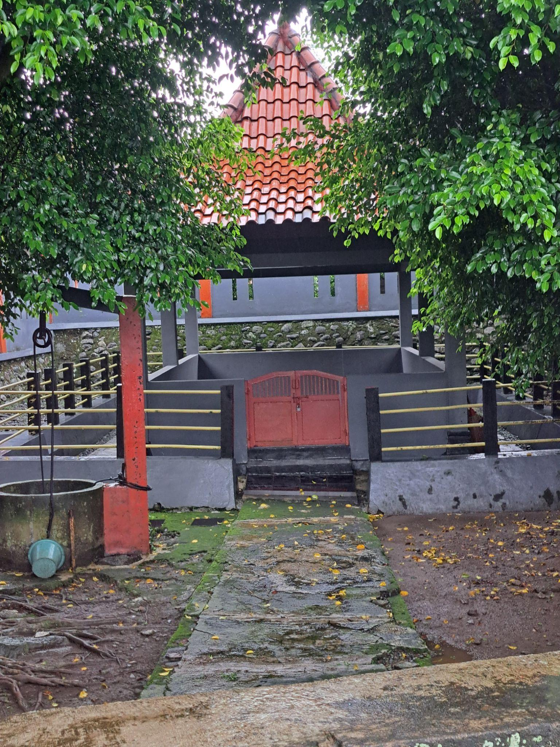
Figure 1. Tomb of Duke Mersi
(Source: Researcher's Personal Collection)

- Arcawinangun Subdistrict
Arcawinangun is one of six sub-districts in Purwokerto Timur District. This sub-district has an important role in the formation of Purwokerto City. The origin of Arcawinangun Sub-district until now is based on oral tradition in the local environment. The name Arcawinangun comes from a figure who has a big role in the environment, namely Adipati Kabakan Arcawinangun. Adipati Kabakan Arcawinangun was killed by Raden Kamandaka as a result of killing Adipati Mersi. However, based on other oral traditions, the name Arcawinangun cannot be separated from Astana Duwur Mbah Karta. In the tomb, ruins of a temple and several statues were found so the area was called Arcawinangun.
Based on the ruins, the temple located there is not far from the Prambanan temple. The Ratuboko figure is often associated with the power struggle in Pasirluhur. The struggle took place during the Ancient Mataram kingdom. Rakai Pikatan from the Sanjaya dynasty with Balaputera Dewa fought over territory in Pasirluhur (Priyadi, 2019). Pasirluhur has been an area that has existed since the Ancient Mataram era to Demak, so many statues have been found in this area. The existence of statues in the Arcawinangun area can still be found in the Dhuwur tomb, even the ruins of the temple are still there today.
In line with previous oral traditions, the name of the Arcawinangun sub-district is based on interviews with local people. The oral tradition that developed the name Arcawinangun came from the discovery of temple ruins and statues in the Dhuwur Cemetery, in addition Arcawinangun comes from 2 words arca and winangun which have meanings in Indonesian that the statue was deliberately built. The statue in the Dhuwur Tomb was deliberately built during the Hindu/Buddhist kingdom with the aim of being presented to Mbah Karta (Interview with Bardi, 70 years old).
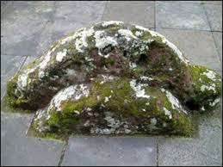
Figure 2. Statues that are still in the Cemetery area
source: https://shorturl.at/vva

- Kranji Village
Kranji is one of the names of the sub-districts in East Purwokerto. The name Kranji comes from the name of a river that flows through the village. The Kranji River has benefits for the surrounding community. Apart from being used to irrigate agricultural land or plantations in the area, the Kranji River is also used by people to bathe, wash clothes, and clean. The Kranji River has clear water. Based on its location, this river is in the low area of ​​Purwokerto. This area used to have lots of trees to maintain the water flow when the dry season arrived so that it remained stable and to prevent landslides. The vegetation that is widely planted in this area is keranji acid. People choose Keranji Acid because it has many benefits. Apart from the fruit which humans can consume, the roots of keranji acid can support the soil so that it does not landslide, apart from that the stems can be used to make materials for houses (Sutejo, 69 years old).
During the Dutch colonial period in Purwokerto, in addition to bringing negative impacts, it also brought positive impacts to the local community, one of which was the construction of the Banjaran Dam to increase the harvest of the surrounding community. This Banjaran dam is one of the irrigations that is lowered into the Kranji River, initially this river was a river with a relatively small flow, but with the presence of this Banjaran dam, this river has a greater discharge than before. The sustainability of the planting of this tamarind tree is closely guarded because it brings enormous benefits to humans.
Based on the oral tradition obtained, the name of the Kranji sub-district is inseparable from the tamarind tree vegetation in the area. The Kranji tamarind tree is very useful for the community. The usefulness of the Kranji tamarind maintains the sustainability of the community's life, so the community wants the area to be named the Kranji sub-district so that the area provides benefits for the people who live in the sub-district
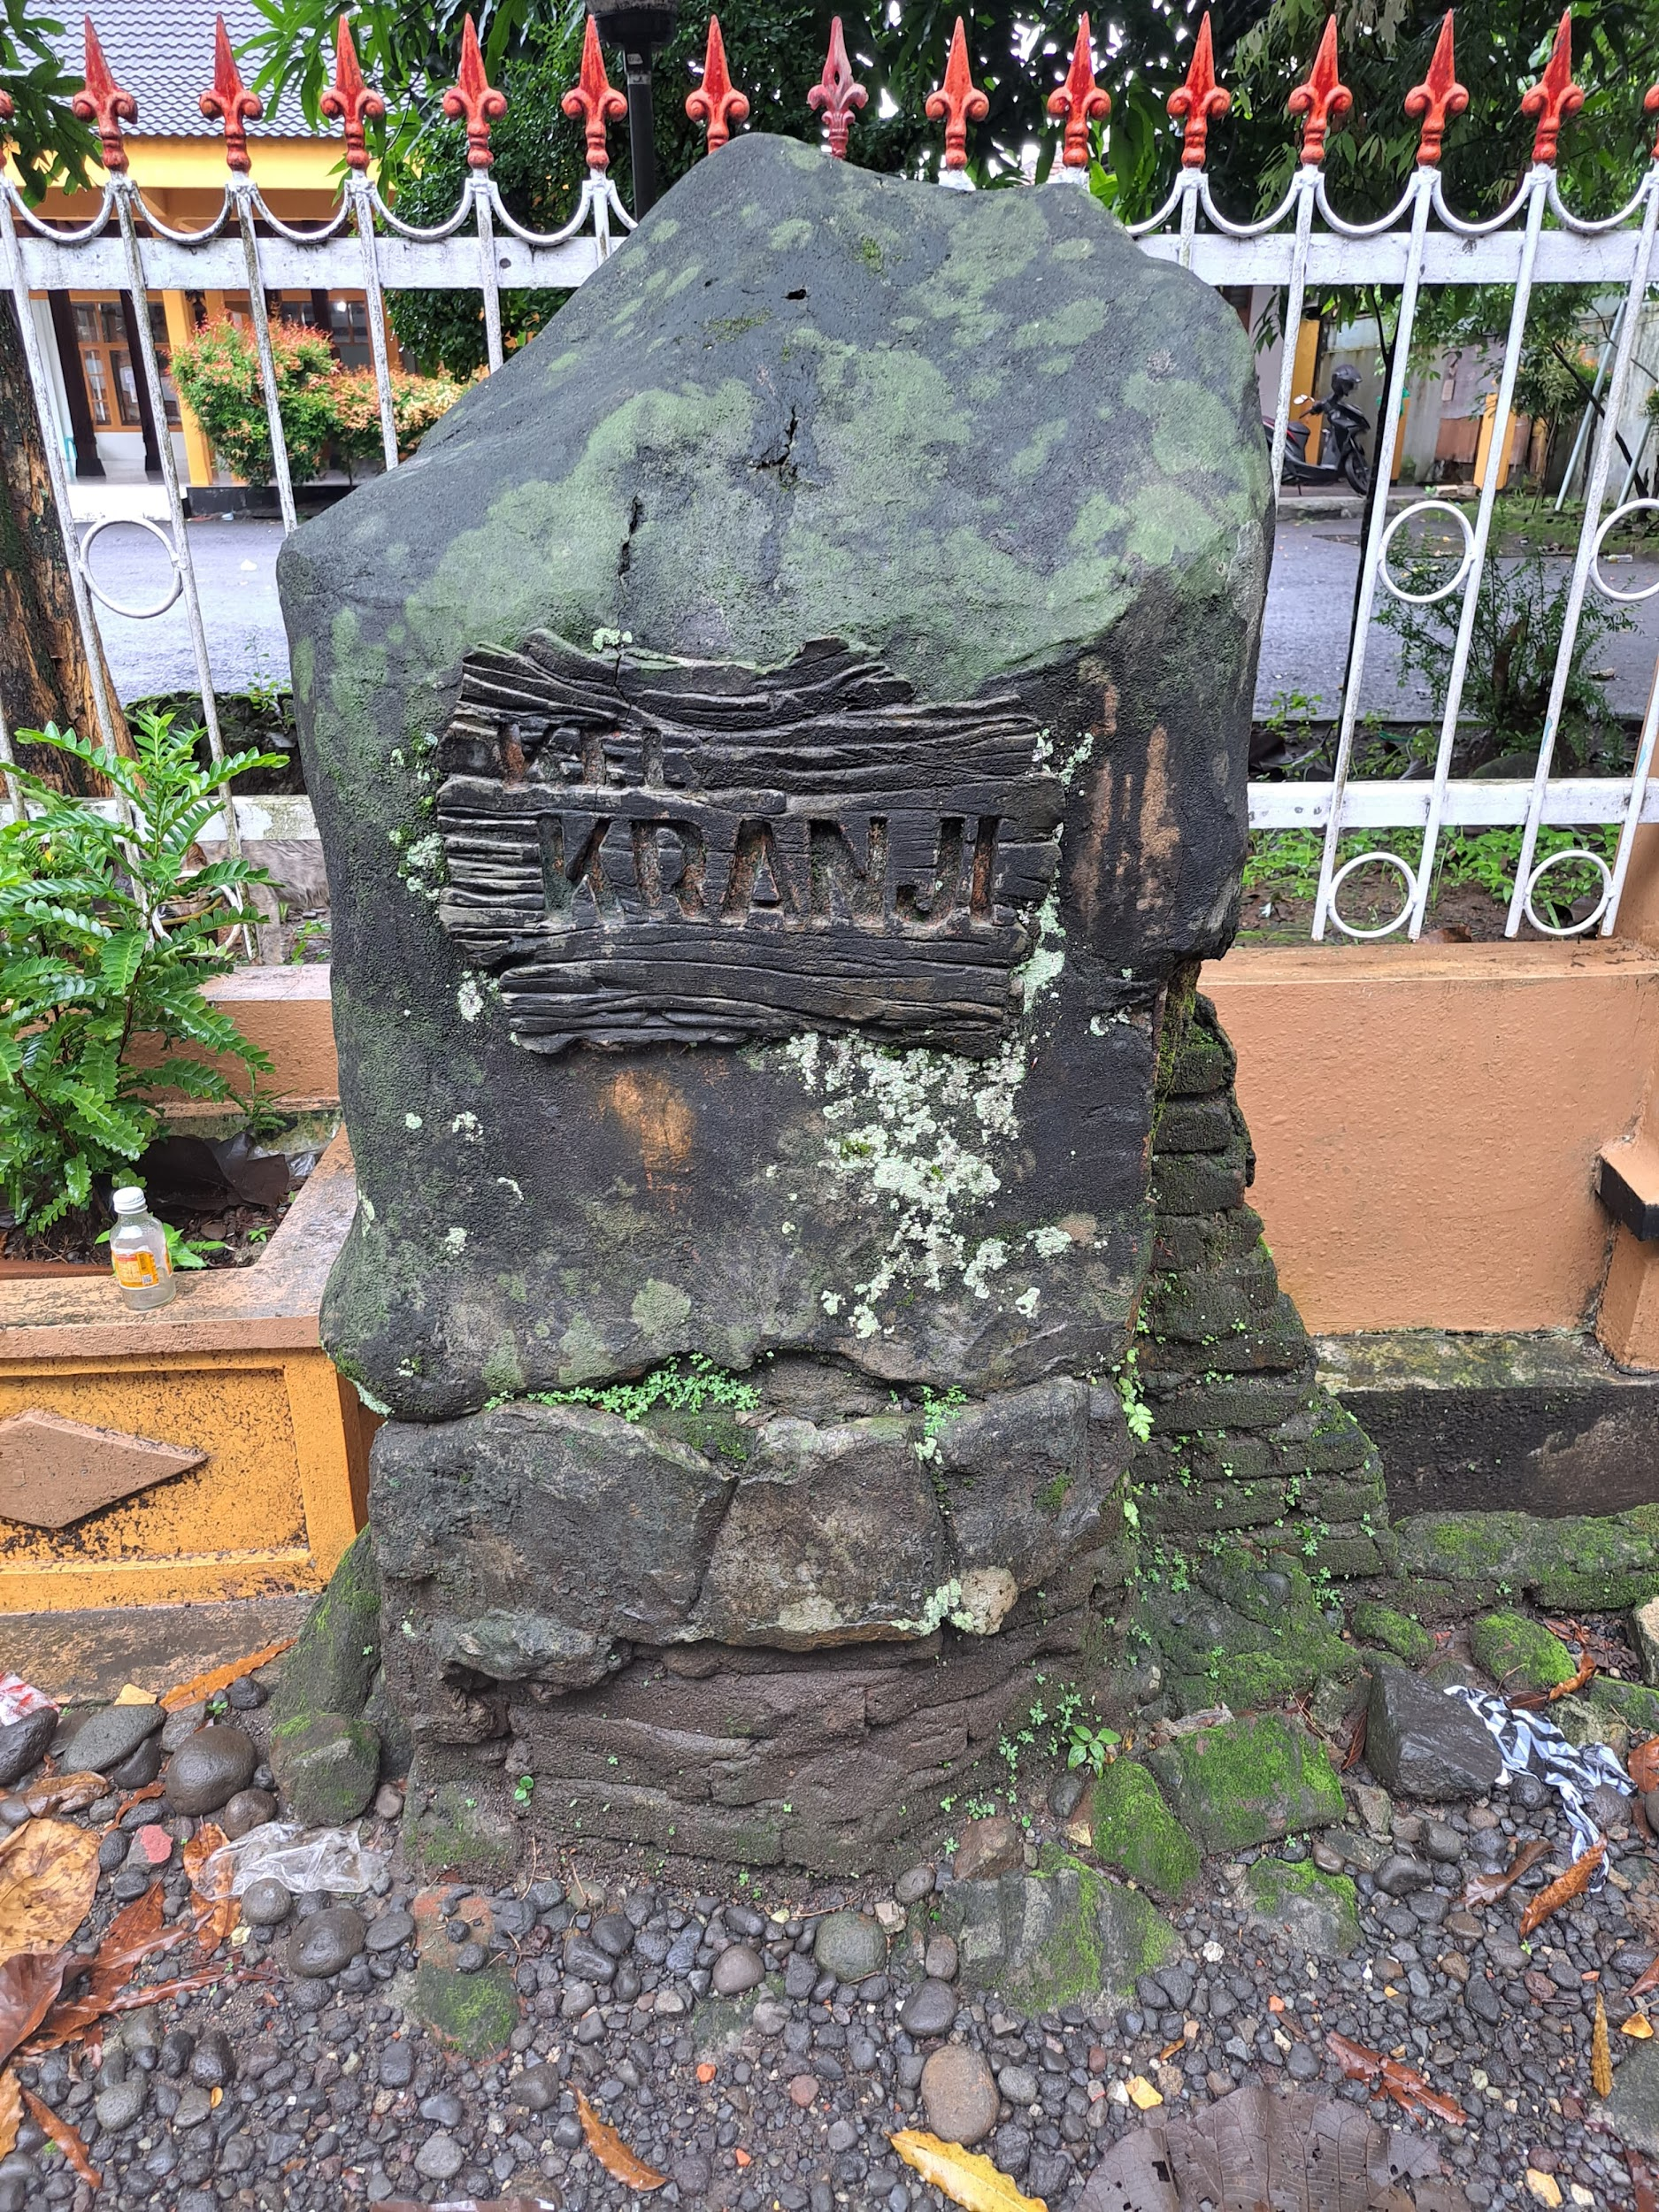
Figure 3. Kranji Marker
(Source: Personal documentation of researcher)

- Purwokerto North Subdistrict
Purwokerto lor is one of the sub-districts in Purwokerto Timur district. Purwokerto lor is currently part of the administrative area in Banyumas district. From the town square, the center of government is included in the Purwokerto Lor administrative area.
Purwokerto Lor consists of two sentences "Purwokerto" and "lor" in Indonesian means North Purwokerto. In its history, Purwokerto was originally part of the Ancient Mataram region, where in its life the ancient Mataram adhered to two religions, Hinduism and Buddhism. In addition, the Mataram kingdom has established cooperation in all fields, with other kingdoms both from within the country and abroad.
Cooperation between the Ancient Mataram kingdom in the economic sector has experienced very rapid development. Many traders came to Ancient Mataram to trade and spread religion, one of which was brought by the monk Sitompoa who came from Tibet. When Situmpoa first came to Purwokerto, there were still many criminal acts in the area, but thanks to Situmpoa, the area became safer. In addition, when Mount Slamet was erupting, Sitompoa managed to save the community from the lava of Mount Slamet (Priyadi, 2019) Situmpoa lived in the northern part of Purwokerto or called Purwokerto Lor. Purwokerto Lor was Sitompoa's choice because it was considered the safest area.
Based on oral tradition circulating in the community, the name Purwokerto Lor originates from the story of Cakrawedana who married the daughter of Situmpoa, after the marriage Cakrawedana moved the capital of Pasir Kertawibawa to the north of the northern village of Pancurawis, precisely in Purwokerto Lor.
- Sokanegara Subdistrict
Sokanegara is a sub-district in East Purwokerto which is located between the sub-districts of Purwokerto Lor and Purwokerto Wetan. Based on the oral tradition that developed in the community, Sokanegara comes from two words in Javanese Soka and Negara. Soka means flower so Sokanegara is the flower of the nation. The name Sokanegara was chosen by the community so that they could live peacefully side by side among their people.
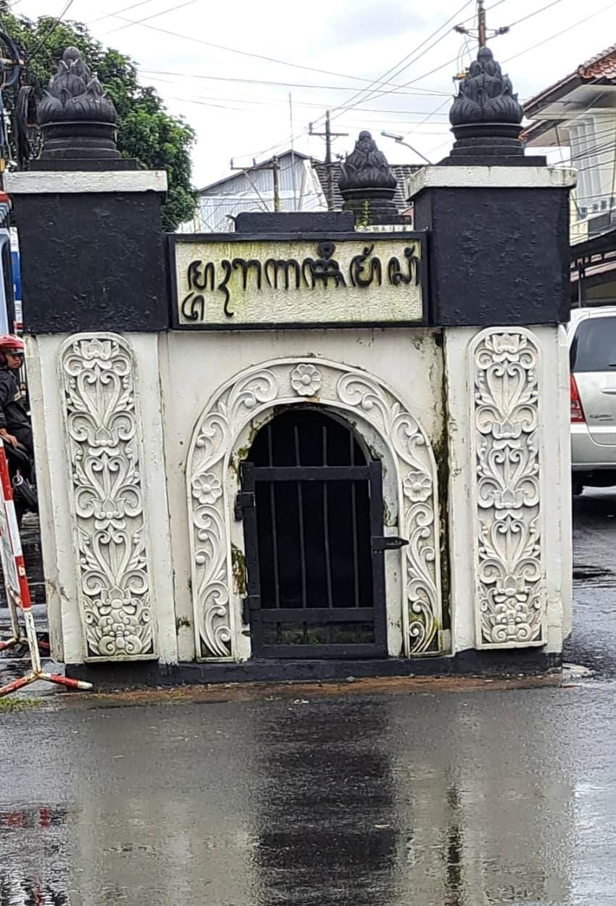
Figure 5. Ragasemangsang Tomb
(Source: Researcher's Personal Collection)
In Sokanegara sub-district, there is a unique tomb, a tomb located in the middle of the road. Based on the oral tradition that developed, the tomb is the tomb of Ragasemangsang. Ragasemangsang is possibly a figure who had influence in the local area. The community gave the name Ragasemangsang because the person was found dead on a tree so it was called Ragasemangsang.
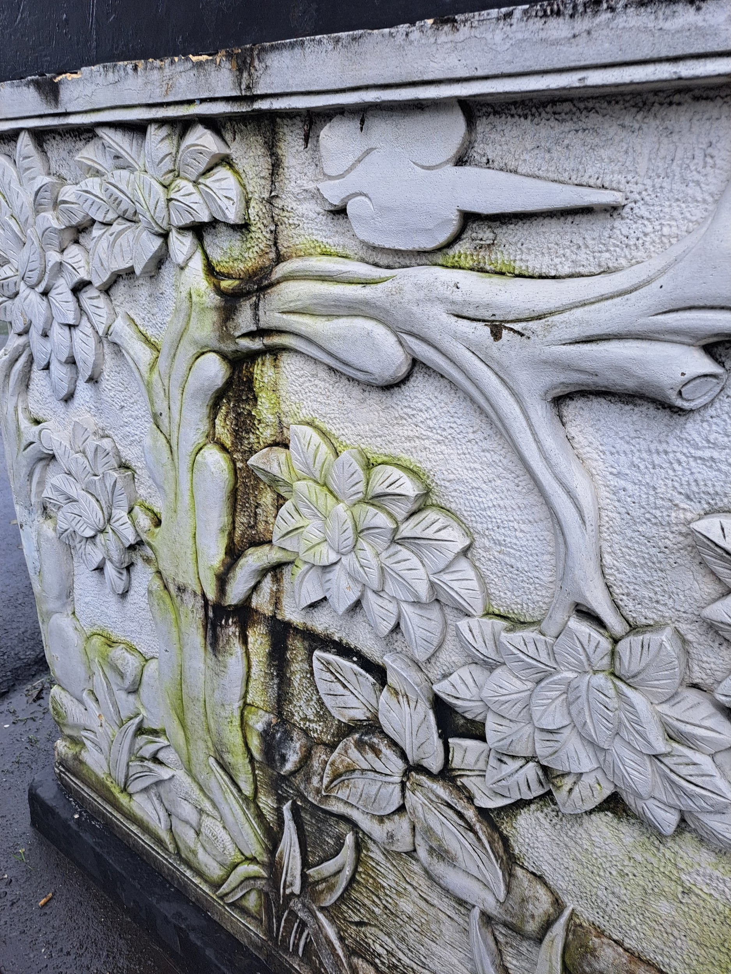
Figure 6. Relief of the wall of the Ragasemangsang tomb
(Source: Personal documentation of the researcher)
On the tomb, there is a relief in the form of a large tree, in addition there is a makara at the bottom of the entrance pillar. The relief of the large tree illustrates that the figure died in the tree or depicts the surrounding environment which used to have vegetation in the form of large trees. For makara has the meaning of warding off disaster (Sinaulan, 2018), in addition the makara symbol indicates that the tomb is influenced by Hindu/Buddhist culture that is developing in the environment.
- Purwokerto Wetan Subdistrict
Purwokerto Wetan is one of the sub-districts located in East Purwokerto. Wetan in Indonesian means East. Initially, Purwokerto consisted of several associations. One of them is the Purwokerto association. The Purwokerto association consists of four sub-districts, namely Purwokerto Wetan, Purwokerto Lor, Purwokerto Kidul and Purwokerto Kulon. These four sub-districts became the center of the economy and government in Banyumas. However, along with its development, the Purwokerto Wetan area was included in the Purwokerto Timur sub-district..
Based on the oral tradition that developed in the community, until now the name of the Purwokerto Wetan sub-district is because the location of the area is in the eastern part of Purwokerto, so it is called Purwokerto Wetan. The mention of Purwokerto Wetan is closely related to Cakrawedana.

- Contribution of Toponymy in the Field of Education
Based on the current curriculum that applies to education in Indonesia, namely the independent curriculum, toponymy in each region has its own historical value in each region in Indonesia. The independent curriculum is one of the learning focuses related to local areas and local wisdom. This was stated by the Acting Head of the Center for Curriculum and Learning of the Ministry of Education and Culture, Research and Technology (Zulkifli, 2022). The addition of local content is determined by the regional government which is adjusted to the characteristics of a region or the local wisdom of the region. In this case, the toponymy of the sub-district in East Purwokerto District can be one of the local histories that can be conveyed to students, so that students know the history around their place of residence, with the intention of participating in preserving the history in their place of residence because currently, because many students do not know the origin of the name of the area where they live in each region.

CONCLUSION
Based on the data obtained, the researcher concluded that the names of the 6 sub-districts in East Purwokerto cannot be separated from the natural conditions around them, in addition, the formation of the name Purwokerto cannot be separated from the influence of Hinduism and Buddhism in Java, especially in Banyumas Regency until Islam came to Banyumas. Banyumas Regency became part of the territory of Ancient Mataram, so it is inevitable that some names and relics are influenced by Hindu/Buddhist culture, such as the naming of the Ragasemangsang tomb. In addition, the Mersi sub-district is inseparable from a figure named Adipati Mersi. Arcawinangun which comes from the discovery of statues and ruins of temples, Kranji which comes from the name of the river located in the area and the vegetation it has, namely keranji acid which has many benefits from the roots, stems to the fruit.

REFERENCE
Basundoro, P. (2020). Arkeologi transportasi: perspektif ekonomi dan kewilayahan keresidenan Banyumas 1830-1940an. Airlangga University Press.
Beridze, M. (2020). HISTORICAL AND MODERN TOPONYMY: THE EXAMPLE OF QIQINETI VILLAGE. Karadeniz Uluslararası Bilimsel Dergi, (47), 1-15.
Dede, B., Agus, S., Luthfi, H., Ahmad, M., Mawi, K. A., Choerul, F. Y., & Ahmad, Y. (2022). Islamisasi Jateng Bagian Barat-Selatan. Litbangdiklat press.
Dinas Kebudayaan (Kundha Kabudayan) Yogyakarta. (n.d.). Perjanjian Giyanti.
Dinas Komunikasi dan Informatika Kabupaten Banyumas, 2024, Data dan Informasi Kabupaten Banyumas 2024. Volume 8 tahun 2024.
Herusatoto, H. B. (2008). Banyumas; Sejarah, Budaya, Bahasa, Dan Watak. LKIS Pelangi Aksara.
Irwanto, Y. (2025). BIG Serahkan Peta NKRI Kepada Kemenkokesra.
Kadmon, N. (2000). Toponymy: The Lore, Laws, and Language of Geographical Names. Vantage Press.
Kraton Jogja. (2021). Wilayah Yogyakarta dari Giyanti hingga Kini.
Mardiyono, P. (2021). Genealogi Kerajaan Islam di Jawa. Askara.
Pengelola Web Kemendikbud. (2022). Implementasi Kurikulum Merdeka, Muatan Kearifan Lokal Bisa Dimasukkan Melalui Tiga Opsi.
Priyadi, S. (2019). Sejarah Kota Purwakerta (Purwokerto) (1832-2018). Pustaka Pelajar.
Rusu, M. S. (2019). Mapping the political toponymy of educational namescapes: A quantitative analysis of Romanian school names. Political Geography, 72, 87-98.
Sinaulan, J. H. (2018). Akulturasi Kebudayaan Hindu Di Era Multikulturalisme Identitas. Ideas: Jurnal Pendidikan, Sosial, Dan Budaya, 4(2), 215–224.
Sugiyanto, D. (2016). ARTIKULASI POLITIK DALAM GENDING PAKURMATAN MIYOS DALEM SISKS PAKU BUWANA DAN KGPAA MANGKUNEGARA.
Sujarweni, V., & Wiranata. (2021). Menelusuri Jejak Mataram Islam di Yogyakarta. Anak Hebat Indonesia.
Yasadipura, I. (2018). Babad Giyanti.
Zed, M. (2004). Metode Penelitian Kepustakaan. Obor.

