DESIGN EMPLOYEE ATTENDANCE INFORMATION SYSTEM USING BARCODE CODE 39
Suharjo^{1,} Muhammad Sakban²
AMIK PARBINA NUSANTARA
suharjo@amikparbinanusantara.ac.id , sakban@amikparbinanusantara.ac.id

Abstract

Article Info | The development of information and Communication Technology at this time has touched all sides of life. There is almost no side of human life that is not touched by information technology, not least also with computerization that is popular in the corporate environment. When in ancient times everything was still done manually. However, at this time all the leaders and management of the company have realized the importance of this information technology product that can facilitate them in carrying out Daily company functions. Many a design that uses computerized attendance but not integrated with attendance recording. Attendance recording is still manual so that it takes a long time in the process of making attendance because they have to do the counter manually. In this study will be designed a computerized attendance information system where the attendance process using database processing applications ysng assisted by using the barcode method code 39. The final result of the design of attendance information system is expected to help companies to manage attendance data effectively and efficiently.
Received
Revised
Accepted

Keywords: Design, Bacode, Information Systems

- Introduction
Barcode-based employee attendance Information System is one of the information technology that is widely used by companies today. This is because the use of this method is very helpful and easier in the attendance process itself and the creation of the required reports. Technology and science in the field of computerization at the present time makes the use of computers as supporting work, because at this time it is no longer possible to do something manually. Because if we still use the system manually, there will be many errors that occur and it is difficult for us to change back. Conversely, if using a computerized system, it can be overcome and the time required for these activities will be faster.
Computers are considered to improve the performance of an institution or company in terms of increasing speed, capacity and accuracy. The use of computers is very necessary considering the problems faced by more and more difficult. The computer is used as a tool in operating the inputs to provide the expected output and results. The processed computer data or output is referred to as information.
This has several weaknesses, especially in terms of the accuracy of information needed by management such as employee attendance recapitulation. It required a tool that can process the attendance data. A Barcode is basically an arrangement of black and white vertical lines of different thicknesses. With the barcode and computer attendance data processing will be faster and more accurate where the barcode scan results are stored in a reminder media called the hard drive.

2. Theoretical Basis
Design is a system design to determine how a system will complete what must be completed, this stage involves configuring the software and hardware components of a system so that after installation of the system will completely satisfy the design that has been set at the end of the system analysis.
2.2 System
A system is a set of subsystems that are interrelated and dependent on each other, working in tandem to achieve pre-established goals and objectives. All systems have inputs, processes, outputs and feedback.
2.3 Information
Humans often use the terms data and information as the same thing. However, more views data as raw raw material resources that are processed into finished information products. Information is defined as data that has been transformed into meaningful and useful contexts for specific end users. So data usually depends on value-added processes (as data processing or information processing) in an aggregated form, manipulated or organized, analyzed and evaluated, placed in an appropriate context for the wearer. So information is as data that has been processed and put in a context that provides value to a particular end user.
2.4 Information Systems
Information system is a system within an organization that meets the needs of daily transaction processing that supports the functions of managerial organizational operations with the strategic activities of an organization to be able to provide certain external parties with the necessary reports. Based on the understanding of information systems above, it is concluded that an information system is a system that transforms data into information and is useful for users.
2.5 System Development Life Cycle
The system development life cycle is an approach that is carried out through several stages to analyze and design a system that has been developed very well through the use of specific analysis and user activity cycles. The life cycle of system development is the stage of the process of developing the old system into a new system by correcting the deficiencies contained in the old system.

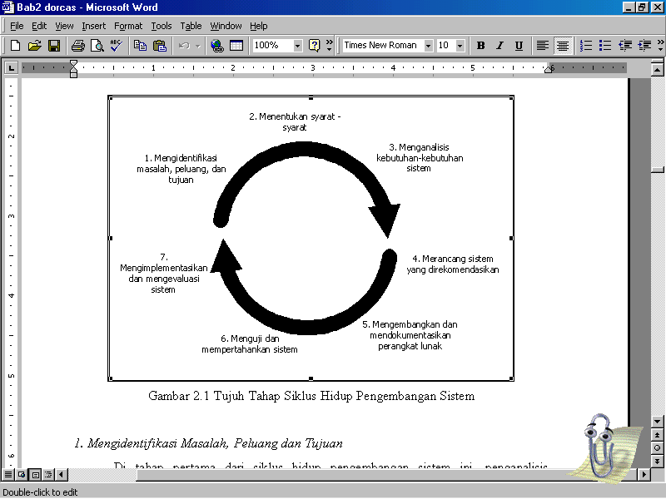

Figure 1 : System Development Life Cycle
2.6 Barcode
Barcode or in Indonesian often called bar code is an optical machine-readable representation of data. The code is black and white lines and contains a collection of combinations of different sizes, and arranged in such a way according to certain atauran so that it can be translated by the Reading Machine. If you search on google with the keyword "barcode", you will find various types of barcodes that are growing. The code inside the barcode collects data in a one-dimensional linear symbology or also has the shape of a square, point, Hexagon and other geometric shapes in a two-dimensional symbology. Furthermore, since barcodes are usually attached to a specific product, it is of course present the data related to the product where the barcode is located. Using the correct barcode system will certainly benefit the company. Starting from standardized coding, automation and speed in data Reading Ease of users and so on. More fully, here are some of the benefits of barcodes.
- Standardization Of Data Encoding
The use of barcodes will certainly adhere to a certain standard in coding. With good standardization, it will provide uniformity and ease of data processing. Standardized data encoding using barcodes will certainly ensure that information is received and conveyed in the right way, so that it can be generally accepted and understood.
- Data reader automation
Barcodes can be read automatically with a fast time by its reader machine. Thus the user does not have to manually write the code data of an item. For example, the cashier in a supermarket does not type the item code when entering the item data on the computer, but simply shines a barcode reader on the item and the code will automatically be entered into the computer by the barcode reader.
- Reader Accuracy
Typing data manually by Humans, Of course, is at high risk of error. Errors that commonly occur if typing data manually for example are code reader errors and typos. The slightest typo when entering data, will certainly cause an error in the report resulting from the data processing. The use of barcodes will certainly be able to improve accuracy by reducing human error when entering data manually.
- User Convenience
Although using a code that is complicated and difficult to read by the ordinary eye, but the barcode scanner machine will simplify everything. Barcode scanner is very easy to use to read barcodes. Just by shining the reader light on the place where the code is written, the code will be read immediately. Furthermore, with the right hardware and software will certainly be able to maximize the process of data collection automation. With this, of course, it will be easier to make an accurate inventory with a barcode system, than manually.
- Increase productivity and profits
With the ease of use, automation and accuracy offered by barcodes, it is clear that barcodes greatly help increase productivity and company profits. Information generated from data processing will be more timeliness (on time). Thus data will be received quickly, and allow quick decision making based on the latest information. Barcodes also keep business operations short. The increased efficiency that barcodes provide allows companies to save costs most importantly increase profits in their business.
2.7 Barcode type type Code 39 (code of 39)
An alphanumeric (full ASCII) barcode that can represent alphabets (A-Z) and numbers (0-9), as well as some other characters, such as $, /, +, %, periods and spaces. The maximum number of digits is 16. Codes like this are usually suitable for barcodes for books and for library members. Other applications for example for inventory, asset tracking and used in identity identification. Barcodes have varying line
lengths.



Figure 2 : Code 39

Barcode Pattern 39 is very easy to apply. There are several options for programmers to display barcodes 39. For those who don't want to bother with coding, you can buy a ready-made application and sell it commercially, so the programmer will focus more on the form application that must be done, because it is already plug in in the script that is built. However, for programmers who want to write a programming language routine, they can make a translation of Barcode pattern 39 into a script that will describe 0 with a white image and 1 with a black graphic. Barcode length 39 can be used as a variable and in accordance with the needs of the application. Likewise, the thickness and thickness of the black and white image display can be adjusted according to the ratio, starting from 2 to 3, meaning that the comparison of thick black images is 2 times (maximum 3) with thick white images. As the limiting character in Barcode 39 at the beginning and end of the code is given the character “*” so that the scanner will be easy to interpret the code listed. If the code will be re-examined for correctness, validation characters can be included in the following example. Suppose the exhibitor ID is: * ZB65732* then the * character at the beginning and end is a delimiter, and re-translation (recode) for ZB65732 which is equipped with validation facilities using the Barcode pattern table 39, character value: Z = 35; B =11; 6 = 6; 5 = 5; 7 = 7; 3 = 3; 2 = 2, if the sum of all the code the result is: 35 + 11 + 6 +5 +7 +3 +2 = 69. Because all character values in the 30 barcode pattern table are 43, the value of the result of the number of All codes will be divided by 43, the result is: 69 / 43 = 1, remaining 26.

3. Systems Analysis and design
Systems analysis is a human-oriented, unstructured activity that involves forecasting and negotiation. While the system design is basically more structured and technical. Conceptually, system analysis is the decomposition of an information system into its component parts with a view to studying the existing system with the intention of conducting research and observation of work units that are seen in managing employee attendance data. To make it easier to analyze the attendance process carried out on a running system, Flow of Documnet (FOD) is used. FOD employee attendance system as follows :
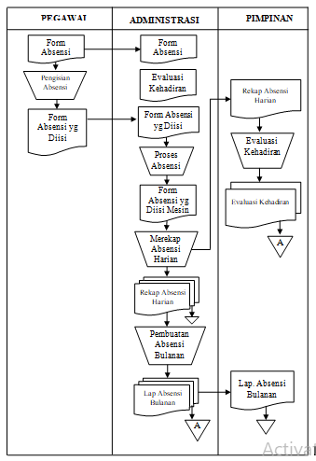

Figure 3 : Document attendance flow
Description :

1. Employees submit attendance forms to employees to be filled. After the employee fills out the attendance form, the employee again submits the form back to the administration for further processing.
2. Attendance Data are processed using an attendance machine by the administration and will produce a daily attendance recap to be submitted to the leadership.
3. Based on the daily attendance recap of administrative staff then prepare monthly attendance reports.
4. At the end of the month the leader will make a Attendance evaluation report using the daily attendance recap and submitted to the administration.

3.1 Analysis Methods Used
Code 39 can encode alphanumeric characters i.e. decimal numbers and uppercase letters as well as additional special characters (-.*$/%+). One character in code 39 consists of 9 elements, namely 5 bars (black vertical lines) and 4 spaces (white vertical lines) arranged alternately between bars and spaces. 3 of the 9 elements have a thickness thicker than all the others. The 3 thicker elements consist of 2 bars and 1 space. The wide element represents the binary digit 1 and the narrow element represents the binary digit. Images of code 39 characters and their character values are listed below:

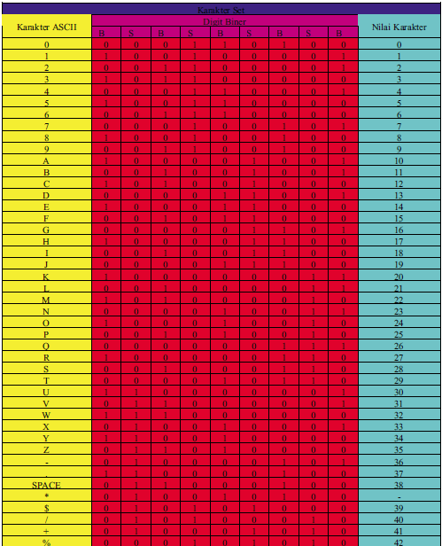

Figure 4. Character Code 39 And Its Character Value

The structure of the barcode Code 39 is as follows :

(1)

Description :
X:: narrow element thickness (minimum 0.19 mm).
QZ: quiet zone or Start-Stop Margin with a minimum thickness of 6 mm or 10 times X
SC: start character (character *)
ICG: Inter Character Gap with a thickness of 1 kaliX
C1 .. CN: 1st character to Nth character.
CC: check character
PC: stop character (character *)

To be able to distinguish wide and narrow vertical lines, the thickness ratio between wide and narrow vertical lines is at least 2:1, where a 3: 1 ratio would be better. The overall width of the barcode can be formulated as follows:
(2)
L= N(3RX+7x) + (6RX + 13X) + (3RX + 7X) + (MI + M2)
I II III IV
Description :
L: Overall Width of barcode
N: number of characters
R: comparison of wide and narrow vertical lines
X: Narrow Vertical Line Thickness
I: N character width plus N inter character gap
II: the width of the start and stop characters plus 1 inter character gap between the start character and the first character.
III: check Character width plus 1 inter charcater gap
IV: width 2 times quiet zone (M1 ( start margin) + M2 (s t o p m a r g i n ) ) .
Check character is the remainder of the sum of all character values divided by 43.

Here is the implementation of barcode structure using employee NIP
1. Barcode for NIP : 19521206
Message: 19521206
Character: 19521206
Character value: 1 9 5 2 1 2 0 6
Total : 1 + 9 + 5 + 2 + 1 + 2 + 0 + 6
26/43 = 0.61
here is barcode 39 for 19521206

Figure 5. Barcode Result 39 Text 19521206

- Barcode for NIP : 19521207
Message: 19521207
Character: 19521207
Character value: 1 9 5 2 1 2 0 7
Total : 1 + 9 + 5 + 2 + 1 + 2 + 0 + 7
27/43 = 0.62
here is barcode 39 for 19521207



Figure 6. Result Barcode 39 Teks 19521207

3. Barcode for NIP : 19521208
Message: 19521208
Character: 19521208
Character value: 1 9 5 2 1 2 0 8
Total : 1 + 9 + 5 + 2 + 1 + 2 + 0 + 8
28/43 = 0.65
here is barcode 39 for 19521208



Figure 7. Result Barcode 39 Teks 19521208

4. Barcode for NIP : 19521209
Message: 19521209
Character: 19521209
Character value: 1 9 5 2 1 2 0 9
Total : 1 + 9 + 5 + 2 + 1 + 2 + 0 + 9
28/43 = 0.65
here is barcode 39 for 19521209



Figure 8. Result Barcode 39 Teks 19521209

4. System Design
4.1 Entity Relation Diagram (ERD)
The explanation Entity Relationship Diagram designed in the system is as follows :
1. In the FK position entity, the position is the primary key and is the foreign key in the Employee entity where the relationship formed is one to money.
2. In the FK group entity, the primary key and the foreign key in the Employee entity where the relationship formed is one to money.
3. In the FK employee entity, the employee is the primary key and is the foreign key in the attendance entity where the relationship formed is one to money.
4. In the noabsen attendance entity is the primary key where the relationship formed is one to money with the Employee entity.
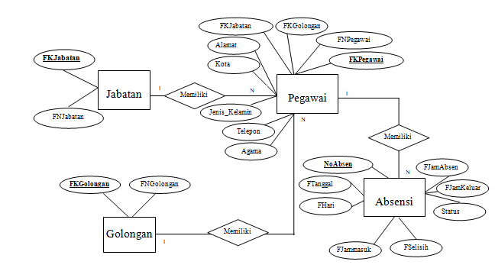
Figure 9. ERD Attendance Information System

The output design of employee attendance information system is as follows :

A. Attendance Card
The employee attendance card design is as shown below :

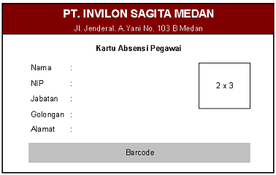
Figure 10. Attendance Card

Output name: attendance card.
Function: as an employee attendance tool.
Media: paper, computer and Barcode Scanner.
Distribution : personnel.
Description: This card is used every day by employees to record hours presence. Usage using a parallelized barcode scanner with a computer.

B. List Of Employees
The design of the list screen is as shown below :

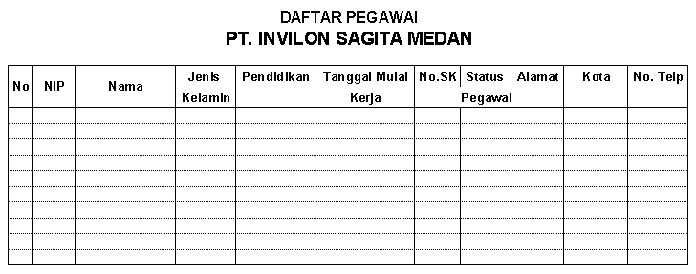

Figure 11. Staff List

Output Name: List Of Employees.
Function: to display the list of employees
Description: this report displays data such as NIP, name, address, Work start date, SK number and
employee status.
Media: Paper
Frequency: any additions or changes in employee data.

C. Daily Attendance Report
The design of the Daily Attendance Report screen is as shown below :

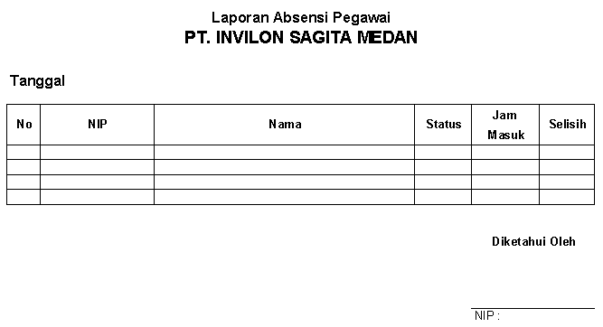

Figure 12. Daily Attendance Report

Output Name: Daily Attendance Report.
Function: to present daily attendance report
Description: this report displays attendance data such as clock in, and the difference if the employee concerned is late coming.
Media: Paper.
Frequency: every day.
D.Employee Attendance Recapitulation
The design of the employee attendance recapitulation screen is as shown below:
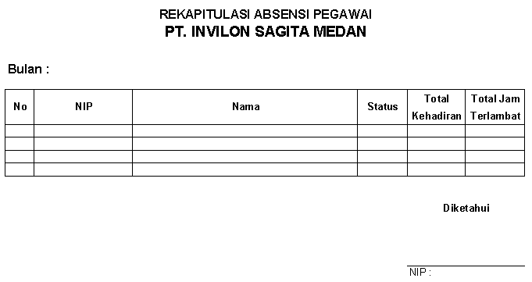

Figure 13. Employee Attendance Report

Output Name: Employee Attendance Report.
Function: to present employee attendance reports at PT. Invilon Sagita Medan.
Description: this report displays employee attendance data such as hours enter, and the difference if the employee concerned is late to come.
Media: Paper.
Frequency: every day.

4.2 Design Input
The design input system informsi employee attendance as follows :

A. Master Class
The design of the master input group is as shown. here :

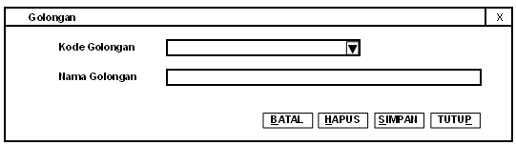

Figure 14. Master Class Sail Plan

Input name: Group.
Function: to perform data input Officer Class
Information: class code and class name must be filled in the data.

B. Master Department
The design of the position master's output is as shown below :

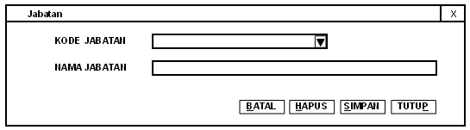

Figure 15. Master Sail Plan Department

Entry Name: Department.
Function: to perform data input Officer Department
Description: position Code and position name must be filled in the data.

C. Master Officer
The employee master consists of three tabulations, namely employee data tabulation, academic data tabulation, personal data tabulation. The design of the employee Tab employee master input is as shown below :
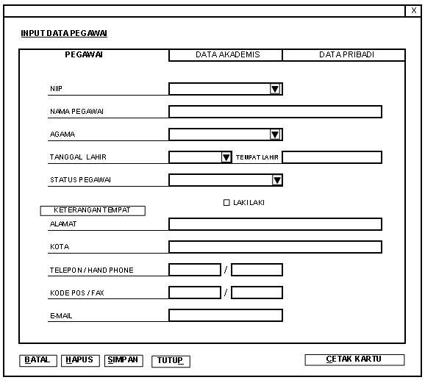

Figure 16. Tab Master Screen Design

D. Academic Data Tab Master
The design of the input Master employee academic Data Tab is as shown here :

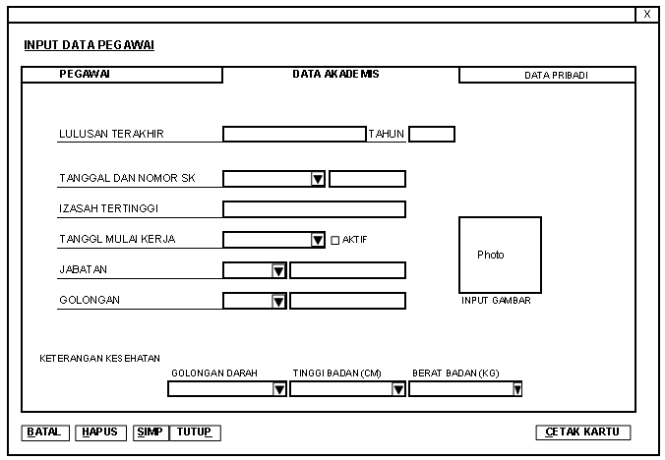

Figure 17. Academic Data Tab Master Screen Design

E. Master Personal Data Tab
The design of the Personal Data Tab employee master input is as shown below :
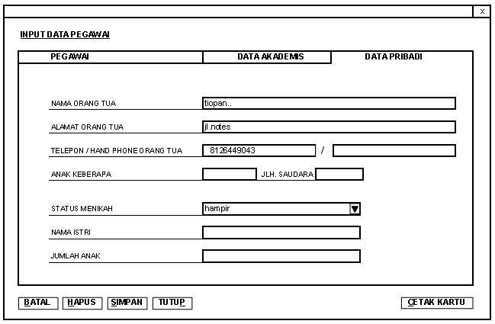

Figure 18. Personal Data Tab Master Screen Design

Entry name: Officer.
Function: to input employee data
Information: Code, Name, Address, City, phone, religion, class, position, All Academic tabs must be filled in or they must not be empty.

F. Attendance
The design of employee attendance input is as shown below :
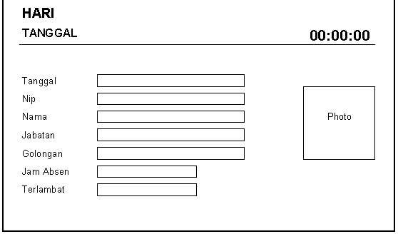

Figure 19. Employee Attendance Screen Design

Input name: attendance.
Function: record employee attendance every day.
Description: employee attendance process is done using barcodes.

5.Conclusion
The conclusions obtained as follows:
1. The system that runs requires a long time in the preparation of reports needed by the company.
2. The running system has a high error rate in the process of making reports because the recording uses manual.
3. The lack of control over the attendance process used by the old system, so the occurrence of fraud is very high, this is because the recording is done manually.
4. The system designed is a computerized system.
5. The system is designed to avoid fraud during the process of recording attendance. This is because the attendance process uses a barcode scanner and the recording time is adjusted to the computer where the system is located.
6. The system is designed to generate daily attendance reports and attendance recapitulation automatically.

6. Bibliography
- Aris Rakmadi, 2003, Teknik Pengkodean Barcode dengan Metode Universal Product Code dan European Article Numbering, Teknik Elektro Universitas Muhammadiyah Surakarta,
- Kadir, A., 2003, Konsep Tuntunan Praktis Basis Data, Andi Offset, Yogyakarta.
- Harip Santoso, 2003, Pemograman Client – Server menggunakan SQL Server 2000 dan Visual Basic 6.0, PT.Elex Media Komputindo, Jakarta
- Henry Pandia, 2004, Visual Basic 6 Tingkat Lanjut, PT.Elex Media Komputindo, Jakarta
- Kendall, K.E., dan J.E. Kendall., 2003, Analisis dan Perancangan Sistem, Alih Bahasa oleh Thamir Abdul Hafedh AI - Hamdany, Jilid Ke-1, Edisi Ke-5, PT. Prenhallindo, Jakarta.
- Kendall, K.E., dan J.E. Kendall., 2003, Analisis dan Perancangan Sistem, Alih Bahasa oleh Thamir Abdul Hafedh AI - Hamdany, Jilid Ke-2, Edisi Ke-5, PT. Prenhallindo, Jakarta.
- Leman, 1998, Metodologi Pengembangan Sistem Informasi, Penerbit PT. Elex Media Komputindo, Jakarta
- O’Brien, J. A., 2005, Pengantar Sistem Informasi, Alih Bahasa Dewi Fitriasari dan Deny arnos Kwary, Edisi Ke-12, Salemba Empat, Jakarta.
- Tata Sutabri, 2004, Analisa Sistem Informasi, Tata Subtari, Penerbit Andi, Yogyakarta
- Teguh Wahyono, Membuat Sendiri Aplikasi dengan Memanfaatkan Barcode, Penerbit PT. Elex Media Komputindo, 2010

