Stability of Cervical Cancer Model by Human Papillomavirrus (HPV) with Migration

Irma Suryani¹, Mohammad Soleh², Sarbaini³, Anggi Prayoga⁴, Boby Fahlezi⁵
^{1,3}Department of Mathematics, Universitas Islam Negeri Sultan Syarif Kasim, Riau, Indonesia

Article Info |  | ABSTRACT
Article history:  Received mm dd, yyyy  Revised mm dd, yyyy  Accepted mm dd, yyyy |  | Cervical cancer is a chronic disease that attacks the cervix. This disease is caused by the human papillomavirus (HPV). Over time, cervical cancer is modeled with a mathematical model to describe the development of its spread. In this study, cervical cancer is modeled into four subpopulations; susceptible subpopulation (S), HPV-infected subpopulation (I), infected but not infected with cervical cancer (U) and infected and infected with cervical cancer (C). The SIUC model is then added to the existence of migration within the population. Furthermore, the equilibrium of the model is determine and its stability is analyzed using the Jacobian matrix and eigenvalues. The result is that there are two equilibrium points, namely the disease-free equilibrium point and the endemic equilibrium point. The disease-free equilibrium point is asymptotically stable if the eigenvalue conditions are met. The endemic equilibrium point is stable if the eigenvalues are met. Furthermore, the numerical simulation model shows that migration that occurs within the population can cause cervical cancer to still exist in the population because the contact rate is getting bigger.
Keywords:
Eigen Values
Equilibrium
Jacobian Matrix
Model of Cervical Cancer SIUC

This is an open access article under the CC BY-SA license.

Corresponding Author:
Irma Suryani,
Department of Mathematics,
Universitas Islam Negeri Sultan Syarif Kasim, Riau, Indonesia
Email: irma.suryani@uin-suska.ac.id

- INTRODUCTION
Cervical cancer is a chronic disease caused by sexually transmitted diseases. Cervical cancer usually attacks the cervix, which is the area of the female reproductive tract which is the entrance to the uterus. Cervical cancer is caused by the Human papillomavirus (HPV) which is a disease that is transmitted through sexual contact. Unsafe sexual intercourse carries a high risk of contracting the HPV virus.
The virus that most often causes sexually transmitted infections is the human papillomavirus (HPV). Specifically, there are more than 40 different types of HPV affecting the genitals. Some types of HPV can also infect other parts of the body, including the mouth and throat. Most people are infected with HPV without knowing it. In many cases the immune system defeats the HPV infection before the virus has a chance to create warts. At least 70% of sexually active people will be infected with HPV in their lifetime. 80% of cases of people infected with HPV will go away on their own within a few months due to the immune system without treatment, while the remaining 20% of infections become persistent.
Furthermore, several mathematical models have been used to analyze and observe the development of cervical cancer. Barnabas, etc. (2006) with his journal "Epidemiology of HPV 16 and cervical cancer in Finland and the potential impact of vaccination: mathematical modeling analyses", Puspitasari (2019) in journal entitled "Local Stability Analysis in Mathematical Models of Human Caused Cervical Cancer Papillomavirus ", "A Mathematical Model of Human Papillomavirus (HPV) in the United States and its Impact on Cervical" (Lee, 2012) and journal "Global Stability of Disease-Free Equilibrium Points in the SIS Model Transmission of Human Papillomavirus (HPV)”(I. Suryani dan Asandi, 2019).
Furthermore, the author wants to see the influence of individual entry and exit that occurs in an area with the development of the cervical cancer HPV virus. So the author discusses SIUC Human Papillomavirrus(HPV) Model by adding migration.

- RESEARCH METHODE
In this model, the population is divided into four sub-populations:
a. Susceptible subpopulation (S) is a population that has the possibility of being infected with HPV
b. Infected subpopulation(I) is the population infected with HPV,
c. The subpopulation infected but not affected by cervical cancer (U) is the population infected with HPV but not affected by cervical cancer,
d. The infected and infected subpopulation (C) is the population infected with HPV then develops cervical cancer.
In this study, we will examine the SIUC model for HPV transmission with migration. The steps to be carried out in this research are as follows:
1. Make assumptions involving parameters and variables.
2. Identify the parameters and variables used in the model.
Table 1. Parameters and Variables of the SIUC HPV Model
No | Parameters and Variables | Information
1 | $$S$$ | Susceptible subpopulation
2 | $$I$$ | Infected subpopulation
3 | $$U$$ | population infected with HPV but not affected by cervical cancer
4 | $$C$$ | population infected with HPV then develops cervical cancer
5 | $$b$$ | Birth rate
6 | $$μ$$ | Death rate
7 | $$p$$ | Proportion of infected individuals
8 | $$δ$$ | Death rate of population infected with HPV
9 | $$v$$ | Infected contact rate
10 | $$m_{1}$$ | Immigration rate
11 | $$m_{2}$$ | Emigration rate
3. Model SIUC HPV:
$\frac{dS}{dt}=bN-\left(μ+vI\right)S$
$\frac{dI}{dt}=vSI-\left(1-p\right)I-\left(p+μ\right)I$ (1)
$\frac{dU}{dt}=\left(1-p\right)I-μU$
$\frac{dC}{dt}=pI-\left(μ+δ\right)C$
4. The equation (1) in step 3 above is added to the migration, immigration ($m_{1}$) and emigration ($m_{2}$) in the population.
5. Next, determine the equilibrium point in the model obtained in step 4, disease-free equilibrium point and endemic equilibrium point.
6. Analyzing the stability of the equilibrium point obtained in step 5.
7. Make a numerical simulation using maple software.
The following is a theorem relating to the stability of the equilibrium point,
Theorem 1.(Perko,2001) Such as $x'=Ax$ with $A$ is a matrix of $n×n$ has $k$ different eigenvalues $λ_{1},λ_{2},…,λ_{n}$ with$k≤n$:
a. The equilibrium point $x'$ is said to be asymptotically stable, if and only if $∃R_{e}<0$ for each $i=1,2,…,k$.
b. The equilibrium point $x'$ is said to be stable if and only if $∃R_{e}≤0$ for each $i=1,2,…,k$.
c. The equilibrium point $x'$ is said to be unstable if $∃R_{e}>0$ for every $i=1,2,…,k$.

- RESULT AND ANALYSIS
3.1. Model of Cervical Cancer by Human Papilloma Virus (HPV) with Migration
Based on Equation (1) then migration is added to the model so that the transfer diagram is as follows:
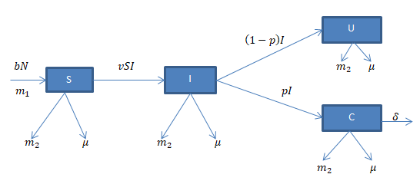
Figure 1. SIUC Model Transfer Diagram with Migration

From the Figure 1 obtained system of differential equations:
$\frac{dS}{dt}=(b+m_{1})N-\left(μ+vI+m_{2}\right)S$
$\frac{dI}{dt}=vSI-\left(1-p\right)I-\left(p+μ+m_{2}\right)I$ (2)
$\frac{dU}{dt}=\left(1-p\right)I-\left(μ+m_{2}\right)U$
$\frac{dC}{dt}=pI-\left(μ+δ+m_{2}\right)C$

3.2. Equilibrium point and Stability
Next, we will look for the system equilibrium point (3). The equilibrium points obtained are disease-free equilibrium points and endemic equilibrium points. A disease-free equilibrium point occurs if $I=0$ and $C=0$ which indicates there is no population disease. The disease-free equilibrium point can be expressed in the form $E^{0}=(S,I,U,C)$.
$E^{0}=\left(S,I,U,C\right)=\left(\frac{b+m_{1}}{μ+m_{2}},0,0,0\right)$ (3)
And the disease fixed point can be expressed in the form $E^{*}=\left(S^{*},I^{*},U^{*},C^{*}\right)$. According to the system (2) on the model is obtained:
$\frac{dS}{dt}=\frac{dI}{dt}=\frac{dU}{dt}=\frac{dC}{dt}=0$
$E^{*}=\left(S^{*},I^{*},U^{*},C^{*}\right)$ (4)
with,
$S^{*}=\frac{\left(1-p\right)+\left(p+μ+m_{2}\right)}{v},$
$I^{*}=\frac{\left(b+m_{1}\right)v-μ\left[\left(1-p\right)+\left(p+μ+m_{2}\right)\right]-m_{2}\left[\left(1-p\right)+\left(p+μ+m_{2}\right)\right]}{v\left[\left(1-p\right)+\left(p+μ+m_{2}\right)\right]},$
$U^{*}=\frac{1-p}{μ+m_{2}}\left[\frac{\left(b+m_{1}\right)v-μ\left[\left(1-p\right)+\left(p+μ+m_{2}\right)\right]-m_{2}\left[\left(1-p\right)+\left(p+μ+m_{2}\right)\right]}{v\left[\left(1-p\right)+\left(p+μ+m_{2}\right)\right]}\right],$
$C^{*}=\frac{p}{μ+δ+m_{2}}\left[\frac{\left(b+m_{1}\right)v-μ\left[\left(1-p\right)+\left(p+μ+m_{2}\right)\right]-m_{2}\left[\left(1-p\right)+\left(p+μ+m_{2}\right)\right]}{v\left[\left(1-p\right)+\left(p+μ+m_{2}\right)\right]}\right].$

Then, linearization using Jacobian matrix and obtained,
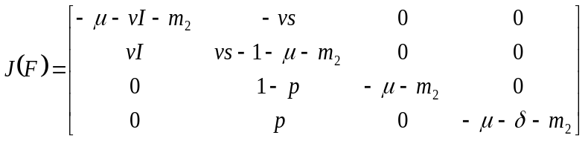 (5)
And substitute $E^{0}$ obtained,
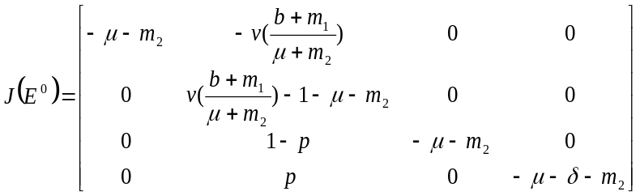 (6)
Then look for the eigenvalues of the Jacobian matrix (6) and it is obtained $λ_{1},λ_{2},λ_{3},λ_{4}<0$ , so according to Theorem 1, the equilibrium point $E^{0}$ is asymptotically stable.
From the equilibrium analysis in $E^{0}$ above, we get,
Theorem 2. The disease-free equilibrium point $E^{0}$ in Equation (3) is asymptotically stable if the condition are met.
Then, we find stability of endemic equilibrium point. In the same way, it is linearized using Jacobian Matrix (5) dan substituted endemic equilibrium point in (4), we get $λ_{1},λ_{2},λ_{3},λ_{4}≤0$. And according to Theorem 1, the equilibrium point $E^{*}$ is stable. Then, we can make the theorem,
Theorem 3. The disease-free equilibrium point $E^{*}$ in Equation (4) is stable if the condition are met.

3.3. Numerical Simulation
Numerical simulation aims to see an overview of the dynamics of cervical cancer due to viral infection (HPV). This simulation uses the Maple 18 program and the parameter values are as follows:
Table 2. Parameter Values
Parameter | Nilai |  | Sumber
$$μ$$ | $$\frac{1}{840}$$ | Kemenkes
$$δ$$ | 0.0043 | Shernita L. Lee dalam Hasnawati, Ratianingsih dan Puspita (2017)
$$v$$ | 0.6 | Puspita sari, Yudi dan Sandhy (2019)
$$p$$ | 0.7 | Puspita sari, Yudi dan Sandhy (2019)
$$b$$ | $$0,0187$$ | Kemenkes
$$m_{1}$$ | $$0.0188$$ | BPS Provinsi Riau
$$m_{2}$$ | $$0.0174$$ | BPS Provinsi Riau
The dynamics of the spread of cervical cancer by HPV with migration in$E^{0}$ and $E^{*}$ is presented in Figure 2 and Figure 3.

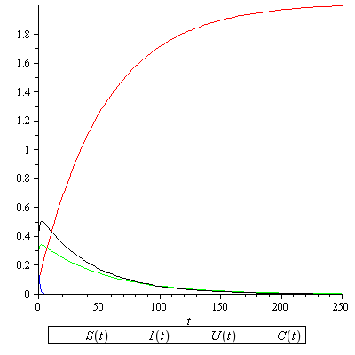
Figure 2. Population Dynamics for Disease-Free Ekuilibrium
From the Figure 2, Model Cervical Cancer with Migration there was increase and decrease in subpopulation. The susceptible subpopulation (S) experienced significant increase and stable in population. The infected subpopulation (I) initially existed but soon experienced a decline in the population. The subpopulation infected with HPV but not without cervical cancer (U) which initially increase and decrease significantly together with the subpopulation infected with HPV and developing cervical cancer (C). This means that individuals who are infected and infected with cervical cancer will eventually run out and cervical cancer will no longer exist in the population.

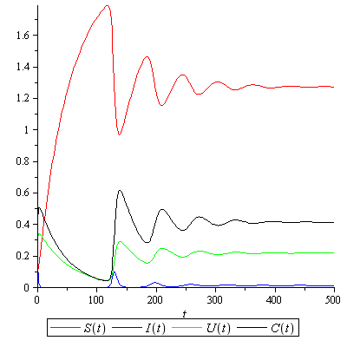
Figure 3. Population Dynamics for Endemic Ekuilibrium
Figure (3) above is simulated with the same parameter values but the contact rate (v) is increased to 0.8. And the results show that the susceptible subpopulation (S) experienced a sharp increase but decreased and decreased repeatedly and stabilized at a certain point. The subpopulation infected with HPV (I) experienced a significant decrease, then increased for some time and returned to stability (still in the population). The subpopulation infected with HPV but not infected with cervical cancer (U) experienced repeated increases and decreases due to natural deaths, migration to subpopulations infected with HPV and cervical cancer but stable at a certain point. The subpopulation infected with HPV and infected with cervical cancer (C) decreased significantly and increased again repeatedly and stabilized (still in the population). This is due to natural death and migration within the population. This means that individuals in the subpopulation infected but not infected with cervical cancer can at any time turn into individuals who are infected and infected with HPV because there are still individuals infected with HPV (I) and subpopulations infected with HPV and infected with cervical cancer (C) in the population.

- CONCLUSION
From System (2) two equilibrium points are obtained, namely the disease-free equilibrium point ($E^{0}$) which is asymptotically stable and the endemic equilibrium point ($E^{*}$) which is stable. Giving treatment $m_{1}>m_{2}$ shown in Figure (2) shows that with a greater number of individuals entering than leaving the population, it does not really affect the population because contact with infected individuals is limited so that it can be said that the spread of cervical cancer is gradually disappearing from the population. population. Figure (3) shows that the number of individuals entering is more than leaving and the increase in the contact rate of susceptible individuals and infected individuals has an impact on the presence of individuals infected with the disease in the population who can infect other individuals at any time so that it can be said that cervical cancer still exists in population.

REFERENCES
[1] A. Bastian, “Penerapan Algoritma K-Means Clustering Analysis pada Penyakit Menular Manusia (Studi Kasus Kabupaten Majalengka),” J. Sist. Inf., vol. 14, no. 1, pp. 28–34, 2018.
[2] A. P. Sari and F. Syahrul, “Faktor yang Berhubungan Dengan Tindakan Vaksinasi HPV Pada Wanita Usia Dewasa,” J. Berk. Epidemiol., vol. 2, no. 3, pp. 321–330, 2014.
[3] A. Yasmon, "Patogenesis Human Papillomavirus(HPV) pada Kanker Serviks," Jurnal Biotek Medisiana, vol. 8, no. 1, pp.23-32, 2019.
[4] F. Utomo, A. Afandi, and S. B. Rivai, “Korelasi Durasi Penggunaan Kontrasepsi Oral Dan Stadium Kanker Serviks Di Rsud Arifin Achmad Provinsi Riau,” Collab. Med. J., vol. 3, no. 1, pp. 24–31, 2020, doi: 10.36341/cmj.v3i1.1126.
[5] I. Suryani and A. Asandi, “Kestabilan Global Titik Ekuilibrium Bebas Penyakit Pada Model SIS Transmisi HUMAN PAPILLOMAVIRUS (HPV) Dengan Populasi Berbeda,” J. Sains Mat. dan Stat., vol. 5, no. 1, pp. 68–78, 2019.
[6] J. Paavonen, “Human papillomavirus infection and the development of cervical cancer and related genital neoplasias,” Int. J. Infect. Dis., vol. 11, no. SUPPL. 2, 2007, doi: 10.1016/S1201-9712(07)60015-0.
[7] L. Perko, Equations and Dynamical Systems. 2001.
[8] N. Puspitasari, Y. A. Adi and R. S. Winanda, "Analisis Kestabilan Lokal pada Model Matematika Kanker Serviks Akibat Human Papillomavirus. Jurnal Ilmu Alam dan Teknologi Terapan, vol. 1, no. 1. pp.115-125, 2019.
[9] R. V. Barnabas, P. Laukkanen, P. Koskela, O. Kontula, M. Lehtinen, and G. P. Garnett, “Epidemiology of HPV 16 and cervical cancer in Finland and the potential impact of vaccination: Mathematical modelling analyses,” PLoS Med., vol. 3, no. 5, pp. 624–632, 2006, doi: 10.1371/journal.pmed.0030138.
[10] S.H.Strogatz, “Nonlinear dynamics and chaos,” Growing Explanations. pp. 65–66, 2020, doi: 10.1515/9780822390084-003.
[11] L. Perko, Equations and Dynamical Systems. 2001.
[12] S. L. Lee and A. M. Tameru, “A mathematical model of human papillomavirus (HPV) in the united states and its impact on cervical cancer,” J. Cancer, vol. 3, no. 1, pp. 262–268, 2012, doi: 10.7150/jca.4161.
[13] V. Nita and Novi Indrayani, “Pendidikan Kesehatan Dalam Upaya Pencegahan Kanker Serviks Pada Wanita Usia Subur,” Din. J. Pengabdi. Kpd. Masy., vol. 4, no. 2, pp. 306–310, 2020, doi: 10.31849/dinamisia.v4i2.4175.

