Electroencephalogram Signal Analysis For Drug User Identification Using K- Nearest Neighbor

Michael Siahaan¹, Mertfil Efrat Freditus Tampubolon², Erdani Agustina Ginting³, Delima Sitanggang⁴, Mardi Turnip⁵
^{1,2,3,4,5}Faculty of Science and Technology, Universitas Prima Indonesia, Medan, Indonesia

Article Info |  | ABSTRACT
Article history:  Received mm dd, yyyy  Revised mm dd, yyyy  Accepted mm dd, yyyy |  | Drug misuse can disrupt brain function and increase the likelihood of repeated impulsive actions. The application of the K- Nearest Neighbors (KNN) algorithm to detect impulsivity among drugs users is still underdeveloped, creating opportunities for further study. In this work, KNN is employed to categorize Electroencephalography (EEG) signals by extracting neuroelectric features linked to impulsive behavior. The method is suitable for processing nonlinear and multidimensional data. EEG recordings were obtained from drug-using individuals engaged in tasks designed to stimulate impulsive responses under controlled conditions. The analyzed data were compared with a control group to evalute drug effects. Findings reveal that KNN reached 95% accuracy in recognizing impulsivity-related brain activity, offering valuable support for objective monitoring of drug users cognitive and psychological conditions.
Keywords:
Electroencephalography;
K- Nearest Neighbors;
Impulsivity;
Drugs;
Classification.i

This is an open access article under the CC BY-SA license.

Corresponding Author:
Delima Sitanggang,
Faculty of Science and Technology,
Universitas Prima Indonesia, Medan, Indonesia
Email: delimasitanggang@unprimdn.ac.id

- INTRODUCTION
The rising prevalence of drug addiction necessitates new scientific approaches to analyze its neurophysiological effects[1]. Substance abuse significantly alters brain functions, particularly those associated with executive control, such as impulse regulation and decision-making[2]. While rehabilitation programs may alleviate dependency, residual changes in brain activity often persist and are challenging to assess through conventional clinical evaluations[3]. One of the main challenges in the recovery process is identifying users who still have high impulsive tendencies, as this condition may increase the risk of relapse[4]. Measuring impulsivity precisely remains difficult due to the subjectivity of traditional tools, which often depend on self-reports or behavioral assessments. Thus, objective and quantitative methods are essential to capture neural responses, with EEG emerging as a promising modality for real-time brain activity monitoring[5]. EEG technology offers a real-time window into brain electrical activity and is now widely recognized as an important instrument in both cognitive neuroscience and psychiatric studies[6]. When EEG data are combined with machine learning techniques such as K-Nearest Neighbor (KNN), distinctive signal patterns related to impulsive behavior can be detected[7].
This study emphasizes the application of the KNN algorithm to classify EEG signals from drug users in order to detect impulsive behavior, with the goal of supporting early and objective relapse prevention. With continuous technological advancements, the computer science field is increasingly encouraged to contribute to medical research and practice[8]. In line with this progress, numerous methods have been implemented to identify and manage impulsivity issues among drug users[9]. Among these, EEG monitoring is one of the most widely adopted technologies, as it allows for the analysis of brain activity and the identification of impulsive patterns[10]. EEG is considered effective because it records brain electrical activity in real time, providing essential information to detect disturbances in cognitive functioning[11]. In this work, the KNN algorithm within a Machine Learning framework is utilized to classify EEG data, uncover hidden impulsivity-related patterns, and support more objective diagnostic outcomes[12]. Other studies have also reported the effectiveness of techniques such as fMRI (functional Magnetic Resonance Imaging) in mapping brain alterations in drug users during rehabilitation; however, high costs and limited accessibility remain significant obstacles[13]. Thus, EEG combined with machine learning methods offers a promising, affordable, and efficient solution for the early detection of impulsive tendencies, which is vital in preventing relapse among drug users[14][15].
As technology advances, several recent innovations have the potential to increase the effectiveness in addressing impulsivity issues in drug users. One such technology under development is Artificial Intelligence (AI)-based neurofeedback that combines EEG signal readings with machine learning methods to real-time identify impulsive patterns in the brain[16][17]. This technology allows direct training of users to stabilize brain activity, so that they can better control their impulses towards stimuli that trigger drug cravings[18]. In addition, Augmented Reality (AR)- based learning systems combined with EEG are also being researched to create a more immersive interactive experience in the rehabilitation process. The system allows users to practice self-control in a fully customizable virtual environment, providing more personalized and effective training[19]. The technology also enables in- depth monitoring of brain responses in various situations such as stress or temptation. The combination of EEG, AI and AR offers a multidimensional approach to understanding and tackling impulsivity in drug users[20]. While promising, these technologies are still in the experimental stage and are not yet widely available in the market, thus requiring further research before they can be implemented clinically.
The KNN algorithm has frequently been applied in EEG signal classification because of its straightforward implementation, efficiency, and capability to process high-dimensional datasets without requiring assumptions about data distribution[21][22]. Within the scope of neuroinformatics, KNN can differentiate between normal and abnormal brain activity patterns by utilizing the similarity of previously trained signal data[23]. A number of studies have demonstrated that KNN is dependable in recognizing neurological conditions such as epilepsy, ADHD, and addiction, though its accuracy is strongly influenced by the quality of preprocessing and feature extraction. In the area of drug rehabilitation, the application of KNN remains limited and has not been specifically directed toward detecting or assessing impulsivity among drug users[24]. Nevertheless, its potential is considerable, particularly when combined with feature selection or dimensionality reduction approaches like Principal Component Analysis (PCA) or Wavelet Transform[25]. Consequently, the use of KNN in EEG analysis for identifying impulsivity patterns in drug users represents a novel and promising direction that has not been extensively examined in prior research. This approach could also serve as a foundation for developing an artificial intelligence–based rehabilitation support system that is simple, fast, and cost-effective[26].
Along with the development of technology, some new innovations that have great potential to improve effectiveness in addiction rehabilitation are still in the development stage and not yet widely available in the market. One promising technology is AI-based neurofeedback, which combines EEG signal reading with machine learning methods to predict impulsive patterns in the brain. With this technology, therapy can be conducted in real-time to stabilize brain activity associated with addiction or impulsivity[27]. Although this technology has been used in several fields such as stress management, its use in drug rehabilitation is still limited. In addition, AR-based learning systems coupled with EEG is also an emerging research area. These systems provide interactive and immersive training in a virtual environment that can be customized to individual needs, helping users control their impulses in situations that resemble the real world. However, this technology is not yet widely available in the market, as many challenges remain to be resolved in terms of integration, cost, and user acceptance. Therefore, although promising, both technologies still require further research and development before they can be applied in rehabilitation practice.
In contrast to the technologies being developed, some methods and technologies already exist and are used in the field of addiction rehabilitation, although their application has not been optimized. One of the methods already implemented is EEG-based neurofeedback, which is used to monitor brain activity and provide feedback to the user to help control brainwaves associated with impulsivity[28]. Although effective in some applications, such as the management of anxiety or sleep disorders, its use for drug rehabilitation is still limited. Several studies have shown that KNN, a machine learning method used for data classification can identify patterns in EEG signals related to addiction or impulsivity. However, although KNN has been used in EEG signal classification to detect other neurological disorders, such as epilepsy and ADHD, its application to identify impulsivity patterns in drug users is still rare. This opens up a great opportunity to develop the KNN method with more advanced signal processing techniques, such as feature selection or wavelet transform, to more accurately detect brain patterns associated with addiction. Therefore, although this technology already exists, its further development is urgently needed to improve its accuracy and efficiency in the context of drug rehabilitation[29].

- RESEARCH METHODE
This research was conducted at one of the Correctional Institutions in North Sumatra Province which involved collaboration between Prima Indonesia University and Padjajaran University Bandung. In this study, the tools and materials used included an electrocap, conductive gel, laptop, and Win EEG software to record and observe the subject's brain electrical activity. In addition, multi-channel EEG devices, amplifiers, and signal processing filters such as band-pass filters (BPFs) were used to perform additional analysis and application of the KNN method in EEG signal classification. During data collection, the subject was asked to sit relaxed in the chair provided, then the electrocap was attached to the scalp with the help of gel to ensure signal conductivity, and a seat belt was attached to the chest to keep the body position stable. Subjects were shown brain images to stimulate neurological responses, the signals of which were recorded using Win EEG software. In this study, EEG recordings were carried out using 19 standard channels located at points such as Fp1, Fp2, F7, F8, F3, F4, Fz, C3, C4, Cz, T3, T4, T5, T6, P3, P4, Pz, O1, and O2. A total of 33 electrodes were attached, with 31 placed on the scalp and two additional electrodes positioned on the left and right ears as reference points. Through this setup, researchers were able to examine brain responses to stimuli associated with addictive behavior. The EEG data analysis in this research followed several systematic stages to maintain accuracy and validity. The first stage was preprocessing, where noise and artifacts were minimized using filtering techniques so that the signals truly represented relevant brain activity. Following this, feature extraction was conducted through Fourier Transform or Wavelet Transform to isolate frequency components linked to impulsive or addictive reactions. The extracted features were then used to train a classification model based on the KNN algorithm, with labeled data corresponding to participants’ responses to stimuli that provoke addictive tendencies. Finally, the performance of the model was evaluated using accuracy and F1-score metrics to measure the effectiveness of KNN in identifying EEG signal patterns associated with impulsive behavior in drug users.
Depiction of the flow of the EEG signal acquisition and analysis system to identify the effect of drug administration on the subject's brain activity. The process begins with the administration of drugs to the subject, then the brain activity is recorded using the MISTAR 201 EEG device. The resulting EEG signal is then processed through the filtering stage using BPF to filter out relevant frequencies and remove noise from the raw signal. After the filtering process, the EEG signal is analyzed as a representation of brain waves, which reflect various neurophysiological conditions of the subject. Variables from the brain waves are then extracted and classified using the KNN method, which serves to identify patterns or levels of impulsivity based on the brain's response to drug influence. The results of this classification are displayed in a user interface (impulsive level interface) that visualizes the subject's level of impulsivity. This interface is designed to help users, including researchers and medical professionals, in interpreting the analyzed data and making decisions accordingly. In general, the system is intended to facilitate clinical or experimental studies concerning the pharmacological impacts on human brain activity, as illustrated in Fig. 1.
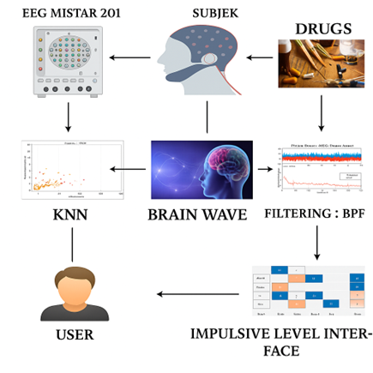
Figure 1. Diagram Block

- RESULT AND ANALYSIS
The collected data is still in raw form and contains significant noise, therefore a Band Pass Filter (BPF) is applied for filtering. With a frequency of about 0.5 to 50 Hz. The signals recorded before and after filtering can be seen in Fig 2, that the raw data in Fig 2(a) contains high noise that can obscure relevant information, while the results after filtration in Fig 2(b) show cleaner and more structured waves, making it easier to analyze brain activity. The purpose of filtering is to improve the quality of the signal representation that can be further processed and remove artifacts and unnecessary frequency components.
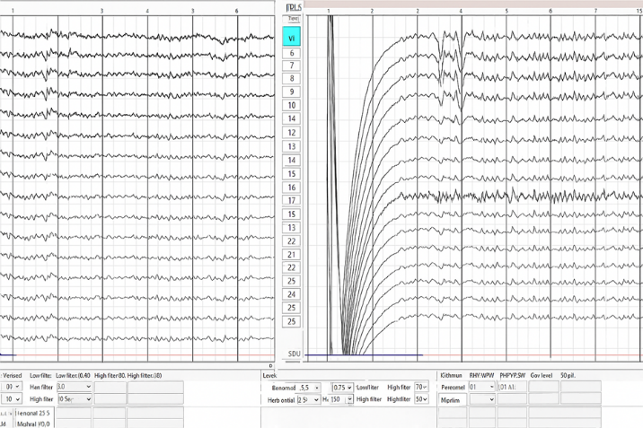
Figure 2. Data Before and After Filtering

The brainwave feature comparison results of the EEG signals in each subject consist of five main frequency components, namely Delta, Theta, Alpha, Beta 1, and Beta 2, as well as the total output value which is the aggregation of the five features. Delta waves, with a low frequency, are usually associated with a state of sleep or highly relaxed brain activity, while Theta waves correspond to a state of drowsiness or emotional processes. Alpha waves indicate a state of relaxation and calmness, while Beta 1 and Beta 2 waves, which have higher frequencies, are associated with more active mental activities such as concentration and alertness. In this table, it can be seen that subjects S1 to S10 had relatively high Delta and Theta values with lower Beta values, resulting in a total output that varied from 314.66 to 1033.37. In contrast, subjects S11 to S21 showed a dominant Beta wave pattern with much higher values than Delta and Theta, which was reflected in a similarly large total output, ranging from 851.66 to 998.11. These differences in spectral patterns indicate variations in mental or physiological states between subjects that can be utilized in analysis and classification using machine learning methods for identification purposes, such as drug user detection based on EEG signal characteristics. This data becomes the main quantitative basis in the process of feature identification and classification modeling of EEG signals, in accordance with the basic principles of EEG signal processing, transformation from time to frequency domain is carried out to obtain relevant spectral information as shown in Table 1.

Table 1. Comparison of EEG Feature Values Across Subjects
No. | Delta | Theta | Alpha | Beta 1 | Beta 2 | Output
S1 | 158 | 127,04 | 605,72 | 69,2 | 73,41 | 1033,37
S2 | 231,81 | 131,12 | 236,22 | 61,64 | 46,33 | 707,12
S3 | 195,37 | 103,89 | 78,31 | 28,03 | 30,28 | 435,88
S4 | 132,7 | 156,4 | 143,4 | 44,18 | 46,9 | 523,58
S5 | 115,99 | 64,34 | 160,16 | 28,44 | 31,06 | 399,99
S6 | 229,79 | 107,07 | 102,73 | 49,82 | 57,1 | 546,51
S7 | 75,28 | 47,52 | 124,82 | 31,48 | 35,56 | 314,66
S8 | 105,35 | 62,91 | 92,29 | 44,92 | 82,68 | 388,15
S9 | 228,61 | 89,53 | 144,32 | 32,36 | 46,73 | 541,55
S10 | 131,5 | 79,26 | 83,94 | 32,11 | 35,67 | 362,48
S11 | 35,1 | 79,15 | 123,12 | 283,19 | 370,85 | 891,41
S12 | 36,08 | 82,04 | 176,81 | 299,8 | 370,09 | 964,82
S13 | 35,1 | 70,38 | 123,12 | 272,48 | 400,4 | 901,48
S14 | 37,06 | 77,17 | 125,06 | 273,45 | 358,37 | 871,11
S15 | 35,1 | 70,38 | 131,89 | 252,92 | 507,82 | 998,11
S16 | 35,1 | 86,87 | 151,43 | 269,55 | 365,22 | 908,17
S17 | 35,1 | 72,33 | 135,79 | 298,81 | 360,35 | 902,38
S18 | 35,1 | 70,38 | 210,96 | 250,95 | 399,41 | 966,8
S19 | 36,08 | 70,38 | 173,9 | 270,5 | 371,74 | 922,6
S20 | 18,62 | 74,29 | 129,96 | 259,73 | 371,07 | 853,67
S21 | 35,1 | 70,38 | 123,12 | 265,66 | 357,4 | 851,66

The results of EEG data visualization using the KNN method can help us understand the patterns and graphs contained in EEG data which presents a graphical representation of five types of brain waves based on the results of EEG signal recordings. Each graph shows the change in signal amplitude against time or observation point. Delta waves in Fig 3(a) show high fluctuations at early points, with amplitudes reaching more than 250 µV, before decreasing significantly and stabilizing at low values after the 10th point. The Theta wave in fig 3(b) shows a similar pattern with a relatively high initial amplitude (around 150 µV), followed by a decrease and stabilization at a lower value. Fig 3(c) shows the Alpha wave, which has a very high amplitude at an early point (around 700 µV) and then rapidly decreases and stabilizes at a low amplitude range, indicating a decrease in mental relaxation activity. Meanwhile, the Beta 1 wave in Fig 3(d) displays a sudden increase in amplitude after the 9th point, from a low value to an amplitude of about 300 µV, which then stays at that level. Similarly, the Beta 2 wave in fig 3(e) shows a significant increase in amplitude at the same point, and then fluctuates but remains high compared to the initial condition. This increase in beta waves can be associated with increased cognitive activity or mental stress. Overall, these graphical data indicate a shift in the dynamics of brain activity before and after a certain point, which most likely represents the time of stimulus or drug administration. This change in wave amplitude can be used to assess the pharmacological effect on the subject's neurophysiological state as can be seen in Fig 3.
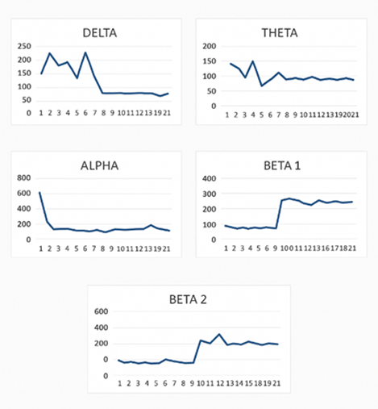
Figure 3. Visualization of EEG brainwave patterns: (a) Delta, (b) Theta, (c) Alpha, (d) Beta1, and (e) Beta2.

A scatter plot is a form of two-dimensional visualization that illustrates the relationship between two numerical variables. Each point on the plot corresponds to a single observation, with its position determined by the values of the two analyzed variables. In machine learning research, such as EEG signal classification using the KNN algorithm, scatter plots are commonly employed to display the distribution of features in a reduced multidimensional space, for instance through PCA, in order to assess the degree of separation among data groups. Figure 4 presents the visualization of KNN model predictions in classifying impulsivity levels based on Delta and Theta brainwave patterns. Each point in the plot represents a data sample, where the X-axis denotes Delta wave values and the Y-axis represents Theta wave values. Orange indicates the active class, purple the tend to be active class, green the less active class, and light blue the very active class. The color of each point reflects the actual impulsivity class, while the point’s shape represents the predicted class. The plot demonstrates that the KNN model successfully classifies most data samples, although some errors remain, highlighting the inherent complexity of EEG signals. Beyond classification, this visualization provides flexibility for adjusting parameters and facilitates evaluation of model performance. The KNN method is also recognized for its ability to perform multi-class predictions, enabling researchers to estimate class probabilities of the target variable. KNN is extensively applied in various domains, such as text classification, where it often outperforms other methods. Consequently, this scatter plot serves as an important tool for evaluating the model’s capability to differentiate brain activity patterns from EEG parameters, while offering an initial visual understanding of feature distributions in a two-dimensional domain. Such analysis is particularly valuable in neurophysiological research, especially for detecting specific conditions or pharmacological effects from brainwave activity, as shown in Fig. 4.
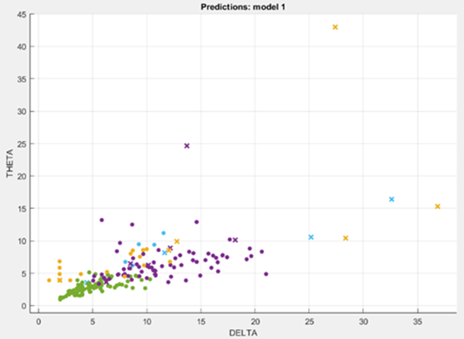
Figure 4. Scatter Plot

The ROC (Receiver Operating Characteristic) curve is a graphical tool used to assess the effectiveness of a classification model by plotting the true positive rate (sensitivity) against the false positive rate across different threshold values. This visualization demonstrates the model’s capability to separate two classes, where performance improves as the curve moves closer to the top-left corner. The Area Under the Curve (AUC) serves as a quantitative indicator of accuracy, with scores nearing 1 reflecting excellent classification capability. On this curve, the horizontal axis denotes the false positive rate, while the vertical axis corresponds to the true positive rate. The obtained AUC score of 0.84 indicates strong discriminative power in distinguishing between high-impulsivity and low-impulsivity groups, surpassing baseline models such as random guessing. The orange marker located at the coordinates (0.01; 0.70) represents the current classifier output, showing that with a false positive rate of 0.01, the true positive rate achieved is 0.70. Since an AUC value approaching 1 signifies robust predictive accuracy, the model can be classified as having relatively high performance, as presented in Fig. 5.

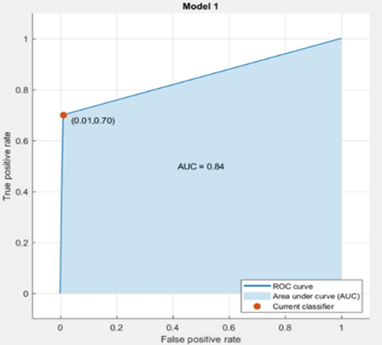
Figure 5. ROC Curve Displaying Classification Performance with AUC = 0.84

The confusion matrix is a widely used evaluation tool in machine learning for measuring the performance of classification models. It provides details on the number of accurate and inaccurate predictions by comparing the actual categories with the outcomes generated by the model. The matrix is composed of four key elements: True Positive (TP), True Negative (TN), False Positive (FP), and False Negative (FN), each describing correct or incorrect classifications in different contexts. From these values, several performance indicators such as accuracy, precision, recall, and F1-score can be derived, offering a more comprehensive assessment of model effectiveness. In this research, the confusion matrix serves an essential role in determining the system’s ability to differentiate between drug users and non-users based on processed brainwave signals. The output from Model 1 categorizes EEG-based activity into four primary groups—Active, Tending to be Active, Less Active, and Very Active—with two additional classes labeled Other and Classification Result. By comparing the actual labels (vertical axis) against the predicted labels (horizontal axis), the confusion matrix illustrates how well the model performs in classification tasks. The results show that the model demonstrates strong performance in detecting the Active category, successfully identifying 205 data points. However, there were a few misclassifications: 3 data points from the Active class were predicted as Tending to be Active, and 2 as Very Active. In the Tending to be Active class, 66 data points were correctly classified, though 2 were misclassified as Active and 1 as Less Active. For the Less Active class, the model correctly classified 83 data points, with 4 misclassified as Tending to be Active. The model showed weaker performance in the Very Active class, correctly classifying only 7 data points, while 3 were incorrectly classified as Active. Additionally, in the Other class, 1 data point was misclassified as Active and 2 as Very Active. The Classification Result class does not appear to be a primary target class, as it recorded only one misclassification into the Other category. Overall, Model 1 demonstrates reasonably good classification performance, especially in classes with larger amounts of data such as Active. However, the model’s accuracy tends to decline in classes with fewer data points, such as Very Active. This highlights the need for further evaluation and potentially implementing data balancing techniques to optimize model performance across all classes, as illustrated in Fig 6.
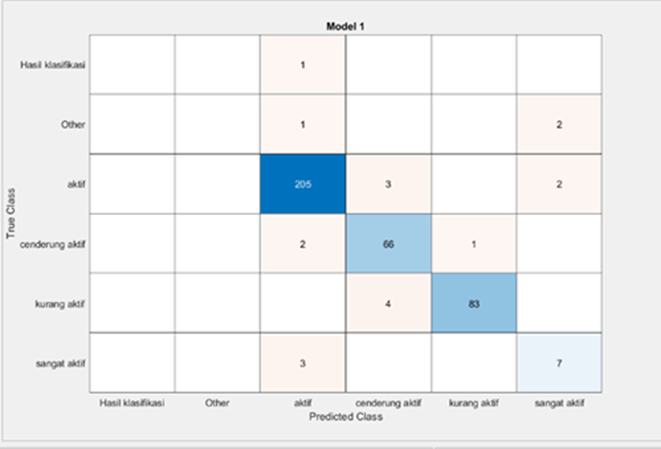
Figure 6. Confusion Matrix

- CONCLUSION
The findings of this study indicate that the KNN algorithm is capable of recognizing brain activity patterns with a high accuracy rate of up to 95%, thereby offering an objective foundation for evaluating relapse risk. In implementing this approach, EEG signal processing is integrated with filtering techniques such as BPF to minimize noise and enhance the quality of the analyzed signals. Feature extraction from EEG waveforms enables a more detailed examination of an individual’s neurophysiological condition. Furthermore, the KNN model successfully differentiated various levels of impulsive activity through numerical analysis and data visualization. These results highlight that the complexity of impulsive brain signal patterns necessitates more representative training datasets. This research also emphasizes the critical role of effective data preprocessing and the careful selection of relevant features in EEG signal analysis.

- REFERENCES
- N. D. Volkow, M. Michaelides, and R. Baler, “The neuroscience of drug reward and addiction,” Physiol Rev, vol. 99, no. 4, pp. 2115–2140, 2019, doi: 10.1152/physrev.00014.2018.
- P. Giovannelli and H. Pfister, “Neuro-circuitry of Impulsivity and its Relation to Substance Use Disorders,” Rev Psiquiatr Clín, vol. 50, no. 6, pp. 31–37, 2023, doi: 10.15761/0101-60830000000705.
- X. Li, Y. He, D. Wang, and M. J. Rezaei, “Stroke rehabilitation: from diagnosis to therapy,” 2024, Frontiers Media SA. doi: 10.3389/fneur.2024.1402729.
- W. Sliedrecht, H. G. Roozen, K. Witkiewitz, R. De Waart, and G. Dom, “The Association between Impulsivity and Relapse in Patients with Alcohol Use Disorder: A Literature Review,” Nov. 01, 2021, Oxford University Press. doi: 10.1093/alcalc/agaa132.
- H. Soltanian-Zadeh, E. M. Sokhadze, O. R. Dobrushina, and G. Federico, “Simultaneous real-time EEG-fMRI neurofeedback: A systematic review.”
- Z. Bin Akhtar and V. S. Rozario, “AI Perspectives Within Computational Neuroscience: EEG Integrations and the Human Brain,” Artificial Intelligence and Applications, vol. 3, no. 2, pp. 145–160, Apr. 2025, doi: 10.47852/bonviewAIA52024174.
- A. S. Ginting, R. M. Simanjuntak, N. Lumbantoruan, and D. Sitanggang, “EEG Signal Classification using K-Nearest Neighbor Method to Measure Impulsivity Level,” Jurnal Sisfokom (Sistem Informasi dan Komputer), vol. 13, no. 2, pp. 261–266, Jun. 2024, doi: 10.32736/sisfokom.v13i2.2154.
- N. Liladhar Rane, A. Tawde, S. P. Choudhary, and J. Rane, “Contribution and performance of ChatGPT and other Large Language Models (LLM) for scientific and research advancements: a double-edged sword”, doi: 10.56726/IRJMETS45312.
- J. Vassileva, J.-H. Lee, E. Psederska, and W.-Y. Ahn, “Utility of computational approaches for precision psychiatry: Applications to substance use disorders.”
- V. Khurana et al., “A Survey on Neuromarketing using EEG Signals.”
- N. Jamil and A. N. Belkacem, “Advancing Real-Time Remote Learning: A Novel Paradigm for Cognitive Enhancement Using EEG and Eye-Tracking Analytics,” IEEE Access, vol. 12, pp. 93116–93132, 2024, doi: 10.1109/ACCESS.2024.3422926.
- P. Hüpen, H. Kumar, A. Shymanskaya, R. Swaminathan, and U. Habel, “Impulsivity Classification Using EEG Power and Explainable Machine Learning,” Int J Neural Syst, vol. 33, no. 2, Feb. 2023, doi: 10.1142/S0129065723500065.
- V. Kotoula, J. W. Evans, C. E. Punturieri, and C. A. Zarate, “Review: The use of functional magnetic resonance imaging (fMRI) in clinical trials and experimental research studies for depression,” 2023, Frontiers Media SA. doi: 10.3389/fnimg.2023.1110258.
- S. Ibna Abir et al., “Machine Learning and Deep Learning Techniques for EEG-Based Prediction of Psychiatric Disorders,” 2025, doi: 10.32996/jcsts.
- A. Mausd et al., “EEG-Based Neurofeedback for ADHD in Children: Enhancing Attention and Reducing Impulsivity Using Machine Learning,” International Journal of Computing and Digital Systems, vol. 18, no. 1, 2025, doi: 10.12785/ijcds/1571139415.
- A. Frolli, E. Saviano, M. Ricci, S. L. Sica, and M. Romano, “Artificial Intelligence in ADHD treatment: a brief narrative review,” 2023.
- J. S. Cerqueira, “Towards Personalized Therapy: Integrating Real-Time Eye Tracking and EEG to Improve VR-Based Therapeutic Interventions,” 2025.
- C. W. You et al., “Trigger or Treat: Using Technology to Facilitate the Perception of Cravings and Corresponding Cues for Achieving Clinical-friendly Drug Psychotherapy,” Proc ACM Hum Comput Interact, vol. 7, no. 1 CSCW, Apr. 2023, doi: 10.1145/3579535.
- A. M. Roffarello and L. De Russis, “Achieving Digital Wellbeing Through Digital Self-control Tools: A Systematic Review and Meta-analysis,” ACM Transactions on Computer-Human Interaction, vol. 30, no. 4, Sep. 2023, doi: 10.1145/3571810.
- S. N. Saleem Kbah et al., “Review on Fundamental of Electroencephalography and Detection Techniques in Substance and Behavioral Addiction,” Journal of Human Centered Technology, vol. 4, no. 1, pp. 78–85, Feb. 2025, doi: 10.11113/humentech.v4n1.98.
- A. S. Abdulbaqi, M. T. Younis, Y. T. Younus, and A. J. Obaid, “A hybrid technique for eeg signals evaluation and classification as a step towards to neurological and cerebral disorders diagnosis,” International Journal of Nonlinear Analysis and Applications, vol. 13, no. 1, pp. 773–781, 2022, doi: 10.22075/IJNAA.2022.5590.
- A. Alhudhaif, “An effective classification framework for brain-computer interface system design based on combining of fNIRS and EEG signals,” PeerJ Comput Sci, vol. 7, pp. 1–24, 2021, doi: 10.7717/PEERJ-CS.537.
- N. A. Tawhid, S. Siuly, K. Wang, and H. Wang, “Textural feature based intelligent approach for neurological abnormality detection from brain signal data,” PLoS One, vol. 17, no. 11 November, Nov. 2022, doi: 10.1371/journal.pone.0277555.
- P. Kartha, P. P. Nair, R. Ann Reji, and S. S. Suresh, “Predicting Drug Addiction Using Multimodal Data Fusion and Machine Learning Techniques,” International Journal of Computer Science Trends and Technology (IJCST), vol. 12, [Online]. Available: www.ijcstjournal.org
- B. M. S. Hasan and A. M. Abdulazeez, “A Review of Principal Component Analysis Algorithm for Dimensionality Reduction,” Journal of Soft Computing and Data Mining, vol. 2, no. 1, pp. 20–30, Apr. 2021, doi: 10.30880/jscdm.2021.02.01.003.
- U. Khalid, M. Naeem, F. Stasolla, M. Syed, M. Abbas, and A. Coronato, “Impact of AI-Powered Solutions in Rehabilitation Process: Recent Improvements and Future Trends,” Int J Gen Med, vol. Volume 17, pp. 943–969, Mar. 2024, doi: 10.2147/ijgm.s453903.
- Y. H. Chen, J. Yang, H. Wu, K. T. Beier, and M. Sawan, “Challenges and future trends in wearable closed-loop neuromodulation to efficiently treat methamphetamine addiction,” 2023, Frontiers Media S.A. doi: 10.3389/fpsyt.2023.1085036.
- I. Lucas, N. Solé-Morata, I. Baenas, M. Rosinska, F. Fernández-Aranda, and S. Jiménez-Murcia, “Biofeedback Interventions for Impulsivity-related Processes in Addictive Disorders,” Sep. 01, 2023, Springer Science and Business Media Deutschland GmbH. doi: 10.1007/s40429-023-00499-y.
- S. A. Alowais et al., “Revolutionizing healthcare: the role of artificial intelligence in clinical practice,” Dec. 01, 2023, BioMed Central Ltd. doi: 10.1186/s12909-023-04698-z.

