Optimization of Transportation Infrastructure Networks as a Disaster Risk Mitigation Effort in the Sepaku Semoi Dam Emergency Action Plan
Zony Yulfadli ¹, Friska Putri ²
Lecturer of Civil Engineering Study Program, Faculty of Engineering,
University of Samarinda, August 17, 1945
Corresponding Author : zony@untag-smd.ac.id

Abstract
This study aims to optimize the transportation infrastructure network as part of the disaster risk mitigation strategy in the Sepaku Semoi Dam Emergency Action Plan (EAP). In the context of potential dam failure, reliable transportation access is crucial to support rapid and effective evacuation and emergency response. This study uses the Analytical Hierarchy Process (AHP) approach to evaluate and prioritize transportation routes based on three main criteria: accessibility, road capacity, and physical infrastructure resilience. Data were obtained through a direct survey of 80 respondents, including local stakeholders such as the Regional Disaster Management Agency (BPBD), the Public Works Agency, and community leaders in the affected area. The analysis results indicate that the Sepaku–Petung Main Road is the most prioritized evacuation route with the highest AHP score (0.41). These findings provide a strong scientific basis for the development of evacuation strategies in the EAP document and serve as a reference for planned road infrastructure improvement and maintenance. This study is expected to serve as an applicable reference in dam EAP planning in other areas with comparable geographic and social conditions.
Keywords: transportation infrastructure, RTD, AHP, Sepaku Semoi, evacuation routes, disaster mitigation
- Introduction
Transportation infrastructure plays a crucial role in disaster management systems, particularly in supporting the rapid and accurate evacuation of residents and distribution of logistics. The quality, condition, and connectivity of the road network significantly determine the effectiveness of emergency response and contribute to reducing the risk of loss of life and economic loss [1] . In Indonesia, large dams such as Sepaku Semoi not only serve as raw water supplies and flood control facilities, but also pose a high risk of collapse or uncontrolled water release [2].
The Sepaku Semoi Dam, located in East Kalimantan, is part of the National Strategic Project (PSN) and supports the infrastructure of the Indonesian National Capital City (IKN). According to Minister of Public Works and Public Housing Regulation No. 27/PRT/M/2015, the preparation of an Emergency Action Plan (RTD) is mandatory, including the arrangement of evacuation routes for vulnerable downstream communities. However, previous studies have shown that most road networks around dams in Indonesia have not been specifically designed for evacuation purposes, making them vulnerable to congestion, damage, or even being cut off during disasters. [3]
Therefore, this study uses the Analytical Hierarchy Process (AHP) method as a multi-criteria approach in evaluating the four main evacuation routes in the RTD document (A1–A4) based on physical conditions, accessibility, and distance to the evacuation assembly point. In addition, this study also recommends two additional routes, namely Route A5 (Sepaku Lama–Tengin Baru–Karang Jinawi) and Route A6 (Gunung Intan–Sukaraja–Giri Mukti–Petung), to reach unserved settlements and strengthen connectivity between routes.
The strength of this study lies in the integration of the quantitative AHP approach with field survey data and spatial analysis of the affected area. This approach allows for more objective and responsive decision-making to local conditions, unlike previous studies that were more descriptive or based on general assumptions [4] . In addition, the integration of the AHP method in the context of disaster evacuation has also proven effective in various international studies [5] , which show that this method is able to capture the complexity of decision-making based on multiple criteria and spatial data. Thus, the results of this study are expected to strengthen the evacuation system in the Sepaku Semoi Dam RTD and increase the preparedness capacity of local governments for potential dam disasters.

- Methodology Study
  - Analytical Hierarchy Process (AHP)

The Analytical Hierarchy Process (AHP) was developed in the early 1970s by Thomas L. Saaty [6] [7] a mathematician affiliated with the University of Pittsburgh. AHP stands out for its ability to collect data from one or more experts using the pairwise comparison method, creating a structured comparison hierarchy that includes criteria and sub-criteria in between various choices, assigning priority vectors to each set of items being assessed, and collecting local preferences influenced by subcriteria and criteria at all levels of the hierarchy to set priority overall in all choice. Saaty (2008) take notes that research Which apply approach AHP No need a group big participants but focuses on key individuals who have expertise and are very important. In this study, the AHP method is used to determine the ranking to select the best location for a bonded logistics center, by relying on the insights and experiences of various specialist industry. AHP chosen Because method This in a way effective measure Qualitative information by evaluating abstract factors, which are important because they cannot be measured directly using fixed scales, but can only be assessed through qualitative methods. This study applies the Analytical Hierarchy approach.
Process (AHP) for analysis. The steps in the AHP method consist of [6] :

- Identifying the problem and clarifying the desired outcome. This first stage focuses on explicitly defining the problem requiring resolution and establishing the solution's objectives. This stage lays the foundation for the entire process by clarifying what needs to be achieved.
- Develop a hierarchical framework that begins with the overarching objective, followed by the criteria, and finally, the alternatives at the lowest criterion level. At this stage, a hierarchy is formed with the overarching objective at the top. Below this objective, the various criteria that influence the decision are listed, and at the bottom, the potential alternatives are placed. This organization helps to systematically manage the decision-making process. 3. Formulate a pairwise comparison matrix that outlines the relative impact or contribution of each element in relation to the criteria above it. In this section, a matrix is created to evaluate each element against the other elements in pairs, reflecting how much contribution or influence each element has on the criteria at the next level. This process clarifies the relative importance of each element.
- Standardize data by dividing the value of each element in a pairwise comparison matrix by the sum of each column. Normalization means adjusting the values in a pairwise comparison matrix to allow for comparisons on a uniform scale. This is achieved by dividing the value of each element by the total of its column, ensuring that the comparisons are logical and relevant.
- Calculate eigenvalues and assess their consistency; if inconsistencies occur, repeat data collection. Eigenvalues are calculated to determine the priority ranking of each element. A consistency check is performed to ensure that the comparisons made in the pairwise matrix are logical. A high consistency ratio indicates potential unreliability in the assessment, which requires repeating the data collection process.
- Carry out steps 3 through 5 for each level of the hierarchy.
- Determine the eigenvectors for each pairwise comparison matrix. Eigenvectors indicate the relative weight or significance of elements in the matrix. Eigenvectors are derived from the eigenvalues and provide a ranking based on element importance.
- Verify hierarchy consistency. If the value exceeds 10%, the assessment value is reconsidered. The final step requires extensive consistency checks across the hierarchy. A consistency ratio greater than 10% indicates potential inconsistencies in the assessment, requiring a re-evaluation of the value to ensure the reliability of the decision-making process.
2.1 Research Location and Object
The study was conducted in the area surrounding the Sepaku Semoi Dam, Sepaku District, North Penajam Paser Regency, East Kalimantan Province. The focus of the study was the main and alternative road networks located within the potential inundation zone, based on HEC-RAS simulation results.

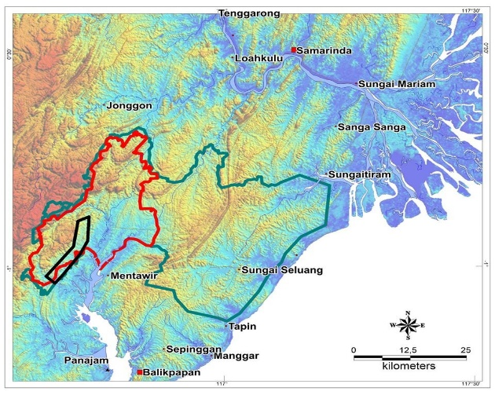
Figure 1. Location Map of the Sepaku-Semoi Dam Figure 2. Map of Flood-Affected Areas
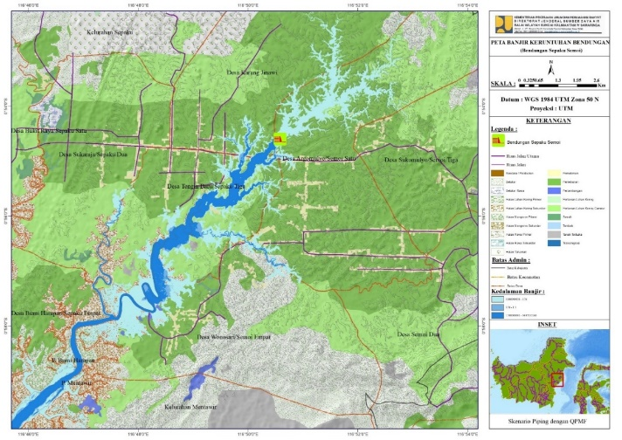

Bendungan Sepaku

2.3 Data Collection

The data used consists of:
- Primary Data: Field survey of road, bridge, and supporting facility conditions; AHP questionnaire via Google Form to 80 expert respondents from BPBD (Regional Disaster Management Agency), Kalimantan River Basin Office, and the Regent of North Penajam Paser, BMKG, PUPR Office, and other RTD related institutions.
- Secondary Data: Flood inundation map from HEC-RAS modeling, Sepaku Semoi Dam RTD document, road data from Bina Marga and Regency RTRW.
2.4 Criteria and Alternatives in AHP The criteria used in AHP analysis include:
- Accessibility (C1)
- Distance to settlements: How close is the route from the affected settlements?
- Ease of access: Availability of connections to main routes/main roads
- Continuity of the route: Existence of access breaks (damaged bridges, rivers without bridges)
- Road surface conditions: Is the road asphalt, concrete, dirt, or gravel?
- Availability of transport: Potential for emergency vehicles (ambulances, BPBD cars) to pass through
- Road Capacity (C2)
- Road width: Is it wide enough for 2 directions or only enough for 1 direction?
- Daily traffic volume: Normal daily vehicle load on the route
- Potential for congestion: Is the route prone to congestion during emergencies (e.g., markets, schools, etc.)
- Evacuation capacity: Vehicle/mass capacity at peak evacuation

- Physical Endurance (C3)
- Road structure condition: How good is the base structure and road surface?
- Landslide/flooding risk: Is the route prone to landslides or local flooding?
- Condition of bridges/supporting structures: Are there any bridges that are old, damaged, or fragile?
- Damage history: Has the line ever been damaged or cut off due to a previous disaster?
- Routine maintenance level: Frequency of maintenance by the Public Works Department or local government
Alternative evacuation routes analyzed:
- A1: Sepaku–Petung Main Road
- A2: Trans Kalimantan Highway
- A3: Reservoir Ring Road
- A4: Karang Jinawi-Sotek Road

2.4 AHP Process
The steps in the AHP method carried out in this research are:
- Constructing a decision hierarchy (Objectives–Criteria–Alternatives)
- Create a pairwise comparison matrix between criteria and between alternatives
- Calculating eigenvector values (priority weights)
- Conduct a consistency test with Consistency Ratio (CR < 0.1)
Data processing was performed using Expert Choice software and Excel for weighting and CR calculations. The final results are a priority ranking of the four analyzed pathways, with technical recommendations for the pathway with the highest score.

  - Results and Discussion
The following graph illustrates the number of respondents who prioritize each -criterion in AHP (Accessibility, Road Capacity, Infrastructure Resilience) based on the results of a survey of 80 people from the results of the survey via Google Form.

Figure 3. AHP Criteria Graph
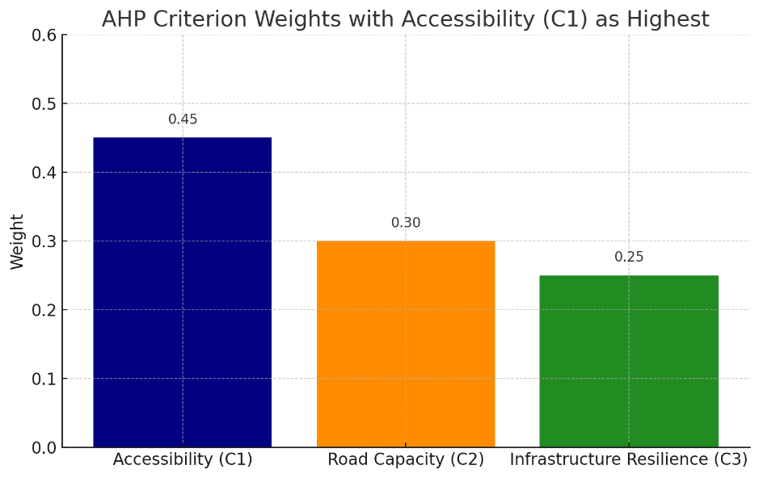
Based on the bar graph above, the distribution of weights for the three main criteria in selecting evacuation routes, with Accessibility (C1) as the most important criterion:
- Accessibility (C1) – 0.45
Has the highest weighting, emphasizing that ease and speed of access to evacuation routes are top priorities. Infrastructure must be designed to allow people to reach evacuation routes quickly and smoothly.
- Road Capacity (C2) – 0.30
Shows the importance of road capacity to accommodate vehicle volume during mass evacuations, reducing the risk of congestion that can hinder the evacuation process.
- Infrastructure Resilience (C3) – 0.25
Although still significant, its weight is lower than C1 and C2, indicating that the physical resilience of roads needs attention but does not outweigh the speed of access and road capacity.
These results can be a primary focus of RTD planning: ensuring evacuation route accessibility first, followed by increasing road capacity, and then strengthening resilience. This approach will maximize evacuation effectiveness during a crisis by prioritizing speed and smooth access. [8] [9]

3.2 Criteria Weight Analysis
A criteria weighting analysis was conducted to determine the importance of each criterion in determining the optimal evacuation route. This study used three main criteria: Accessibility (C1), Road Capacity (C2), and Physical Infrastructure Resilience (C3). Data were obtained through a paired comparison questionnaire completed by the 80 expert respondents mentioned above.
The pairwise comparison matrix from each respondent was then averaged and normalized to obtain priority weights (eigenvectors) using the AHP method. The results of the data processing are presented in Table 3.1.
Table 3.1 Evacuation Route Criteria Weighting (AHP Results )
Criteria | Weight
Accessibility (C1) | 0.45
Road Capacity (C2) | 0.30
Physical Endurance (C3) | 0.25
The table above shows that accessibility is the criterion with the highest weighting, at 0.45. This indicates that ease of access from residential areas to evacuation points is considered the most important in the context of disaster preparedness due to the potential collapse of the Sepaku Semoi Dam. Road capacity ranks second with a weighting of 0.30, indicating that the road's ability to accommodate the volume of evacuation vehicles is also a significant consideration. Meanwhile, the physical resilience of road infrastructure received a weighting of 0.25, reflecting attention to the quality of road structures against flooding, landslides, and damage during disasters.
The consistency value of the AHP assessment shows a Consistency Ratio (CR) of 0.069, which means it is consistent (<0.1) and methodologically acceptable [6] . This consistency ensures that the resulting weighting and ranking are valid to support decisions in determining evacuation routes [10].

3.2 Evacuation Route Score Evaluation
The following table presents the scores of alternative evacuation routes against each criterion based on the results of the adjusted AHP survey.

Table 3.2 Alternative Evacuation Route Scores for Each Criteria
Evacuation Route | C1 (0.45) | C2 (0.30) | C3 (0.25) | Global Score
A1 – Silkar–Bukit Raya–Petung | 0.48 | 0.38 | 0.32 | 0.41
A2 – Southern Ring Road (PLTA) | 0.42 | 0.30 | 0.25 | 0.34
A3 – Trans Kalimantan | 0.40 | 0.35 | 0.25 | 0.31
A4 – Sepaku–Petung | 0.35 | 0.40 | 0.30 | 0.33

Route A1 received the highest score (0.41), making it the most optimal evacuation route. A high score for criterion C1 (0.48) indicates that the road is in relatively good physical condition, with an asphalt surface and sufficient width for large vehicles. High scores were also seen for criteria C2 and C3, indicating that this route is directly connected to Petung and has a relatively short evacuation distance from densely populated areas. Route A1 is recommended as the primary evacuation route in emergency scenarios. Repair and maintenance of this route's infrastructure should be a top priority in strengthening the RTD system. With a global score of 0.34, Route A2 is the primary alternative after A1. A relatively high C1 score indicates generally good road conditions, but a C3 score (0.25) indicates that this route is quite far from several vulnerable settlements . A2 is suitable as a backup route or rotation route in the second phase of evacuation. Accessibility and connectivity to affected villages need to be improved. This route received the lowest score (0.31) due to a low C3 score (0.25), indicating the distance of the evacuation point from densely populated settlements. Although connected to the national road, its connectivity to vulnerable points is not optimal. Route A3 is more appropriately used as a logistics distribution route or auxiliary route after the main evacuation process is complete. A global score of 0.33 places A4 as an important route serving densely populated areas. Although its physical condition (C1 = 0.35) is still poor, this route has high accessibility (C2 = 0.40). The A4 route has significant potential if its road infrastructure is improved. It plays a crucial role in supporting the evacuation of residents in the center of Sepaku District.

The following is an evacuation route map, which depicts four main alternative routes connecting affected residential areas to safe evacuation points outside the flood hazard zone due to the potential collapse of the Sepaku Semoi Dam. These routes were designed based on three main criteria: accessibility (C1), road capacity (C2), and physical infrastructure resilience (C3).
Figure 4. Evacuation Route A1 Figure 5. Evacuation Route A2
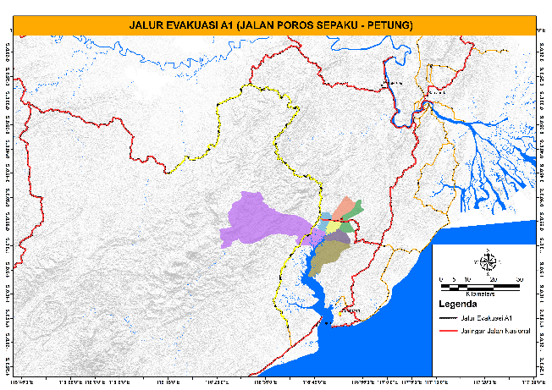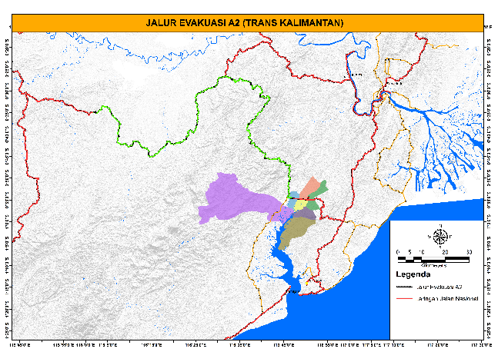
Figure 6. Evacuation Route A3 Figure 7. Evacuation Route A4
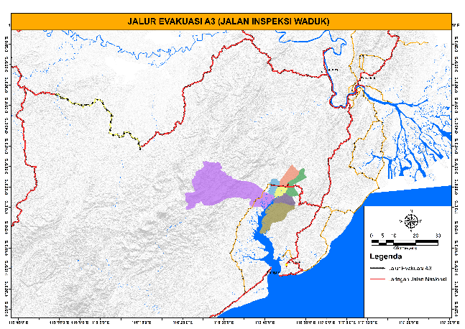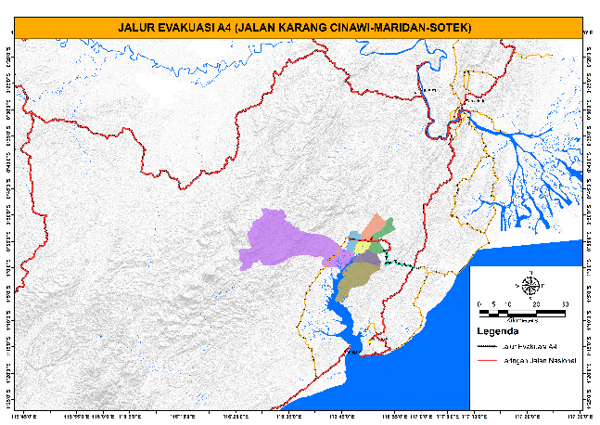
- Route A1 – Silkar–Bukit Raya–Petung
This route is the main route with the highest global score. Starting from the Silkar and Bukit Raya areas , the route follows a paved road corridor to Petung, one of the safest locations outside the flood zone. This route offers direct access to densely populated areas, adequate road width for large vehicles, and relatively good road conditions.
- Route A2 – Southern Ring Road (PLTA)
Starting southwest of the affected area, this route follows the Southern Ring Road, which passes through the area near the hydroelectric power plant. Although the road is in good condition, this route is relatively far from several vulnerable settlements, so it is used as an alternative or detour route.
- Route A3 – Trans Kalimantan
This route uses the Trans Kalimantan national road corridor, with connections to key logistics hubs. However, this route has lower accessibility and resilience scores due to its distance from residential centers and lack of access to public transportation. directly to the main evacuation point, making it more suitable as a post-evacuation logistics distribution route.

4.3 Implications for RTD Strategy

Based on the AHP results, there are several important implications for the RTD implementation strategy for the Sepaku Semoi Dam, including:

Focus on Infrastructure Strengthening on Route A1: Route
A1 has proven to be the most viable route. Road maintenance, shoulder widening, and improved evacuation markings are highly recommended to strengthen this route as a primary route.

Second-Lane Route Development
Routes A2 and A4 have strategic value as a complement when the main route is disrupted. Their presence is crucial in multi-lane evacuation scenarios and can be used in vehicle evacuation rotation strategies (2 trips).

Reorienting the Function of Route A3
Route A3 is more effective if it is directed as a logistics and post-disaster aid distribution route. A re-evaluation of this route's role in human evacuation scenarios needs to be considered.

Network Expansion with Recommended Additional Routes
The routes A5 (Sepaku Lama–Tengin Baru–Karang Jinawi) and A6 (Gunung Intan–Sukaraja–Giri Mukti–Petung) recommended in this study, although not yet evaluated in the AHP, have the potential to close the connectivity gap between the main routes. These routes can be proposed as part of the strategic backup routes in the revised RTD.

3.3. Recommended Additional Evacuation Routes (A5 and A6)
Based on a spatial evaluation and distribution of the affected population in Sepaku District and its surrounding areas, it was found that several villages were not optimally served by the four main evacuation routes (A1–A4). Therefore, two additional routes were proposed as backup routes and to strengthen the evacuation system:

Route A5 – Old Sepaku – New Tengin – Karang Jinawi
- Villages/sub-districts passed through : Old Sepaku, New Tengin, Karang Jinawi
- District : Sepaku
- Function : Lateral connecting route between A1 and A4, serving residential areas with limited access.
- Number of affected residents : ± 1,500 people
- Recommendation : Improve the road surface and widen the road body in several aggregate-soil segments to support smooth evacuation.

Route A6 – Mount Intan – Sukaraja – Giri Mukti – Petung
- Villages/sub-districts passed through : Gunung Intan, Sukaraja, Giri Mukti, Petung
- Districts : Babulu and Waru
- Function : Alternative route from the north side, strengthening logistics and evacuation access to Petung
- Number of affected residents : ± 2,000 people
- Recommendation : Revitalization of inter-village connectivity and improvement of connecting bridge structures.
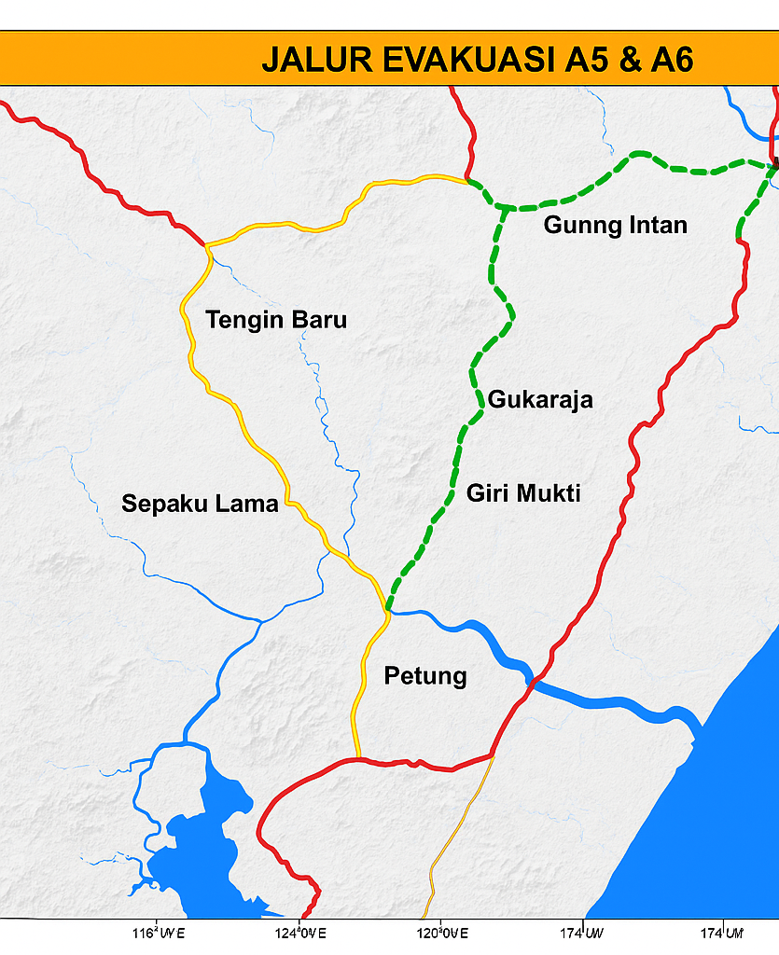

Legenda
Jalur Evakuasi 5
--------------- Jalur Evakuasi 6

3.4. Estimating Accommodation and Evacuation Fleet Needs
Based on the total number of affected residents along the A1–A6 routes, an estimated 23,700 people would require evacuation in a disaster scenario. Therefore, adjustments to the number of evacuation vehicles and shelter capacity are required.

Evacuation Fleet Estimation Table for Routes A1–A4 (1 Evacuation Trip)
Line Code | Affected Population | Bus Fleet  (40 people) | Truck  (30 people) | Pick-up/Minibus  (10 people)
A1 | 8,200 people | 205 | 274 | 820
A2 | 6,500 people | 163 | 217 | 650
A3 | 1,200 people | 30 | 40 | 120
A4 | 4,100 people | 103 | 137 | 410
Note : The number of fleets can be reduced by up to 50% if done in 2 trips.
4. Conclusions and Recommendations
Based on the analysis using the AHP method and field surveys, it can be concluded that optimizing the transportation network is a strategic component in disaster risk mitigation efforts at the Sepaku Semoi Dam RTD. The Sepaku-Petung Main Road was designated as a priority evacuation route due to its highest scores in terms of accessibility, capacity, and physical resilience. The Trans Kalimantan Road and the Reservoir Ring Road serve as alternative routes, while the Hydroelectric Power Plant Logistics Road is considered a limited access route for logistics.
Further research can integrate GIS-based transportation network simulation models to predict evacuation travel times and the influence of dynamic traffic conditions during disasters.
Recommendations from this study include:
- Accelerating improvements to the quality of the Sepaku–Petung Main Road as the main evacuation route, including widening, improving the road surface, and installing evacuation signs.
- Regular maintenance of alternative routes and strengthening of bridge and drainage structures.
- Integration of the results of this analysis into official RTD documents and regional development plans.
- Conducting periodic evacuation simulations and providing information to the public regarding evacuation routes and procedures.
- Integration of Routes A5 and A6 into the official RTD of Sepaku Semoi Dam , as a strategic reserve evacuation route based on spatial and risk distribution.
- Provision of emergency accommodation/shelters along A1, A2, and A6 , taking into account a capacity of ≥100 people/shelter, ventilation, clean water, and basic sanitation.
- Evacuation simulation with the community and village government in the A5–A6 route area, considering that the public's understanding of the role of this route is still limited.
- Mapping travel times and route segmentation based on topographic characteristics , in order to optimize staging areas and placement of evacuation officers.

Bibliography
[1] A. Massaro et al. , “Innovative DSS for intelligent monitoring and urban square design approaches: A case of study,” Sustain. Cities Soc. , vol. 65, p. 102653, 2021, doi: 10.1016/j.scs.2020.102653.
[2] K. Endo, Y. Taira, and N. Yamaguchi, “The relocation of the capital of Indonesia under the Jokowi administration: Issues and government responses,” no. 12, 2025, [Online]. Available: https://jicari.repo.nii.ac.jp/records/2000099%0A https://jicari.repo.nii.ac.jp/record/2000099/files/Knowlege_Report_No12.pdf.
[3] A. Sha et al. , “Advances and development trends in eco-friendly pavements,” J. Road Eng. , vol. 1, no. December, pp. 1–42, 2021, doi: 10.1016/j.jreng.2021.12.002.
[4] M. Hussain, MM Ajmal, M. Khan, and H. Saber, “Competitive priorities and knowledge management: An empirical investigation of manufacturing companies in the UAE,” J. Manuf. Technol. Manag. , vol. 26, no. 6, pp. 791–806, 2015, doi: 10.1108/JMTM-03-2014-0020.
[5] P. Thammaboribal, NK Tripathi, and S. Lipiloet, “Using of Analytical Hierarchy Process (AHP) in Disaster Management: A Review of Flooding and Landslide Susceptibility Mapping,” Int. J. Geoinformatics , vol. 21, no. 4, pp. 177–196, 2025, doi: 10.52939/ijg.v21i4.4091.
[6] TL Saaty, “Decision making with the Analytic Hierarchy Process,” Sci. Iran. , vol. 9, no. 3, pp. 215–229, 2002, doi: 10.1504/ijssci.2008.017590.
[7] S. CHOOSUMRONG, V. RAGHAVAN, and N. BOZON, “Multi-Criteria Emergency Route Planning Based on Analytical Hierarchy Process and pgRouting,” Geoinformatics , vol. 23, no. 4, pp. 159–167, 2012, doi: 10.6010/geoinformatics.23.159.
[8] JO Ebingner and N. Vandycke, “Moving Toward Climate-Resilient Transport The World Bank's Experience from,” World Bank Gr. , 2015.
[9] “Guide for Planning Mass Evacuations in Disasters.”
[10] G. Gagliardi et al. , “Optical fiber sensing based on reflection laser spectroscopy,” Sensors , vol. 10, no. 3, pp. 1823–1845, 2010, doi: 10.3390/s100301823.

